Sheet no : 4
Refer to slide no : 4
Written by : Mahmoud Qaisi
corrected by Sahem Jamaen
**************************************************
As mentioned in the last lecture, some sperms may contain “YY” chromosome, and when they fertilize a normal ovum it will result in a male with “XYY”, these patients have attention problems, and they are inconsiderate “aggressive”. Another case is a male with “XXXY”, these patients have low IQ “between 20- 80”, they have gonad hyperplasia, and coarse facial appearance. Other case is male with “XYYYY”, this abnormality happens when two sperms are not segregated and they both contain “YY” chromosomes and they both fertilize the same ovum at the same time, these patients are tall , they have aberrant behavior, low intelligence, developmental delay, testicular abnormalities.
Chromosomal instability
Here the chromosome are not stable, they can break easily, this happens due to number of causes, susceptibility to drugs is one of them, instability may happen also when the telomeres are not at the end of the chromosome, and these unstable chromosomes may join with other pieces from the same chromosome.
This instability results in some diseases like, defect in DNA repair and replication, usually the DNA has a repair mechanism that detects abnormalities in the DNA and repair them this mechanism may be defected, and these patients have high susceptibilities for leukemia, lymphoma, and many other malignancies, an example of these malignancies is xeroderma pigmentosum, ataxia telangiectasia “which mainly happens in the eye, the main characteristic is increased vascularization the sclera of the eye”, Bloom syndrome, Fanconi anemia “we need to know only the names of these diseases”, other diseases include, Cockayne syndrome, Werner’s syndrome. To detect the problems in DNA repair we grow the cells in a Folate deficient media “Folate is essential for DNA repair”, so if there is problem in DNA repair the chromosome will break easily and the problem can be detected.
Structural abnormalities
Translocations, Inversions, Insertions, Deletions, Rings, Duplication, Isochromosomes, these are the structural changes that can happen in the chromosome, these can be seen when the chromosome is cultured and G-banding is done for it.
As seen in the previous photo, genetic diseases in population are caused by many factors, chromosomal disorders can cause genetic diseases before and slightly after birth “and most abnormalities end up with abortions”, multifactorial “gene abnormalities+ environmental factors” after birth this factor increases then it decreases at puberty, then after adulthood it increases tremendously, single gene problems at childhood are high “because of metabolism” then they will decrease, then they will increase again “because some Mendelian diseases are seen in the adulthood (like Marfan disease)”.
Disorders in the genes usually result in abortions, the baby may survive but he will suffer from disorders throughout his life due to imbalance in the chemical component in his body “enzymes, or structural proteins”, this imbalance will cause molecular abnormalities, there are some cases where the baby may survive with these abnormalities in the gene.
These abnormalities usually happen due to, missing material in the gene “here the gene is missing”, extra material in the gene “here the gene is duplicated”, or a combination of both causes.
The abnormalities “rearrangements” in the gene may be:
-Balanced: there is no loss of DNA but the location of the DNA has changed “certain gene is usually found on the p-arm, in this case it’s found on the q-arm”, the individuals with balanced rearrangements are normal “this rarely causes diseases”, but the offspring of these individuals will have problems.
-Unbalanced: here the DNA is altered and there is a problem in the DNA “here gain or loss happens”, and it’s usually associated with diseases.
Translocation
translocation has two types:
1-In chromosomes with p- and q- arms, it’s called reciprocal translocation, here a chromosome loses a number of genes and it’s given to another chromosome, if the translocation is balanced then the individual is normal “because all the genes are present”, but when the genes are transmitted to his children’s cells this will result in a disease “in the following photo the two cells on the left are normal and the two cells on the right are abnormal.
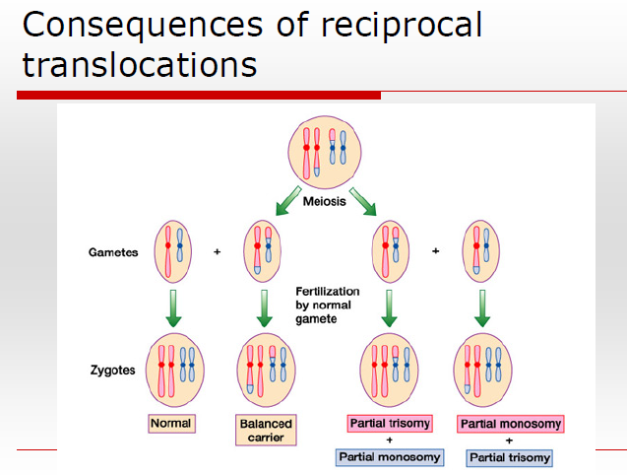
2-In chromosomes with no p- arm “acrocentric”, it’s called Robertsonian translocation, it happens in the acrocentric chromosomes “13, 14, 15, 21, 22”.
All translocation abnormalities happen during meiosis.
Inversions
Here the sequences of the genes are altered, for example, instead of having a chromosome that has “ABCDE” genes, the chromosome will have “ACBDE”, if the alteration happened between the p- and q- arm then it’s called pericentric inversion, but if the alteration happen within the same arm then it’s called paracentric inversion.
Deletion
Here is segment of chromosome is deleted
If the deletion is terminal, then we put the last gene that isn’t present in the chromosome, like (p13) in the photo above, but if it’s interstitial then we put the two genes where the deletion happened between them, like (q12q21) in the above photo.
Duplication
Here a segment of the chromosome will be doubled
duplication can happen in three ways “tandem, reverse tandem, terminal tandem” as seen in the following picture
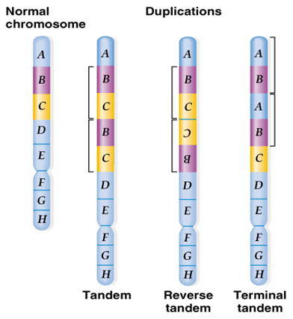
Insertion
Here a segment of a chromosome is removed and then inserted in the same chromosome or in another chromosome, it’s not a translocation “because there is no exchange between both chromosomes it’s only a “one way” transfer of the gene.
Insertions can be:
-Direct: the segment is inserted in the new chromosome as the same sequence
-Indirect: the segment is inserted in the new chromosome in a reverse sequence.
**Dominant genes, the presence of one gene is enough to give the disease, Recessive genes, the two genes must be present “maternal and paternal” to give the disease.
If duplication happened to a recessive gene, then it’ll give the disease “it’ll become pseudo-dominant”.
If there is a gene “two alleles” that produces 100 mg of certain protein in our bodies, and one allele has been deleted from the chromosome then production of this protein will decrease to 50 mg, this amount of protein is not enough for the physiological function, this is called haploinsufficiency.
Ring formation
At the end of each chromosome there is a “telomere”, sometimes these telomeres are separated from the chromosome “from the q-arm and from the p-arm” (*note: the telomeres in p-arm and in q-arm are complementary to each other) and the chromosome will coil on itself and connect itself at its ends and form a ring structure, this ring formation usually happens at anaphase, this ring that is formed will cause a disease.
Isochromosome
In cell division sister chromatids will separate from each other by a vertical cut in the centromere “so they will be separated vertically so each sister chromatid will contain one p-arm and one q-arm”, then segregation will happen. In isochromosome the sister chromatids will be separated by a horizontal cut in the centromere, so one of the resultant chromatid will contain two p-arms and the other chromatid will contain two q-arms
Chromosomal deletions
Large deletion can be detected by normal G-banding, but micro deletions can’t be detected by G-banding and they need special tests to detect them.
Large deletions syndromes
-Cri Du Chat syndrome, the deletion is at the end of p-arm of chromosome 5, clinical pictures for these patients, mental retardation, microcephaly, mewing cry, epicanthic folds “around the eye”, hypertelorism, retrognathia.
-Wolf-Hirschorn syndrome, partial monosomy of the short arm of chromosome four, “the clinical picture isn’t important” it’s diagnosed by looking at normal chromosomes and detecting the deletion in the patient’s chromosome using FISH technique.
-DiGeorge syndrome, is due to deletion in chromosome 22, it’s an important cause of neurological deficiency, typical features are seen in this syndrome’s patients, and deletions could be detected also by FISH.
Micro-deletions syndromes
*PWS/AS: Parder-Willi and Angelman syndromes
Unfortunately these should be remembered.
-Parder-Willi and Angelmam syndromes are caused by the same deletion “in chromosome 15”, the difference between them is that Parder-Willi’s deletion is inherited from the father, while Angelman syndrome’s deletion is inherited from the mother. (This is called imprint because one abnormality is coming from the father and the other is from the mother)
Clinical features of Parder-Willi, the patients are short, obese, with small hands and feet and small eyes.
Clinical features of Angelman syndrome, the patient is happy and his posture is typical.
“As you can see although PWS/AS happens due to a deletion from the same gene “except that one from the father and the other is from the mother” the clinical features are completely different”.
-Neurofibromatosis (NF-1): the clinical features, small tumors are spread through-out the body, and there are small spots all over his body.
Duplication syndromes
-Beckwith-wiedemann: due to duplication on chromosome 11 or chromosome 17.
-Cat-eye: due to duplication on chromosome 22
-Velo-cardio–facial syndrome due to duplication on chromosome 22
-PWS/AS may also happen due to duplication
Marker chromosomes
Sometimes when chromosomal analysis is done an extra DNA segment may be found, this is called marked chromosome, it’s from unknown origin. This marker can be important in chromosomal analysis.
Other abnormalities:
-Dicentric chromosome, chromosomes with two centomeres.
-Double minutes, the finding of two marker chromosomes, it can be the telomeres that broke of when the ring formation has happened.
2.5% of infertility cases are due to chromosomal abnormalities, and 6% of miscarriages are due to chromosomal abnormalities, these abnormalities increases when the age of the mother increases.
The 6% miscarriage are due to:
Indications for chromosomal analysis,
-If there is clinical features of a syndrome in a person
-If there are congenital abnormalities
-If there is mental retardation
-If there is gonadal dysgenesis
-If there is infertility, miscarriages, dead born babies
-If there is occurrence of certain malignancies.
In malignancies, genetic changes usually happen after birth (only the genetic problems that happen before birth are called inherited diseases).
Diagnosis of genetic diseases, begins by looking at the clinical picture of the patient, then chromosomal analysis, if it’s not enough FISH analysis is done, if it’s not enough molecular biological analysis is done.

