Sheet no :9

Refer to slide no : 9

Written by : Mahmoud Qaisi  
 corrected by Sahem Jamaen

\*\*\*\*\*\*\*\*\*\*\*\*\*\*\*\*\*\*\*\*\*\*\*\*\*\*\*\*\*\*\*\*\*\*\*\*\*\*\*\*\*\*\*\*\*\*\*\*\*\*\*\*\*\*\*\*\*

Multifactorial diseases  
  
Penetrance; refers to the proportion of people with a particular genetic change who exhibit signs and symptoms of a genetic disorder.  
Prevalence is a statistical concept referring to the number of cases of a disease that are present in a particular population at a given time.  
17% of the population older than 25 years has diabetes “this is prevalence”, while only few of them know that they have the disease and show symptoms “this is penetrance”.  
  
In the spectrum of human diseases, some diseases are purely genetic, while others are purely environmental “like infectious diseases” and between them there are many diseases (like spine bifida) that are caused by combination of both these factors “multifactorial diseases”.  
  
Genetics can rarely cause diseases alone, the types of genetics that can contribute to a disease can be:  
-Mendelian  
-Polygenic: means that many genes contribute to the clinical picture “it usually affects organs”, and every gene will contribute in a small portion to the final clinical picture “polygenic is not only associated with diseases, height and eye color for example are polygenic traits”.   
-Multifactorial: means that there is an effect from the environment in addition to the effect of the genes.  
  
As mentioned previously there are two types of phenotypes:  
-continuous: here the trait is in an array, like the color of the skin for example the person can be really white or darker or darker, etc. according to the number of contributing genes.  
-discontinuous: here only a single gene contributes to the trait, like thalassemia, the person either has thalassemia, or he does not have it, there no third option.  
  
Additive model of polygenic inheritance.  
  
The previous diagram in this model resembles a “bell-shaped” graph.  
  
  
  
The main characteristics of multifactorial diseases.  
  
  
Multifactorial diseases can be  
  
  
  
Threshold and liability.  
If we take a sample of people and we want to examine them for diabetes, we will find that 1%, for example, have the disease, this is called the (prevalence) of the disease, (incidence) on the other hand is different, when we take a sample of people and find the percentage of people who has diabetes, then after a year we examine the same sample of people again for diabetes and we find the percentage, the difference between these two percentages is called incidence.  
Incidence and prevalence are important for studying the disease and planning for the future, whether a neonatal screening for a certain diseases is needed, for example.  
  
Standard deviation: how much the values are far from the mean.  
In normal distribution, if we take one standard deviation for certain character then 68% of population has this character. “if we take 2 standard deviations then 95% of the population will have the character, if we take 3 standard deviations then 99.7% will have the character”.  
There is 5% variation when two people do the same experiment.  
  
If we want to measure the distribution of certain character in the population then, if it’s controlled by 1 gene, we use (a+b)^2 “(a) is an allele and (b) is another allele”, if it’s controlled by 2 genes then we use (a+b)^3.  
  
  
In the previous photo, the threshold of the disease “its incidence in the population is nearly 6%”   
  
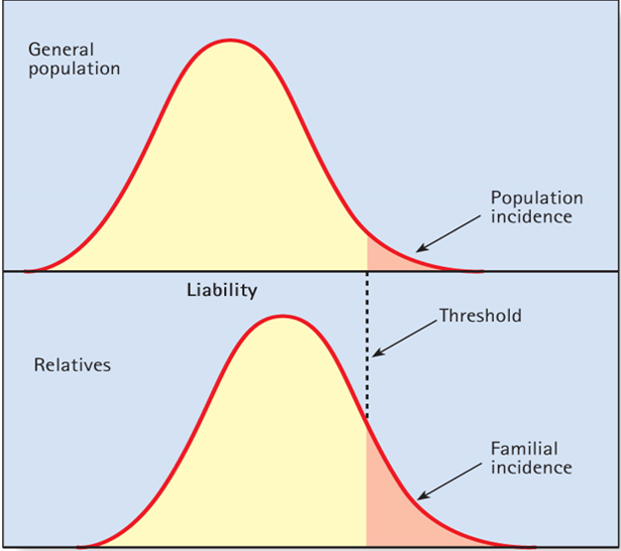  
  
In this picture, if we take the first degree relatives to the patients and make a normal distribution curve for the disease, we will find that the threshold went to the left and the amount of people with the disease has increased “to 10% for example”, then the disease increases in the family “familial disease”.  
To make sure that the disease is familial then we make another curve for second degree relatives, we should find that the threshold is more than that of the population curve “more than 6%”, but less than that of the first degree relatives curve “less than 10%”.  
  
This analyzing pattern can be applied for many diseases like: diabetes, cancer, Alzheimer, psychiatric, and obesity diseases, these diseases have familial tendency, and usually we don’t know the specific location of the mutation “we know the group of genes that the mutation is present on, but not the exact location”. To know the exact location, a full genome sequence is done and then we look for the mutation.  
  
It’s difficult to study multifactorial diseases.  
There are monozygotic twins “identical genetically”, and dizygotic twins “not identical genetically”.  
If we want to study the effect of the environment, we take monozygotic twins and put them in different environments “so the genes are the same but the variable factor is the environment".  
We can also study the effect of genes, by taking dizygotic twins and making them live in the same environment so here the environment is stable and the genes are the variable factor.  
Using this we can look for “empiric risk”, “prevalence”, “incidence”, etc.  
Empiric risk: recurrence of the same characteristic in the population.   
Factors affecting empiric risk:   
1-The incidence of the condition is greatest among relatives of the most severely affected patients.  
2-Recurrence risk increases with increasing number of previously affected children.  
3-The risk is greatest among close relatives of the index case and decreases rapidly in more distant relatives.  
4-If the condition is more common in individuals of one particular sex, recurrence risk varies according to sex of index case.  
  
  
we conclude that if the recurrence risk of a disease in a population is 1% then in identical twins it’s about 40% “not all diseases of coarse”.  
  
  
  
If there are certain patients with hypertension, for example, and we want to look for certain character “patient’s blood pressure is above 150”, then we take the patients and a control group “with different ages and sexes”.  
We use symbol (a) for the positive patients “who have blood pressure above 150” and (b) for the negative patients “who have blood pressure below 150”, and (c) for positive control, and (d) for the negative control.   
To calculate the reletice risk: a/c ÷ b/d = ad/bc then the percentage results.   
  
Heritability  
how much the disease is inherited, whether it has genetic factor or not.  
  
The heritability of the disease has nothing to do with the frequency of the disease in the population.   
Multifactorial analysis can be used for association studies “like the association of certain HLAT types with diabetes disease type 1 for example”  
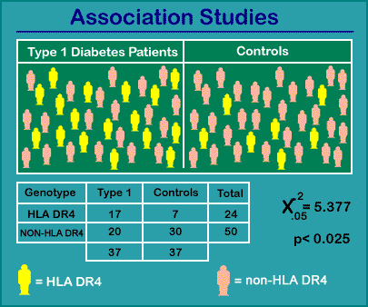  
  
  
  
Population: a group of people living in the same area “Jordan”.  
Subpopulation: part of the population “Amman”.  
Local population: جبل عمان  
Gene pool: the collection of all alleles in the members of a population.   
Gene flow: the passage of genes from one generation to the other.   
  
  
  
Mutation has positive effect “it’ll increase Thalassemia “for example” in a population”.  
Migration can increase or decrease depending on who is coming to the population.  
Drift: it’s also negative because the genes are kept without mixing from outside.   
  
  
  
When we are talking about gene frequency then we should count the frequency of the two alleles “so the frequency of one allele is multiplied by 2”.  
  
The same disease has different frequencies in different populations.   
  
  
Hardy-Weinberg theory  
these conditions must be present in order for the theory to be applicable:  
1- There is no selection.  
2-There is no mutation.  
3-There is no migration.  
4-There are no change events.  
5-Individuals choose their mates at random.   
  
  
  
  
  
The summation of p^2 + pq + pq + q^2 = 1   
(p) is used for dominant and (q) for recessive.   
  
Regarding example 1, the MN blood group table resulted from taking samples and testing the patients.  
  
In X-linked traits we have 3 X’s “two from the mother and one from the father” and 1 Y which is from the father.  
  
In blood groups there are more than 2 alleles affecting them so the rule is different it’s (p+q+r)^2 = 1  
  
\*\*\*To lesson for the examples on the recorder, star from 38:27, you will not get a thing ,, but try.