Sheet no :10
Refer to slide no : 10
Written by : Mahmoud Qaisi
corrected by Sahem Jamaen
*********************************************************

Cell growth happens when a molecule “growth factor” has a receptor on the cell membrane then this receptor will activate kinases reactions on the cell membrane, which then activate signals in the cytoplasm which will result either in the production of metabolic enzymes, or certain proteins, or “2A gene regulation protein” , or cellular proteins which determine the cell’s structure and the shape of the cell.
The cells are programmed to develop, grow, differentiate, and die “this is normal”.
So there is a series of signals to determine the cell’s life, if there is any problem “mutation” in this series, normally the cell will go through apoptosis to stop this mutation, but if the apoptosis isn’t functioning then the cell will keep growing and dividing producing a tumor in the body.
Growth factor: these are chemicals produced by certain cells and affecting other cells “like hormones”.
If there is something abnormal, then the cell’s function will be inhibited.
As have been discussed earlier the cell’s division is controlled by many check points “G1, S G2, mitosis”. When going from G1 to S phase if the tumor suppressor gene and the oncogene re normal then the division will proceed, but if there is mutation in them, a tumor will result.
In the S phase the tumor suppressor genes will try to stop the growth but if they fail a tumor will result.
The mutation can happen in:
1-Growth factor “the signal isn’t normal”.
2- The cell membrane itself “the kinases”.
3- The cytoplasm.
4- The nucleus.
All these can be considered oncogenes or tumor suppressor genes.
These oncogenes can be amplified, for example myc gene when it has a mutation it’ll be activated 20 times more than the normal conditions.
N-myc will result in 5-1000 fold increase, C-myc will result in 5-20 folds increase, myb will result in 10 folds increase.
Tumor suppressor genes.
DCC in chromosome 18 are cell-receptor interaction, they cause colorectal tumor, WT-1 transcription factor will lead to lung cancer, RB transcription factor will lead to retinoblastoma, P53 transcription factor will lead to breast cancer, lung cancer and other cancers and syndromes.
Tumor suppressor genes are autosomal genes “2 alleles must be mutated for the tumor to hppen”, while oncogenes are autosomal dominant “1 allele mutation is enough to result in a tumor”.
The sporadic causes of tumors can be:
1- Physical: light, X-ray, radiation, like in skin carcinoma and melanomas.
2-Chemical: “Benzopyran”, alpha toxin, oxidative stress,like in lung cancer, liver cancer
3-Biological: viruses, like in liver cancer where the integration of viral DNA in the cellular DNA happens.
Chemical signals that controls the cell’s cycle.
Cyclins and kinases in the membrane, hormones “like TSH which is important in regulating the thyroid gland function, growth factors like PDGF which is important in regulating the growth of epithelial cells.
Normally there is a balance between growth factors and growth inhibitors because the number of cells generated should equal the number of cells that die, when the death of cells dominates a problem will result, when generation of cells dominates a tumor will result.
Mutations can be deletion “like in the suppressor genes”, or amplification “like in the oncogenes” or point mutations or interstional mutations.
There is chromosomal instability which may result in a problem, or microsatellite instability “microsatellite can be present either in the telomere region or in the centromere region”, so if there is any problem, the division will not be normal because the segregation of the genes will not be normal.
85% of cancers are environmental, while only 15% are inherited.
A single hit “mutation” will not cause cancer, multiple hits are needed in order for the cancer to result.
Because it’s a gain or loss mutation, CGH method can be used to detect it.
5 hits are at least needed to result in colon cancer. APC has familial tendency.
In familial colon cancer they look for deletion in chromosome 5q21 if it’s present the the patient should be followed up carefully.
Mismatch repair may also be not functioning which may result in serious problems.
Within the same family different cancers may be present.
Loss of heterozygosity means the loss of 1 allele.
Retinoblastoma has two types; inherited and sporadic.
In sporadic type the baby is born with two normal genes, with time one gene can get damaged, then after a while the other gene may be mutated then retinoblastoma will result.
In the inherited type the newborn will have an abnormal gene inherited from his parents and with time he will get other abnormal gene so the tumor will result faster than in the sporadic type.
Breast cancer is number 1 tumor in women in Jordan, it has inherited tendency
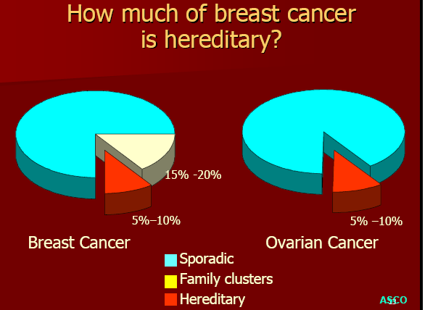
In familial types chromosome 16 will have the mutation.
Chromosomes.
When mitoses happen chromosomal abnormalities might happen “nondisjunction, translocation, etc”.
Myelogenous leukemia results mainly form translocation of “abc genes”, which when translocated will result in new gene.
Translocation mutations can be seen in nearly all types of blood and lymph tumors
Each tumor may result from more than one type of translocation, usually translocation happens in immunoglobulin genes “chromosome 8 for light chains and chromosome 14 for heavy chains”.

