  - Sheet no.: 5
Refer to slide no.: 2
Written by: QaisMismar
Corrected by: Abdelaziz Al-Shawwa
Medical virology
- Viruses are electron-microscopic particles, this means that they cannot be detected using a light microscope, we need to use an electron microscope in order to recognize the morphological structures of viruses (their size: 10-300nm)
- Tissue culture might be used to observe their action on tissues, and for other reasons ,but tissue culture can not lead to recognize the morphological structures of viruses.
- Morphological structure of viruses is highly important, because different morphology means different pathogenicity, any change in the configuration of a virus leads to a change in its patho-physiology (ex. mutations in influenza viruses –usually related to the protein spikes on the envelop of the virus- and this small change ends up with new strains of the virus ,,so new type of infection or different manifestations of the disease)

- There is a huge number of types of viruses (~0.5-1 million) that affect humans, animals, insects, plants or even bacteria, but only about 100 types of them are considered human pathogenic groups (cause infections in humans)
- Viral structure and morphology differ from the more complex bacteria(the bacteria has a cell membrane and a cell wall ,LPS..etc)
- The genome, which is the most important part of the virus, which is composed of number of genes that differs from one to other virus (from only 10 genes to about 300 genes maximum generally,, while E.coli’s genome may contain 3000 to 5000 genes). Also viruses can be classifiedinto DNA or RNA viruses based on the type of genome they contain ( DNA or RNA genome) , there’s no virus that contains both DNA and RNA at the same time
- Note: certain studies indicated that some types of malignancy are caused by viruses by integration of their genome in the genome of human, and this results in some sort of mutation

- 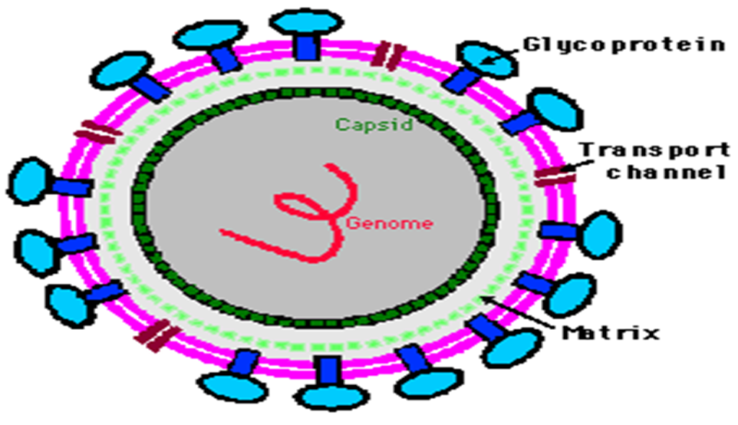
- We might find some viruses with only the genome and no other cellular components except for a thin lipo-protein layer that acts like a cell membrane to protect the genome
- But in the majority of viruses, we have a special layer (coat) called capsid“composed of specific proteins”, capsid is composed of numerous repeating similar subunits attached together by hydrogen bonds called capsomeres, these capsomeres are composed of 1-5 (usually 1-3) major polypeptides
- The capsid functions in protecting the genome from environmental factors for a short time when the virus is being transferred from one host to another
- The capsid is considered a protein coat
- The capsid is surrounded by another layer called the envelope, which is originated from components (membranes) of other types of cells (animal cells, human cells… etc), and contains glycoproteins and a lipid bilayer
- The envelope is also associated with projections known as spikes , composed of glycoproteins
- Note: you might think that the presence of the envelope in addition to the capsid will further protect the genome, but in fact the envelope makes the virus more susceptible to environmental factors (lysing, acidity… etc)
- But The envelope will enhance the attachment of the virus to the host cells and tissues, thus enhancing the pathogenicity, and that is due to the presence of the spike-like structures that interact with specific receptors on the surface of the mucosal cells “respiratory tract GI tract ….etc” , this interaction betweenthat spikes and surface proteins of the host cell is similar tokeys and Locksmechanism
- The capsid or envelope can be present or absent, not all viruses are associated with all these structures
- Viruses can be classified according to configuration into: icosahedral/cubic configuration, and helical symmetry configuration “these are the most important shapes to study because they are the most related to human disease, although theres more complex configurations of viruses affecting plants “
- 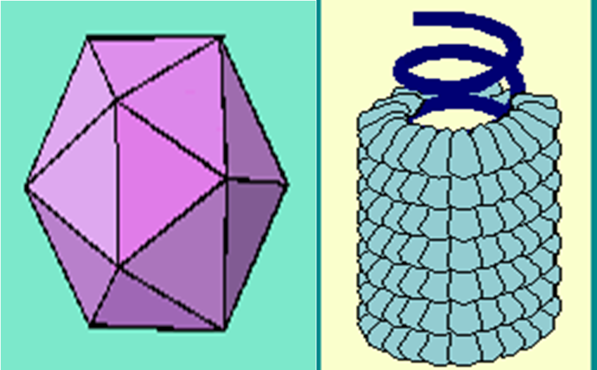
- icosahedral/cubic symmetry: has almost 20 faces, viruses with this configuration can attach to tissues and cells by their spikes (if they have an envelope) or by capsomeres (if they don't have an envelope), it is not more complex than the helical symmetry
- helical symmetry: can be found in a cylindrical or a coil-like structure, with a repeated type of subunits (if capsulated then called capsomeres) , inside it we can observe the linear form of the genome ….not circular as bacteria “linear DNA if found in bacteria ,will be eliminated by nucleases
- Important notes:
- the 2 configurations we mentioned can be associated with capsid and envelope
- The genome of a virus can be single or double,, DNA or RNA and according to the type of DNA/RNA there’s a process of transcription and translation …
- Most DNA viruses are double-stranded
- RNA viruses with single positive stranded RNAacts directly as m-RNA for transcript
- Negative stranded RNAfirst produces mRNA from the genome RNA
- The following terms are important to know (some are mentioned previously):
- Nucleocapsid: Genome surrounded by aproteincoat / Capsid (Composed of numerous repeating similar subunitsCapsomeresEach composed of 1-5 polypeptides "1-3 in majority of human viruses")
- Capsid: mentioned earlier,might be later associated with the envelope and spike-like structures which are responsible for the attachment of the virus to the host cells and tissues (remember that the spikes are associated with the envelope)
- Virion: is the complete entire infectious virus particle, associated with the infection of cells and tissues. If the virus lost any of its parts like its envelope or capsomeres and is no longer infectious, we don’t call it a virion.
- Viroids: are the smallest known agents of infectious disease “smallest pathogens known", but they are usually not related to humans, they are related to plants, and they are single-stranded molecules of infectious RNA
- Prions: these are usually confused with viruses, but in fact they are not. They are infectious protein particles (no DNA or RNA). There is still no information on how these prions developed inside the humans and animals, but it is known that they produce a disease called Transmissible Spongiform- Encephalo- pathy, which once accumulates in brain cause severe damage in the brain and CNS of humans and animals. Prions has known among certain populations who eat meat of humans or certain types of animals (specially the brains)
- Creutzfeldt-Jakob disease: this disease was known among jews who used to eat the brains of animals
- Scrapie: a disease that developed in sheep and goats which used to eat remnants of dead animals meat “ dead animal bodies was used in the past-not more allowed now- to produce protein substances used to feed sheep”
- there are 6 steps of viral infection: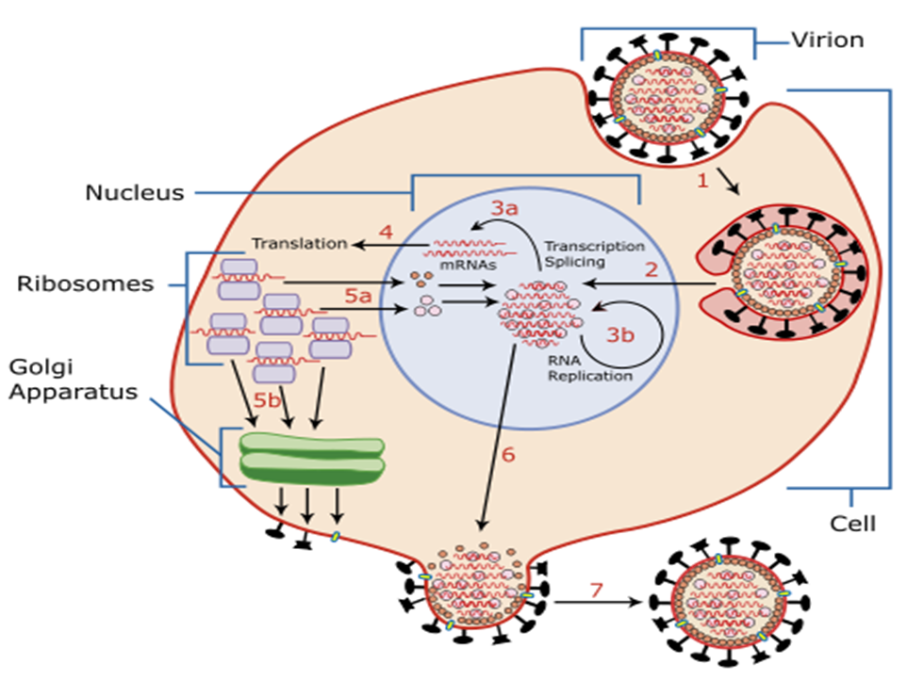
- Attachment: if the virus was enveloped, attachment will be using the glycoprotein spikes, but if there is no envelope, attachment will be by capsomeres , once the attachment achieved , directly many enzymes produced that allow the virus to fix with specific proteins on the mucosal cell
- Adsorption (penetration) and endocytosis: invagination of the virus into the host cell, followed by the formation of a vesicle
- The previous 2 steps may take different times in different viruses, in some they may take a few hours, in others they may take sometimes 24 hours
- Uncoating: the removal of the protein coat or envelope from the virus, which will release the viral genome and enable viral genes to become available for transcription (not more than 30 genes are released)
- Synthesis of viral components: viral genes start to control all the metabolic activity of the infected cells, benefit from the cell's components and start producing new viral genomeand components in numerous numbers
- Example: if one influenza virus infects one cell, 100,000 new viral particles will be produced after 48 hours
- Assembly: new viral particles and genome are assembled with newly formed capsid and/or envelope
- Release: new viruses are released from the infected cells
- The fate of the infected cells after the release of the new viruses differs after the release, they may be damaged (cell lysis) and the viruses proceed to infect other cells, or they might be viruses can be released in the process of cell budding (the infected cell membrane will be a part of the new viral envelope,so in this case cells remain intact to some extent and may be subjected to damage if another virus infected the same cell again.
**note : this process of infection it’s not necessarily to be accomplished in each type of viruses and this is important to understand the clinical features of any infection
- Question: why are certain people more susceptible to viral infections than other people?
- This is related to the infectivity of the virus to a specific host,it’s not necessary if you were exposed to the certain virus ,to develop the same clinical features as others, you may be infected but your body responds and inhibits the replication of the virus, especially at the process of adsorption, and this will inhibit the production of new viral particles. The effect of a virus on the host cell depends on many factors such as host immunity
- Certain studies indicated that when a population is introduced to a new virus, only 1-5% of it will develop the clinical features of the disease associated with that virus, although others are exposed to the virus without developing any infection. Why? This is due to many factors, a virus may undergo an abortive infection, it reaches the host cells but cannot successfully complete replication, this can result from a non-permissive host-cell, immunity, or because the virus is defective
- Abortive viruses can be associated with asymptomatic infection, the individual is infected but did not develop the clinical features(ex. if you had an asymptomatic respiratory tract infection you might feel some fever for a short period or uncomfort in your throat like an allergic reaction ,with no signs of running nose , coughing or damaged mucosa… so your has managed to control the infection)
- Examples of abortive viral infections: Poliovirus (in the past nearly new born were exposed to the virus but 1 out of 10,000 children infected with this virus will develop clinical features, but 1 out of 1000 adults will develop clinical features and they will be more severe damage to CNS)

Enterovirus (1 out of 100 people infected with this virus may suffer from mild diarrhea ; and the factors are : the acidity of the stomach, if there’s past infection of the same strain of the virus or no)
-also recently they discovered that there’re some people infected with Hepatitis B virus but developed immunity against the virus without any complications.

Good luck

