Amino acids metabolism
-In the last lecture we talked about the metabolism of the amino group, this lecture we’ll be talking about the metabolism of the carbon skeleton chain .
-Breaking of an amino acid will give us one of 7 products for energy production . (Slide#5)
-In catabolism process there is a usage of an important Co-enzymes .
(Mentioned in slide #2)
PLP is used for every trans-aminase reaction .
FH4=vitamin B9 , important for the transfer of one carbon unit .

Amino acids : Essential , non- essential or conditionally non-essential.(Slide #3)
-Essential : have to be obtained from the diet, cant be synthesized de novo in the body .
- Non-essential : Can be synthesized in the body .
-Conditionally Non-essential :Synthesized by essential ones, so with a deficient in the essential amino acids they become essential –have to be obtained from the diet - .

-Carbon skeleton of the amino acid is : (slide #3)
1) Glucose derived: metabolism of glucose can produce them , for 9 of them “or 10 with cystein”.
2)2 out 11 are conditionally essential : (tyrosine and cysteine [S only]), require essential for synthesis, the carbon skeleton is glucose derived but they need essential amino acids to get synthesized .
For example : With no phenyl alanin , tyrosin becomes essential
For Cystine synthesis , degradation of methionin is required to get (S) group .

-Degradation of amino acids : This pathway is distinct from biosynthesis pathway (compartmentalization)for regulation (slide #4)
-NADH in cytosol enters the mitochondria by malate-aspartate shuttle to be used in the electron transport chain .
-Fed vs. fasting state decides if we’ll have synthesis or degradation .
-Liver is the only tissue that has all the needed enzymes for amino acids synthesis and degradation .
-Degradation of amino acids gives intermediates for glycolysis or gluconeogenesis –TCA intermediates - (glucogenic) , ketone bodies –lipids related-(ketogenic ) or both (mixed) .

-Notice that the mixed amino acids have a ring structure .

slide #5 :
-Acetyl Co-A and Acytoacetate have a relation with ketone bodies .
-The others got a relation with TCA ,including Pyruvate .
-Pyruvate has something to do with glycolysis too .

Slide #6:
-The corresponding amino acid for oxaloacitate is aspartate (by AST-aspartate transaminase-)
- Aspartate Aspargine by adding NH4+
The source of this NH4+ is Glutamine .
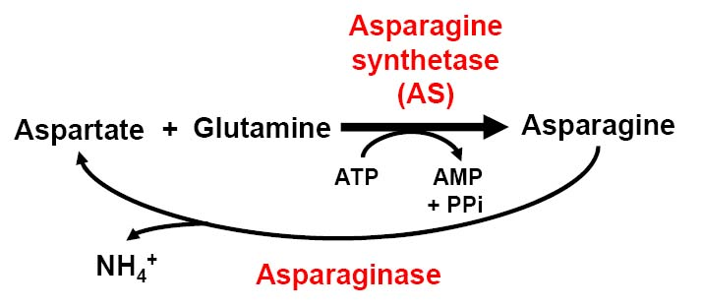

Because Glutamine is degraded into Glutamate and NH4+ by (AS) and this reaction is ATP dependent .
Asparaginase and Glutaminase work with the same mechanism .
-The difference between AS and Glutamine synthetase is that AS can’t fix the free amino group and the amino group that is added here isn’t free like what we explained in the previous lecture .

Slide #7 :
Glutamine synthetase fixes the free ammonia.
-Fixation of free ammonia is restricted to 3 enzymes :
(Glutamate DH because it helps in reversible reaction “oxidative deamination and reductive amination “ & CPSI & Glutamine synthetase)
Slide #8 :
Glutamate is converted to an aldehyde by reduction , spontaneously cyclizes followed by reduction to give proline.

Slide #9 :

Histedine differs in one carbon atom from glutamate .
Glutamate +Formyl group (one carbon atom) + N Histidine (with the usage of FH4 as Co-enzyme)

Histidine by histidase is converted into uroconic acid , this acid by series of reactions gives FIGLU-similar to the structure of histidine-

Deficiency in FH4 , we’ll not have a conversion of FIGLU to glutamate , so we use FIGLU concentration to know if there’s a deficiency in FH4 (vitamin B6)
Histidine is a precursor for histamine (inflammatory )so when you have inflammatory signs you take anti histamine as anti-inflammatory (by hestidine decarboxylation )

Good luck
Mays Abu-Afifeh .

