Throughout the previous lectures we can say that the Fetal nervous system and immune system are developed slowly whereas the endocrine system is developed properly
*the fetal hormones form the same function as in the adult, adrenal glands are unique in their size and function, at 4 months of gestation the size of adrenal glands is more than the size of kidneys ,also both parts of adrenal gland " adrenal cortex and adrenal medulla " function properly.
usually the 3 zones of the adrenal cortex function properly but mainly the second and the third zones
-fasciculata ; produces cortisol which has some important multiple functions including :
promotion of pancreas , lung maturation , liver enzymes , intestinal tract cytodifferentiation
-reticularis and fasciculata of the adrenal cortex produce relatively high amount of estrogen and androgen .
-the adrenal medulla at about 10th week of gestation becomes capable of synthesizing and secreting proper amounts of adrenaline and noradrenaline.
-the fetus grows or significantly during the last trimester .
surprisingly the GH of the mother ( from the maternal placenta ) has a little effect on fetal growth.
However the fetal insulin is the most important hormone in the regulation of growth in the fetus ( its not the GH of the fetus or of the placenta that plays a role in fetus growth but it’s the insulin )
-glucose is considered the main metabolic fuel for the fetus
fetal insulin which is produced by the pancreas at the 12th week of gestation ; regulates tissue glucose use , controls liver glycogen storage and facilitates fat deposition , it doesn’t control the supply of glucose however its determined by gluconeogenesis and placental glucose transport .
the main idea is the role and the function of insulin in fetus which is produced in the fetal pancreas
*duing pregnancy the uterus is quiescent because of progesterone and relaxin . ( progesterone , the pregnancy hormone , no movement , no contraction in the uterus )
*weak and irregular uterus contractions occur throughout the last month of pregnancy ,eventually a series of regular , rhythmic and forceful contractions develop ( irregular then regular and rhythmic contractions in the uterus )
although not all of the factors that lead to the initiation of labor are known but endocrine , paracrine , mechanical stretching all play a role in this initiation.
-paracrine and endocrine ( hormones which are released in the interstitial space )
-the stretch ( the size of fetus in the uterus )
figure 51-30 ,page 61.
once the labor is initiated , its sustained by a series of positive feedback mechanisms, but the most important hormone is ACTH which initiates delivery ,there are other factors that play a role as we said previously, such as ( paracrine , endocrine and stretching ) . although these factors don’t determine a 100% initiation, but the initiator is the ACTH from the fetus .
*now the fetal adrenal gland becomes activated , sometimes premature babies born but their lungs don’t function properly ,so we give them cortisol ,within minutes the cortisol functions and the baby breathes properly .
also aldesterone sulfate ( from the Adrenal cortex " reticulars " ) affecting placenta , local estrogen ,progesterone ratio , local prostaglandin, maternal pituitary oxytocin and catecholamines ,all these play a role in delivery , but the initiator is ACTH .
*once delivery occurs , prolactin is needed, since the baby needs mlik (milk production requires prolactin )
estrogen modulates the synthesis and secretion of prolactin ,by :
1- increasing the sensitivity of lactotrop cells for the TRH
2- reducing the sensitivity of lactotrop cells for the dopamine
*RECALL, there is no specific stimulus for prolactin but TRH might be a stimulus !
*after delivery ,prolactin remains relatively high for about 3 weeks , if the mother does not nurse the baby , prolactin level generally decreases to the non pregnant level after 2-3 weeks.
if the mother does nurse the baby, the secretion of prolactin is maintained as long as the mother nurses , but not after 9-12 months even though the mother nurses the baby (usually prolactin level doesn’t remain high after several months of lactation )
* lactation inhibits the ovarian cycles ,however ,if the mother continues nursing the baby for prolonged duration , ovarian cycle eventually resumes.
if the mother does not nurse the baby the ovarian cycle resumes on average from 8-10 weeks after the delivery .
in some countries such as Africa , this average reaches up to 18 weeks .
*Menopause is when the ovaries stop functioning mainly around the age of 45 ,the age of menopause has increased since the end of 90’s century due to the improvement of the life style
the menopause in males called climacteric , when the testosterone levels begins to decrease but it does not decrease too much (which means it will not be zero or even close it )
-early menopause ( very rare ) , when women have menopause around the age of 35 to 40 years , they are more exposed to osteoporosis and heart diseases .
Refer to page 44 in the booklet .
-the level of gonadotropin hormones (FSH , LH ) is high in females and low in males because its inhibited by the testosterone .
*infertility in females affect one of five women in the United States.
the understanding of the female endocrinology ,anatomy and physiology is critical in solving this major health problem
*several factors can cause infertility :
disorder of CNS 1-
2- hypothalamic diseases
3- pituitary disorder
4-ovarian abnormalities
5. environmental factors
all of these affect the follicular development or the whole ovulation.
The most common cause of sterility in females is failure of ovulation.
The contraceptive use and efficacy rates (table 39.A ;page 63) :
pills , female sterilization , male sterilization , condom , diaphragm ,spermicides and the intrauterine device
The most common method which is the pills ,has the most side effects and the method with the least side effects is the intrauterine device ( almost has no side effects)
: the rhythm metohd
RECALL that:
* the ovarian cycle duration is 28 days
*average menstrual phase is 4 days
*ovulation occurs at day 14
*the life span of sperm or ovum is 2 days ( we can give one extra day )
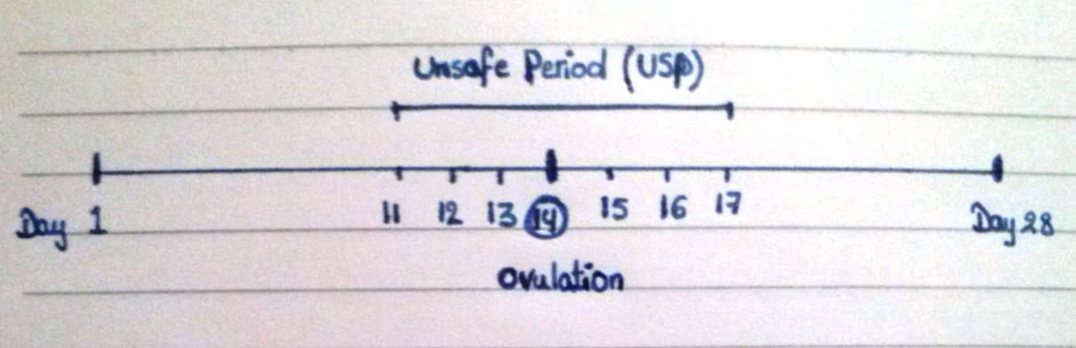
If the sexual intercourse occurs at day 14, fertilization occurs and if the intercourse was at day 11,12,13 or at day 15,16,17 ‘’ the ovum still can receive the sperm ‘’ fertilization occurs too since the sperm lives for 3 days (with an extra one day) . This is called the unsafe period
which means couples should avoid it.
*ovarian cycle is 28 days ( ideal cycle ) in most women and in some others it ranges from 21-35 days (plus or minus 7 days ) , less than that is very rare but it might reach up to 42 days which is rare as well .
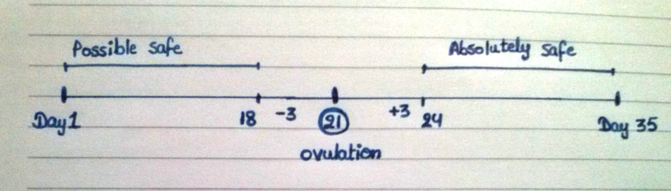
*always after ovulation 14 days .
follicular phase changes before ovulation( whether the follicles develop quickly or not ) which is known as possible safe period.
The same is applied on the 21 days cycle .
summary of the rhythm method :
period duration – 14 days = ovulation day
ovulation day -3 or +3 days = unsafe period
advantages of estrogen therapy :
*against osteoporosis
*for beauty ; against wrinkles and for bright looking
*low desire for sexual intercourse
*for treatment of extreme high facially and body hair
*to maintain the size of breast
*prevent urine incontinence /involuntary
*against Alzheimer and Amnesia
*reduce the flushes of Menopause
Most of the slides that were explained are not in the booklet
P.S this is the last lecture for Dr. Salim Khresha

