**Metabolism of phospholipids (continuation)**

After synthesis of phophoacylglycerol , we can change the :

1)the polar head group

2)**the fatty acid** : so that fatty acid at carbon number 2 can be removed by phospholipase A2 action and can be replaced as well .

Example: phophotidylcholine

* lysophosphatidylcholine is obtained from phospholipase action, then by adding the **activated** form of fatty acid( arachedonic acid) at position number 2, the fluidity of the membrane would be changed.

**Phospholipids function as:**

1- membrane components

2-activator/signal molecules such as :-

A)Phosphatidalethanolamine ( plasmalogen) : contains ether rather than an ester bond (ether phospholipids / ether glycerophospholipid)

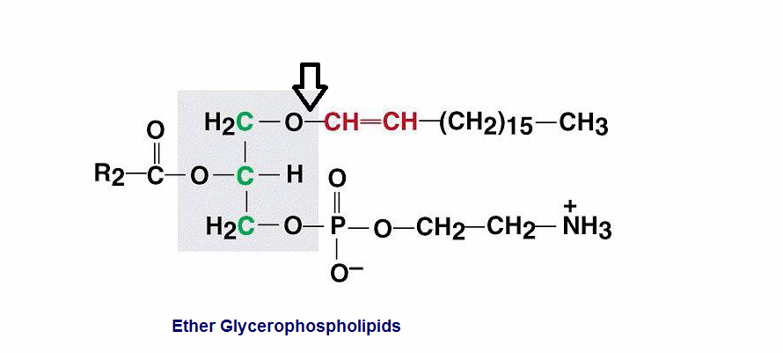

B)Platelet activating factor: ether group+ acetyl group(fatty acid at position 2).

-Phospholipids have a surfactant action :-

Surfactants lower the surface tension of fluids

Surface tension comes from Hydrogen bonds between water molecules .

Ex: imagine a droplet of water on a glass plate, the droplet will form a particle whereas if you had ether or acetone( substances that do not form hydrogen bonds ), these will spread over the plate and wont form a droplet .

The reason of droplets formation is due to hydrogen bonds .

-so the surfactant lowers the surface tension by spreading the liquid all over .

**In our lungs , there is surfactants (phospholipids) to reduce the surface tension of liquids In the alveoli (;smallest unit of the lungs)

In expiration **with** surfactant : alveoli will not totally collapse

In expiration **without** surfactant : alveoli will collapse

- surfactant is synthesized in the last weeks of pregnancy where fetus starts to synthesize the surfactant(phospholipids)

- But a preterm baby may have respiratory distress due to the low level of surfactant

-we measure the viability of the baby by measuring the dipalmitoyl lecithin in the amniotic fluid to tell if the baby can survive and breath normally.



Phosphatidylinositol bisphosphate : (phospholipid+inositol+2phosphates )

-can undergo hydrolysis by phospholipase to give two molecules; DAG and inositol1,4,5-triphosphate .both of them are signal molecules and this reaction happens due to a hormonal signal “hormones bind to cell’s surface and stimulates phospholipase C “ .

**Metabolism of sphingolipids/glycosphingolipids**

-They contain sphingosine;(aminoalcohol) instead of glycerol (Refer to its structure in the slides)

-characterized by hydroxyl group at carbon1 , amino group at carbon 2 , another hydroxyl group at carbon 3 and a long hydrocarbon chain

-made up of 18 carbon atoms

-form amide bond with the Fatty acid between carboxyl and amino groups.

- sphingomyelin is a phosphosphocholine ester of ceramide, no ester bond at carbon 1 , it is a covalent bond so no bond to be cleaved .

Space filling model

-shows a similarity in phosphatidylcholine and sphingophospholipid molecules such as the long hydrocarbon chain , phosphate, phosphocholine and both can from a lipid bilayer ,micelles or liposomes.

Synthesis of sphingoPhospholipids

Remember that phospholipids are synthesized starting from palmitoyl coA and serine . Palmitoyl CoA (16 carbons ) , L-serine (3 carbons) both condense together in a reaction that requires **pyridoxal phosphate** (vitamin b6) with the elimination of CO2 to give sphinganine(as sphingosine but with no double bond) .therefore the first step is **condensation** .

** decarboxylation and CoA cleavage drive the reaction in the forward direction.

-addition of acyl group from acyl CoA gives a structure similar to ceramide but with no double bonds (18 carbons ) and this is **the Acylation** , the last step is **the addition of the double bond** .

*16 C +3C –carboxyl group =18 carbons

**\*Transfer of phosphocholine to ceramide produces sphingomyelin**

**\***the removal of phosphocholine from phosphatidylcholine and joining it with ceramide will give sphingomyelin . What remains is DAG . Its an exchange process between 2 similar molecules .

*Other sphingolipids are called “Glycolipids”

-sphingolipids are either with phosphate and called sphingomyelin or with carbohydrates and called glycolipids

-glycolipids: sugar added to ceramide

1) cerebroside : ceramide added to it glucose or galactose (glycosidic bond between sugar and alcohol), its is related to brain tissue

2)Sulfated Galactose

3)Oligosaccharide ( 2 or 3 sugars)

4) Oligosaccharide with NANA(N- acetylneuraminic acid is a sugar of 9 carbons which is acylated or sialic acid found in glycolipids ) . Glycolipids that contain this N- acetylneuraminic acid are called gangliosides (called so since they are isolated from the nerve ganglia ) such as GM1 , GM2 , GM3

Neutral sphingolipids : contain glucose , galactose or oligosaccharide

Acid sphigolipids: contain oligosaccharide + NANA to form gangliosides GM1, GM2, GM3

(refer to the slide #8 to see these sequences ,its not logic how number 1 which must be the smallest has the largest sequence and so on )

GM1: sequence 1

GM2: sequence 2

GM3: sequence 3

M:mono (one NANA)

G:ganglioside

Activated donor in glycolipids synthesis

As we know from the previous lecture that joining of molecules should be in their active forms .

These active forms are :

- UDP glucose ( as in glucose synthesis)

-UDP galactose ( as in galactose synthesis)

-UDP-N-Acetyl galactoseamine

-CMP-N-Acetylneuraminic acid = it is the only donor that produces NANA

*Enzymes determine whether glucose or galactose will be added to ceramide.

-Glucose and galactose are very similar ,The difference between them is carbon # 4 therefore 2 different molecules of different properties are formed , they are found in the cell membrane giving different information such as:-

-allowing different enzymes to act or allowing some bacteria to infect or not infect the cell .

So one enzyme is required for every sugar , and each sugar is added one at a time .

*Degradation is more important than synthesis, due to what we said previously that those are membrane components and usually they continuously undergo degradation and synthesis but those have a long life yet they have to be degraded .

-sphingolipids are degraded by **hydrolytic enzymes** that are specific for sugars (different enzyme to degrade each sugar).

**-α Galactosidase**

- **β Galactosidase**

- **neuraminidase**

- **Hexoaminidase**

*those enzymes are found in lysosomes .

-Lysosomes degrade molecules to undergo normal turnover process.( they are firmly attached to lysosomes membranes in order not to leave the cell,if they leave they will start degrading cell’s components).

-PH:3.5 to 5.5 ( work at acidic PH)

- Last on, First off: last one added , is first one to be removed

-slide # 11 illustrates the process

-every hydrolytic enzyme is required to break a specific bond one at a time and so called enzyme 1, enzyme2, enzyme 3 referring to the number of products, emphasizing that degradation is more important than synthesis.

Sphigolipidosesis

- they are lipid storage diseases

-there’s defect in one of the enzymes causes accumulation

-these are inherited as ‘autosomal recessive disease (autosomal: carried by somatic chromosomes , recessive: disease should be inherited from both parents in order to appear)

-if person is producing 50% or 25% of the enzymes , it will be sufficient because degradation is a very slow process with no half life .

-if not degraded -> accumulation in the cells -> brain damage (CNS disorders)

-accumulation of substances , other sequential enzymes will not work .(they act sequentially )

-brain is mostly affected since most of the cells in the body can be generated but brain cells once they die they cannot be renewed 🡪CNS disorder as mental retardation or blindness

-Biopsy or taking cells from white blood cells or microblast to diagnose the enzyme deficiency

*degradation of sphingomyelin is not with us *

Only know the following examples of lipid storage diseases and their symptoms :-

-TAY-SACHS DISEASE ( most common in Jewish people of eastern European descent )

-GAUCHER DISEASE

-NIEMANN-PICK DISEASE

