Page 1
-when glycerol is joined to fatty acid, an ester bond is formed & it can be hydrolyzed by the addition of water, so, synthesis of ester involves dehydration.
Page 2
-TAG → is formed from 3 FA esterified to Glycerol & this bond could be cleaved by hydrolysis.
-phosphoacylglycerol → is similar to TAG ,but instead having a third fatty acid , there is phosphate group that is esterified to alcohol . the addition of alcohol emphasizes the amphipathic property of the molecule & now its able to form micels that has hydrophilic surface & hydrophobic interior.
♥♥♥♥♥♥♥
Lipoproteins:
-from its name we could conclude that it’s a protein with lipid property , but actually they are multi molecular complexes of lipids & proteins , that means they are not composed of equal halves .
-they are made for the transport of lipids in plasma , cause lipids are insoluble in water ,so it should be transported via soluble protein. 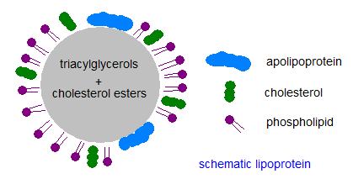

-they are made of 4 kinds of lipids : TAG – cholesterol ester (both are non-polar hydrophobic, so, they present the core of lipoprotein) – cholesterol – phospholipid (both have a polar part, so, they are amphipathic & present in the surface of lipoprotein).
Page 3
Apolipoproteins:
-they are the protein part of lipoprotein.
-Apo means : protein that bind to something else.
-they are amphipathic, having polar & non polar part.
-include several classes : Apo A- Apo B –etc…
-they have a role in structure or integrity of lipoprotein molecules, regulatory role, & binding to cell surface receptors.
♥♥♥♥♥♥♥
*the picture here shows the lipoprotein particle .

Page 4
As we see , the surface composition comes from polar lipids (phospholipid & cholesterol) , while in the core we have the non polar lipids (cholesterol ester & TAG).
NOTE: phospholipids & cholesterol are somehow polar, cause they contain phosphate group & OH respectively in their structure.
♥♥♥♥♥♥♥
Classes of lipoproteins:
-they are classified to what they are different in which is density.
-we can separate any large particles soluble in water by centrifugation at very high speed (100,000 gravity) based on their density , so the more dense particle will move away , & the less dense will stay near the centre.
-density is g/cm3
-by centrifugation we can separate lipoproteins into classes: chylomicrons – vLDL – IDL – LDL – HDL .
-NOTE: we are not obligated to memorize the numbers, but we have to know that chylomicrons have the least density & it less than the density of water, while HDL has the highest density (1.21), 20% more than water's density.
-lipoprotein particles are not completely similar, cause they are in a range of densities, that means they undergo changing.
-proteins/lipids ratio determines the density, so the more the lipid , the more density is.
-Proteins are more dense than water, that’s why when we put an egg (egg is a good source of protein) in water it will sink, while a drop of oil will flow on surface.
-HDL has the highest density cause its composed of 45% proteins , on the other hand, chylomicrons have the lowest density cause 2% only of it is proteins.
♥♥♥♥♥♥♥
-major lipids in lipoproteins:
chylomicrons | vLDL | IDL | LDL | HDL
TAG ( 85%) | TAG (55%) | TAG & CE | CE | PL (25%)
It’s a core component,& its function to transport TAG | It transport TAG |  | Transport CE | Mainly it composed of proteins & PL,so,it’s a surface component,its function in transporting cholesterol ester, the PL is just to keep cholesterol ester soluble.

Page 5
-The relation between increasing surface component with the size:
As the surface component increase → the relative size will decrease.
(& the - BA6I5AH's – example will help you to understand how this could happen. So, when we have 4 small ba6ee5at with 3Kg for each, & also we have another large ba6ee5ah with 12Kg , that means, the whole 4 ba6ee5at have the same mass of the large one , but they differ in size, so , lmma n2asher el 4 wl 1, ra7 no7sol 3la 2esher aktr mn el 4 ba6ee5at).
-because HDL has the most of surface component (PL & cholesterol), it becomes the smallest in size , while chylomicorn is the biggest.
♥♥♥♥♥♥♥
-the table in this page shows types of Apoproteins, & we conclude from it:
*Apo A → is only found in HDL.
*Apo B →is not found in HDL, but it’s the only Apoprotein found in
LDL & nowhere else.
-the importance of this: we can separate lipoproteins according to their Apolipoprotein.

Page 6
Electrophoresis:
-we can separate lipoproteins based on their mpbility in electrophoresis, cause they contain proteins that can travel through the electrical field.
-they tend to move toward the anode (+) cause most proteins at PH 8.6 have (-) charge.
-as we have taken before, plasma proteins are separated in the same manner ,such as albumin, alpha 1, alpha 2, beta & gamma globulin. The prealbumin was the fastest. A special stain is used to observe these proteins, but a different kinds of stains are used to differentiate between lipids, & by this we can observe different lipoproteins.
-HDL is the fastest cause it contains more proteins & it has a small size, even it walks with alpha , while chylomicron is huge ,so it remains in its origin.
-vLDL is a little bit faster than LDL cause they contain different amino acidis .
-Notice that there is no relation with density here in this separation, this method deals with charge/mass ratio.
-this separation by charge/mass ratio is suitable for every day use, unlike electrophoresis separation based on density that needs suffocated instruments.
♥♥♥♥♥♥♥
Digestion of dietary lipids:
-it involves hydrolysis of TAG to 2 Fatty acids & monoacylglycerol , also hydrolysis of cholesterol ester to cholesterol + fatty acid.
-these reactions are in between lipids with water, so we have a solubility problem cause lipids are not soluble in water, so bile salts are required.

Page 7
-as we see , cholic acid (bile acid) structure looks like cholesterol but it contains 2 OH & COO- more.
-Bile acid has a hydrophobic region & a hydrophilic region ( COO- & OH).
-cholic acid is a weak acid, if it is conjugated with glycine it will become stronger & called: glycocholic acid (Bile salts).
-Bile salts= Bile acid + Glycine.
-Bile acids & Bile salts can be used interchangeably , cause what determines whether it’s a base or acid is the PH, & the PH could be changed at any time.
-bile salts & lipids tend to form micelles when they are mixed by intestinal movement. At the surface we have the bile (hydrophobic) & in the core we have TAG ( hydrophobic) , so, the solubilization problem is solved now & the contact with water becomes easier.

Page 8
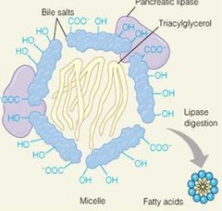
-lipase (that is secreted from pancreas) comes in contact with TAG, along with a protein called colipase, co lipase allow the lipase to anchor into micelles, the lipase now can act on TAG to produce MAG + fatty acid.
-absorption mechanism to occur needs: bile salts – cholesterol- lipid – phospholipid.
♥♥♥♥♥♥♥
-digestion of cholesterol ester : is by cholesterol esterase at carbon 3 to produce cholesterol.
-digestion of phospholipids: can be hydrolyzed by different phospholipases as phospholipase A or B & give glyceryl phosphorylcholine.
-digestion of TAG : is by pancreatic lipase that produce 2-MAG.
*note: if we inhibit the pancreatic lipase , we prevent digestion of fat, So by that , you can eat whatever you want without increasing in weight
*if there is a defect in one of the component ,the digestion & absorption will not occur.
♥♥♥♥♥♥♥
Lipids pathway in the body:
When Dietary lipids got into the mouth, CE, PL & TAG are not changed their → they reach the stomach, most of these particles & short & medium chains of FA complete their way without digestion→ Bile salts & pancreatic enzymes emulsify & degrade dietary lipids → the primary products are: 2-MAG + cholesterol.

Page 9
After the action of lipase, micelles become mixed micelles ,cause it's not only contain PL , but also FA , MAG & cholesterol ,all are amphipathic , →so ,they go through lumen of the intestinal mucosal cell→& by diffusion the get inside the cell.

Digestion of TAG:
-begins in stomach by lingual lipase ( at the end of the mouth) & gastric lipase (both are acid stable so, they are not destroyed by the high acidity of the stomach).
-significance (the importance of digestion):
1-in neonate: short & medium chain of fatty acids that present in milk, can be digested very early in the stomach.
2-in pancreatic insufficiency.

Page 10
Absorption

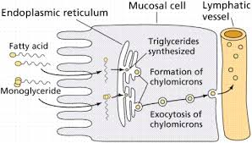
1-now, cholesterol, fatty acids & 2-MAG enter the intestinal mucosal cells.
2-2MAG forms again TAG , & the purpose of that is just to make the fat enters the cell.
*note: to convert MAG to FAG, we need the active form of Fatty acid which is fatty acyl CoA.
*note: digestion occurs in the lumen of small intestine, while absorption & resynthesis occurs in intestinal mucosal cells.
3-CE,TAG & PL are incorporated with (apo B-48) to make a very large particle of chylomicron.
*NOTE: all processes of digestion (degradation) & absorption (resynthesis) are just to cross the intestinal mucosal cells to go to blood & tissues.
4-chylomicron now in ready to get out from intestinal mucosal cell by exocytosis→ to lymphatic system→ to thoracic duct→ then to large vein, so , they enter the blood stream via large vein, not a capillary cause it small & a block may occur in it then.

The pathway of chylomicron:
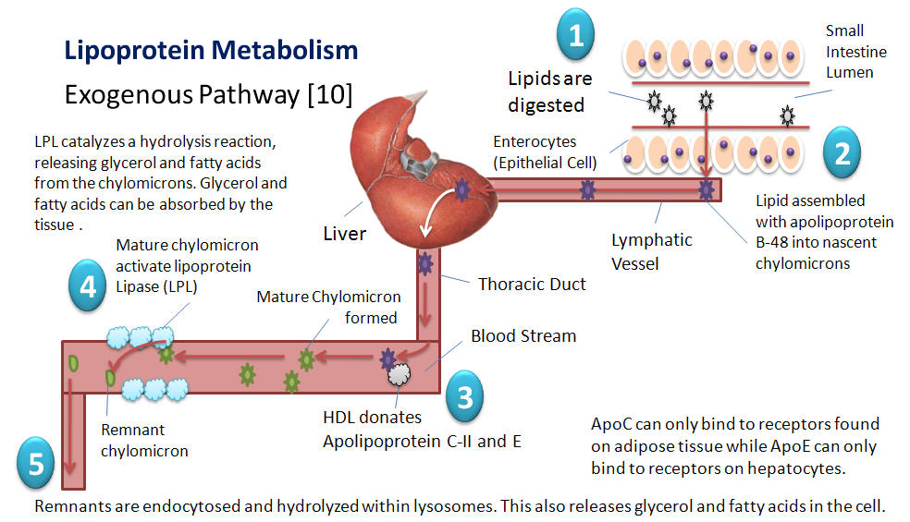

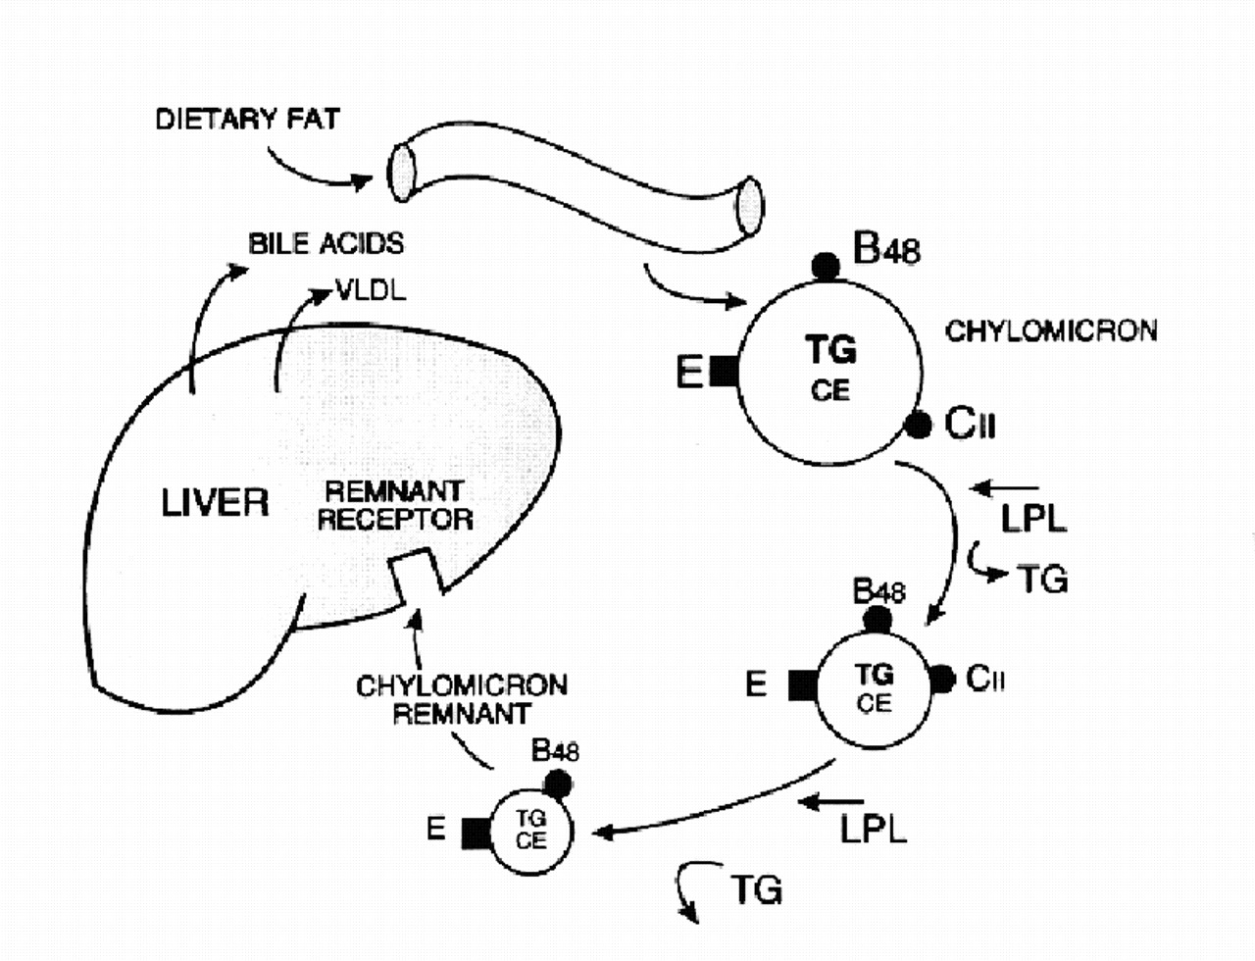

1-they are synthesized in intestinal cells.
2-they are released in plasma.
3-in plasma, they require Apo C2 & Apo E (taken from HDL), & from before in intestinal mucosal cells we have Apo B-48.
4-then they travel to capillary ,here, there is a protein called: lipoprotein lipase (it acts on lipids in the lipoprotein to remove FA), its specific for the lipoprotein. It is considered as an extracellular enzyme produced in tissues but its transported & remain attached to the capillary wall, so , when chylomicron walk through the capillary ,the enzyme will act on it to hydrolyze again the TAG to 3FA ( which will be taken by tissues) & Glycerol ( transported to liver).
5-chylomicron particle by this way will get smaller & smaller .this process takes up to 12-14 hours to be completed.
*so, the size of chylomicron becomes small & its density increases, & at the end we will have what is called :chylomicron remnant (which is smaller than nascent chylomicron).
*after a fatty meal, chylomicrons will stay in blood for several hours ,& completely cleared after 12 hours, that’s why when you take a plasma sample from a person who has just eaten a fatty rich meal, it will have milky appearance cause chylomicrons are large particles rich in TAG.
6- because of the presence of Apo E , these cholymicron remnant will bind to cell surface receptor & taken by endocytosis to liver (here, cholesterol ester is more than TAG ,so CE is taken by the liver).
*NOTE:
1-lipoprotein lipase: acts on Apo C2 which is acquired from HDL,so the action of Apo C2 is the activation of lipoprotein lipase.
2-if there is a lipoprotein lipase deficiency → chylomicron will remain in circulation for a longer time & plasma will be yellow. (this is a pathological condition).
Sorry for any mistake , & Good luck ♥

