Sheet no: 18
Refer to slide no:
dr : suzan
Written by :lina jumah ,maysa alramahi
Corrected by: lina jumah

What are non carious lesion ?
-They are the loss of 2 structures : enamel & dentin
-Anything other than caries and trauma is considered as non carious lesion
-highly prevalent : 31-50% of population
-usually the affected teeth are premolars and maxillary premolars(not sure) ,due to great occlusion forces on these teeth
what are the predisposing factors of the lesions ?
A- age group (++ in elderly )… why?
1)longer time of exposure to etiological factors
2)gingival recession
B- exposed root surface ( roots are always more susceptible for these lesion than enamel surface) .
Non Carious lesion :-erosion ,abrasion ,attrition ,abfraction,non hereditary enamel hypoplasia ,hereditary hypoplasia (dentinogenesis imperfecta ,amelogenesis imperfecta ). 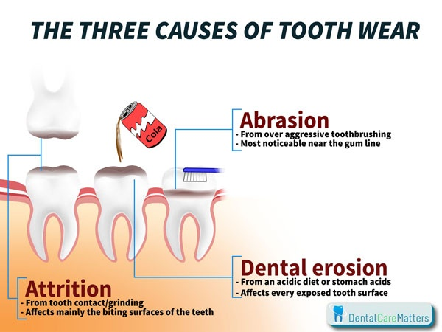
***********************************************************
Erosion : it is a progressive loss of tooth structure by chemical process ,not involving bacterial action like caries .
Etiology : chemical acidity .
Acidity is either extrinsic like :
1- ingestion of citrus jucies ,pepsi .. etc
2- exposure to air born acids that came from factories ,they affect mainly facial aspect of anterior teeth .
Or Intrinsic : anorexia nervosa ,pregnancy…. Etc which affects mainly palatal surface
What is the shape of this lesion ?
this will be known by clinical appearance and history of the patient .
clinical appearance of erosion is smooth round cut out defect
Sometimes it appears as increased incisal edge radiolucency
Becoz enamel is thinner in these areas and loss of minerals)
sometimes it appears as raised out amalgam restoration
Erosive lesions are not always cervical **notice**
In deciduous teeth it might make pulp exposure.
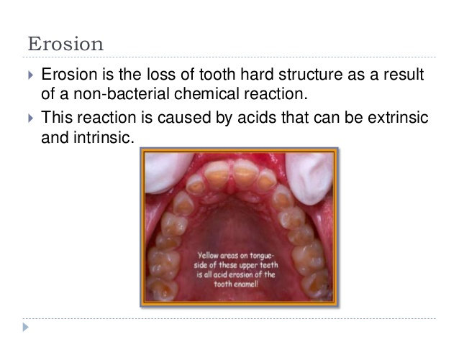

*******************************************************.
Abrasion :it is the loss of tooth structure by mechanical foreign body to tooth contact or friction force ( remember attrition is tooth to tooth contact ) .
Etiology : incorrect tooth brushing or forceful brushing or using of hard brush or abrasive tooth paste .most common abnormal habits that cause abrasive lesions in incisal edges is ……cpt !!…?(can't hear it well)
Sometimes the cause is old removable appliance that is not well stable : when the clasps are movable in some areas this will lead to abrasions especially in cervical area .
So it is abrasion coz Porcelain versus tooth structures not natural tooth versus tooth structure .
*clinical appearance of abrasion: sharp v shape notches usually in cervical area & affects more than one tooth
Clinically abrasion and abfraction are similar together, but can be differentiated by some features like more than one tooth affected in same quadrant.
ex. forceful tooth brushing found in 2-3 teeth
When the lesion is on one tooth think of abfraction not abrasion .
also, both have v- shape sharp edge notches but:
abrasion >>> more wide and shallow
abfraction>>> very deep and narrow
+ both are more common on cervical areas + more common in canines & premolars
Any way you can't differentiate 100% between them clinically so a good history is very imp ..
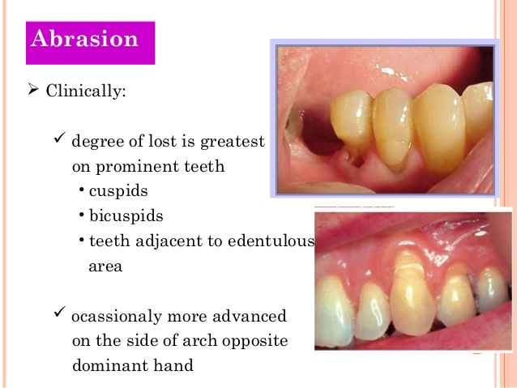
***********************************************************
Attrition : it is a mechanical wear due to tooth to tooth contact ,occurs mainly in occlusal and incisors and proximal .
elderly patients, have wider contact area between teeth than in younger ones.
why ?
due to Physiological movement of tooth against tooth & rubbing >> this will increase the contact area.
It occurs either by functional or para functional movement of the mandible ,that means attrition may be physiological : 75 years old patient for example with tooth wear .
Or pathological : 25 years old patient with 1/3 of his tooth is weared .
**facets is found **
How to know they're facets or not ?
by Iooking at the opposit side … is there a matching wear on occluding surface or not?
clinical appearance is small saucer shape on cusp tip and flat occlusal surfaces

*********************************************************** 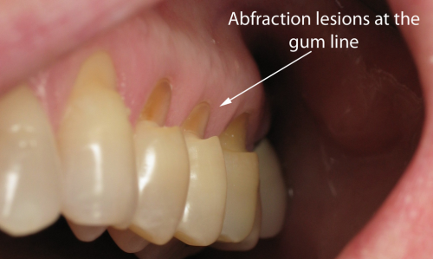.
Abfraction : it is the loss of tooth structure in the cervical area of teeth caused by tensile and compressive forces during tooth flexure .. this is the theory of abfraction .
Etiology : heavy eccentric occlusal forces resulting in microfractures and consequently break down of cervical enamel and dentin
the theory of abfraction ( refer to the record ) : steep flex under occlusal load stresses are transmitted to the cervical areas causing cervical enamel rods to fracture & slot … this is the reversible part …..once other molecules are integrated within these rods a break down of enamel will occur and this is the irreversible part .
imagine your tooth within it's socket and periodontal ligament and alveolar bone is under occlusal load. it will flex even if you can't see it . this flextion lead to compression & tensile stresses on cervical neck of tooth . the contineous moving of your teeth with time will cause this lesion .
forces on anterior teeth come always oblique not longitudinal that’s the cause of flexure . in posterior teeth most of the forces are along the long axis of the teeth that's why abfraction is rare there but still can happen .
Remember that flexures are always cervically
clinical appearance : affects buccal aspects of the tooth but could also affect lingual aspects, commonly associated with wear facets .
Most cases has abfraction lesions with wear facets & This is expected becoz The cause of abfraction is occlusal load which is either increased or normal . deep narrow sharp edge v shape notches ,commonly affect single teeth with excursive interference ,note that molars are not immune from this lesion ,
All non carious lesions have the same rule : the (?) Depends on magnitude ,frequancy and duration of the insult .
in literature there is certain evidence that even tongue thrusting may cause abfraction lesion, so it's not always caused by para functional habit ,especially if the tooth is weakened by very deep large amalgam restoration .
.
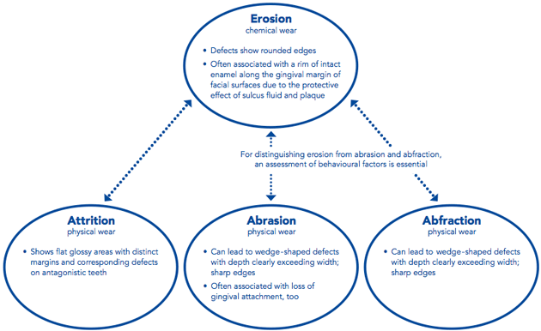
***********************************************************
Non Hereditary enamel hypoplasia :it is an injury to the ameloblast during enamel formation caused by trauma or infection and can result in defected enamel formation .named turner tooth .
Clinically, how does enamel hypoplasia appear inside patients mouth ? - change in tooth color
.change in color depends on the severity , duration ... etc of the insult on ameloblast. it can start as mild as white opacity with nothing affecting the tooth structure into a dark brown opacity & pitted groove or deformed surfaces , ***********************************************************

Amelogenesis imperfecta :
- hereditary hypoplasia
- it's a genetic disease with responsible gene called amelogenin which affects the structure of enamel protein
Dentinogenesis imperfecta :
- the responsible gene called dentincialoprotein
When u find enamel still remaining on both structures but deformed & hypoplastic it is amelogenesis . when u don’t find enamel but only find dentin it is dentinogenesis.
The best way to differentiate between them is by x- ray : in dentinogenesis the enamel was normal but lost early that patient himself doesn't remember it's existence so only dentin remain so the tooth appear short & stunted (?) & obliterated
Predisposing factors for any of non carious lesion :
1- Developmental anomalies : including dentinogenesis & amelogenesis imperfacta, both are manifestations of a disturbance in the calcified tissue of the tooth .
2-malocclusion : interferences make abfraction on the tooth . on the same tooth wear facets or cracks can also occur .
3- Posterior tooth loss : due to increased load on the anterior teeth so attrition or abfraction will be found on these teeth ( parafunctional habits ) .
( all are parafunctional habits ) خياط او باكل بزر كتير او بدخن كتير 4- .
)Especially pipe(
5-Restoration materials causes abrasions especially porcelain
What's the restoration material that have the same wear resistance like natural tooth ?
Gold .
6-Diet is very important ( ingestion of citrus juices, cola … etc ) ,systemic diseases ,gastric diseases ( cause reccurent vomiting).
7-natural wear : with time you will finally wear & attrition of your teeth will happen (after 50 years) .-
Again : In order to diagnose the non carious lesions taking a full history is very important .
Non carious lesions are considered a modern phenomena , coz it occurs by our modern type of diet & stressful life
Treatment of non carious lesions :
Principles of treatment :
before any treatment is done , proper diagnosis & recognition of the cause of the cervical lesion is import, this will influence the long term success of your treatment .
To restore or not to restore ?
-Cervical lesions resulting from caries always require treatment .
-Non carious lesions may be left some time untreated .
small cavities with no signs and symptoms ,advice your patient to remove the causative factor & contineous monitoring of the tooth
when do i have a real indication to restore the tooth?
1- Dentin hypresenstivity : it is not an absolute indication for restoration Coz there is many other methods for treatment like laser , desensitizing agents & fluoride rich tooth paste .
2-secondery caries is large and deep lesion,and the remaining of it is weak and it’s a plaque accumulation area and I cant remain it ,, I have to restore it
Some patients came to our clinc with secondary carious lesion but they didn’t want to replace it saying that they weren’t complaining from teeth sensitivity !!!
Sometime its difficult to restore these lesions becoz it might lead to chronic pulp exposure .
patient come to clinic 27 years old ,have teeth loss due to para functional habit ,you cant leave patient and told him to stop the habit, cc: tmj proplem ,proplem in mastaction so here restoration is needed.
Always non carious lesion have two stages of treatment pre restorative and active one.
What are pre restorative management?
1) occlusal adjustments when there are interferences on teeth.
2)elimination of habit
3)dietary advice and medical referral like anorexia nervosa
4)Desenstivity agent .
5)Occlusal splint for patient with parafuncional habit
6)Patients who lost posterior teeth: partial denture restoration
Surgical intervention or crown lengthining may be needed .
If non carious lesion is on root and is subgingival : you have to do crown lengthening .
In Crown lengthening you remove soft tissue alone or soft tissue & bone
note that subgingival are usually with abfraction
After pre treatment ( which aims to prevent re occurrence ) go for restoration which is either direct or indirect depending on :severity of your case ,age of patient & location
If location is cervical : 99% we go for direct restoration
If location is incisor edge of anterior teeth : either direct or indirect
if location is posterior teeth : most of the cases is indirect restoration
Cervical restoration especially cervical restoration of an abfraction lesion, you need a material that can flex with the teeth coz it's less susceptible to fall after restoration. So we are talking about microfilled composites . They are indicated especially for abfraction lesion
- You should know all advantages and disadvantages of amalgam, glass ionomer & modified GI .
Remember : GI
- used on non stress areas
- fluoride release
- biocompatible
- binding slightly to the 2 structures
- relative ease of manipulation
The only case where u don't use a composite restoration is when u don't have isolation
problems of cervical lesions
why there's frequent dislodgement of cervical restoration ?
1)dentin sclerosis : if dentin is exposed it's called dentin sclerosis
2)moisture control : ( v imp cause ) un noticable leakage from sulcus will cause your restoration to fall down
3)abfraction
-veneers can be the solution for some cases of non carious lesions -
-there's also a Palatal veneers which are made of gold used for patients having erosive lesions on palatal surface . Gold is the best because it will not cause attrition to the lowers but unfortunately it's very ugly
-if there is enough 2 structures go for gold onlays
-Crowns and bridges are used in severe cases when u have loss a large amounts of 2 structure & u can't restore with other means
-veneers are not usually used in patients with parafunctional habits but if u used it, give an occlusion splint as well in order to reduce forces on it. ( note that it's not contraindicated)

