SHEET NO:5
WRITTEN AND CORRECTED BY:ALA'A ATEF&HADEEL JASSEER

Most common diagnostic test required
All the tests based on comparison between normal and non normal
Vitality test -Percussion test -
Palpation test -Thermal test -

Thermal test:
1-cold test
-done by: air spray,ice stick,CO2 ice, ethyl chloride[most common], endo ice.
-before you apply the test you should dry and isolate the tooth with cotton rolls.
- first apply the test on sound/collateral tooth to educate the patient the principle of the test [essential].
-protect the gingiva because if we apply it on gingiva the patient will feel the cold on gingiva false response.
more common than heat test. -
-before you test the offending tooth you should test the sound / collateral tooth .Normally, when you applied the cold to sound tooth the pt feel pain, and when you remove the cold the pain goes away
-in case of irreversible pulpities when you apply the cold the patient will jump (Painful response that ligers after the thermal stimulus is removed irreversible pulpitie).
-cold test is the most effective test in diagnosis irreversible pulpities.

2-heat test :
- temperature for a heat test is about 65.5C this can be done be [hot water/coffee/green stick] .
as cold test apply the test on collateral tooth first. -
isolate the tooth with rubber dam to prevent false response. -
-the least useful vitality test and isn’t use routinely however this test is very helpful when the major symptoms is heat sensitivity and the patient cant identify the main tooth .
-less common , we use it when we are unable to determine the main tooth.
Effective in diagnosis non irreversible pulpities [dying pulp not died] so when the patient come and say he feel pain when he drink sth hot dying pulp –not irreversible pulpities .
-Dying pulp more aggressive than irreversible pulpities
Because all diagnostic test are based on comparison ,the use of controls (collateral) tooth is essential in performing these tests .function of collateral.
Control teethe functions:
1-the patient knows what to expect from the test
2-the dentist can observe the nature and the level of patient responses
3-it can be determined that the stimulus is capable of invoking a response .EX molar teeth may be unresponsive to thermal test this would make cold invalid as tasting modality, if we apply the cold test on molar[less dentine] with narrow pulp champer the response will differ if we apply it on ant. Tooth[more dentine].

Response of the patient to thermal testing:
No response it can be due to:-A
- non vital pulp[necrotic pulp][common]
- trauma [destruction of blood supply]
–excessive calcification[pulp champer full of dentine so the cold doesn’t reach the nerve so there is no response
- the tooth has an open apex
-medication
B-moderate transient response usually : considered normal
C -Painful response:
Painful response subside quickly after the stimulus is removedreversible pulpities and it can be due shallow cavity-caries-unexposed dentine.
Painful response that ligers after the thermal stimulus is removed irreversible pulpities.

Electric pulp testing
Pulp tester use to determine if the pulp vital or non vital
Electric pulp tester is an instrument used to stimulate a response by electric excitation of the neural tissue within the pulp.
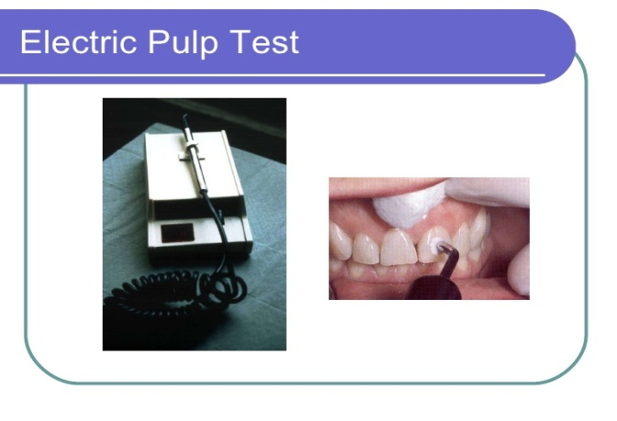
First test any sound tooth
When we use this the machine will give us numbers from [1-80] some patient give the response after [ 50/60..] put the number has nothing to do with the health of the pulp, just determine if the pulp vital or not
This is Electrode that we apply it on tooth and we put on it tooth paste

Testing procedure :
A-the teeth to be tested must be air dried and isolated with cotton rools .
B-the electrode of the tester should be coated with a viscous conductor
C-it is important to avoid contact of electrode or paste with any restoration or gingival tissue ,this would cause a false reading .
D-the dentist must hold the electrode with his hand with no gloves in order to complete the circuit ,the rheostat on the tester should always be on #5 or #6.
E-what the patient will feel is a sense of heat or tingling in the tooth when the nerve tissue is excited the patient is instructed to raise his or her hand when the sensation is experienced
If there is no response tooth no vital
False positive response(for pulp tester)
-Failure to isolate and dry the tooth
-Contact of electrode/conductor to the gingival or large restoration ,the current will reach the attachment apparatus
Patient anxiety-
-Liquefaction necrosis will conduct current to periodental tissue ,and the patient will response slowly at the highest range.
-We can use cold test instead of Electric pulp testing
False negative response(for pulp tester)
-patient heavily medicated
-inadequate contact with enamel
-recent trauma to the tooth being tested
-calcification
-teeth with immature apex (open apex)
Contraindication of the use of the electron pulp tester
- a patient with a cardiac pacemaker because of the interference the pulp tester may cause to the pacemaker
-the tooth with amalgam restoration
-the tooth with full crown

Percussion test:
Useful in determining when the inflammation is extending from the pulp to periodontal tissue, so
Positive precaution test when inflammation extend to periodontal tissue-
negative precaution test when inflammation not yet extend to periodontal tissue-

So the precaution test is a periodontal test.#

With the handle of the mirror apply precaution to:#
Incisal edge for anterior teeth.-
Each cusp for posterior teeth .-

(acute apical condition) Positive response mean there's acute periodontal involvement#

#The acute apical condition may be caused by:
1.extention of pulp inflammation
2.tramatic occlusion
3.recent high restoration.

We can't rely on precaution test (only) to determine if the tooth need RCT or not. #
Bite test:
Firm pressure on cotton swab that produces definite pain ,is a good indicator of apical periodontitis.
Palpation test:
Sensitivity of finger pressure of soft tissue over apex of a tooth buccally or lingually may indicate that inflammatory process begin to affect the overlying mucoperiostum.
Use two fingers (to comparison between sound tooth and offending tooth)#

All tests based on comparison
mobility test :
Grade 1 barely noticeable movement -
Grade 2 horizontal movement of 1mm or less-
Grade3 horizontal movement greater than 1mm(the tooth has to be extracted)-

Causes of of pathological movement :#
1.advanced periodontal disease
2.horizontal root fracture
3.chronic bruxism

Tracing the fistula:
Fistula Opening on oral mucosa over canine or premolars contain pus ,when push on it pus comes out.
Tracing the fistula to determine which tooth is involved for RCT , by placing GP in the fistula then take radiograph to determine which of these two teeth are involved for RCT

Cavity test:

This test involves the removal of enamel and dentine by a high speed bur without local anesthesia. If the pulp is vital the pt will experience a sharp pain shortly after the bur reaches beyond DEJ .
This test determine the vitality of the pulp
This test should be performed only when all other thermal and electric tests have been inconclusive.
We don’t do this test unless we have to .EX: tow teeth adjacent to each other and these two teeth have a crown and we are suspected that one of them non vital we can perform the cavity test if the pt feel pain that’s mean that this tooth is vital .

Anesthesia test :
Sometime the pt come to with pain(pt feel pain while he in your clinic) but he can't determine if this pain come from upper jaw or lower jaw so, you give him ID block if the pain goes away that mean that the pain come from lower.

The strategic value of the tooth and the restorability of tooth should always be determined before decision is made to do RCT (When the pt come to your clinic you have to determine whether the tooth is restorable or not ).

