Title of lecture : Dental Caries .
Date of lecture : 9/10/2014
Sheet no. 4
Written by : Ala’a B. Bashir .

Dental caries is an infectious microbiologic disease of the teeth that results in localized dissolution and
destruction of the calcified tissues.
By infectious here we mean that if you used someone’s else toothbrush who has a bacteria that causes caries , it can be transmitted to you and cause dental caries just like influenza . microbiological means that "caries" are caused by micro-organisms that come from outside the body.
As we know from oral histology 95% of enamel is calcified tissue , while dentine 70% by weight and the rest is organic material “ organic portion & water “ .
- Dental caries is demineralization “ if we placed a tooth in an acid it will get demineralized and that’s what carries is but here without the pathogenic bacteria ofcourse “

- There are four main elements required for caries formation:
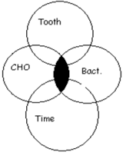
- A tooth surface (enamel or dentin)
- Cariogenic (or potentially caries causing) bacteria specific
bacteria causes carries .
- carbohydrates ( sucrose) sucrose has a double bond , when
bacteria attacks it , it gets divided into fructose and glucose that
“ single bond “ .
chocolates and sweets can cause caries more than bread because
bread is formed by starch and it needs time to reach sucrose , But
sucrose is existed in its pure form in chocolates and sweets .
the carbohydrates that are able to be fermented by bacteria are the
ones that cause caries .
- Time

- The caries process does not have an inevitable
outcome, and different individuals will be susceptible
to different degrees depending on ;
- the shape of their teeth : We can find two people have the same oral hygiene but one of them has higher risk than the other to have careis , their fissures are so deep and their anatomy is so complicated so its harder to clean it by the patient so we will have more food stuck there and more fermentation.
- oral hygiene habits : Some times The oral hygiene differs because we can find a patient who eats one sweet meal at the day and brushes his teeth after it direct , while we can find another one who keeps eating sweets the whole day and brushes his teeth only at the morning , this patient forms a perfect culture to the bacteria to work .

- the buffering capacity of their saliva :
some times we can find people with good oral hygiene but the lingual surface of their lower teeth for example have heavy calculus because they have high precipitation of calculus in their saliva . the more the saliva is sticky the more its hard to remove the dental plaque from the teeth , forming plaque will cause calculus and caries .
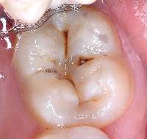
- Dental caries can occur on any surface of a tooth that is exposed to the oral cavity ; some parents will come to us with their children that have primary teeth in a very bad condition and start telling you that they are like this since their eruption ! Never believe them , once the tooth erupted in the oral cavity it erupts in a good health but if we didn’t take care of it , caries will be formed .

- Caries activity, as evidenced by demineralization
and loss of tooth structure, is highly variable, and
therefore the course of individual lesions is not always predictable ;
we cant follow the same plan of treatment with every patient
we should take in consideration all the factors in every case and
treat the patient according to them .

- It is essential to understand that cavitations in teeth (destruction of the tooth surface, creating a cavity ) are signs of bacterial infection , because in clinical practice, it is possible to lose sight of this fact and focus entirely on the restorative treatment of the lesions, thereby failing to treat the underlying cause of the disease ;
When a patient comes to you , you shouldn’t just drill and fill , you can give him oral hygiene instructions,change his life style and show him how he should brush his teeth , we show him how to use the dental floss…etc that’s how we change the quality of the patient’s
life ;)

- The availability of simple carbohydrates, such as sucrose, greatly stimulates plaque metabolism. Exacerbations of caries activity are characterized by periods of high bacterial metabolic activity and low pH in the plaque near the tooth surface.
if we brushed or if we didn’t , if we eat or if we didn’t , we have bacteria in our mouth and it should work , but we should try our best not to provide the perfect environment for it .

PH ACIDITY DEMINERALIZATION

- If the PH was higher than 5.5 , no acidity , remineralization can happen . when we eat something sweet , the PH will drop below 5.5 and here bacteria starts working and once it reaches 3-4 another bacteria join us here .
- we can find people with some white lines on their teeth that’s how demineralization looks at the beginning .
- Dental caries initially is a reversible disease , until we reach threshold for clinical detection “ we see it by our naked eyes “ , we can keep saying its reversible as long as the surface is intact and we don’t see shadows of discoloration , its possible to be remineralized again .
- If caries didn’t reach amilodentino junction , its still reversible .
- Saliva contains high concentrations of calcium and phosphate ions in solution that serve as a supply of raw material for the remineralization process. also sometimes when we use fluoride to clean our teeth after the demineralization started to happen , this fluoride might be good to form crystals again and block the surface of the tooth again but here we can see shadows of blue or black color inside because the caries already have reached the dentine .
- Acid attack on tooth surfaces continually occurs throughout an individual's life .

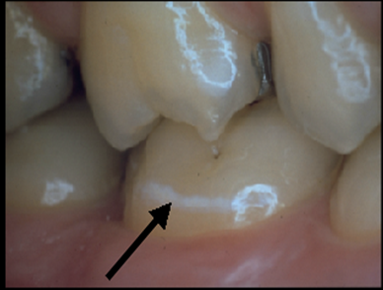

- Understanding the balance between demineralization and
remineralization is the key to enlightened caries management ;
depends on the PH we have tooth gain if it increases and tooth
lost if it decreases .

- Below the critical pH (5.5), the tooth minerals act as a buffer and lose calcium and phosphate ions into the plaque ; which means that 5.5 is the critical point of dental caries , we have dental plaque on the tooth , when we reach PH 5.5 demineralization happens here, calcium and phosphate get out of the tooth but still in the dental plaque so they work as buffers here but if the PH drops below 5.5 they cant work as buffers anymore , and bacteria starts causing caries .

- This buffering capacity maintains the local pH at approximately 5.0, which is responsible for the characteristic histologic form of carious lesions. The surface remains intact while the subsurface mineral is lost “ had nafso eli 7keena 3nno abl shway beseer discoloration w benshoof shadows “ . This initial carious lesion limited to the enamel is called incipient caries and is characterized by a virtually intact surface, but a porous subsurface.

- At lower pH values, such as 3.0 or 4.0, the surface of enamel is etched and roughened.

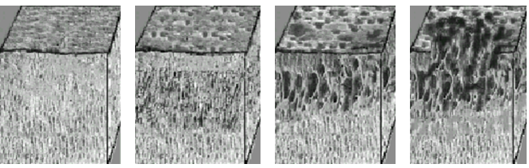

Here at the beginning we can see porous Subsurface and surface intact “ incipient caries “ , then the pores in the subsurface start to increase and the surface cant take this anymore so a cavity in the surface appears .

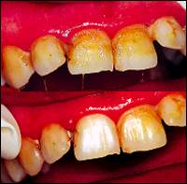
- Carious lesions occur under a mass of bacteria
“Dental Plaque” capable of producing a sufficiently
acidic environment to demineralize tooth structure.

“ Dental plaque has bacteria , So the bacteria is on the tooth already , surrounded by the plaque & cant get out , so the only thing acid can work on here is the tooth . “

- Dental plaque : Is a gelatinous mass of bacteria adhering to the tooth surface.
- The plaque bacteria metabolize refined carbohydrates for energy and produce organic acids as a by-product causes demineralization of crystals .
- These acids may cause a carious lesion by dissolution of the tooth's crystalline structure.
- Carious lesions progress as a series of exacerbations and remissions as the pH at the tooth surface varies with the changes in plaque metabolism.
- Exacerbations and remissions occur as episodes of demineralization and remineralization.
- Survival of micro-organisms in the oral environment depends mainly on their ability to adhere to a surface.
- The First thing the dentist start with is the periodontal therapy which is scaling and polishing because the patients may have class 5 dental caries beneath calculus or dental plaque and I can easily miss it .
- The main cause of dental caries is a bacteria called Streptococcus mutans because it’s the only one that can adhere to the dental plaque , after that the rest of the bacteria “ lactobacill “ follow it and by a team work they cause us caries .
- It has become clear that a relatively small group of bacteria is primarily responsible for the two major oral diseases; caries and periodontal disease.
- One group of bacteria, which consists of eight Streptococcus mutans (SM) serotypes has been associated with caries. The serotypes have been labeled a through h.
- All S. mutans serotypes have been demonstrated to have a significant potential to cause caries.
- SM and lactobacilli can produce great amounts of acids (acidogenic), tolerant of acidic environments (aciduric), vigorously stimulated by sucrose, and appear to be the primary organisms associated with caries in humankind.
- There are 3 terms that we should be familiar with :
- Organisms that cause caries are termed cariogenic .
- Acidogenic : produces acid SM ..
- Acidouric : lives in acidic medium lactobacilli ..
- MS are most strongly associated with the onset of caries while lactobacilli are associated with active progression of cavitated lesions.
- The enzyme glucosyltransferase may be crucial in the adherence of MS to the pellicle when sucrose is present. “ that’s why the MS is the only one which can adhere to the dental plaque because of the presence of this enzymes in it “ .

- Hypotheses Concerning The Etiology Of Caries :
- 1) The Non-specific Plaque Hypothesis :
Promotes the universal presence of potential pathogens in plaque and therefore assumes that all accumulations of plaque are pathogenic.
Therapeutic goal based on this theory would be the complete elimination of plaque in the oral cavity.

- 2) Specific Plaque Hypothesis:
Based on the observation that accumulation of plaque is not always associated with disease; accumulation of plaque could be regarded as normal in the absence of disease. Plaque is assumed to be pathogenic only when signs of disease “ caries “ are present.
The specific plaque hypothesis provides a new scientific basis for the treatment of caries that has radically altered caries treatment.

Etiology | MS infection
Symptoms | Demineralization lesions in teeth
Treatment (symptomatic) | Restoration of cavitated lesions
Treatment (therapeutic) | Eliminate MS infection  “ decrease it by oral  Hygiene habits “
Post-treatment assessment (symptomatic) | Examine teeth for new lesions
Post-treatment assessment (therapeutic) | Bacteriologic testing for MS
- New caries treatment based on the specific plaque hypothesis :

- Caries is a bacterial disease ;
There is abundant evidence that the initiation of caries requires a relatively high proportion of streptococci mutans within dental plaque. These bacteria adhere well to the tooth surface, produce higher amounts of acid from sugars than other bacterial types, can survive better than other bacteria in an acid environment, and produce extracellular polysaccharides from sucrose. “ same thing we mentioned earlier at the beginning “
- Caries is dependent on dietary sucrose ; Dietary sucrose changes both the thickness and the chemical nature of plaque. Mutans streptococci and some other plaque bacteria use the monosaccharide components (glucose and fructose) and the energy of the disaccharide bond of sucrose to assemble extracellular polysaccharides.

- Caries is modified by saliva :
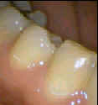

- Caries is modified by fluoride ; The mineral of enamel, cementum and dentin is a highly-substituted calcium phosphate salt called apatite. The apatite of newly-formed teeth is rich in carbonate, has relatively little fluoride and is relatively soluble. Cycles of partial demineralization and then remineralization in a fluoride-rich environment creates apatite which has less carbonate, more fluoride and is less soluble.
“ calcium phosphate apatite has carbonate that’s easy gets demineralized , toothpastes have fluoride , so when the patient brush his teeth , this fluoride will replace the carbonate and it becomes much more resistant to acid attack and it protects the tooth more as a
result . “
- Fluoride-rich, low carbonate apatite can be up to ten times less soluble than apatite low in fluoride and high in carbonate. Topical fluoride also inhibits acid production by plaque bacteria.
- Fluoride in food, drinks, dentifrices, oral rinses and gels, and fluoride in filling materials can therefore all reduce the solubility of teeth, helping to reduce caries risk.

- Tooth Habitats for Pathogenic Plaque ;
Tooth habitats favorable for harboring pathogenic plaque include:
- Pits and fissures.
- Smooth enamel surfaces both immediately gingival to the proximal contacts and in the gingival one third of the facial and lingual surfaces of the clinical crown.
- Root surfaces, particularly near the cervical line . once the root is exposed , its easy to become demineralized .
- These sites correspond to the locations where caries is most frequently encountered –
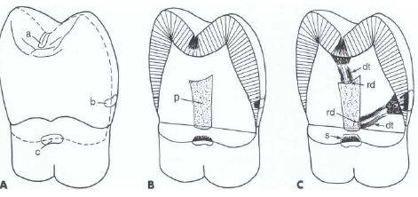

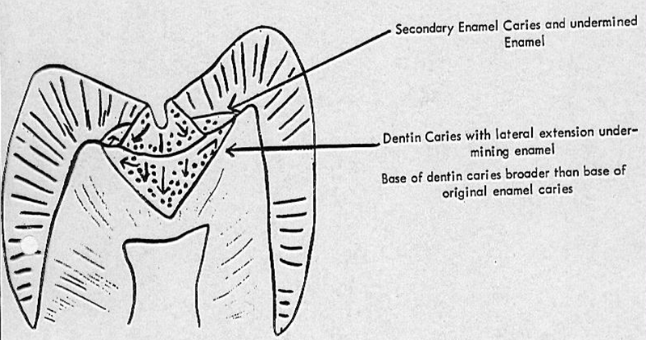

- Pit-and-fissure caries :
Pit-and-fissure caries has the highest prevalence of all dental caries ; the deep infolding of enamel makes oral hygiene along these surfaces difficult, allowing dental caries to be common in these areas.
The pits and fissures provide excellent mechanical shelter for organisms and harbor a community dominated by S. sanguis (especially in newly erupted teeth) and other streptococci.
- If you find the rate of S.sanguis higher than normal , then expect caries after 6 to 24 months later ; The appearance of MS in pits and fissures is usually followed by caries “Sealing the pits and fissures just after tooth eruption may be the single most important event in providing their resistance to caries. “

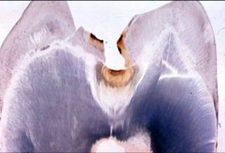
- In Enamel the appearance of the caries is cone shaped ,
While in the dentine is upside down cone shaped “ called
Base to Base “ in pits and fissure caries.
In Enamel the base is directed toward amelodentinal
Junction , and in the dentine toward the amelodentinal
Junction also “ remember its base to base so the base
Is going to be directed to the same direction “

- In smooth surfaces caries its Apex to Base , apex of
Enamel is on the base of dentine .

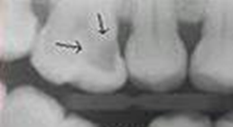
- Hidden caries ; a dentinal caries lesion near the occlusal
surface of the tooth, seen in x-ray photograph, whereas in visual
examination the occlusal enamel is seen intact or only minimally
perforated. The proposed patho-physiology of this phenomenon
is based on reinforcement and re-mineralization of the outer
enamel layer by topical fluoride.

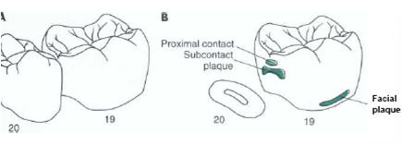

- Smooth enamel caries ; The proximal enamel
surfaces immediately gingival of the contact area are
the second most susceptible areas to caries. These
areas are protected physically and are relatively
free from the effects of mastication, tongue
movement, and salivary flow “ nothing to clean the
area , dental floss should be used to protect our teeth
from this type of caries . “
- Proximal caries, also called interproximal caries .
- We cant detect this type of caries by the probe , we should use X-rays .

Sorry for any mistakes , if you have any question , don’t hesitate to ask ..
Best of luck ^_^

