Sheet no. :11

Refer to slide no. :

Written by: Samar Al-Jaiose – Sana Sami.
Corrected by: Samar Al-Jaiose – Sana Sami.

Class III cavity preparation

*Class III:
1-is an aesthetic restoration. 2-smooth surface caries. 3-involves proximal surfaces of anterior teeth.
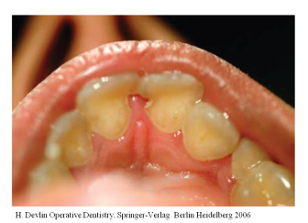
***The picture in slide 3: There are caries on mesial surface of the two centrals, there is a gingival growth (The cavity is a space, so if we leave it without treatment for along time and there is a gingival inflammation, the gingiva will grow in it).
*If a patient comes to me with class III caries, from where should I start???
-The most important thing the patient wants is the aesthetics, so I have to be aesthetic as much as I can.
-There are two approaches:
1) Facial approach :usually we don’t prefer it but sometimes we have to do it like:
a) Caries location: the tooth is already opened from the facial surface.
b) Alignment of teeth: sometimes the patient comes and his teeth are tilted or misaligned in a way makes the facial surface more accessible than the lingual one.
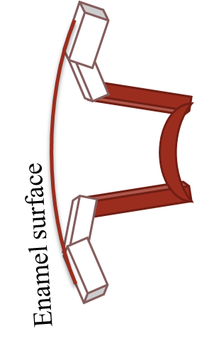
c) Replacement of restorations: when another doctor has already made the restoration from the facial surface and there is a discoloration and I should remove the restoration.
2) Lingual approach:
-more preferred.
-we always do it unless it would remove excessive amount of tooth structure.
-more aesthetic because we conserve the facial wall (we use it in bonding) and all the caries removal is from the lingual side and the staining is invisible (because all the margins are lingually).
***Which is more important in class III preparation aesthetic or conservation of tooth structure???***
-Aesthetic is more important for the patient. The conservation of tooth structure is more important for us as dentists. So we tell the patient that we have to remove more from the tooth structure to give him the aesthetic properties that he want, If he doesn’t have any concerns we always go conservative.
***Clinical Technique***
-The steps are the same for any restoration, the differences are: the caries location, the design that I use, and the restorative material.
-General steps:
1-Giving anasthesia: some patients refuse anesthesia, others prefer it always. It is better for us as dentists to give anesthesia because it: a)makes the patient comfort [no pain, he won’t stop us a lot]. b)decreases salivary flow [it is important if we don’t have good isolation].
2-Occlusal assessment: before we prepare the tooth we have to let the patient bite on his teeth (to assist his occlusion, to see if there is a misalignment in the teeth, to see if the tooth itself has a high contact or it is out of occlusion) to know the cavity design and how much restoration do I need and if the restoration will stay in it’s place or not [sometimes the patient has edge to edge centrals because part of the tooth is broken so I have to know if the restoration will stay in it’s place or not].
3)Shade selection: we have to do it BEFORE preparing the tooth because if we prepare the tooth it will be dehydrated and it’s color will change so there will be a mistake in the shade selection.
4)Isolation: in amalgam restoration it is acceptable to put cotton or suction only but in anterior teeth composite restoration isolation is more important because we need good bonding and good bonding needs good isolation. So always try to put a rubber dam before doing the cavity (the isolation before doing the cavity because if any pulp exposure happens there will be no cavity contamination and the tooth prognosis will be much better).
5) Tooth preparation (3 types).
6) Pulp protection.
7) Restoration.
***cavity preparation***
-We have 3 types of class III cavity preparation:
1) Conventional (تقليدي): the first cavity to be used in dentistry, gives us mechanical retention.
2) Beveled conventional.
3) Modified conventional.
1-) Conventional:
- Indication: caries on the ROOT of anterior tooth on the proximal surface. **Note: Class V: caries on the gingival third on FACIAL and LINGUAL surfaces, here the caries are on the proximal surface, anything proximal anterior is class III.
- Why do we use conventional?? Because the bond will be on the dentin(there is no enamel margin), and the composite is an aesthetic restoration needs enamel margin for more retention, in this case we don’t have enamel, we have dentin, so we will deal with the cavity like we are making it for amalgam to get mechanical retention.
- Design: Butt Joint margins (like amalgam).
-Walls: like amalgam walls in class l and occlusal extension of class ll.
-Cavosurface margin=90˚(between outside surface and the external wall).
-External walls perpendicular (┴) on the root surface.
-Uniform depth.
*In the picture we have caries on the root, if we only remove the caries and make a circular cavity there will be no enamel margin and we can’t use composite, so we have to prepare the cavity in a way to have more retention: Two parallel external walls/axial wall/junction between outside surface and the external wall=90˚ [butt joint: end to end].
*If we put the restoration there will be: 1-Mechanical retention: from the conventional design(parallel walls, uniform depth of the floor) 2-Micromechanical retention: from the bonding to dentin. We increase the surface area for bonding (bonding to dentin is weaker than bonding to enamel but there is bonding).
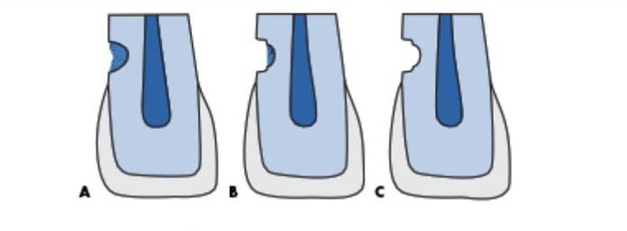

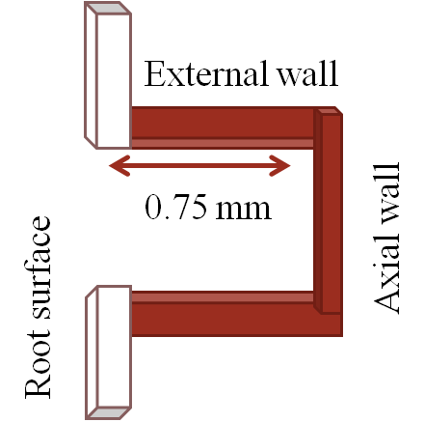

*Steps for cavity preparation:
1-outline form: we use round curbide burs [different sizes depend on caries size], or diamond burs [they are better than curbide in composite because it makes the surface rougher and roughness is important for bonding so they help us in bonding]. The depth is uniform, the initial depth is 0.75 mm inside the root (the root is very thin so we may reach the pulp very easily).
2-then we start removing caries completely like any other cavity, we may reach the pulp then the patient needs endo treatment. Sometimes initial cavity preparation removes all the caries so I don’t need to remove more.
*If there is a defective existing restoration and I have to remove it, we do the same [initial axial wall, initial depth, then I start to remove the restoration].
3-Retintion: we need mechanical and micromechanical retention on the root. *If the cavity is larger than expected, and needs more retention we make grooves. *Grooves: increase retention, decrease polymerization shrinkage effect on composite, protect the marginal seal by resisting tooth flexure. *Note:tooth flexure: Two forces in opposite directions try to rotate the tooth together. So if we have two grooves each one will resist the direction of one flexure force to conserve and protect the marginal seal. *Placement of grooves (for retention): we use round bur (very thin round bur), with a diameter of 0.5mm, but we usually enter with half the length only (0.5/2=0.25mm). *Position of the bur: internal portion (towards the pulp) of the external wall (the external wall, between the axial wall and outside surface of the tooth). *Distance from the root surface (between the groove and root surface) = 0.25mm. *Depth: 0.25mm (half the length of the bur). *We enter in a perpendicular way to the enamel surface not making sharp angle. ***Every cavity must have FOUR walls.*** *Axial wall is always towards the pulp. External walls between the axial wall and outside surface of the tooth. *The grooves must be continuous. *Location of the grooves: we direct them by bisecting the angle between axial wall and external wall.

2-)Beveled Conventional:
-Indication: restoration of large carious lesion or replacing defective restoration in the CROWN. *In the crown means that we have enamel margin. *Beveled means that we can use the enamel margin for retention. *Conventional means that we still need mechanical retention.
-Why: there is a large cavity so we need more resistance or retention or both.
-Design: some beveled enamel margins with conventional wall design.
- Cavosurface margin=45˚ on beveled, 90˚ on non beveled margins (conventional margins).
-External walls ┴ enamel surface
*Steps for cavity preparation:
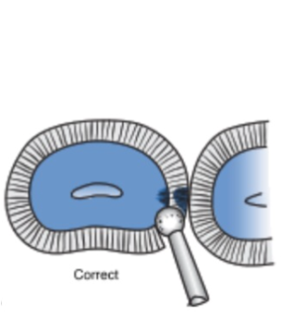
1-outline form: a-point of entry: * In class lll on the crown surface (regardless the size) the entry is always in the inciso-gingival dimension of the cavity or the carious lesion *The instrument must be perpendicular to the enamel surface (outside surface). *The neck of the bur (not the cutting end) bur as far into the embrasure as possible and must be near the adjacent tooth to make the cutting edge nearer to the point that we are working, so we preserve parts of the tooth.
*correct entry (angle) : The neck of the tool is near the adjacent tooth so we enter with an angle on the carious lesion, and preserve parts of the lingual wall.

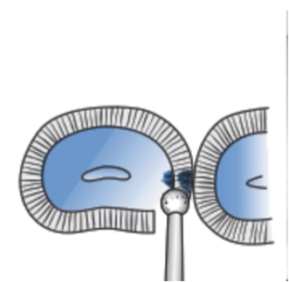
*Incorrect entry (angle) : The bur is perpendicular on the outside surface, so we remove sound tooth structure.

*Note: On the upper central lingual surface there is a cingulum, the occlusion is on the lingual surface of this tooth, so if we enter directly (incorrect entry) on the lingual side the cavity will be on high stress area (there is occlusion on it), and this will weaken the tooth.
*In this type we also use round bur (carbide or diamond according to the type of the carious lesion), but here the depth is 0.2mm (initial depth in dentin).
b-The axial wall: It must be convex outward (with the outside surface) rather than 90˚, so here we follow the normal contour (normal convexity) of the tooth, because if it is flat it will be nearer to the pulp.
2-Removing caries: unlike amalgam (where we eliminate undermined enamel), here with composite we keep undermined enamel unless it is a stress point or in a contact area (chemical bonding).
3-Retintion: here we have mechanical retention (the wall is perpendicular (90˚) on the outside surface, and enamel beveled (45˚ on the surface), and retention grooves. A) bevel: we use bevel technique to: 1-increase the surface area (more surface for bonding to enamel). 2-to expose more enamel rods so we provide more itching (increase the surface area for itching). - we use flame shaped or round diamond bur, 45˚ to the external tooth surface, with 0.25-0.5 mm width, if the cavity is large we increase the width to increase the bonding. -bevels are performed on any accessible enamel margin except gingival margin to maintain the enamel thickness there not to decrease it, or on lingual margin if as we said there is stress or contact point. B)Retention grooves: if we need more retention (like in large cavities). -position: on two line angles ( inciso-axial line angle and gingivo-axial line angle, then we make them continuous). -We use quarter round bur, 0.2mm inside DEJ, 0.25 mm depth into dentin, bisect the angle formed by the junction of axial wall and external wall.
3-)Modified Conventional:
-Here no conventional characteristics are observed (modified). -It is the most common type due to esthetic reasons. -Indication: small and moderate lesions or faults designed to be as conservative as possible in the crown. -Why? Because we have all the enamel margins (the cavity is small). -Design: scooped or concaved. -Cavosurface margin ≥ 90˚ (diverged). -External walls = no shape. -Only include caries or defective restoration. -We just enter the bur and remove the caries…Just!!!
*Steps for cavity preparation:
1-outline form: a-point of entry: *within the inciso-gingival dimension of the cavity or the carious lesion. *The instrument must be perpendicular to the enamel surface (outside surface). *Also here the neck has to be as far into the embrasure as possible. b-the axial wall has no uniform depth unlike the two previous types. 2-Removing caries. 3-Retintion: Enamel bevel or flare. *here also there is no bevel on gingival margin, or on lingual margin if there is stress or contact point.
*** What if the caries extends on both crown and root surface?*** *Root: conventional. *Crown: -Large: beveled conventional. -small: modified conventional.
**Remember to isolate the working area.
***pulp protection***
-In general, in deep carious lesions we put calcium hydroxide on the carious lesion and over it we put thin layer resin modified glass ionomer cement [liner], (resin modified: needs light cure). -The glass ionomer protects the calcium hydroxide from dissolving in acid itching and provides seal for dentinal tubules by chemical bonding (reaction between the glass ionomer and the calcium inside the dentin). -Glass ionomer is the only true adhesive material in dentistry.
***Restorative procedure***
-For anterior teeth, esthetics(composite) is almost always recommended. -The only contraindication is root caries because composite shrinks, the shrinkage pull the composite up, because this shrinkage is stronger than the initial bond strength between the composite and the root surface, so a gap is formed ( V shaped gap). -This gap is hard to be avoided but we put resin modified glass ionomer to decrease: 1-gap formation. 2-microleakage. 3-recurrent carious formation.

-Light cure for: 1-bonding agent. 2-composite resin. -We use Mylar strip (not metal because it takes space), it is thin and transparent to have a clear vision, and allow light cure to pass. -We use wedges between the teeth to protect the gingiva and the adjacent teeth.
**Acid itching: -phosphoric acid 37% , liquid or gel (better because we control it easier). -We put it in the cavity + ½ ml away from the cavity(on the margin), for (15-30) seconds, then wash it and dry the tooth but not over dehydrate it, in order not to lose the inorganic material (calcium and phosphate) from the dentin, so the organic material in the dentin will remain (collagen fibers), this collagen fibers will make tags (area) the resin can get between them, eventually collagen will collapse, SO we must keep the dentin moist. -then we place the bonding agent according the manufacturer instructions, then we use gentle air to distribute the bonding agent and to remove any solvent, after that we put light cure for (10-20) seconds.
**Restoration: -We put the composite in the cavity then tighten the two Mylar strips on the outside surface of the tooth (cervical part of the tooth)by our hands to contour the composite.
**Finishing: -We usually use finishing strips and blades. -We move strips by “S motion” in order not to break the proximal contact. -Polishing disks helped us on lingual side.

