

***Sheet no. :10***

***Refer to slide no. :***

***Written by: Elaf Alomoush – Nisreen Alkooz***

***Corrected by: Elaf & Nireen***

**h**

**Rotary instruments in operative dentistry**  
1- **hand piece.**   
2- **Burs.**

**Hand piece**: device used for holding rotary instruments and making operation intra orally and extra orally.  
Extra orally→ like usage in lab!  
  
So, its function is holding the cutting instruments (burs).  
  
**Types of hand pieces:**  
two main type:  
1) strait hand piece:   
the bur is at the long axis of the hand piece, used in lab because we have freedom to approach the problem that we have .  
  
2) Angled hand piece:  
the bur approximately perpendicular to the long axis of the hand piece, used intra orally , and all hand pieces that used intra orally are angled that because we are limited in the oral cavity .  
  
  
 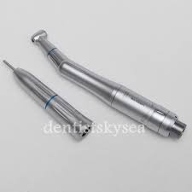  
 *angled hand piece further classified according to the speed of rotation   
  
**speed of rotation:** measured by (rpm) = revolution per minute.   
  
So, angled hand pieces classified to :  
1) low/ slow: less than 12.000 rpm.  
2) Medium /intermediate: from 12.000 to 200.000 rpm.  
3) High/ ultra-high: more than 200.000 rpm.  
   
- This rpm's represents very high speeds and provides sufficient cutting so we have to be very careful when using this instruments.  
  
- Mainly, we use low and high speeds and this is arbitrary.  
  
**Low speed cutting instruments (hand piece):**  
used for:  
1-caries excavation , because caries is soft and we need tactile sensation of cutting (in high speed hand pieces we don’t have this tactile sensation because of efficiency of cutting ) and we need in effective cutting because we remove soft tissue.   
2- Finishing and polishing procedures.   
  
properties :  
-ineffective cutting.  
- Less chance of overheating the cut tooth surface.  
- Time consuming.  
-require relatively heavy forces when applying the hand piece, this is if the tooth is sound but if carious, you don’t need heavy forces to apply on the the hand piece.  
  
- Low speed hand piece fitted with low speed burs.  
Low speed burs made of: tungsten carbide – steel – stainless steel – diamond   
mainly, tungsten carbide & stainless steel.  
  
**High speed cutting instruments:**   
used for :   
1- tooth preparation .  
2- Remove old restorations, crowns or bridges.  
  
properties:  
- very efficient cutting instrument.  
- remove tooth structure faster with less pressure, vibration and heat generation.

→less pressure, because of efficiency of cutting procedure so less tactile sensation.  
→less vibration, patient are generally less apprehensive, low speed hand piece tend to vibrate because they move at lower speed and make the patient apprehensive, high speed have less vibration and they are more comfortable for the patient.   
→ less heat generation, because of cooling with extra water with high speed cutting instrument, if we don’t have enough cooling you will over heat the teeth .

- Operator has better control and greater ease of operation because he don’t have to apply any pressure (in low speed, you apply pressure so your control less).   
  
-decrease the operating time and you can make multiple teeth in the same visit.   
  
-high speed hand piece fitted with high speed burs.

High speed burs made of: usually diamond or tungsten carbide.  
We don’t use steel or stainless steel for it because of hardness of the material. We said that we use high speed hand piece some times on sound tooth structure and this materials are not hard enough to cut it efficiently.   
  
**Maintenance and sterilizing hand pieces:**  
-it is very important to replace and sterilize between patients always and always.  
  
-before sterilize you have to clean and lubricate your hand piece then sterilize in autoclave.  
  
-every fabricator of hand pieces provides special type of lubricants.  
  
- If you don’t lubricate your hand piece before sterilize erosion and wearing will happen and become less effectiveness and shortening the life of it.  
  
- Recently, they are manufacturing hand piece that are disposable, used once and thrown away. Not sterilized, made of plastic and used when there is danger from transmitting diseases (patients with infections like hepatitis) .  
  
  **Rotary cutting instruments (burs)**  
  
**burs:** rotary cutting instruments that have bladed cutting head.  
Bladed→ tungsten – steel burs.  
Rough→ diamond bur.  
  
-used for cutting hard tissue like teeth or bone.  
  
-Made of steel – stainless steel – diamond grit – carbide.  
  
-burs not used only in operative dentistry, we use them also in surgical procedures to cut bone not only teeth structure. **Ex1**. When you extracting an impacted wisdom tooth you need to cut part of the bone and you can use strait hand piece, special kind of burs at a lower speed to not damage the cells of the bone.   
**Ex2.** You can use dental burs to cut bone for dental implant, when you have to prepare site for dental implant when you want to place an implant using special type of hand pieces.

* The difference between surgical hand piece and operative hand piece:  
  
-surgical one is: low speed with high torque.  
speed→سرعة الدوران   
torque→ عزم الدوران   
  
this is because I want to cut without generate heat or killing the cell so,  
slow speed → to cut without kill the bone cells and without generate heat   
but here the bur will be catched by the bone and cannot rotate so,  
high torque → keep rotating at slow speed .  
-operative hand piece (like in lab): the opposite🡪 high speed low torque.  
  
  
* design characteristics of the burs:  
very bur is formed of three parts :  
1- shank.  
2- Neck   
3- head.   
  
 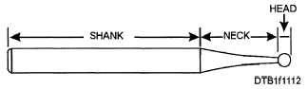   
  
The shank:  
- part that fitted in the hand piece   
- design of it depend on the type of hand piece.  
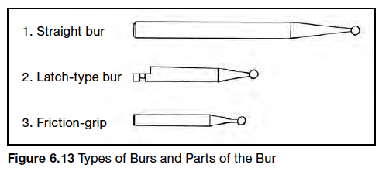- Shank design: three types:   
1- strait: shank longer and bigger.  
2- Latch type angle: low speed bur.   
3- friction grip angle: high speed bur.   
  
  
The neck:   
- inter mediate portion connected head with shank.  
- Narrower  
 - give you possibility to cutting.  
- tapered from the shank diameter for a small immediately adjacent to the head for better visibility for cutting head.  
  
  
Shank and neck hold the bur in position inside hand piece and provide visibility to active part (head).  
  
  
The head:  
- cutting part of instrument –working part.   
- perform desired shaping for tooth cutting.  
  
  
- The shape of the head and the material used to construct it are closely related to its intended application. **Ex.** if I want to excavate caries I will use low speed round bur because this is the shape of caries extension, so more conservative. **Ex**. If I want to prepare class1 cavity I will use fissure bur (245) and so on.

* In general, burs are design of basic head designs:

**1- Round bur:**- It has rounded or spherical head.- Can be plan or crosscut.- Used for:1- initial cavity preparation ( initial entering into the tooth).2 - Extension of preparation.

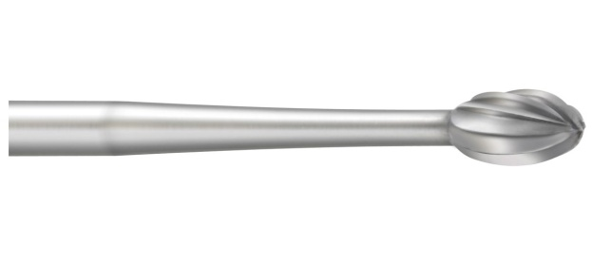 3-Preparation of retentive features

4- Caries removal.

Plane: the angle with tooth structure is strait.

Cross cut: in addition to the strait plane there is مسننات)) indentations 🡪Give more cutting efficiency if we are removing restoration to a cutting metal.   
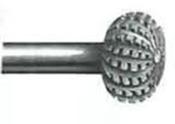   
  
* Numbers of burs is not included. :)

**2- inverted cone bur:**- the head of the bur is like a pyramids , the apex of the cone directed toward the shank.   
- The head length is approximately the same as the diameter.  
- used for: providing under cut for tooth preparation. 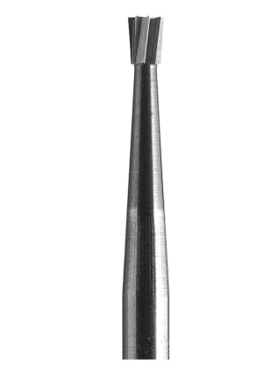

**3-Pear shaped bur:**-It looks like inverted cone bur but with a flat end and Rounded corner

-It is the most desirable shape of bur for tooth preparation; why??

Because it will give rounded internal line angle so it will improve resistant form and it is more conservative.  
(sharp internal line angle increase the strait concentration).  
flat end will improve the resistant also.

-it is a combination of inverted cone bur and round bur.

-Slightly tapered cone with the small end of the cone directed toward the bur shank.

- The end of the head either is flat with rounded corners.

- Used for class 1 cavity preparation for amalgam or gold foil.

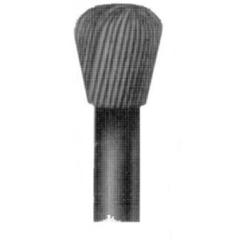-it has its numbering system starting from 230!

### 

### 4-Straight fissure bur: -another basic desirable burs.

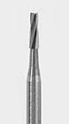-it is a cylinder whether it is carbide or a steel or diamond.

- may has slightly curved tip.

-can be planed or with cross cuts.

** NOTE: DON’T MEMORIZE NUMBERS EXCEPT 330 AND 245 BURS ;)

### 5-Tapered fissure bur:

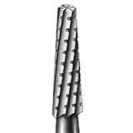- It is a cylinder with a slight tapering (opposite to inverted cone fissure bur).

-uses: since it gives diverging walls 🡪Mainly used in indirect restoration mainly inlays or onlays; ex: we use it in class1 (ceramic or gold), here we don’t want undercut because the restoration is indirect so I have to fabricate it in the lab and cement it properly.

I can’t cement it if it contains undercuts (opposite to direct restoration which need undercuts to retain the restoration inside the cavity.

- A slightly tapered cone with the small end of the cone directed away from the bur shank.

*numbering system: they are arbitrary numbers; the no. doesn’t indicate anything except that the bigger the no🡪the bigger the size of the bur.

In this picture you can see the same bur with different sizes.

¼ round bur used for doing retentive features of the cavity.

While 4 round bur is used to remove caries.

*there is misconception upon students; we think that if we use a smaller bur we are more conservative. This is not true, to clarify:

If you want to dig a hole (1m*1m) you can use many instruments even a spoon! But which will be more time consuming?! The same applied to tooth cavity, you will end up with the same cavity 🡪 so use the bur that is suitable with the size of the cavity.

When you are going to do caries excavation, select the largest bur that can fit in the cavity, why?

Because smaller burs are more dangerous; imagine that you applied a force to a low speed ¼ bur it will penetrate easily into the pulp specially if the cavity is deep. So use a bigger bur( size 4 for ex.). be aware don’t enlarge the cavity to make the bur fit into it🡪 if the cavity is large enough to accommodate a large bur then using a large bur to excavate caries is less dangerous.

## blade design of burs

Each blade has two sides:   
1-the rake face (toward the direction of cutting).

2- Clearance face.

the bur rotate in a certain direction, if the bur rotate in the opposite direction it will not have the same cutting efficiency; because if the bur is designed to rotate clockwise (direction of the blade) it will give its maximum cutting efficiency if it rotate in this direction, but it will not cut if it rotate counter clock wise because the direction of the blade isn’t right .

All low speed hand pieces can rotate clock wise or counter clock wise. So in order to have the maximum cutting efficiency use a hand piece rotates at the same direction of the blade.

If it rotates on the opposite direction: it will not cut + it will generate heat and more pressure is needed.

*to know the direction of the rotation, turn on the bur at low speed and just look to the direction.

*most of the burs cut when rotating clock wise.

*Some burs cut when rotating counter clock wise (special types) examples:

-maseran kit? 🡪 it is a hollow cylinder bur ,the tip of the cylinder cuts a circular shape(without excavation) around structures, rotate counter clock wise .

While doing root canal treatment we use posts to help retaining the restoration

If the bur become fractured inside the tooth during preparation, we can extract it using maseran kit which will cut around the fractured part, removing undermine enamel, in a counter clock wise direction (this movement will dislodge the fractured instrument).

-lentulo-spiral 🡪 used to introduce cements inside post’s core and rotation counter clock wise will push the cements inside the canal.

So certain applications required rotation counter clock wise and needed specific burs.

**the problem is less with diamond burs because There is no specific pattern of the cutting edges🡪 cutting occurs because of roughness of the surface.

*The blade of the bur has three important angles:

1-the rake angle

2-the edge angle

3-the clearance angle.

If you look at a bur (here a tungsten carbide bur-cross section) this is the center of the long axis of the bur.

-while the bur is cutting it touches the tooth surface at a certain points; not the whole surface of the bur touch the tooth. 

-The importance of these angles:

Clearance🡪 during cutting chipping introduced; it allows chipping and water exit.

Rake angle and the edge angle 🡪determine the sharpness and efficiency of cutting of the bur.

**if I want to use a bur for finishing or polishing of the restoration then I have to increase the # of blades 🡪become closer to each other’s 🡪↓ efficiency of cutting 🡪↑ smoothening of the surface

Because when the distance between blades ↑🡪it will removes chunks but if the distance ↓🡪 chunks of enamel will be ↓🡪more smoothening.

Burs used for finishing and polishing have ↑# of blades and ↓distance in between.

# **Finishing and polishing**

You can use:

Burs, pointes, stones, strips, discs… we will talk about them

If I do composite preparation I need to finish it and polish it, shape the cavity and have a very fine and smooth surface. I can’t use the cutting instrument to perform this job, so we use specific type of instruments to do it.

-we have a whole range and products for finishing and polishing a restoration, they are made of steel, diamond or carbide.

What is the difference between the diamond used for cutting and diamond used for finishing?

Size of particles;

Cutting bur: large particles🡪more efficient cutting and more rough

Finishing bur: smaller particles🡪 less efficient cutting and more smooth.

# **Finishing instruments for amalgam**

*do us need to do finishing and polishing of the amalgam?

After you place your amalgam, you carve it to the shape you want. This amalgam will be rough but you can’t finish and polish it at the same visit, why?

Because the sitting rxn will not be completed.

-Sitting rxn of any material is continuous; it is fast at early stages then become slower.

**We can’t measure the sitting rxn; we can only certain properties of the material to determine the degree of sit.

- Ex.we can’t see the sitting inside the amalgam but we can measure the compressive strength that help determine the degree of sit; after 5 min of mixing amalgam compressive strength =(x) .after 1 hour =2x or 3x

If it=8x for ex. It indicates advanced stage of sitting and this sitting is continuous.

*you can’t finish and polish amalgam at early stages of sitting because the phases are forming so you will disturbed the sitting rxn; you will push part of mercury Because of the vibration and forces to the surface.

So you must wait for the sitting rxn to be almost complete (at least 24hr).

Most (but not all) materials siting rxn is about 24hr.

*other example🡪 glass ionomer

Can I finish and polish glass ionomer immediately?

The answer is no. for a different reason;

Glass ionomer is a material that depends on the rxn of acid with glass🡪acid doesn’t consider acid unless it is in aqueous state🡪so glass ionomer contains water.

**any material contains water in early stages of siting is:

-sensitive to dehydration

-sensitive to moisture

🡪 When we use glass ionomer we must use varnish to separate it and prevent dissolving from oral fluids.

-If we do the finishing immediately we will either dissolve it(with water) or dehydrate it(without water) and both are wrong.

-so we can’t finish and polish amalgam immediately, we must wait for the sitting rxn to be completed (at least 24 hr).

\***Important note**:

Any material that contains water is sensitive to dehydration or moisture contamination. An example on a material that contains water is alginate; that’s why you must pour your impression immediately otherwise it will be distorted by losing its water or if it became contaminated with water.

*back to our question: do we have to finish and polish amalgam?

No, we don’t. the aim of finishing of amalgam or finishing of any restoration is to give a smooth and shiny surface, amalgam after condensation and carving is greyish in color without glossing with rough surface; if you wait for it to sit and then you use instruments to finish it, it will has more glossy, smoother surface (most important is less surface area will be achieved with smoother surfaces).

smooth surface🡪 less bacteria, less of depri…

Smooth surface🡪↓surface area🡪the rxn of amalgam (metal) with the environment↓.

This is in old amalgam.

New amalgam contains high amount of cupper corrosion process is slow and less.

So in modern type of amalgam you can polish it but it is not necessarily and don’t add a value to the restoration.

On the other side most people don’t like the shiny surface of the restoration because it will appear.

Instruments used for finishing amalgam:

Different types of burs which contains more blades in order to smoothen the surface not to cut.

We can use different types of stones or rubber cups that contain abrasive material.

rupper cups is a piece of rupper that impregnated with particles that can polish the restoration.

*important:

-with any finishing and polishing procedure you should go through different steps; you can’t finish the restoration in one step. You must go through different grades

Starting with force 🡪 then medium🡪 fine🡪 extra fine so you’ll have a smoother surface.

**Instruments used for finishing composite**

You can use stones, burs.

Burs used are diamond burs to give a smooth surface .the grids of the diamond is very fine.

The finer the grids of the bur 🡪 less efficiency in cutting and more smoothening of the surface.

-we can use discs; that contain fine grids on the surface.

Ranged from course, medium, fine, extra fine with regard to the size of the particles.becomes smaller as we move from course to extra fine.