Lecture #22 part 1 Thulfeqar Alrubaiey

This lecture is going to be about the clinical presentation of cracked teeth.

The most difficult step in treating cracked teeth is the diagnosis.

A tooth crack is a fracture plane of unknown depth and direction passing through tooth structure. The crack may communicate with the dental pulp or the PDL depending on the depth and location of the crack.

Cracked teeth are observed mainly in patients aged between 30 and 60. Males and females are equally affected.

Mandibular second molars are the most common affected teeth, mandibular first molars are the second most common, and maxillary premolars are the third.

What is the direction of the crack?

* Mesiodistal (most common); splits and tooth into buccal and lingual parts.
* Buccolingual (very rare); splits the tooth into mesial and distal parts.

Cracked teeth affect are found in 10% of the population, 15% of the cases (15% of the 10%) the crack reaches the pulp and tooth is indicated either for RCT or extraction. 35% of cracks are found in caries and restoration free teeth.

Lower second molars are the most common affected teeth because they are the closest to the TMJ so they are susceptible to high occlusal forces.

**Etiology of cracks:**

* Naturally occurring causes: such as bruxism, clenching and severe attrition.
* Iatrogenic causes: such as excessive tooth structure removal.

Taking medical and dental history and carrying out proper intraoral examination aid in the process of diagnosis a cracked tooth.

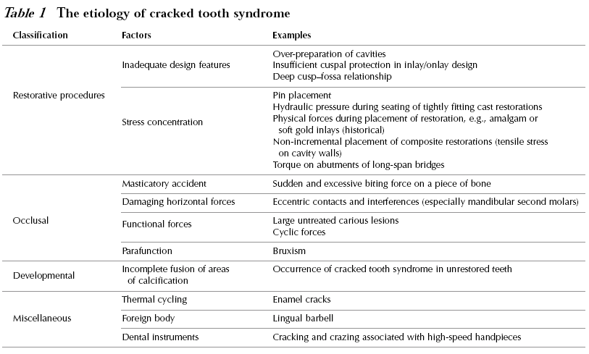

*Miscellaneous cause: causes that may cause cracks.

**Types of tooth crack:**

1. Craze line: observed in most of the patients anteriorly. Involves enamel only. At this stage, the tooth is not indicated for any restorative treatment.
2. Fractured cusps: usually originate in the crown, extend into the dentin, and end in the cervical region.

Management of fractured cusps:

1. Taking pain history: as the nature of the pain is an indicator of the depth of the crack (cracks extending into the dentine have different symptoms than the ones that are extending into the dental pulp).
2. Local anesthesia.
3. Removal of the fractured part.
4. Assess restorability depending on the depth of the crack/fracture.
5. Cracked tooth: A crack extending from the occlusal surface of the tooth apically without separation of the two segments (incomplete fracture). In this case, the tooth looks normal but symptomatic (the patient is in pain).

Detection of incomplete fractures:

* Remove existing fillings and inspect for any cracks.
* Application of dyes that will stain the crown.

1. Split tooth: A crack that extends through both marginal ridges usually in a mesiodistal direction, splitting the tooth completely into two separate segments. It is detected by wedging and instrument in the crack. Teeth with split tooth cracks are non-restorable.

Note: if an incomplete fracture was left untreated, it will result in a split tooth type of cracks.

**25-5-2015 cons sheet 10/part 2 Eman Al.hamad**

We started talking about CRACK TOOTH it’s definition ,it’s possible etiologies and it’s types/forms ;

* Craze line
* Fractured cusp
* Cracked tooth
* Split tooth

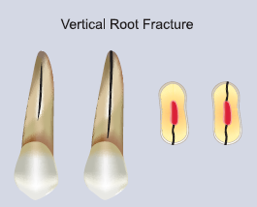

AND now lets talk about the fifth type which is **“ vertical root fracture** “ .

* It’s a complete or incomplete crack initiated from the root at any level, usually directed buccolingually.
* It’s problematic to diagnose because it’s initiated from the root area that is covered and we can’t clinically see and recognize it by direct inspection.
* There is an image of a lower anterior tooth that we might be suspicious it has a vertical root fracture and when we open a surgical flap we distinguished the vertical fracture .
* 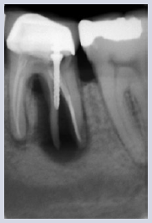 So in the case when vertical root fracture is suspected , we’re going to make certain tests to distinguish this fracture :

-Firstly, it has got a very **familiar radiographic appearance** “ J “ shape radiolucency >> bone loss.

**- Probing** the sulcus around the tooth , there will be a deep drop of the probe in a very shallow pocket ( exp. The probing depth all around ranges 2-3 mm -normal-, except in a certain area it falls in to 9-10 mm ) .

-**Surgical exploration**, by opening a flap so we can see the vertical fracture frankly and the bone loss around.

………………………………………………………………………………………………………………………………………

* The most critical step in the CRACK TOOTH is reaching a proper Diagnosis , once its diagnosed properly it’s management gonna be easy .
* Because of widely variable sings and sympotoms of a crack tooth, it’s diagnosis is problematic.
* For example the pain might be intermittent, deep , sharp , aggravated sometimes by hot and cold but sometime not , sometimes awakes him up sometimes not ! .
* Generally the symptoms depends on the depth of the crack ; if its in the **enamel** there might be a mild pain or asymptomatic. If it reaches **dentinoenamel junction** will induce similar symptoms of reversible pulpitis ( but in irreversible pupitis the symptoms are persistent the ptn always feels sharp provoked pain on cold or hot , but in a crack tooth he bites >> crack opens >> when he drinks >> irritation to dentinal tubules >> feels the pain ) . when the crack reaches the pulp it induces signs of irreversible pulpitis ( we should do vitality test) .



* The most identifiable symptom that we rely on is what we call **Pain on release** or rebound. It is a sudden sharp pain on biting/chewing and in some cases on release . we check for this symptom by different means :

1.Bite on a cotton roll.

2.percussion tabbing on the cusps.

3.Bite test by a Tooth slot >> reliable .

It has a flat surface and another pointed surface , we direct the pointed one towards the cusp which might have a crack by this the biting forces are directed to it , and the flat one towards the opposing teeth..Then we ask him to bite on it >> the patient gonna feel the pain once he releases.

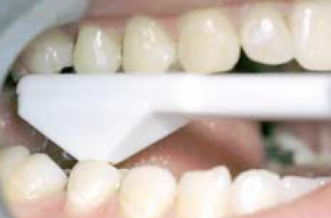

Tooth slot

**OTHER diagnostic** methods to identify a Cracked tooth in addition to tooth slot are :

4.Wedging > when there is a frank large crack that causes separation .

5. Magnification

6. Transillumination

7. Staining

8. Restoration removal

9. Surgical assessment

10. Radiographs

………………………………………………………………………………………………………………………………………………………

**Management of teeth cracks :**

* The severity and consequences of the fracture can range from minor, needing no treatment at all, to severe, resulting in root canal therapy (RCT), or even tooth loss.
* Treatment planning depending upon the amount of remaining tooth structure .
* Affected tooth part removed and defect restored.
* Root canal treatment or vital pulp therapy **is only necessary** in the event that the crack affects the pulp chamber or has resulted in irreversible pulpitis or pulp necrosis.
* ***Craze line***: no treatment warranted. but instruct ur ptn for bad habits decussation to prevent crack propagation .
* ***Fractured cusps***: affected cusp removed >>RCT if pulp involved>> bonded tooth restoration.
* ***Cracked tooth***: depends on location and extent of crack, RCT if pulp involved >> Full crown or onlay. Poor prognosis.
* ***Split tooth***: depends on depth of fracture, usually extraction.
* ***Vertical root fracture***: removal of fractured root ( sectioning ) or extraction.

***About the case introduced at the beginning of the lecture :***



The First thing to do is :

1. Remove the filling >> we noticed clinically the crack extends to the distal root > causing loss of vitality.
2. 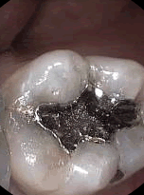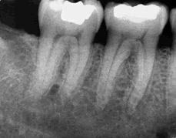 RCT by using preferably resin-based system for the root canal filling material ( Endolaze system and Resilon system) .
3. Crowning or bounded restoration .

***Good luck***