Last lecture we talked about TMDs and its classifications, it could be due to:

- Muscular problems: protective cocontracture, myospasm, trigger point myalgia.
- TMJ problems: internal derangement of disc, surface incompatibility(adhesion, obstruction, subluxation, spontaneous dislocation)
- Mandibular hypomobility
- Growth disorder that could affect any organ in the body such as TMJ.

So this was the last week`s classification. Today we are gonna talk about stomatognathic system and how to examine it, to know what is trigger point, muscle tenderness, and this should be applied to all of ur pts, not only extraoral examination as we do in clinics by checking symmetry and lymph nodes only.

Examination of the articulatory system

- What are the signs and symptoms of TMDs?

-Joint pain
-sounds
-dysfunction or limitation of movement
-muscle tenderness
-headache

- What is the Articulatory system? What should be examined? When we talk about examination, its related to:

-Neuro-muscular system (muscles)
-the TMJ and
- occlusion.

They are 3 components, so we have to examine each one.

A student asked what is the difference between pain and tenderness?
Pain is when the pt tells you I have pain, while tenderness is when you palpate u feel a tenderness, so one is a sign and the other is a symptom.

- Examination consists of:

-Range of movements
-TMJ tenderness, TMJ locking, TMJ sounds
-Radiographs sometimes although they are not very conclusive
-Muscle tenderness (palpating muscles)
-signs of bruxism (don’t forget to look for signs of parafunction)
-Headache (you ask the patient if he has headache in the morning after waking up , or it might be a continuous headache, in the frontal area or the lateral (temporalis) areas, so it could be a sign of TMDs.

So this is the sequence that we follow

- Range of movement: is the only measurable character that can be objectively recorded. ( when you and I examine, we will notice the same result of range of movement, it wont be different)

- Causes of limitation of the range of movement are either:
- muscular (pain or muscular problem, when you solve it the problem will no longer exist)
- articular (physical obstruction- problem in the disc, and cant be solved).
So one of the causes of limitation of movements will be solved, and the problem will be reversible, on the other hand, the latter wont.
When a pt had extracted a tooth, and comes complaining of limitation of opening, this would be muscular problem and temporarily.
We should measure the mouth opening range, direction, notice any deviation or deflection and lateral movements.
When you examine mouth opening, you either sit behind the pt or directly infront of him, to see the midline and the movement, and we usually expose the teeth in order to see the midline. This is how to know if there is deflection or deviation.

- Types of openings:

-Diagonal: when the patient starts opening his mandible goes toward one side, mainly the other side is not moving and we have something non-functional at that side or it may be locked because the patient has adhesions.
Sometimes the movement would be diagonal from the beginning, means that one of the condyles is not moving in, this is due to adhesion
``adherence: is when it’s a sticky movement initially, then I can open and adapt to it. While adhesion is more permenant (ankylosis).``

-Deflection: Once you open,there is a straight line, then you go to one side, usually it is associated with disc displacement without reduction. During the rotation of the condyle we have the vertical line.
`` initially, it will be a normal vertical opening, then lateral movement of TMJ.``
``in ipsilateral direction, the condyle is not moving there.``
(diagonal from the beginning it goes laterally, deflection will be normal initially, then it goes laterally.)

-Deviation: is vertical then lateral movement in the middle, then it returns to the vertical path, happens with disc displacement with reduction.
``going out and coming back. Normal opening, then lock, then comes back``

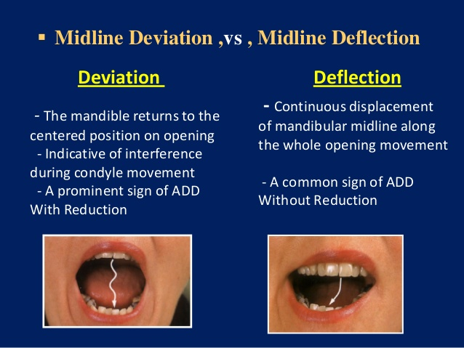

For the range of movement, we have technique for measuring the maximum opening, measured from the upper incisor tip to the lower incisor tip , when the patient opens to the limit of their maximum pain free range of movement. you can measure it using your fingers or a ruler (instrunment). Sometimes you force it to know the difference.
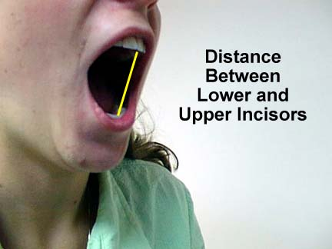

The normal range is 35-40 mm. or 3 fingers of the pt not ur fingers.
Technique for lateral movement is measuring from the midline to the midline.
the lower limit is 7-8mm.
you put a ruler and ask the pt to move laterally and see the lower midline range of movement .
If the patient’s midlines do not coincide with each other, we have to put a mark and measure according to it.
Some say to add the OB, but it wont make a difference since it Is only 2mm.
The dr thinks that the safest way to measure is to eliminate the OJ and OB, because it is a measurement of movement not a dental one.(you concentrate on the condyles).

- TMJ tenderness/TMJ sounds

How would you palpate the tenderness? Use two fingers in the area front to the ear.(around the ear area).
Pain is the most common cause for patient to seek treatment. Causes of pain can be inflammation, acute or chronic trauma to condyles.
Usually the pt comes to you and he knows that there is pain, not after you examine him he senses a pain.
Acute trauma results from injury or v. high restoration.
While chronic trauma, results from parafunctional overloads on TMJ.
Pain induces inflammation and this causes pain or upon palpation u will feel pain.
You can palpate the retro-discal tissues with your index finger inside or infront of the external auditory meatus.
So palpating can be from the inside of the ear or the lateral tissues and ligaments of the condyle, and the posterior aspect (capsule).
We can hear TMJ sounds better by collaborating palpating with ur fingers to the sound, you can also use stethoscope. U can also ask the pt too.
U palpate lateral or intraarticular.
The most important ligament is the lateral TMJ ligament, it limits the lateral movement of the TMJ.
In normal opening the condyle rotates around an axis( the disc doesn’t move) , in wide opening translation occurs when the condyle and the disc slides forward, below the posterior surface of the articular eminence.
In normal opening the disc is usually interposed, moves forward downward and the condyle passes forward across the disc, in maximum opening the head of the condyle is a little bit anterior to the disc, the condyle is more free. Initially, the disc moves superior and anterior to the condyle in partial and fully opened state, it stills do not dislocate (normal opening).
In subluxation, the disc moves more forward and returns back with no problem. If it slides and is locked, then it is a spontaneous dislocation (remember it with yawning).
Popping sound is usually due to dislocation or when the condyle recaptures the disc. The etiology of this sound is injury to the bilaminar zone, hyper tonicity of the lateral pterygoid superior head, or injury
Most common dislocation is the anterio-medially. The only posterior dislocation is when the pt opens widely to the maximum, and spontaneous dislocation happens (locking), this is v. aggressive so that the disc moved posteriorly.

- Types of clicks are: : (it could be reversible) Popping sound is usually due to dislocation or when the condyle recaptures the disc
Single or multiple (very serious disc instability or perforation in the disc).
Early (minor displacement or the beginning ) or late.
Soft (minor displacement) or loud.
Painful or painless.
Simple or reciprocal (in opening and closing).

The mild problem in TMJ clicking is when it is single, early, soft, painless, and simple.

Crepitus happens with degenerative diseases such as osteo-arthrosis, articulating surfaces display erosions or little lubrication of the joint, usually symptomless associated with pain in advanced cases.

What happens if the disc is out of its space, what will you hear? a click. (internal derangement).
What happens if the articulating surfaces are worn? Crepitus. (degenerative diseases or incompatibility of the articulating surfaces)
Can you hear clicking and crepitus at the same time? Then it’s really a severe case.

- TMJ locking refers to two clinical presentations:

- the patient can open to a limited degree, movement of the closing and opening is free to a limit that the pt describes sticking sensation and its usually painless, beyond this limit the patient feels pain and locking of TMJ, this is usually due to anterio-medial disc displacement, and its dislocation without reduction, the condyle is unable to gain access under the surface of the disc during opening, so rotation will happen but translation is very minimal (15-20mm)or none at all, this is disc dislocation without reduction. (the pt opens to a certain range, then he senses a lock , so this is locking)

- The second scenario of TMJ locking is much less common and v. severe, occurs when the mandible opens and locks temporarily into one position, the patient is unable to open or close any further, this is what we call spontaneous dislocation, the condyle goes beyond the articular eminence and the disc would be anteriorly or posteriorly. It sometimes happen when the condyle gains access to a serious perforation in the disc. (u open maximally, then u cant open or close anymore, example when u have a perforation, and the disc locked into it, its much more severe, and the mandible cant even open or close, temporarily locked, locking in further opening not initially, because it opened, the condyles opens and then locks).

Correct diagnosis depends on good examination, , it could be with or without reduction. You should ask the pt about time and onset and location , and how does it?

Locking: anterior disc displacement without reduction
Clicking: anterior disc displacement with reduction

- Radiographic examination is only indicated when we suspect a bone pathology, we take trans-cranial , trans-pharyngeal radiographs, or OPG.
Radiographs have do much shortcomings, they can’t be conclusive nor reproducible, because the articulating surfaces of the condyle and the fossa won’t be visualized and because early changes in bone won’t be detected in radiographs. You should take it in at least 2 positions, like in opening and closing

- Muscle examination

- Muscle tenderness:
you can start from the muscles origin to its insertion, usually bilaterally and don’t exert too much pressure. If u cant examine muscles by ur hands, then do a functional examination. Palpate among the whole muscle to see if there is trigger points (you examine the muscle and the pt feels pain in the molar area, and its rare)
The most area you feel it tender is the attachment of the muscle fibers to the bone (insertion).
-Masseter examination: 2 fingers (extraoral and intraoral), one from the inside and the other from the outside and ask the patient to clench. From origin to insertion by 2 hands. -Temporalis: we have anterior, middle and posterior fibers. Palpate at the temporal area bilaterally (extra and intra oral examination), it’s inserted on the coronoid, you can palpate its insertion with your finger and ask the patient to try to close while keeping his mouth open (close with an open position). If you are not able to palpate, then ask the pt to clench, but we always prefer to examine at rest (relaxed palpation).
-Lateral pterygoid: functional examination, opening and lateral movements against resistance.
-Medial pterygoid: very difficult, won’t be able to palpate it, so it’s also functional. No intraoral examination at all. When the dr was a student, she was asked to examine the medial pterygoid posterior to the maxillary tuberosity, this is v. painful, and its wrong because every pt will sense pain.

- Trigger points palpation:
-if we have trigger points in masseter the pain can be sensed in the maxillary molars, over the angle of the mandible or in the supra-orbital region.
-If you have trigger points in the temporalis, the pain will be in the upper molars or the upper anterior teeth and the supra-orbital region.
-Lateral pterygoid: referred pain to the ear or infra-orbital regions.

- Bruxism:

-Teeth attrition and wear fascist
-sensitivity in teeth
-teeth or restorations fractures
-scalloping of the tongue
-ridging of the cheek (approximately all of us have it)
-headache usually at the temporal area upon waking up or could be during the day. (it could be associated to TMD, so u have to ask about time, onset, origin, severity).
-some complain of abfraction

Bruxism is acknowledged by 50% of pts, means that 50% o pts know that they have bruxism, and the other hald don’t even know they have parafunction. So this is why you need to see the signs.

- Occlusal examination (static and dynamic):

-Static, angles classification, we should also check if the centric occlusion coincides with the centric relation, check for premature contacts ( if you know it, you will be experienced in occlusion), magnitude and direction of the slide between centric occlusion and relation and the premature contact that caused it, check if the patient has freedom in centric. Interference is when you occlude firstly on a molar, then you slide to MIC (shift from CR to CO).
Which interference is the most harmful? The lateral or the anterior? The lateral slide, when one of the condyles is moving outwards, and the other moves inwards. And the bigger the slide, the more risk you will have. If less than 2mm slide, then it is ok, but if u have for example 6mm slide, then it would be an ortho instability.
90% of people have slide, only 10% CR=CO.
How to find CO? Don’t do anything, just ask the pt to close in MIC contact position.
How to find CR? Guide the pt (We should know how to bring the patient to the centric relation by using the bi-manual manipulation technique by Dawson.)

. when you open or close, you will feel that you make rotation in opening, in different cases, you can put a cotton roll and ask the pt to bite on it until he feels tired, then you can manipulate well (in the relaxed or semi-relaxed in supine position). This is how to know the CR from CO and if the pt has slide and how much is it.
Retruded contact position: it’s the position of the mandible to the maxilla where there’s just the first contact upon closure, when the condyle is in the centric relation, then a slide occurs due to this contact, and we go to the maximum intercuspation.
How to find the slide? Let the pt be in the supine position, then ask him to occlude, then take the CR by telling him to inform you once he feels his teeth are touching and in which area and direction. This will be the closure interference. The pt will close and tells you in this area the teeth are touching each other, then tell him to occlude.
A student asked: why we don’t notice the slide everytime we close? Because we close in MIC directly, we don’t go for CR, something related to brain adaptation, which lets you close in MIC (habitual bite).

-Dynamic occlusion examination, check for incisal (anterior) guidance, working and non-working side interferances.
In anterior guidance you look for how much of the lower teeth in contact with the upper teeth during protrusion, it should be from 5-5 ideally, but could be from 4-4, and should be simultaneous contact, and equal in density, then you will have a nice harmonized anterior guidance.( this is applied to lateral movement also). If only a lower central incisor is in contact, instability, occlusal trauma and pain would result.
The most important function of anterior guidance is to disocclude the posterior teeth, to be in a pain free motion.

The dr mentioned some rules to be included in comprehensive presentation: Restorative occlusion not only the static, also the anterior and canine guidance, is there interference? Diagnostic study models articulated with wax up , Xrays ,Photographs (anterior for smile analysis if u have anterior restorations , and lateral views in MIC with colors.

The Dr asked us to refer to the chapter she gave us, and she showed some videos to be given later.
Best wishes,
Haya Hasweh

