Vertical compaction of guta percha:
It used to be the second technique in obturating the root canal system, but now it’s the first technique for obturating the root canal system. First it was lateral condensation and the second one was the vertical condensation, but now we gave up on using the lateral condensation and started to use the vertical condensation.
We as an endodontists, we always look for an endodontic technique that is safe, predictable, reversible, and 3 dimensional. In the old obturating techniques we used to have a single cone technique in which we clean and shape the canal and then we fill the canal with the sealer and then we dip the single cone in it, then we had the lateral condensation technique that you know, therma fill, and then injectable gutta percha and then warm gutta percha technique.
The dr. showed a picture of the thermafil technique, its consisted of a file with an attached gutta percha, and then we heat the file and then we insert it into the canal, it has a point where it can be broken so it separates from the file and stays in the canal. It is no longer used nowadays.
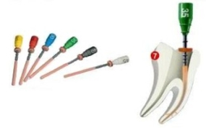

The dr showed another picture, obtura II , in which you can see the gun filled with gutta percha and we heat it on this device until its melted. Then we inject it in the canal and after injecting we do packing with a plugger, this is called thermafil (as the dr said but im not sure of this info).
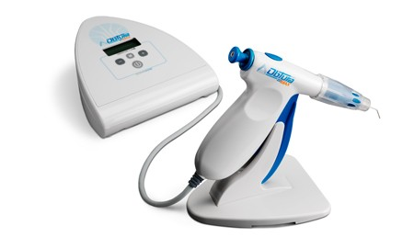
Note: Thermafil is a patented endodontic obturator consisting of a flexible central carrier that is uniformly coated with a layer of refined and tested “alpha phase” gutta-percha. When heated, the “alpha phase” gutta-percha becomes sticky and tacky, with excellent flow characteristics and obturates the canal and available lateral and accessory canals.
we should pay attention when putting the GP in the canal, we have to do some condensation with the plugger so no voids will occur, we have to have a solid fill.
Old filling techniques had some disadvantages, such as lack of control, dimensional instability, inconsistency, and leakage. These are the major disadvantages of the warm GP technique.
In vertical condensation the cone of GP itself, if we sealed it at the tip with heat instrument, this heat will move from the tip away for 4-5 mm. (y3ni eza s5ana 3l tip , 4-5 mm fo2e bseer 6ari) this property helps us in doing compaction, its now moldable. This is the most important property that made us use the soft, moldable GP. GP temperature is 3-8 degrees above the body temp. if its more it will harm the periodontal ligament.
Vertical condensation or vertically condensed GP as it cools produces an optimal adapted and dimensional stable material. (bnsa5en el gp w b3d ma nsa5nha bndo2ha , b3d ma ndo2ha bt36eena good dimensional stability). Any warm GP technique must include … 8.27 impaction 4-5 mm. every time we use moldable GP you should compact it and condense it by vertical condensation to ensure general adaptation and to encourage shrinkage and loss of volume.
Advantage og warm GP ,it will fill all irregularities of the canal including the lateral canals and the accessory canals, internal resorption, all these things will be filled.
The dr showed a picture with obvious lateral canals, he mentioned that by lateral condensation it is difficult to fill them, so we filled them by vertical condensation.
Disadvantage of warm GP, difficulty in length control, requirement of large assortment of instruments, necessity of large canal preparation. These disadvantages has no importance as it used to have in the past, we can use only 2 or 3 pluggers, and its not really important to have a large canal, we can use the protaper to have a wider canal.
As we said, one of the warm GP disadvantages is lack of control, If we have a wide open apex and we want to obturate it in the same visit for emergency, we do what’s called a surgical procedure through and through. We do endo and surgery at the same time. We fill it very well (we overfill it) then we do a flap design and we remove all the excess GP. So we didn’t need to do apexfican or used MTA. So its all done at a one visit appointment. This technique is discovered by Herbert ( I couldn’t hear it).
The dr showed a picture with a lateral canal of a root that shows a lesion, the lesion is not at the apex of the tooth,these canals cant be filled with lateral condensation so we filled it using vertical condensation with warm gutta percha to around 5 mm from the apex which is enough, then we might put a post and crown or if we are not planning to do this we might just continue filling it with gutta percha.
What is the armamentarium that’s is needed to do vertical condensation? Pluggers, heat carriers, gutta percha, and sealer.
In the past they used to use about 12 plugger (8, 8.5, 9, 9.5, …), now they use 2-3 pluggers for every case.

GOOD LUCK

