Cons. lecture #4
5/10/2016
Occlusion in Restorative Dentistry
<The references for this lecture are 2 articles about occlusal practice>
you should apply occlusion in your daily practice in both direct (simple) or indirect (crown and bridge) restorations.
How you take the bite? In which relation you take the bite in crown and bridge?
Occlusal practice in simple restorative dentistry
- Aim:
- to provide restoration that is functional and cosmetic for the patient.
- to provide a restoration that is in harmony with existing occlusion of our patient and that will not have any negative effect on the teeth, alveolar bone, periodontal ligament, neuromuscular or articulator (TMJ) system.
....so imagine that sometimes from simple crown or simple bridge you miss the patient occlusion, that you will interfere with patient occlusion or make high crown or restoration, you could have certain problems for this patient, so you have to check the static occlusion and lateral movements "right & left movement of the jaw".
- Starting point: EXAMINATION
"you have to check the occlusion for the patient before you start working, ... you have to check if he has canine guidance, group function,..."
The lecture today will be about two concepts, the first one is about conformative approach and the second concept is about re-organized approach.
In most of our work, if we can be conformative we stay conformative, it simpler for us and for our patients, but in other cases if we can't stay conformative, we have to re-organize the occlusion.
The conformative approach
- defined as: the provision of restorations in harmony with the existing jaw relationships (we don't say existing occlusion, because we don't talk about static movement only, but also about the dynamic movements of your patient).
- In practice, we provide a restoration that does not alter (does not change ) in both static and dynamic occlusal contact of the remaining teeth.
sometimes you say that if I do a simple crown then I am conformative and if I do a bridge I will be re-organized and not conformative... this sentence is wrong , most of the times it works but not always.
- The conformative approach is the easiest, simplest and safest method to maintain the occlusion for your patient.
Re- organized approach is not that easy, its need studying, full mouth wax up, occlusal analysis, new occlusion, new anterior guidance and correct vertical dimension...so most of the time we try to be conformative as possible.
Most of your work will be on conformative approach " 90% of your work".
the doctor shows a pictures ,,, this is a simple crown on articulator , the crown have the same occlusal relationship and lateral movement of the patient ... so this crown is conforming to the occlusion.
- When to use the conformative approach?
- the patient has an ideal occlusion, CO=CR with anterior guidance free from posterior interferences.
(this point is a little bit philosophical , because the idea of ideal occlusion is a concept not real, we don't have an ideal occlusion... we can substituted this word by comfortable occlusion (the patient is not complaining of esthetic, function and TMJ disorders for a long time))
- the patient is free of (TMDs) TMJ disorders (because if the patient stay in the same occlusion you will keep the same problems, so he has to be free of TMDs)
- the patient does not have an ideal occlusion, however the restoration provided will not change the existing occlusion
(as we said before, when you made simple restoration most of the time you will be conformative, but this is not a rule ............ ex.: if you want to make a simple class 1 amalgam restoration on lower 5 ... you're not allowed to decide to make a re-organized occlusion "re-organized mean you are changing the occlusal table and surfaces")
... EXCEPT:
- deflective contact or posterior interferences
ex.: I want to make a single crown on upper 7, but this upper 7 have a deflective contact (it make the CR & CO not coincide when the patient close his mouth " as 90% of people") ... this mean he had deflective contact or closing interferences
when the patient close he had a contact on CR on 7 that make a shift then he close on CO ... so how I prepare this tooth?
the crown here will be re-organized .. we make simple justify (change its shape)... I prepare the occlusal table of the teeth , then I let the patient close in CR .. there will be change.
if I change any of the jaw relationships of the patient this mean that I am not conformative, this is also applied on the lateral movement, If you change them then you are not conformative you are re-organized.
- lateral interferences, working & non-working side interferences

- Improving the occlusion within the restrictions (limits) of the conformative approach:
1. the forces in line with the long axis of the tooth and simultaneous with other contacts
2. we prefer point contact upon incline contact, because in point contact there will be distribution of forces and in incline contact when teeth touch each other's there will be tooth wear ( Incline contacts are considered to be potentially harmful)... so eliminate incline contacts.
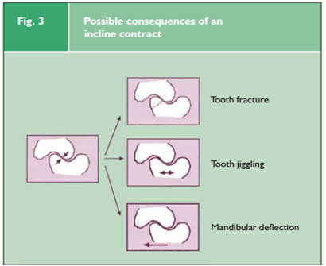
3. avoid infra or supra- occlusion
- Technique:
The EDEC principle
Examine and record pre existing occlusion
Design the restoration
Execute it
Check the occlusion in the next visit
this four steps to do any occlusion for all your restorations either conformative or re-organized, direct or indirect restorations.
- EDEC for simple restorations (in the same visit):
1-examine and check the points of occlusion for you patient
2- design mentally
3- execute it
4- check
- EDEC for indirect restorations:
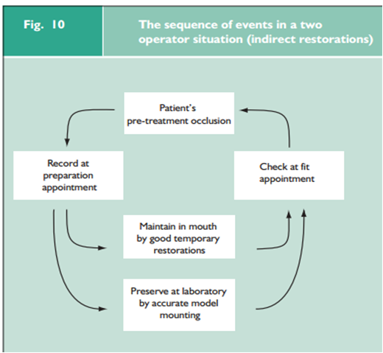
Start
*record the occlusion ... study models, take a photograph for the case & look for points of contact.
*design & maintain this occlusion inside the patient mouth (by putting provisional's that are confirming to existing patient occlusion)
*make a good mountain to your working cast, to let the lab give you a good restoration.
- Bite records:
- Two dimensional bite records:
- photographs
- written records ( the dr. use this method, but it's very tiring)
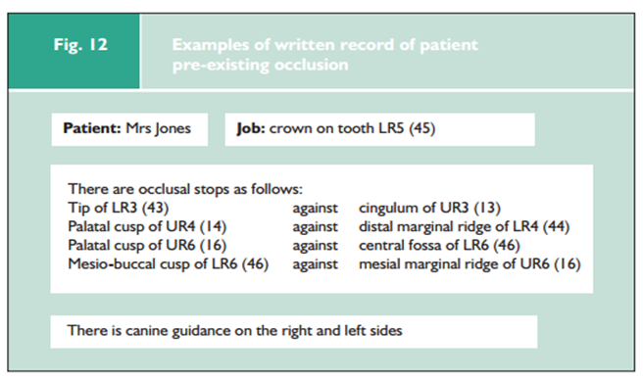
- occlusal sketching
you have already sketches and you make design on it then you put the points of occlusion on static and dynamic occlusion.
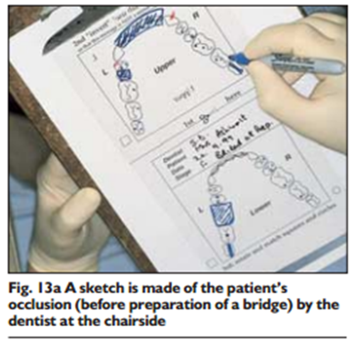
- Three dimensional bite records: take a bite and put it on articulator
Aim of bite records: is to record only the correct spatial relationship of the prepared tooth to its antagonists. Other teeth should contact as before (because I still conformative.. so when I take the bite on the area you prepare without affecting other areas ..the bite will be accurate, why? because your patient have an clear ICP ... if you have all teeth,,, hand articulation will give you proper ICP without needing anything else.
you take the bite by hard and accurate material then attach the cast manually to each other's then mounting .. there will be no problems in this technique
but this will not work in cases where the patient has already attrition, so in this case you are the one who choose the way for articulation (with bite record or only by hand articulation)
why I don't put anything between teeth? because sometimes it make miss interception, so the patient will bite laterally.
If you want your bite in maximum inter cuspation (CO) your wax bite should be perforated all around ( because the maximum inter cuspation is the maximum inter digitations) and the opposite of that if you want to make a bite in CR, there should be no perforations.
The bite should be taken before and after preparation.
→ Bite registration materials:
- elastomers (bite registration base)
-acrylic resin or duralay (the doctor use this material, but it only used for small sector, mostly on prepared teeth)
-hard wax ( it should be HARD)
→ Guidelines:
1. If possible, the bite material is used only between the prepared teeth not the full arch.
2. wax should be as thin as possible to not engage soft tissue (it should be on occlusal surfaces and not contact mucosal surfaces because if it attach mucosal surfaces, it will increase the proprioception and then the patient will move his jaw right or left.)
3. multiple recordings may be taken to confirm the relationship (this should be considered when I have a suspicion that the CR is not correct).
Occlusal practice in advanced dentistry
when we will change to re-organized occlusion
in most of the patients the existing occlusal scheme is functional, cosmetic & comfortable, so the most appropriate way is to adopt the conformative approach (to provide treatment within the existing envelope of static and dynamic occlusal relationship of the own patient). However, there is some situation where we can't adopt it, such as when I treating the patient with advanced restorative (when multiple posterior teeth are prepared your patient will lose occlusion in maximum intercuspition so you have to be re-organized... this when you have multiple lose posterior teeth but this is not a rule, because sometimes you still preserve the occlusal relationship.
-changing occlusion will not be necessary even if you preparing multiple posterior teeth.
ex. : I want to prepare 4 teeth (from 4 to 7)
if I prepare them in one shot I will lose my occlusion because I don't have a reference
so I prepare one tooth and I leave the one near to it and so on, & let the most posterior one unprepared, then I take the bite by putting bite material only on prepared teeth, the bite will be as original because the 7s are coincide each other then I prepare the last teeth ... so in some cases when you have multiple preparation if I do not prepare all the teeth at the same time I can maintain the maximum inter cuspation of the patient as original and you will stay conformative. 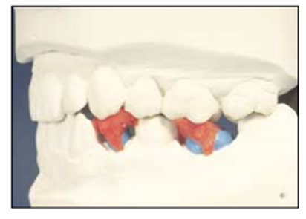

Q: when is the conformative approach is not appropriate?
when we need to change the actual occlusion:
1- increase in vertical height is wanted
2- teeth are significantly out of position
3-change in appearance is wanted
ex.: patient have attrition in upper and lower anterior teeth and you want to return the height of his teeth back as before 20 years, so this new teeth needs new anterior guidance... so I am re-organized.
4- history of occlusally related failure or fracture of existing restorations
(it's very rare to see this in clinic, but sometimes it might happen, the patient came complaining of fractured or fallen bridges for many times, you will see fractured porcelain here the patient has heavy occlusion and interferences in some teeth so we should think of a new occlusion scheme for the patient).
5- recurrence of TMDs that has relapsed after a period of successful splint therapy.
(the relation between teeth and TMDs are not strong relation ... less than 10%, but if your patient have a splint therapy that relief TMJ pain then this patient have a problem in his occlusion so you re-organize it)
--- ortho and cons department can re- organize occlusion
---it's wrong to make a restoration because you want to change occlusion only.
.... so when the conformative approach cannot be used you have to examine and plan for a new restoration
*changing occlusion without having planned the new occlusion this is called Unorganized approach شغل شلفقه
Re - organized approach:
aim: to provide a new occlusion that should be in harmony with all the neuromuscular systems that are involved.
a poorly tolerated reaction for high restoration could cause; fracture for cusp tip, fracture for the restoration, mobility on the tooth, tenderness in percussion, muscle problem, tooth sensitivity and the last thing is TMDs.

- Ideal occlusion:
- Tooth level:
- multiple simultaneous contact
- cusp to fossa contact
- occlusal contact
- simultaneous bilateral Occlusal contacts that are in line with the long axis of the tooth
- Patient level:
- the patient is comfortable
- no muscular problem
- vertical relation is good
- Articulatory system level:
- CO coinciding with CR
- freedom in CO (means that when patient make lateral movement he will not feel his teeth are blocked, there will be liberty and mainly in anterior teeth this is very good for artiucular system and for the patient when he changes his position as when he sleeping and on CO there will be micro discrepancy that give the patient some freedom).
this freedom happen when you don't make the cusp tips pointed, it has to be slopes.
- No posterior interferences
*How to be re-organized:
first step, is to provide an appropriate diagnostic wax up (mock up) on articulator.
EDEC principle;
- Examination: you record the jaw relationship in CR by...
- bimanual manipulation technique of Dawson (you position the patient supine, but the 2 thumps on patient chin and four fingers on the mandible, then rotate the mandible upward backward to put the condoyle on CR position)
- deprogramming
either I put a cotton in patient mouth and let him bite on it, so patient muscles will be tired so you lit him to forget his habitual occlusion and prevent him to resist your movement.
or by anterior deprogrammer "Lucia jig" ... acryl or green stick.
> mount on semi adjustable articulator using a face bow
- Design : we design and do equibilirtion and use articulating paper on the cast to see the points and do diagnostic wax up
Diagnostic wax up advantages : you propose occlusal plane , propose centric stops and anterior guidance, it will help you provide an ideal occlusion, determine if you need crown lengthening or not, guide you how much reduction you need to go in the tooth, fabricate provisional and verify your treatment by this provisional (the patient feel comfortable or not? the height of it is good or not? the occlusion is good or not? ... it will give you an idea about the final restoration)
when I extremely need to try the provisional that build up from the wax up in patient mouth? when I am restoring anterior teeth, it will help us to check the height, facing, lip support,...
- Execution phase
- Check your definitive treatment
lab copies the occlusal feature
customizing an incisal table mold of acryl used to copy the anterior guidance to the lab
  - Guidelines of occlusal practice:
