Sheet no. : 6
Refer to slide no. : 6
Written by : Fatima al-hilli

Endodontics vs. dental implants
starting with this picture
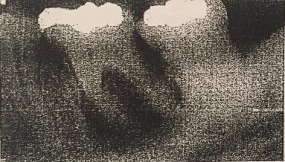
It’s a customize tooth , heavily destructed with significant bone lose around it
You should do RCT and we know the prognosis not that much or to take it out and put an implant ??

First let’s talk about the advantages of preserving natural teeth in healthy condition :
- Preservation of function ( chewing and speech )
- Preservation of aesthetics
- Preservation of proprioception : pulp is rich with proprioceptive fibers , you don’t get proprioception in dental implant while if you did an endo treatment it will reduces but still you preserve proprioception
- Preservation of arch integrity and occlusion
- Psychological aspect (pt don't like to loose their teeth )

While there is many disadvantages of preserving natural teeth in diseased condition :
- Risk of acute abscess/ cellulitis ( this is how your body protect you )
- Loss of alveolar bone
- Risk of systemic infection , how ?

by the “Focal infection theory” that was concluded through an experiment in which they brought mice and inject them with large dose of bacteria and then they notice a regenerative disease in kidney , bone , heart .
means that : " focus of infection in your body can lead to problem in distance organs " >> so after that people start to take their teeth out as a prophylactic method.

" Note : also some believe that 97% of terminal cancer patients previously had RCT treatment ( Nothing Scientific ) "
→Now lets go to the implant ..

They notice a master success( osseo-integration is successful in more than 98% of the cases)
Based on success criteria which is : 1- absence of symptoms 2- uniform thickness of periodontal space 3- no apical radiolucency

So by that ;Success of RCT ↓ than ostointegration

Slide9 :
The doctor show us a case with a radiolucent lesion , they did RCT and then with a follow up we found an improvement in size reduction .. but according to the success criteria this is a failure !

So we moved from talking about success to talking about survival
Survival is a functional retention of a symptom-free root canal treated tooth
- We found that outcome of endodontic treatment is 97% , which mean it's similar to dental implant ).

There is many problem with dental implants :-
- loss of integration :
- Before loading the implant with the definitive restoration :
- Failure to integrate
- Management :
Removal and replacement with a wider implant and/or bone graft
- After the definitive restoration has been placed
Progressive bone loss due to either inflammation ( peri-implantitis ) or occlusal over loading
- Management :
- Culture and antibiotics ( don’t have strong evidence in that )
- Resection of soft tissue to remove pockets
- Removal of the implant

- positional failure :
Most common type associated with poor planning and poor surgical execution
Can result in : 1- biomechanical problems ( e.g., fracture )
2- aesthetic problems.
3- inability to restore in sever cases.

Can be avoided by :
- making a proper treatment planning by using a surgical guides , do CBCT and there is so many software programs simulate the reality guide us to put the implant in correct place and correct long and size and direct you during surgery to make it an easy procedure
- good understanding of the restorative aspects by the surgeon

- soft tissue failure
If you lose the interdental papilla it will be impossible to restore it by dental implant

- biomechanical failures :
Range from loosening of screw to fracture of implant components
Stress will results in :
- screw fracture
- Screw loosening
- Super-structure failure
- De-cementation
- Pain
- Implant fracture

And here ;implant success, survival, failure category
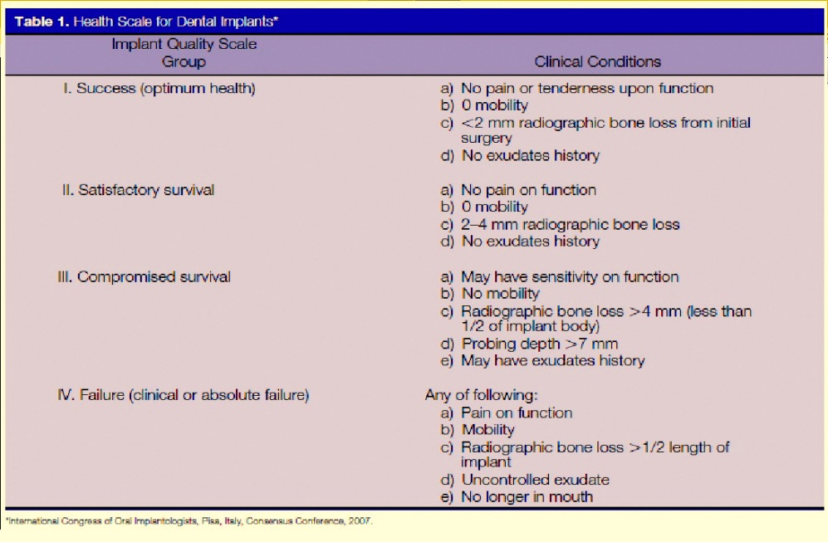

Now back to our question

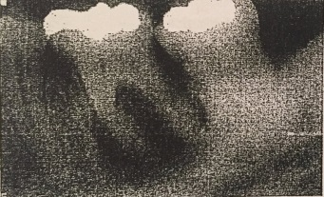
" which treatment option is superior ? "
The answer is : there is no significant difference in survival rate between both of them.
upon meta-analysis of the relative survival rates of single-tooth implants versus endodotically treated and restored natural teeth , they discover after 6 years : survival rate is 97% for both treatments.
So they conclude that: ( thedecision to treat a compromised tooth endodontically or replace it with an implant must be based on factors other than treatment outcome. (because there is no differences in treatment outcome for both )

Other factors to consider : →

- patient factors
1- Systemic and local health factors :
1. uncontrolled diabetes
2. smoking
3. bisphosphonates
4. osteoporosis
5. paget's disease of bone and all diseases of bone
6. bleeding disorders : when INR 4, 5 or higher
All these are contraindication in implant . #

2- age :
Implant placement should be postponed until after the growth spurt has ceased.
Implants placed in young patients are expected to serve for longer periods of time.

3- Patient concerns :
1. time and cost
2. potential for adverse outcomes
3. satisfaction with treatment ; some patients have bad history with endo treatment so he come and ask you to take out the tooth
4. fear of surgery

- tooth and periodontium related factors

- Pulpal and periodontal condition , restorability and treatment plan.
e.g.,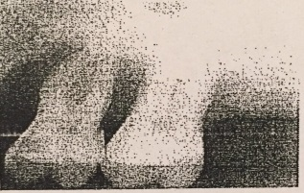
( showing no bone around the tooth , here we go for extraction and do sinus lifting that will give us up to 3-4 mm for bone grafting and then put an implant )

- Aesthetic zone
- Unique colour characteristics
- Soft tissue anatomy : when you have case with high smile line and thine gingival biotype you don't think of implant.

- Bone quantity and quality : the success rate of dental implants depends to a great extent on the volume and quality of the surrounding bone.
Bone quality is broken down into four groups:
Type 1 : homogeneous cortical bone
Type 2 : thick cortical bone with marrow cavity
Type 3 : thin cortical bone with dense trabecular bone of good strength.
Type 4 : very thin cortical bone with low density trabecular bone poor strength.
# the best site for dental implant is Ant. Mandible and the worstsite is the pos. maxilla .

- treatment related factors

- Procedural complications
- Hemorrhage and hematoma : when you prepare for implant and hit the lingual artery it will be life threatening .
- Neurosensory disturbances : paresthesia when you inter the inferior alveolar nerve .
- Injury to adjacent teeth
- Loss of implant or graft materials into the maxillary sinus

- Adjunctive procedures
- In endo we may need : 1. Crown lengthening 2. Post and core 3. Buildup and the a crown
- In implant : we may need : 1. Sinus lifting 2. Bone graft

- Maintenance : management of biomechanical failure and management of peri-implantitis and peri-mucositis ( plz refer to slide #44 " PIMI prognosis system " )

So implants or endodontic treatment?
Lets summarize these :
Contraindications for endodontic treatment | Indication for endodontic treatment
- In teeth that are unnecessary ( e.g.: don't have opposing )  - In teeth that are non-restorable.  - In teeth displaying severe periodontitis with extensive pocket depths.  - In teeth with severe injury to the roots and the alveolar ridge restorable ( e.g. : vertically fractured teeth ) | - Any tooth has value, functional, restorable and periodontally sound.  - In trauma cases where esthetic and arch stabilization are a concern.  - Patient with high risk medical conditions.

Indications for implants
- Teeth with non-restorable crowns
- Teeth with non-treatable periodontal conditions
- Teeth with unfavorable crown:root ratio.
- Teeth with unsalvageable resorptive defects
- The restorative treatment plan

Overall , you as a dentist you should work in the systematic way , starting with simplest options that you have .
here is the restorative failure cycle

Normal tooth

in case of caries or truma
we go for
Direct/indirect restoration

recurrent caries or fracture
Root canal treatment

failure
Surgical endodontics
Orthograde retreatment

failure
extraction

replacement with
implants
RPD
FPD
As a conclusion :
There is no competition between dental implants and endodontic treatment. Both options should be used to better serve the patient.
The final decision rests with the patient. The case presentation must include all treatment options, be presented in language the patient understands, show valid reasons as to which option is best, explain the procedure and how long it will take, identify the expected prognosis and estimate how much the treatment will cost THEN the patient decide what the best for him.

ان الذي رزقكالطموح سيعينكعلى تحقيقه ..~
طريقمعبد بالتوافيق جل ما اتمناه لكم

