Cons Sheet no. :10 for lec #11 (bcoz there was a lec for Dr.AWNI with no sheet)

Refer to slides no: no slides

Written by: Noura AL-Natour and Noor AL-Shakhatrh
Corrected by: Aseel AL-Ananzeh

Amalgam placement
Policy of our faculty says the we need to use Amalgam restorations!
*two sides of the story:
1-using Amalgam for (occlusal) compound cavities,
2-or for certain walls (by using matrix band)
*Jordan signed an agreement to stop using amalgam in the future, after ten years, and nowadays Dentists use for amalgam is reduced, or they use it but they follow the safety regulations of American dental association.
Even if the use of amalgam would disappear, we may have to remove it and the removal of it will produce more Mercury, (because when we drill amalgam, heat will generate and amalgam will crumble and this will release more mercury).

Armamentariums
1-hand instrument
2-basic examination set
Basic examination set
1-Dental (intraoral) Mirror
-two types:1-front side mirror 2-rear side mirror
*Front side mirror:
1-more expensive, when using it there will be no shadow generating. (the object and the shadow are almost touching each other no space between them and this is more comfortable for the eye and the object will be more obvious.(we you concentrate to see something especially if it is small, adaptation of the eye will occur so using this type is better for this purpose)
2-rear side mirror
1-it is cheaper, easily produced and similar to the mirrors that we use at home (our dental mirrors are rear side).
2-probe, sickle probe, periodontal probe
3- tweezers
4-amalgam carrier (was known as amalgam gun)
Misusing the amalgam carrier can lead to setting of the amalgam at the tip of the carrier and it will stick there so you cannot use the carrier again ( you have to load and unload the amalgam rapidly).
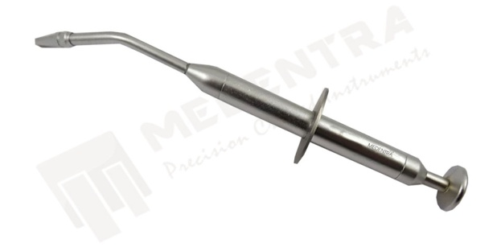

***5-dappen dish and triturator:
We use them for mixing of the amalgam.
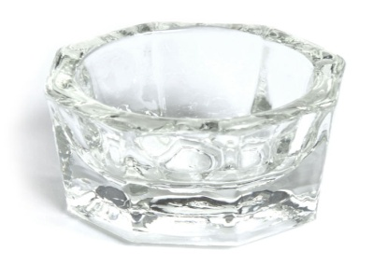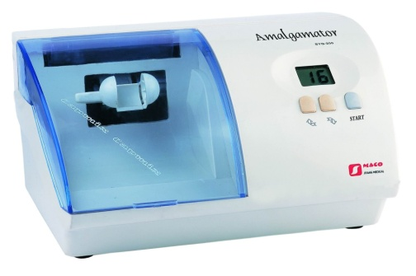
6-amalgam condenser:
Has a flat end and it could be double sided.
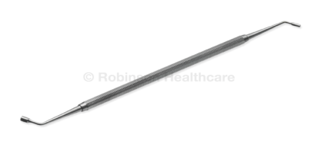
7-amalgam burnisher
it has an oval end, round tip side and other large side.
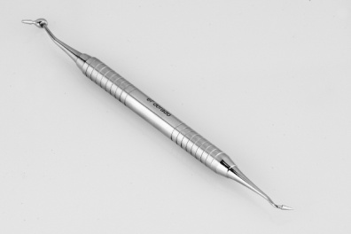
8-amalgam carver
It has a pointed end.
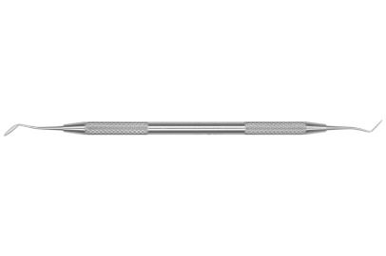
The previous instruments are used for classI restorations and for compound occlusal surfaces, for classII we also need a Tofflemire matrix retainer, a Tofflemire matrix band and a wedge ( the wedge could be plastic or wood).
According to the American Dental Association the best thing to use is precapsulated Amalgam ( with or without a plunger).
This capsule has two compartments that are separated by a membrane: one compartment contains the amalgam alloy "powder", and the other one contains mercury, (if we open the capsule before triturate the components the elementary mercury will spell on the floor so there are still some hazards when using mercury). In the past they were mixing a good amount in a mill and the hazards were more. DO NOT open the capsule before triturate the mixture.
If the capsule has a plunger, pushing the plunger will destroy the membrane between the two compartments. If there is no plunger, the membrane is thin and will be destroyed upon the trituration of the capsule.
capsule is put in the triturator (amalgamator) for 8-10 sec, and it has to be covered bcoz this machine has a very high speed (putting the capsule without covering it, the capsule will go out and hit you, your eye for example. Or it will fall on the floor and now you have to put a new capsule!)
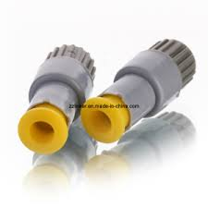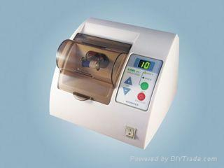

Amalgam for occlusal cavities:
After we finish the cavity preparation and it has a minimal depth so nothing is needed to be replaced below the amalgam or we can put a varnish layer ( the layer of the varnish is almost negligible and does not affect the depth of the cavity so no problem if you don’t put it inside the cavity ).We can also put a bonding agent and this is better specially in the cases of sensitivity.( different ppl have different thoughts, it depends).
Now if you have a deeper cavity you can put a base such as ( zinc phosphate cement , glass ionomer or modified glass ionomer )
In a very deep cavity we can use (calcium hydroxide or light cured calcium hydroxide)
In the cases of pulp exposure under sterile condition or under a rubber dam we can put MTA (mineral trioxide aggregate) it is just like a cement but sterile. we can also also use CaOH2 or bio Dentine for direct pulp capping but MTA is the best.
We also can use (Gluma) which is a desensitizer base, it is just like bonding agent (we will talk about it in composite fillings )
The mixed amalgam has a dull appearance it shouldn’t be very soft and shiny because if it was shiny this mean that we still have some unreacted mercury and this is bad for physical properties and for your own safety. It also does not have to be very hard bcoz this will prevent a good preparation.
There is what so called non contact amalgam which is the extra amalgam that’s outside the mouth " we should get rid of it and throw it in a special containers that contain a depleted fixer that we use in xrays ".
Contact amalgam : amalgam that’s located inside the patient's mouth .
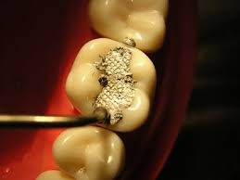

Here I loaded the mixture on the occlusal surface and I used a condenser to make a good condensation " the condenser size depends on the cavity's size "
1) we fill the cavity with the mixture of the amalgam.
2) precarving and burnishing by the small tip of the burnisher.
3) carving on the cuspal plane according to the anatomy of the natural tooth
4) final burnishing .
5) check the occlusion .
Note: In complete dentures we have to put the teeth in the centric relation (unrestrained most superior anterior position of the condyle in the glenoid fossa)
In dentate patients the complete denture balanced occlusion (maximal intercuspation) is in the centric relation or in the retruded contact position .
The maximum intercuspation in complete dentures must be 100% in the retruded contact position or the centric relation. In dentate patients the centric relation = centric occlusion "maximum intercuspation and retruded contact position are coincide in just 2 % of the population .
To check the occlusion : in 98% of patients we don’t check the retruded position we just order them to bite in the maximum intercuspation and this is called conformative approach and we can do it easily with the amalgam filling.we use conformative approach in 99.999% to make occlusal adjustment. the filling shouldn’t be too high to prevent the trauma that could happen bcoz of the force due to occlusal interference .
so we should confined for the occlusion by order the patient to bite in the maximum intercuspation and that’s done by an articulating paper it has two colors and its thickness is between 8 to 60 micron .

NOTES :
-we check the occlusion in 1)maximum intercuspation . 2) lateral movements .
- when the amalgam is initially set it is easier to carve it and remove the extra higher filling.
- the color of the amalgam is dull so if there is any extra high filling it will appear shiny upon biting bcoz mercury is released.
- the force on the anterior teeth ( 150 newton ).
- the force on the posterior teeth ( 500 newton ). The condenser only can generate 20 newton.
- if the amalgam is already set and the filling still high ideally you should repeat the filling . using rotary instruments on a newly set amalgam will destroy the amalgam.
- we can polish the amalgam but the doctor does not advise doing this because the amalgam will appear very shiny .

Proximal placement :
We do the application that we learned in the previous lecture .
In proximal cavities we must fill the box first not the occlusal cavity because filling the occlusal cavity first will make you not sure that the box is filled and the food will impede there and this will lead to caries .

Now to put amalgam :
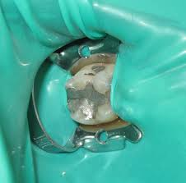
1) remove retainer .
2) slicing the matrix band .
3) remove widges .
4) carving the outer side of the marginal ridge (MO>> mesial side of marginal ridge, DO>> distal side of marginal ridge) by using a sickle probe
Or 45degree probe.The outer side of the marginal ridge should be parallel or on the same hetight of the marginal ridge of the adjacent tooth .
Note :
Occlusal stops are either cusp to fossa relationship or cusp to two marginal ridges relationship .
As we said we don’t want a very high or low filling .
If the filling was too low the food will be impeded inside the tooth so we use a proper probe that make the margins at the same level .

Guidelines of using amalgam restorations (placing or removing)

1-ADA and BDA do not ban using amalgam. Dentists won't use amalgam in 2019 but in Scandinavian states and some european contries they do not use at all. Some other contries are do not use it for pregnant ladies or children below 15 years old.

2-the Dentist should train his staff how to use amalgam.
3-remove your professional clothing before leaving the surgery.
The office should be well ventilated.
3 forms of mercury, vapor, organic ( methyl or ethyl) and inorganic. you have to use a proper work area design.

Mercury Spells
1-never use household cleaning products and particular containing ammonia and chlorine.
2-never use vacuum cleaners.
3- get rid of mercury in amalgam separate then to recycle unit.

Writing this sheet was really annoying. Sorry for any mistakes!
written by: NOURA NATOUR and NOOR GHALEB
Corrected by: ASEEL AL ANANZEH.

