Sheet number: 3
Refer to Dr Alaa’ Sabra’s Adhesion slides
Written by : Ibrahim Khatib
Corrected by : Areen Afghani

Conservative dentistry sheet 3
Esthetic dentistry uses composite as a restorative material and relies on adhesives.
Dental adhesives are the most important foundation in esthetic dentistry.
Benefits of dental adhesives:
1- Conservation of sound tooth structure. Unlike when amalgam is used which requires excessive cutting in order to create retention.
2- Optimal retention is achieved with adhesion without cutting.
3- Marginal leakage is prevented (amalgam has a gap) not 100% though.
4- The foundation for minimally invasive dental therapy (The basis of Conservative dentistry)

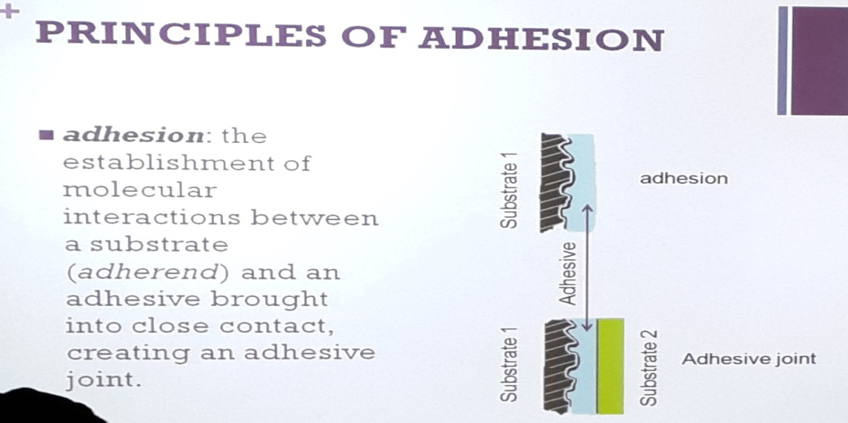
- Surfaces that we wish to attach an object to are known as substrates (e.g. dentine). The adhesive usually is a liquid which creates a bond between two surfaces. If we have only one surface and an adhesive, it is called “adhesion” only. If we have two surfaces and an adhesive, this is known as an “adhesive joint”.

In dentistry, most cases are adhesive joints. The adhesive is an intermediate layer between the two surfaces. ( I’m trying to connect a restoration with a tooth structure)
The principle of adhesion depends on the “wetting”. The wetting phenomena is a property of liquids, it is the amount of spreading a liquid undergoes when dropped on a solid surface.
For example, when placing a drop of water of enamel, does the water droplet remain shaped like a droplet or does it spread?
Mercury is a difficult substance to handle and maintains its shape when placed on a solid surface (low wetting).
Wetting is a very important factor in adhesion. Another important factor is the contact angle. The contact angle is a measurement of wetting; we can use a device to measure it which will measure the angle between a liquid and a solid surface.
If the angle is more than 90 degrees, then the fluid did not spread on the surface. If it is less than 90 degrees, then the fluid is spreading well on the surface.
Another indication is the surface roughness, as the roughness increases; the wetting effect is enhanced as this gives a larger surface area for the fluid to spread on.
Viscosity determines the flow of the material, as viscosity increases; the material becomes less able to flow and spreads less (honey). Meanwhile water which has a low viscosity can flow easily.
Good wetting promotes capillary penetration and adhesion and indicates strong attraction between the liquid and solid surface molecules.
Good wetting makes penetration easier.

Acid etching results in gaps in the dentine and enamel, I want my adhesive to penetrate those gaps, and therefore wetting is the most important property concerning adhesives.
Requirements of forming a good adhesive joint:
1- Good adherend (surface requiring bonding must be clean and able to bond)
Surface energy: Atoms which are already bonded have a low surface energy, whilst atoms with free surfaces have a high surface energy. Atoms with a high surface energy can form bonds more easily. So in order to have good adherence, the atoms should have a high surface energy. Enamel and dentine have a good surface energy while materials such as Teflon and wax have a low surface energy.
2- Good wetting (good spreading of adhesive on surface)
3- Intimate adaptation (adhesive should be in close proximity with the enamel or dentine).
4-Bonding: Chemical (covalent or ionic), physical (friction, some atoms from one surface will attract other atoms from another surface but without a chemical bond), or mechanical (material enters holes, capillaries and gaps such as with amalgam). As bonding increases, adhesion becomes better. There are materials in dentistry which form chemical bonds such as glass ionomers. (Only material that forms bonds)
5- Good curing: After applying the adhesive, it must set in order to change state from fluid to solid.
There are 3 types of adhesive bonds:
1-Mechanical.
2- Chemical (glass ionomer ONLY).
3-Interpenetration (diffusion).
We will rely on these 3 types in adhesion.

Chemical is further divided into primary and secondary valence forces.
Primary are the ionic, covalent, and metallic bonds.
Ionic includes exchanging electrons, covalent includes sharing electrons, and metallic is bonding within the metals.
Secondary valence forces are the van der waal forces.
Mechanical usually we depend on microscopic penetration, and it is most prominent after acid etching.
Diffusion is very important, with better wetting comes better diffusion which also enhances bonding.
In dentistry, true chemical bonding between the tooth structure and restorative material is very difficult to achieve (except in glass ionomer), because of the complex composition of some substrates such as dentine (not homogenous, contains organic and non organic parts), the presence of contaminants, and the presence of water.
Goal of adhesion: Inhibit marginal leakage, otherwise:
Penetration of fluids, microorganisms, and debris resulting in secondary caries, staining of the tooth structure and sensitivity (due to exposure of dentinal tubules to fluids).
Michael Buonocore is the father of adhesives. He used 85% phosphoric acid on the tooth structure, tried acrylic resins and discovered resin tags (resin entering the irregularities in the enamel, and thus invented acid etching).
Steps in bonding to the tooth structure:

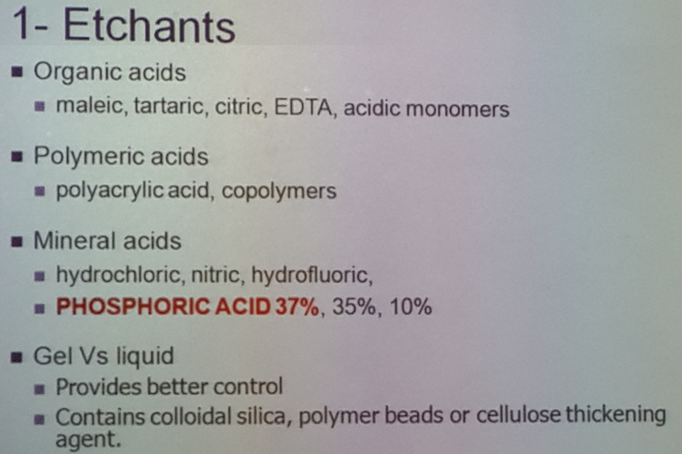
Phosphoric acid is the most common acid etch.
Polyacrylic acid is most widely used with Glass Ionomers.
Each acid works best at a separate surface.
Fluid spreads very easily and therefore is harder to control, Gel gives you better control.(usually thickeners are added to Gels)

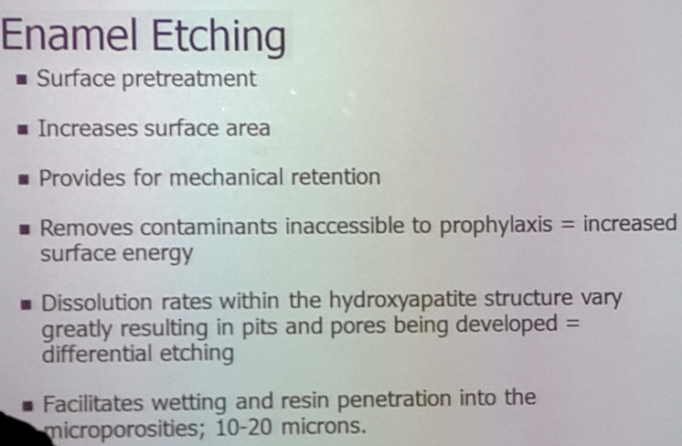
-Increases surface area,by increasing the irregularities.
-It removes contaminants inaccessible to prophylaxis and so increases surface energy because it removes all contaminants thus increasing the irregularities.

Differential etching: some areas undergo more etching than others depending on their chemical content. Central area has more prisms = undergoes more etching.
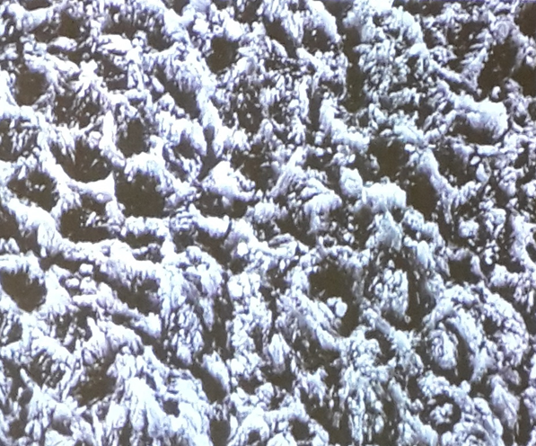

Dentine Etching
Composition is Heterogeneous
<70% inorganic hydroxyapatite.
>20% organic (mainly type 1 collagen).
10% fluid.
Smear layer from mechanical preparation.
Dentinal Tubules (0.5 – 1.5 mm in diameter) supply a continuous flow to the surface. These tubules arises from the pulp’s surface and reach the DEJ.
Due to this continuous flow of water, the surface must be dried well before applying the adhesive.
85% phosphoric acid damages the dentine extensively and therefore in 1978, a scientist s named Fusayama suggested using 37% phosphoric acid on the enamel and dentine. This improved the restoration’s retention, and did not increase the frequency of pulpal damage. This “total etch” technique has been widely accepted since the 1990’s.Total etch is enough to create the retention that we need.

In the Dentine:
Etchants are stronger acids that remove 1-the smear layer and plugs and removes significant amounts of 2- mineralized tissue (hydroxyapatite) 3-leaving an exposed collagen network.
In the enamel the collagen is present in very tiny amounts and therefore a network is not exposed, whilst in dentine it is present in higher amounts.
In the enamel etching only removes part of the hydroxyapatite.

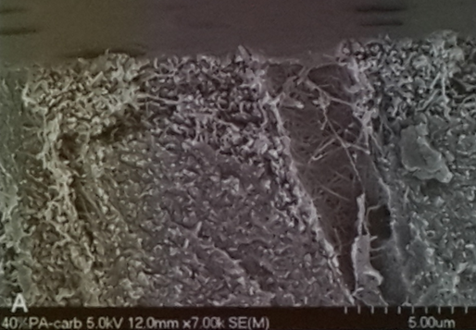
This image shows part of the dentinal tubules, the material between the tubules is mineralized tissue (hydroxyapatite).
The strings shown are collagen.

Technique:
Application time will vary with the condition of the tooth.
Most teeth are adequately etched with in 15 seconds of acid exposure (unless we have fluorosis or primary dentition)
Deciduous teeth and teeth with fluorosis require longer times: 2X (30 seconds)
Deciduous are harder to etch due to their different orientation of prisms.
Rinse thoroughly for 15 seconds with water
Prevent contamination by saliva/ blood/oil or water in compressed air
Contamination requires re-etching for 10 seconds.

If etching enamel only, we can use air for drying.
With dentine, we don’t use air to dry. (Acid etching exposes collagen, using air to dry the dentine will cause the exposed collagen to collapse we lose the irregularities vthat I wanted to use for bonding)
Use cotton pellets to dry dentine.
After we finish etching we apply the bonding agent.
Bonding agent
- The adhesive usually becomes hydrophobic such as dimethacrylate oligomers (bis-GMA / TEGDMA)
- It also contains and initiator / activator which determines the setting reaction (light cure/ dual cure)
- Fillers (up to 40%): Gives the material its thickness, making its application easier.
- Flouride
- Antimicrobials
- Glutaraldehyde

Since it is hydrophobic, it is not used when dentine is involved.
Mostly used in orthodontic applications.
Mechanism:Enamel Bonding agent alone is only used in orthodontic applications. Bonding to enamel occurs by micromechanical retention after acid etching. Fluid adhesive constituents penetrate into the newly produced surface irregularities and become locked into place after polymerization of the adhesive.

In restorative dentistry, the material to be used must function on all surfaces including Enamel, Dentine; all variants of dentine whether it was young and permeable or sclerotic ,(in old patients dentinal tubules are occluded) so the restorative material to be used or the adhesive resin must work on all these. This is why they modified the dentine bonding agents.
In order to overcome the problem of the hydrophobic bonding agent, a primer was used. (Due to the high water content in the dentine).
Primer: a hydrophilic monomer used before the bonding agent. The primers hydrophilic components (HEMA) can wet dentine and penetrates its structure; it can also stabilize collagen and facilitate the penetration of the bonding resins.
The primer is present in a solvent (acetone, ethanol-water, primarily water)

Hydrophilic monomer HEMA / BPDM
Acidic monomer in self etching carboxylic acid or methacrylated phosphates
“Further explanation: I have the dentine which is hydrophilic I have to add to it a hydrophilic material and this hydrophilic material which is the primer must be able to bond with a hydrophobic material”

Hybridization of dentine
1- The acid demineralizes the dentine
2- The collagen fibers are exposed
3- Hydrophilic resins infiltrate the collagen
4- The bonding agent must be hydrophilic and hydrophobic
Hybrid zone: a layer of dentine that contains resin, produced by etching and resin diffusion. (Resin will enter the demineralized part, forming a hybrid layer between the resin and dentine)
Hybrid Layer: is composed of the adhesive and the collagen extensions and the irregularities.
With the total etch technique, both enamel and dentine undergo etching at the same concentration of phosphoric acid, therefore the enamel-dentine adhesive was developed. (hydrophilic/hydrophobic adhesive system for both enamel and dentine).

