Title of Lecture: class 2 cavity preparation
Date of Lecture: 16/11/2014

Sheet #8
Written by : ghaidaa abuzahra &ohood attef
Corrected by: Jumana Kussad

1st part :ghaidaa abuzahra
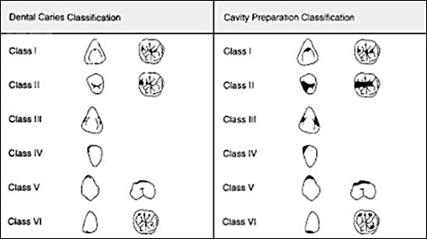

Class 1 :the caries in pits and fissures ( most susceptible area for caries ) Class 2 : the caries on proximal surface (second susceptible area for caries, common in those who brush their teeth without flossing ) this area under the contact point in proximal surface
We cant detect it by naked eye clinically except if :
Demineralization already proceeded >> there is shading under tooth structure
Otherwise these hidden caries appear only in radiograph
General outline of class 2 :box shape with an occlusal extention
All cavity design features of class 1 should be applied to the occlusal extention in class 2
Isthmus
Isthmus connection between class 1(pits and fissures )and class2 (proximal area )
Isthmus must be rounded and narrow to avoid fracture of amalgam
-Rounded(beveled) : to avoid stress concentration
-narrow :to give strong bulk structure not wider than ¼ intercuspal distance
Example: if the distance between cusp-cusp is 10mm, the isthmus = ¼*10= 2.5mm
we have to be conservative, because whatever the material I have its not better than the tooth structure ( therefore it must not be wider than ¼ of the intercuspal distance )
amalgam doesn’t need the width but need the depth
we will take the strength of amalgam from cavity depth
the narrower the deeper is better / the wider the shallower is worse
*start with class 1, then go to class 2 with same principles of class 1
note: Follow the caries (don’t extend all fissures in occlusal surface unless it contains caries – no need to make full class 1 if there is no caries )
*where should class 2 be ended ??
Only we break the contact area with adjacent teeth ( just make 0.5mm a space between the teeth so the tip of explorer can pass). That's because contact area is difficult to clean, and if the filling ends there it will be susceptible to secondary caries. Therefore is must end at an area free of contact.

Tooth –amalgam –tooth

No contact area between 2 adjacent teeth ( so the amalgam can set )

If there is contact point ( the area will suffer from sec . caries )

note:
the angle of facial wall with external tooth surface =90 degree "butt joint"
lingual wall –external tooth surface =90 degree "butt joint"
gingival wall – external tooth surface =90degree "butt joint

from occlusal view: The Reverse curve
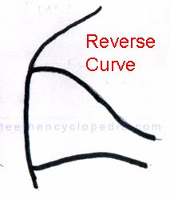
In lower teeth the buccal cusp is the functional cusp and its presence is very important. To preserve the buccal cusp as possible as we do: reverse curve.
Reverse curve: smooth continuous curve on the buccal wall that joins the narrow occlusal isthmus with wider proximal box .
**The reverse curve for buccal wall not for lingual.
Because the contact area is buccal so if we break the contact area more buccaly the buccal/functional cusp will be lost not conservative
** also by the reverse curve we maintain the parallelism between the buccal wall and the lingual wall
from the mesial view:
Lingual wall of proximal box is parallel to the long axis of tooth
Buccal –facial wall approximately parallel to the long axis with slight converging, why?? Because the nature of buccal wall is converging so the buccal wall must be parallel to the long axis with slight converging .

- External of facial wall +gingival floor +lingual wall +isthmus +line angle of facio-gingival +line angle of lingulo-gingival angle
↓
Must be smoothened ( by using the hatchet )
Also we can use white bur for finishing and smoothing.
Yet, if we use other burs we will remove and cut part of tooth structure by mistake, it will weaken the tooth .
** hatchet is better to use than burs because it doesn’t remove any tooth structure – we do just rubbing motion to remove undermined enamel.
Isthmus and line angles must be rounded ? to avoid any force concentrations
Axiopulpal line angle (isthmus) is beveled
when we do the class 2 cavity preparation we are afraid of destroying the adjacent tooth to avoid that we do thinning for MR (marginal ridge) then use hatchet to remove the lipping of enamel (unsupported enamel)
-The floor must flat; perpendicular to the long axis.
-The axiopulpal line angle is beveled
- any unsupported enamel is removed from the gingivo-cavo surface
**Cavity preparation objectives
include all caries ,fault or existing restorative materials
the extention of dovetail must be within the ideal measurements
We don’t change or increase these measurements except if the old restorative materials OR the extension of caries is more than the ideal measurements .
For eg : we cut only 1.5mm from enamel and dentine but if there is deep caries that extend more than 1.5mm I use slow round big bur to drill only in the deep caries area
*create 90 degree cavosurface angle
* ideally axial wall must be concave following the faciolingual curvature of th tooth , not convex
Retentive grooves
Any amalgam restoration need a retentive grooves
*the retentive grooves exist on lingulo-axial & facio-axial line angles
(these grooves are in dentine only )
- to do it we Using small round bur down to up (gingivally to occlusally)
*Base of groove(down) is deeper in the dentine the apex of the groove(up)
-fades as we go up
-must not cross the axio-pulpal line angle
- must be exactly on the lingulo and facio Axial line angle (not wider)
Sec. part : Ohood Attef
*The measurements of ideal class 2 : 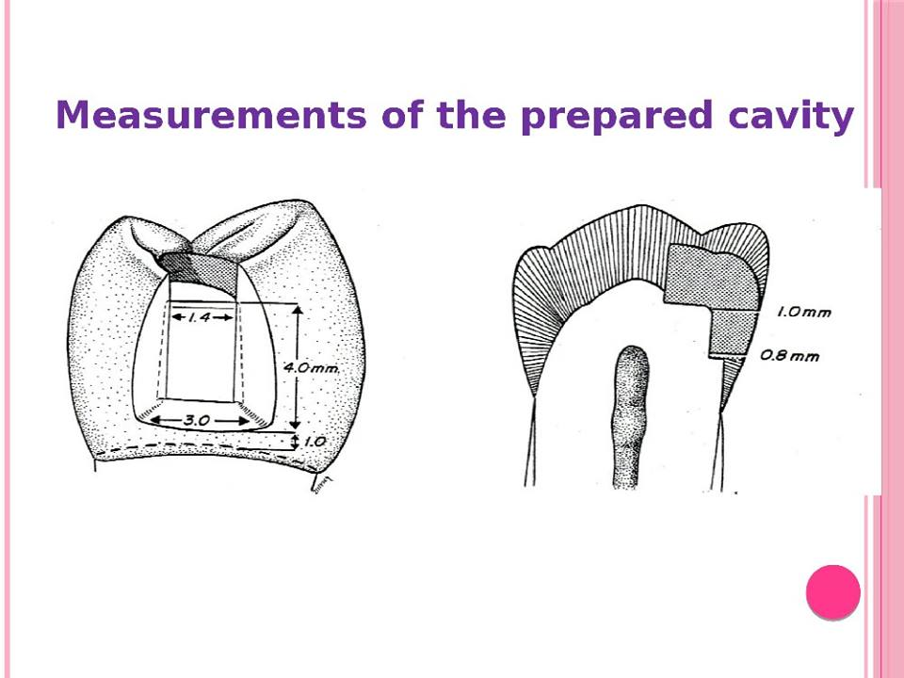
- The isthmus width shouldn’t be exceed 1.5 mm .

- The Dimension of the gingival floor should be between 1 & 1.5 mm far from gingival margin/CEJ
*From this I can guarantee :
That the preparation descended the contact area and now it’s on a cleansable area and in the same time it’s not so deep .

- The width of the box must be 3 to 3.5 mm but the length is about
4 mm .

- The of the gingival floor must be 1mm when seen from occlusal view (from the tooth surface to the axial wall)
**these measurements are estimated by the dentist as he works
------------------------------------------------------------------------------------
we must use the articulating paper to record the occlusal contact of opposite tooth before drilling or filling, why ??
To determine the occluding area and the occluding facet to avoid the filing material to meet the tooth at that area.
No matter what’s the caries you have, modify the margin so that it either contains only filling material or only tooth structure , but not both! why ??
Because the wear resistance of filling material and tooth enamel is different , and If the occlusal forces are applied on area which has tooth structure and filling (amalgam or composite ) it well wear at different rate than tooth structure and will eventually lead to marginal leakage,
yet if it was just against filling or tooth structure there won't be a problem .
Now after you finish your first class or the dovetail then reach the marginal ridge we don’t open it, we stop before the marginal ridge by about 0.5mm to be able to make class 2, without opening the marginal ridge to preserve the neighboring tooth.
Then when we are done with class 2, we start thinning using the burr and then remove it by using the hatchet .
My bur must be stop on the centre of the contact area then it start to down Gradually .( the long axis of the bur and the long axis of the tooth crown should remain parallel during the cutting procedure)).
#As you go down, and the bur is half in the dentine half in the enamel, hold the bur against the enamel (because its harder) rather than the dentine, while pendulating the bur facially and lingually.
#the most important thing when you make class 2 you should check the direction of the bur which must be parallel to the long axis of the tooth all the time .
#we make smoothening for all wall and remove any excess and we make the foundation by use the hatchet ..
#to make grooves we use small round bur on line angles on faciao-axial line angle and lingualo-axial line angle ..
#Resistance & retention form in class 2
what the different between resistance and the retention ??
Retention: avoid the dislodgement of material against any occlusal forces
Resistance : avoid the dislodgement of material against any others forces than the occlusal forces ( lateral forces , oblique forces .. etc ).
#the factors that give resistance are :
1)the pulpal and gingival walls are flat and perpendicular to forces directed with the long axial of the tooth .
2)conserve tooth structure & cusps which gives more resistance .
3)restricting the occlusal outline form to the areas receiving minimal occlusal contact .
4) the reverse curve optimizing the strength of both amalgam and tooth structure at the junction of the occlusal step and proximal pox .
5)rounding internal line angles to reduce stress concentration in the tooth structure .
6) providing enough thickness of restorative material to prevent its fracture under mastication .
#the factors that give retention are:
1)occlusal convergence of buccal and lingual walls of the occlusal and proximal exensions .( in class 1 & 2 )
2)dovetail design of the occlusal outline .
3)retention looks or grooves.
**special considerations (restricted due to tooth anatomy) :
- Mandibular 1st premolar :
1)It is slightly tilted tooth, and I flow the long axis of tooth structure
so my floor ends up slightly tilted .
2) very important in all premolars to preserve the transverse ridge and in oblique ridge in maxillary molar . if It's not necessary to open I don’t open.
if I have mesial and distal caries without caries on transverse ridge > I just open mesial alone and distal alone without breaking the ridge.
- Maxillary 1st molar:
- conserve the oblique ridge
-modify according to the situation you have for example :
- you may have class 2 and class 1 and palatal extension ..
- you may have the oblique ridge intact so you don’t open it and just do a dovetail alone.
- you may have class 1 with buccal extension without oblique ridge caries .

- Maxillary 1st premolar :
The maxillary 1st premolar when you smile it’s appear clearly
So try to make the buccal wall near to contact area to make the amalgam hidden and not show.
And if you can make the premolar without dovetail it’s even better ((like box shape>> class 2 only ))
Here, in box-only prep, because we don’t make the dovetail, the retention grooves are extended up to the end, and when we look occlusally, we see the grooves, since there is no class 1 floor. Unlike when we have dovetail the grooves end before they reach the floor of class 1 cavity .
(( the retention is affected but we try to balance between retention and aesthetics )) .
So I make the grooves and the converging walls (to maintain retention) without the dovetail ( to maintain esthetics)
**The MOD : it’s the same but one from the mesial and one from the distal opened on each other.

written by: Ghida’a abu Zahra & Ohood Atef
Corrected by: Jumana Kussad
**Best of luck

