occlusal radiography : we use large films so it show more structures and it considers a supplementary, it is either maxillary or mandibular there is no bitewing here
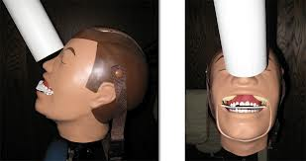
There is subtypes of the occlusal radiographs :
1-cross sectional: the rays are perpendicular on the film
2- topographical : the rays are not perpendicular and the are sensitive to the anatomy which may interfere with some structures
the maxilla can only be radiographed by topographical and not cross sectional because if we want to take a cross sectional at 90 degree there will be many structures in the image and this doesn't make sense
we usually use occlusal radiograpghs when we look for something big like cyst , trauma ,fractures or stones in the salivary glands
