Sheet no. 1 - 30/9/2015
Doctor : Mohammad Rababa’a
Written & corrected by : Ala’a Bashir & Haneen Alkhateeb ♥
ـــــــــــــــــــــــــــــــــــــــــــــــــــــــــــــــــــــــــــــــــــــــــــ
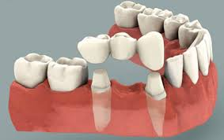
In this course we will discuss the fixed prosthodontics which is
known as crowns and bridges .
In this lecture we are going to discuss general terms and ideas ^_^
- The doctor mentioned that we should Study for this lecture from chapter 1 and 3 in
( Contemporary Fixed Prosthodontics) book.
Composite and amalgam can replace missing tooth structure but if we have a missing tooth “ due to extraction or trauma etc.. “ we can’t replace it with them . So we need a material that can withstand force to replace this tooth such as Ceramic or Metal .
- Fixed dental prosthesis: it’s any dental prosthesis that is luted ( cemented ; we bring a material in a flowy stage and we put it inside the crown ) or we screw it ( ben7ot bor3’i ) or mechanically attached ( this way is used more in implants than in crowns and bridges ) .
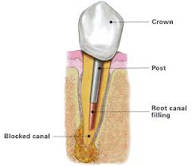
-Retention : We need these crowns to be stable and supported so we basically need retention , Cement, screw or mechanical attachment are used for crowns retention , post is needed for root retention .
“ check the inserted pictures “
In the last year sheet these information were written but the doctor didn’t mention them this time , but no harm to read them ^_^
**Retention method in composite is by micromechanical retention (etching and bonding ).
**Retention method in amalgam is by mechanical method by preparing convergent walls.
**While for indirect restoration or fixed prothodontics is by luting,screwing or mechanical (by friction). We can’t do these restoration inside the patient mouth. We do mold from patient mouth and gypsum model .
**There is a resistance form for amalgam restoration,that’s why cavity depth for amalgam is at least 1.5 mm otherwise it will break .
**Amalgam compared to other metals is brittle but compared to ceramics its brittleness is less .
**The crowns should have support, they are either attached to natural tooth structure or dental implants.

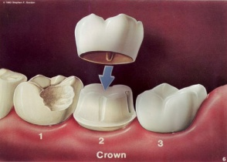

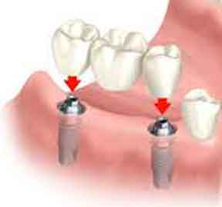

We can replace one tooth , two , three or even full arch , we usually don’t replace the wisdoms cause they are not that much needed , so mainly we make crowns from centrals to first molar . but nowadays we have some dentists that make crowns for the wisdoms too to earn more money from the patient but its not much needed anyway .
Usually patients come with missing teeth in the mandible more than the maxilla that’s due to not having enough primary support areas as the maxilla .
An edentulous patient can’t eat all kinds of food because we can’t give them a 100% chewing ability , we only can give them 50% and this is a major problem for these patients & they also look more like plastic teeth , that’s why we prefer having crowns than a denture , it goes the same way with veneers ; they give a better esthetic appearance .
“ In order to make crowns we should know the dimensions of the teeth , so we have to memorize them all over again “
- 1 of 10 of the prepared teeth for crowns and bridges will go under irreversible pulpitis changes , which means it will need RCT , so do we need to make RCT for all of them before preparing ? the answer is NO , we try to maximize the possibility of retaining pulp health and with time if a tooth needed RCT we remove the crown and make RCT and we put the crown back .

- The doctor then started showing some pictures and he mentioned some important informations that we should take in consideration ;
- the main disadvantages when we do crown preparation, we remove( 50-60%) or even more of the volume of the crown “ we are going to learn how in the lab “
- we prepare the teeth to be convergent so we can have a place to put the cement on.
- we have two materials, inner material that has to be strong (metal or high solid ceramics) to withstand the forces and an outer material ( ceramic ) which is more esthetic but weaker so it does have a fracture rate .
- You have to keep in your mind that there is nothing called permanent restorations because nothing is permanent in the whole life , it’s better to call it definitive restoration .
- Lets assume that we have missing upper right 5 and we want to make a bridge , we need to have something positioned on 4 and 6 that will hold the 5 we made , we call the 5 pontic , 4 and 6 “the natural ones “ are called retainers and the joints between them are called connectors .
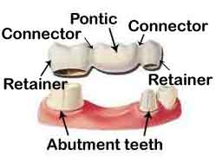
Here is another example in this picture ;

- The doctor mentioned names of types of bridges : “ I used google to write extra informations about them , don’t worry you don’t have to know them now , he said we will take them in details later .
There are different types of dental bridges, which include:
- Traditional fixed bridge
- Maryland bridge
- Cantilever bridge
A traditional fixed bridge is comprised of a false tooth (known as a pontic) which is fused to two crowns. Traditional fixed bridges are anchored by the neighbouring teeth and can also be supported by dental implants.
A Maryland bridge is often used to replace a missing front tooth and is anchored to the teeth on either side of the gap using metal bands. This type of bridge is used when the neighbouring teeth are strong and healthy.
A cantilever bridge is used when there are healthy teeth on one side of the gap. The bridge is anchored by one or two healthy teeth on one side of the missing tooth.

- It’s always about treatment planning in dentistry , you have to know very well what tooth needs to be extracted , what tooth can handle a crown , when do we need to place a crown ; We should determine that on enough good informations , we should diagnose the patient very well to know that .
The first question we should ask ourselves is this tooth restorable or not ?!
if Not ; extract it .
if it is , does it need RCT ? simple restoration works ? do we have enough retention ? do we need post ? Is there enough tooth structure for direct restoration material? etc ..
So again its always about planning ;)

The doctor then placed a chart for planning but he didn’t give us the slides , “ I took this from the last year one “ ;
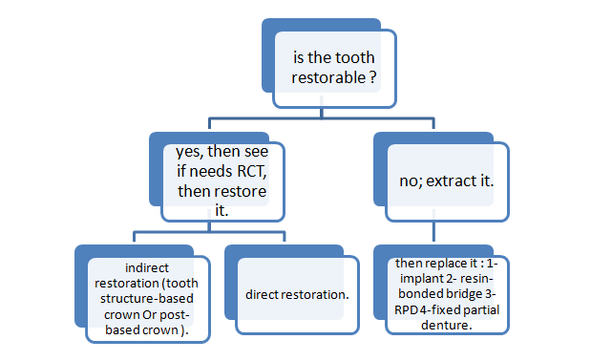
- Now lets talk about Support ; it is either from the tooth structure itself or if there is no enough tooth structure we need a post that can be gold post or fiber post , or support by implant if the tooth is extracted .. life expectancy for a tooth structure-based crown is more than a post-based one.
- We can have metal crowns , ceramic crowns , porcelain fused to metal crowns ; their prices and strength varies ofcourse “ we’ll talk about them later “ .
- We should show the patient the final look of his teeth before we end up the treatment , nowadays we have digital system that can show him the final result before even starting the treatment .
- We should consult the patient before doing anything , its prefer to have it written and to have the patient’s signature on it .

- The doctor then showed some before/after pictures for some patients ..
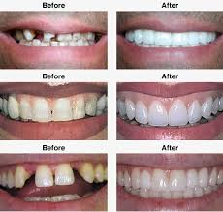
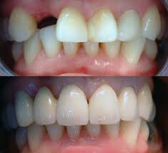

_____________________________________________

Always tell yourself I can & I will nshallah ♥

