Subject: Crowns and Bridges
Sheet no : 3
Date: 14/10/2015
Written by: Leen Musharbash
Corrected by: Tala Ghishan
Reference: Chapter 8 from Contemporary Fixed Prosthodontics

- Few notes on cross infection control:
- Do not move your mask while wearing the gloves you are using to examine the patient.
- Never do a class II cavity without a matrix band even if there is no adjacent tooth. Use a matrix band for a composite filling as well to ensure condensation and therefore prevent any entrapment of voids.

- Complete/full cast coverage/full metal restoration:
-simplest form of preparation.
- the material used is either silver alloy or gold alloy.
- silver alloy is cheaper
-gold alloy is more expensive; however its pour is of better quality and the burnishing of the margins of the end product is better, this is because the preparation for a gold restoration is minimal.
- The following is a photo of a complete gold restoration, a porcelain jacket, and a full porcelain restoration.
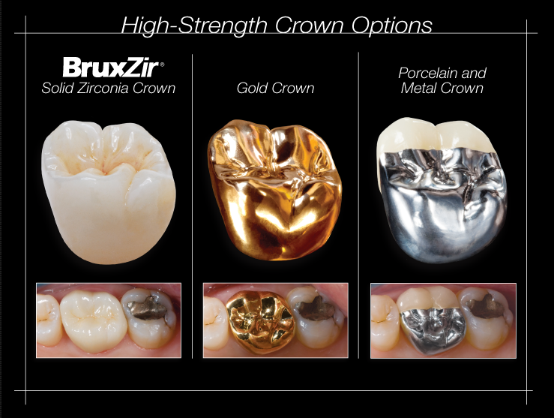
- Indications for a complete cast restoration:
- Extensive destruction/trauma to a tooth
- Endodontically treated teeth
- Replacing an existing restoration due to caries for example
- Necessity for maximum retention and strength and hence minimal reduction of the tooth
Note: we can only achieve a minimum reduction of the tooth structure when constructing a complete cusp restoration since the metal thickness is thin.
- Porcelain fused to metal involves both the metal and the porcelain thickness so the amount of tooth removed during preparation is more.
- RPD; on short clinical crowns or when high displacement forces are anticipated, such as for the retainer of a long span fixed dental prothesis, grooves should be included as additional retentive features.
- An over erupted tooth might need reduction if I want to construct an RPD or a fixed bridge to restore the occlusal plane.

- Contraindications for a complete cast restoration:
- Do not use metal restoration in an aesthetic zone(5 to 5 usually, sometimes to the mesial side of 6)
- If we need less retention (more preparation), we use porcelain instead.

- Advantages of a complete cast/crown restoration:
- Metal is a strong material and will not chip upon biting (porcelain might chip)
- High retentive quality due to minimum preparation/reduction. (a larger surface area providing good retention).
- Easy to obtain an adequate resistance form which will prevent de-bonding or rotation of the crown.
- Modifying the form of occlusion; since reduction is always greater occlusally than the axially.
Notes:
-when finishing an amalgam restoration one should use white stone then green stone then white stone then rubber/silicone tips.
- to modify a crown form one should use diamond bur then green stone then white stone and finally rubber tip for polishing.

- Disdvantages of a complete cast/crown restoration:
- Removal of large amount of tooth structure ( regardless of the type of restoration, preparation of the tooth is needed)
- Because of the proximity of the margin to the gingiva; it is not uncommon to see inflammation of gingival tissues.
Note: Nickel is common to cause discoloration of the gingiva (more in females) due to abfraction, this usually occurs when the finish line sits on a restoration causing secondary caries. The finish line should always sit on sound tooth structure.
- Cannot perform a vitality test.
Note: vitality test could be done on an onlay/inlay since they are partial crown restorations
- Aesthetics

Notes:
-wheel bur is thought to be used on lingual surfaces of anterior teeth, however the ideal bur used for the lingual surfaces of anterior teeth is the flame shaped diamond bur.
- In general, the bite force is greater in men than in females. It is measured by the unit Newton, every 10 N = 1Kg, Average bite of a female= 300, while in males=400 this is important when considering a high restoration which might cause a periapical lesion due to the huge amount of force applied on the root of the tooth while chewing. This problem is resolved by adjusting the height of the restoration.
- the doctor recommends the deep chamfer bur for preparation of the finish line since it gives a rounded angle between the axial wall and the margin and this minimizes the stress on the tooth. However a shoulder bur could be used for preparation.
- types of burs: rounded chamfer, needle diamond, parallel sided chamfer(gives a wider finish line)
- The needle bur is used on the proximal side, typically, if the proper cervical placement of the margin has been selected with proper axial alignment of the instrument, a lip of tooth enamel is maintained between the diamond and the adjacent
tooth that protects it from any damage.
- Coarse and fine burs are used for lingual surfaces for anteriors and occlusal surfaces for premolars and molars.
- Finishing of the preparation is important to avoid the entrapment of the wash (light body) in the micro spaces on the axial walls while taking an impression and hence avoid microtearing.

Preparation:
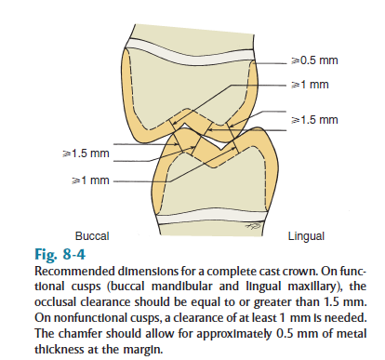

- While for a porcelain restoration we need 0.7mm for metal and another 0.5 mm for porcelain.
-Taper of the bur during preparation should be 6 degrees. Clinically this is impossible, so upon research they discovered that good retention is achieved with a taper up to 20 degrees. A taper of more than 20 degrees will result in debonding due to poor retention.
-Ideal taper degree differs from source to source, this is because it is based on experiments of applying a dislodging force to crowns with different tapers.
- Always start occlusally/incisally. Why? Because the length of the cutting shaft is not always the same height as the tooth, so for the bur to reach the length needed axially, we always start with occlusal reduction.
- Always start with guiding grooves and then link them together.
- Ensure you have round angles.
- Resistance form: the shorter the preparation the less the resistance, and hence dislodgement of the crown upon lateral movement of the mandible.
-Age: you have to take it into consideration the age to estimate the position of the pulp horns and avoid pulp exposure during preparation especially with axial reduction.
- The doctor showed sketches of different finish lines (chamfer, deep chamfer and shoulder).
-Note: deep chamfer is like shoulder but with rounded corners.
- Biological width’s importance in crown prep (cervically) will be discussed next lecture.

