Sheet no. : 11
Refer to slide no. : 8
Written by: Eathar Usama
Corrected by: Ayyan Abu Hawash
“Communication Skills and Motivational Interviewing”

COMMUNICATION SKILLS:
      - Communication skills: is the ability to use language and express information, which is present in sociable people. Communication requires a sender, a message, a medium and a recipient.

- Public and practicing dentists considered communication as 1 of the top 3 most important factors in delivery of dental care.

- Why do we communicate?
70% of the medical issues are caused by misunderstanding or communication problems. So it’s really important to know what to say, when to say it and how to say it.

- American dental education association (ADEA) outlined competencies for communication skills which makes us realize how far off we are from the rest of the world.

- Goals of communication:
- To get and give information; ask about history, pain, habits, and chief complaint
- To persuade the patient; to quit smoking for example, or to learn sth new
- To ensure understanding
- To get action
- To change behavior, which is the ultimate goal

- Communication pathways:
- Verbal communication- the words we choose, whether they make sense or not
- Nonverbal Messages - our body language, for example Greeks and Arabs are very body expressive, which is a good thing in dentistry
- Para verbal Messages - how we say the words, using the right tone, pitch, word stress

- Verbal communication
You have to choose your words carefully, because they might be used against you. Try to be organized. Use the right words to make information understandable at the patients’ point of view, use metaphors and analogies if needed, this doesn’t mean that you’re superior to them.
Effective Verbal Messages:
- Are brief, succinct, and organized.
- Are free of jargon (jargon: words that are used in our profession and difficult for others to understand)
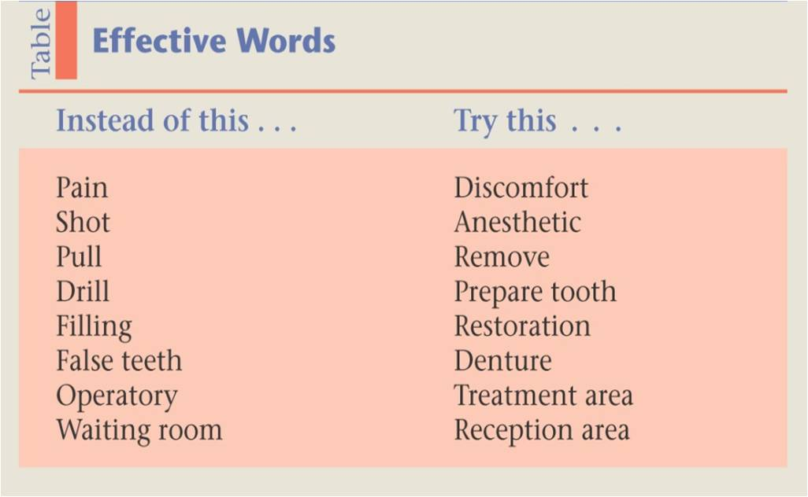
- Do not create resistance, frighten, intimidate or upset the listener. An example of threatening language: “if you don’t come back you’re going to have toothache/your tooth will need to get extracted”

- Nonverbal messages
- Nonverbal messages are the primary way that we communicate emotions; facial expression, and postures & gestures (crossed arms indicates shyness and the patient is not very open to people, open arms and shoulders shows that the patient is socially engaging) which help us dealing with patients. When a patient enters the clinic you can recognize his complaint. If frightened you can let him speak out to know the reason. Also, you can ask assistants and people to leave if the clinic was crowded, because he might need some privacy; he might have HIV and shy to tell you.

- Nonverbal messages are conveyed by:
- facial display
- Body language
- Paralanguage; the way of speaking
- Proxemics; place
- Chronemics; time
The above are important for business-minded people aiming to open a clinic or a centre.
- It’s guaranteed that in the next 10 years of our dental life all of us will be at the same level, some dentists might get to that level faster than others. What distinguish you from other dentists are; your ability to diagnose and your marketing skills provided by communication skills, because at the end of the day you’re taking patients’ money and you’re providing a service for their own good.
- Between 60% and 90% of a message’s meaning is nonverbal

The facial display:
You have to think about your own facial expressions towards patients, and patients’ facial expressions too. You can notice certain facial features, like eyes closure. Some patients actually sleep after receiving anesthesia or having surgery. You have to check the patient’s condition every now and then.
Eye contact:
-Eye contact is important for it helps regulate the flow of communications and reflects interest in others. Some dentists start writing/mixing materials and at the same time asking patients about their complaint without establishing eye contact which is wrong.
-Give time to hear them and sit face-to-face establishing direct eye contact which conveys warmth, credibility and concern.
-Shifty eye contact suggests dishonesty, and indicates that the dentist doesn’t really care about the patient’s complaint he only cares about his money!
-Downward gaze maybe a sign of submissiveness, inferiority or lack of self-confidence. In front of a patient, even if you’re a bit afraid or not confident, you have to act like you are very confident.
Note: If a patient is frightened and has many dental problems, we should start with the easiest and the least time consuming one, to help him overcome his fear.

- Para verbal messages
- It’s the meaning received along the actual words through the vocal delivery of the message, i.e. How to deliver the message.
- Para verbal communication refers to the messages that we transmit through the voice tone, pitch, voices, dialects, accent, rate, pauses…etc, which differ depending on the patient’s level of communication and condition.
- Convey the message politely and respectfully, e.g. if a patient has cancer, instead of saying “you have cancer and you’re going to die”! it’s better to say it this way “we did screening and unfortunately we found something that has a high possibility to be a cancer, but the good thing is that this kind of cancer is apparently treatable and there’s a new drug in the markets for it” this way you grab the patient’s attention.

- You should know when to pause while talking, and what words to stress on:
“I didn’t SAY you are stupid”
“I didn’t say YOU are stupid”
“I didn’t say you are STUPID”

Body language/appearance:
Your movements, your gestures, physical appearance and the way your clinic and your receptionists look affect the way patients see your clinic.

Proxemics:
-Patients have their own Personal space; invisible boundary that they create around themselves. 0.5 mm away is considered an intimate space, 4m represents the social space.
-Differ from patient to patient; People with claustrophobia are okay with the social space but not with the personal space. You might give some patients general anaesthesia in order to be able to work in that intimate space!
-Dentist needs to invade this space to provide treatment; patients trust you with their bodies, and dentistry is very invasive that’s why it’s called dental surgery (DS). Drilling is actually a surgery because you’re cutting a living structure; periodontal treatment and extraction are also surgeries. You’re actually working in the most intimate space; the face, so dentists have to respect this space.
-Verbal and nonverbal communications should mitigate the tension created by this encroachment of their personal space. Ask for permission to invade that personal space, don’t ask the patient to open his mouth outside the clinic, in the corridor for example; he has to be sitting in the dental chair.

Chronemics:
-The use of time; treat patients the way you want to be treated. Respect your appointments.
-Wait time for patients communicate their value; when giving appointments give enough duration of time taking in consideration the possible complications for each patient.
-Waiting rooms; some dentists have two waiting rooms, if a patient has been waiting in the same room for two hours or more this will drive him crazy, but if you moved him to a second waiting room he’ll feel that he’s moved to the next stage, or even some dentists put a patient in another clinic to show him that he’s the next one, and he might not be! Just to break the waiting time. This is kind of a technique and part of the communication skills that makes the patient leave the clinic satisfied.
-Scheduling; ideally, try to have a schedule and don’t allow the entry of a lot of walking patients.
- To sum up: Respect of time and personal space, the words coming out of your mouth, the way you say them, and the way your gestures and body language are, all together are called communication skills.

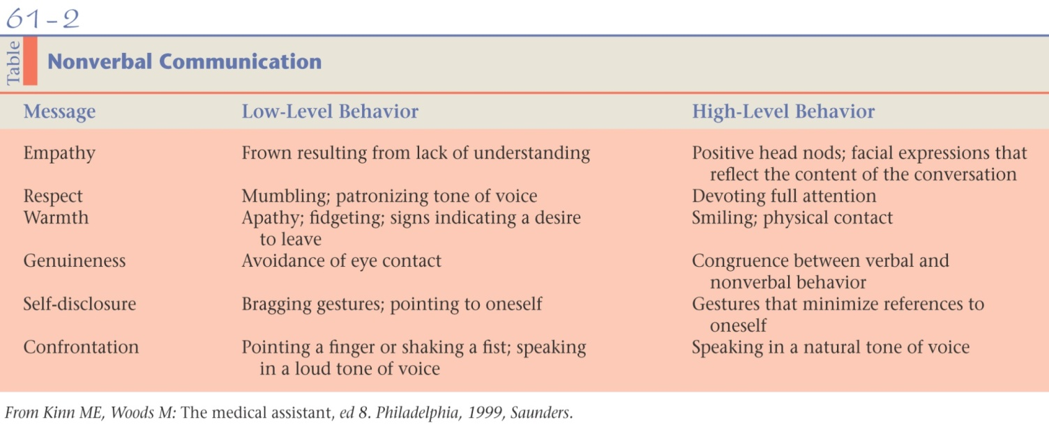
About the previous table, in nonverbal communication try to move to high-level behavior:
How to express empathy talk with the patient with positive head nods, when he says something upsetting you have to show some sadness, this is a sign of empathy.
How to engage in confrontation talking and pointing a finger at the patient is a low-level behavior, whereas speaking in a natural tone of voice is a high-level behavior.
- Understanding message reception. A person’s message is perceived in 3 ways:
55% Visually (facial expressions)
33% Vocally (pitch, tone, volume)
7% Verbally (the actual words)

- Receiving messages/ methods of communication:
Listening;
- Requires concentration and energy; active listening, you have to work and make effort to listen to patients
- Involves a psychological connection with the speaker. Do not let the mind wander; Try to establish eye contact
- Includes a desire and willingness to try and see things from another's perspective
- Requires that we suspend judgment and evaluation; don’t judge the book by its cover, even if a patient does things that you think are wrong don’t judge him just listen to him without showing bad facial expressions, you don’t have to change everybody, always respect others.
Respect culture and religion diversity, e.g. some patients use a product (Emdogain) that’s used in periodontal treatment to regenerate tissues and it comes from pigs. Another e.g. you shouldn’t give an Indian patient collagen which comes from cows. You expect the farmer to speak loudly maybe and have different standards of beauty for example it’s not really important for him to get a Hollywood smile.
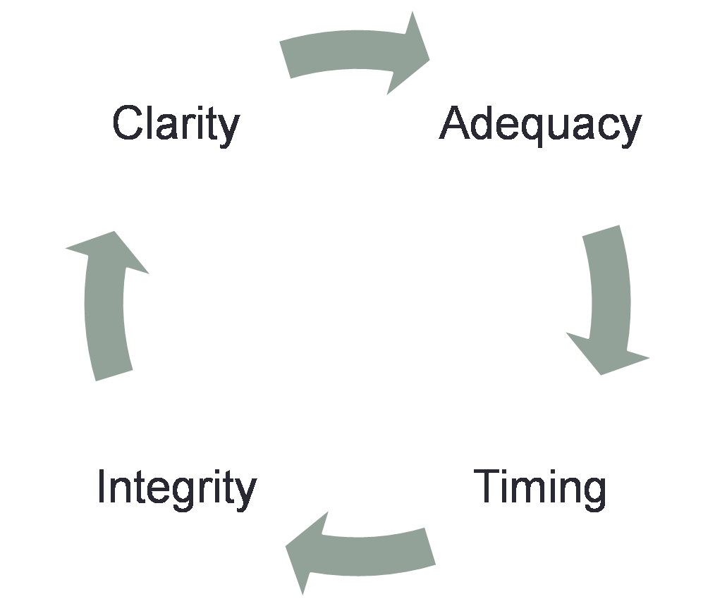
- What makes a good communicator?

A good communicator usually has an adequate knowledge and adequate words to say, controls timing, has integrity which is eventually for his own benefit and should be free of stress.

Tips to good communication skills: (oral, written and nonverbal)
- Maintain eye contact with the audience
- Body awareness
- Gestures and expressions
- Convey one's thoughts
- Practice effective communication skills

- Barriers to effective communication:
- Socio-economic level
- Cultural Diversity, was mentioned before.
- Education; methods of education are:
- Disclosing tablets.
- Brochures
- Videos in the waiting room
The problems with education are:
-it’s clinician-centered
-Educational messages and direct advice provided using a unidirectional form of communication that attempts to persuade patients to comply with professional recommendations and to do something that you want them to do. So you have to make them feel that this is for their own benefit.
This puts the patient in the position of either passively accepting or, alternatively resisting the often unsolicited advice, which usually leads to a clash, so patients might not come back.
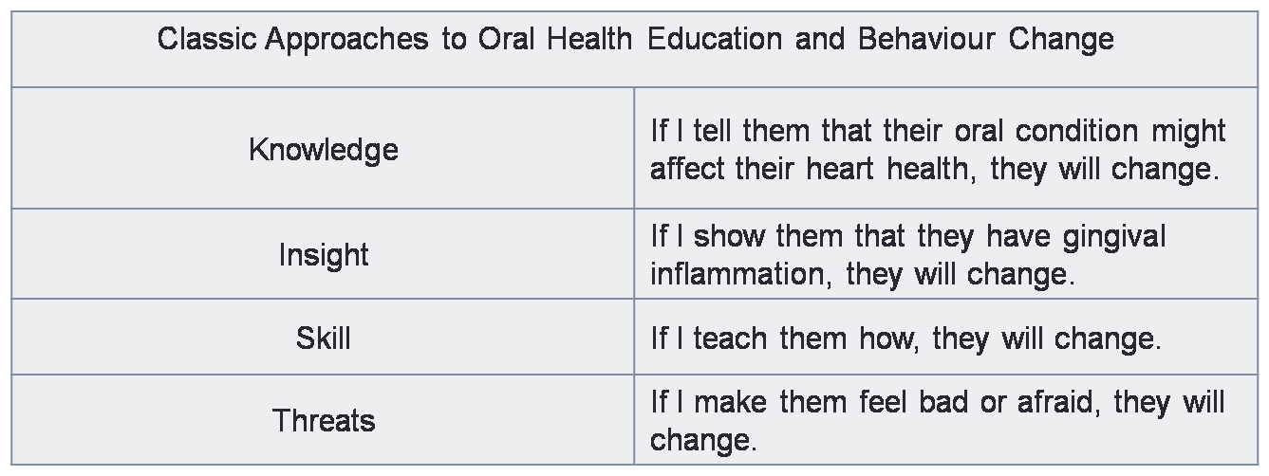

MOTIVATIONAL INTERVIEWING (MI)
“a collaborative, person-centred, goal-directed method of communication for eliciting and strengthening intrinsic motivation for positive change.”
- It’s patient-centered and not clinician-centered, to make the change come from the patient himself.
- In drug addiction and smoking there are many ways. You establish a connection with the patient, you avoid confrontation. You roll with resistance, when he refuses the idea. Patients are experts in their own lives, you don’t know better than them.
Note: try to be at the same level of your patients and not to disrespect nor over respect them, so you should be firm and nice at the same time. If patients are older than you use the courtesy titles Mr. and Mrs. instead of titles that make you seem really young and inferior to them (aunt or uncle).
When you take history to a patient let him sit on a chair of the same level of yours and maintain eye contact, this way he can see your nonverbal messages, because if he was on a dental chair you’ll appear superior to him.

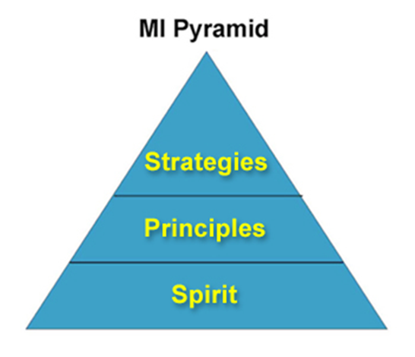
- Pyramid of motivational interviewing:

A.The spirit of MI means that it’s based on collaboration
“Righting reflex”; means when the clinician finds sth wrong he tries to correct it, and this should be avoided. Avoid giving patients commands and persuading them to do sth you want that you think is right. Allow the patient to articulate his or her own solutions.
The Spirit of MI is based on three key elements:
- Collaboration (Vs. Confrontation) between the therapist and the client;
- Evoking or drawing out the client‘s ideas about change; (Rather than imposing ideas),
- Autonomy of the client; he’s free to do what he wants.(vs. Authority)

B.Principles of MI
- Express Empathy.
2. Develop Discrepancies between current behaviour and important goals or values. e.g. when you say “Quitting smoking is up to you, but what do you think about smoking? How would quitting smoking affect your life?“ This might lead him to realize smoking bad effects on him and he might quit it.
3. Roll with Resistance and avoid arguing when reaching a dead end.
4. Support Self-efficacy and optimism. Enhance the patient’s confidence in their ability to make a change. e.g. when you say ”I respect your honesty, you know yourself better than anybody” he might feel guilty this way.
C.Strategies: the techniques used to apply MI
OARS
O: Open ended questions that are not a yes/no questions, e.g. instead of saying “why don’t you quit smoking?” it’s better to say ”what do you think about smoking?”.
A: Affirmations; e.g. “You’re telling me clearly why you’re not very concerned about your tooth brushing and I appreciate that honesty.”
R: Reflections; try repeating what the patient says, to make him know that you’ve been listening to him, and you have empathy. e.g. “You really seem to have lost hope that you can ever really quit smoking.”
S: Summaries; e.g. when the patient says ”I tied to quit smoking but couldn’t because of the family and job stresses and I’m really busy” and you reply “so in your opinion smoking is bad for your health, but you’re having a stressful lifestyle. You never managed to quit but you’re considering it in the future, am I right?” this way you can drive patients to sth called change talk.
Another e.g. “So there’s a big part of you that doesn’t feel ready to change right now. You really enjoy smoking, but you have been a little worried by the way some people react when they find out that you smoke. Is that about right?”

- “Change talk” involves statements or non‐verbal communications indicating the client may be considering the possibility of change.
e.g. “Why would you like to change?” “How do you think you should start your change?” “From 0-10 where do you think you are? What takes you to a higher level/number?” “What do you think of putting your medication near the toothbrush so you don’t forget to take it daily?”
Summarize “what do you think you’ll do?”

- MI strategies in delivery of Oral Health advice:
The key components of brief MI which can be applied for the delivery of oral health information and advice are:
- Always Ask for Permission, “can I talk to you about smoking?”
- Elicit Provide Elicit (using OARS), “I heard/read/was told that powered toothbrush has a timer, that helps to overcome brushing timing problems, what do you think?”
- Explore Options
- Affirm Commitment.

- We were shown video, comparing two different situations for the same patient:
-The first one is bad, because the dentist is imposing orders. “We need you to…”
-The second one is good, for the dentist is using the strategy Elicit-Provide-Elicit. “From zero to ten where do you think you are?”

Best Wishes

