Dental materials lec#3
By:Mays Abu-Afifeh

Note that this sheet contains every single info mentioned in the lecture PLUS some other notes from other references and last years sheet to clarify some points.

- Two methods/strategies for bonding to tooth structure :
- Etch-Rinse (strong acid)
can be either three-or two-step materials depending on whether primer and bonding are separated or combined in a single bottle. The adhesion strategy involves at least two steps and, in its most conventional form, three steps with successive application of the conditioner (acid etchant), followed by the primer (adhesion promoting agent), and eventually, application of the bonding agent (adhesive resin). The simplified two-step version combines the second (priming) and third (bonding) steps, but still follows a separated etch and rinse phase.it is also characterized by postoperative sensitivity because rinsing alters dentinal tubule fluids to trigger sensitivity.

- Self etch-adherent (weak acid):
is an alternative based on the use of non-rinse acidic monomers that simultaneously condition and prime tooth tissues. Regarding technique-sensitivity, this approach seems clinically most promising, since it eliminates the rinsing phase, which not only reduces clinical application time, but significantly decreases the technique sensitivity or the possibility of making errors and the presence of an unprotected collagen fibers area is significantly reduced.

- The following diagram lays out the classification of all the bonding systems in use today with corresponding reference to the generation and examples:
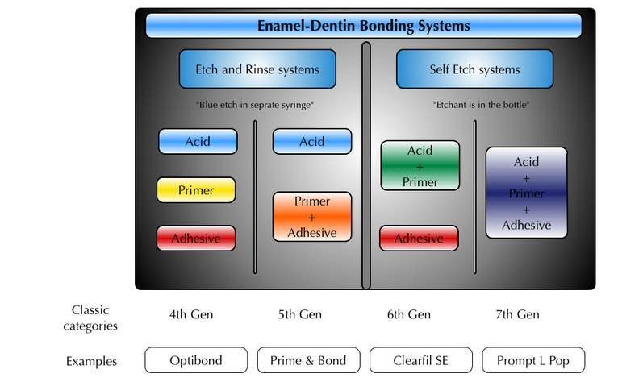

- Etch-Rinse:
Apply phosphoric acid (35-37)% concentration for 30 seconds in enamel and 15 seconds in dentin then rinse for rewetting and dry by air syringe then primer then dry to remove primer solvents for 10 seconds then bonding agent to enhance bonding of restoration to tooth structure then light curing for 10-20 seconds then apply composite.
- avoid over drying but collagen fibers collapse so use the pop/quick drying .
- what method do we use in our clinics? Etch-rinse adhesive system.
- Ways of drying dentin: Use the high volume suction or dry it then rewetting by sterilized cotton pellets.

- Self etch-adhesive/primer:
apply the acid for at least 20 seconds without rinsing then primer then bonding agent.
Its preferable if you’re facing such a critical case or improper isolation,also its used with indirect restorations.

- Indirect restorative materials:
Bonding is very important to this kind of restorations; to increase the retention and rigidity of the restoration.

- Note:we don’t use temporary filling “containing euganol” incase of composite restorations since euganol affects composite setting,in some cases-not deep cavities-you can use the composite itself as a tf without itching and bonding just cure the composite it will survive for a week or two.

- Ceramics can be divided into itchable ceramics like glass ceramics and porcelain , and non-itchable ceramics which are not used that much nowadays.
- The ideal requirement of any restoration is bonding to enamel and dentin that’s why it is important in indirect restoration to retain tooth restoration but this is cost effective and technique sensitive. In full metal crown preparation, if we have enough preparation guidelines and enough length/width we can use regular cement for primary retention and strengthening the mechanical properties especially old ceramics and fibro posts that are bonded for strength and retaining shape( esp. anteriorly if the preparation is 4 mm) otherwise they’ll break but veneers don’t need bonding!
- The cement (bonding agent) that’s used with indirect restorations: (curing methods):
- light cure for veneers because it is thin enough (translucent) to allow light passage and light helps in removal of smear layer around margins easily
- dual cure (light and chemical) for metals and posts because light can’t reach deep to the whole preparation and resin cement located at depth of 10 mm.
- Why don’t we apply chemical or dual cure to veneers? Because the chemical activator (tertiary amines) found in chemical cure is unstable and causes discoloration of veneers after period of time appearing as dark spots which is not esthetic.”But incase if more than 1 mm thickness dual cure should be used”
- When do we need to have cementation ?
1-weak ceramics like the old silica ceramic; there is a study revealed that the glass ceramics that were retained by resin cement got 4folds of success more than those retained with zincphosphate.
- Short clinical crowns , even in the metal crowns we can do adhesive cementation .
- partial crowns .
- fiber posts
- minimal preparations, adhesive bridges , gold onlays , partial coverage , veneers.

- Ceramics can be divided into:
- itchable ceramics: like glass ceramics and porcelain
- non-itchable ceramics.

- REMEMBER: bonding to tooth structure(by etch-rinse-primer if in dentin-bonding agent) then resin cement application ( then HF etching-rinse-ultrasonic heating-coupling agent) then adhesive and bonding agent to ceramic.
- In ceramics, we don't use the phosphoric acid for itching because it causes destruction to ceramics , but we use the hydrofluoric acid which is a little bit weaker .However, the problem is that it is a toxic acid and we shouldn't inhale it , it’s concentration is between 5-10% , the application time is 10 seconds for the 10 % concentration on lithium disilicate ceramics (e.max).

- We have two types of itchable( bonding ) ceramics:
- Feldspathic porcelain and lucide based ceramics:
The structure that is itched is the lucids(needle like structures) when they are removed then spaces are available to bond to.
Examples on these lucide based ceramics are the Empress 1 or the veneering porcelain that we use with enamel
lucid based ceramics need a prolonged itching with hydrofluoric acid , time between 60-90 seconds
rinse for the same period of time or even more ( because ceramics are more resistant to removal of debris than normal tooth structure.
- Having lucide provides us with :
1.preferential itching .
2.makes the coefficient of thermal expansion of the ceramics close to that of the metal .
3. Makes the index of refraction of the light close to that one in the enamel , so from esthetic perspective these are the best ceramics to use.
2. lithium-di-silicate based ceramics or Emax:
- More commonly used than fieldspathic porcelain ceramics
- we use the 5% acid itch with hydro fluoric acid and silane coupling agent for 20 seconds , or 10% for 10 seconds
- rinsing: let it dry at room temperature or using dry -on the silane coupling agent too -because studies showed that when it is exposed to heat then the bonding strength is doubled .

- Hydro fluoric acid itch comes in tubes , and the silane coupling agent comes in one or two tubes and the two tubes are better because it stays for longer times when stored, while if it is a single component then it is not stable and it may degrade when stored for long time .
- After applying the acid itch and washing it make sure of absence of smear layer, we must put it in ultrasonic solution (cleansing path) with distilled water for 10 minutes in order to remove any debris as the smear layer and then we put the silane coupling agent. – doing that makes the veneers life expectancy as the class I amalgam-
- Why do we add silane coupling agent? To provide chemical bonding between silica particles of ceramics and silica particles of the filler of resin cement in addition to presenting mechanical bonding.
- Which method is preferred; drying at room temperature or by heating? By heating NOT to accelerate procedure BUT to increase bonding strength by 1 fold (100% increase) ( even if we add to steps but it is all about better results)
- in veneers; we will have chemical bonding between silica particles in the filler of resin cements and silica particles in the ceramics.
- in the clinics we do the crown preparation and then we put a dentine bonding agent , we light cure it and then take the impression and send it to the lab .
- the cements that we usually use is resin cements which are either chemical (self) , dual or light cure cements, the problem with the self and the dual cure cement is that the activator is not a color stable so you are not allowed to use it in veneers , we only use light cure one in case of veneers , while other restorations like crowns or posts where light cannot penetrate we use the chemical or dual cure one.
- The bond or cement is the weakest among all this procedure so the failure is mostly in cement itself that’s why bond has to be as strong as cohesion inside bonding surface to get the appropriate longevity of porecelain ceramics and others
- what happens if the veneer is placed directly on enamel and dentin that have not been bonded to temporary cement and crown? As a result of non-bonding, contaminated temporary cement that has to be removed and the dentinal tubules that have to be etched will not be available because it is contaminated with restoration temporary cement.
- How to apply bonding between temporary cement and dentinal tubules? Acid etch then rinse then primer then adhesive bonding agent then the temporary cement.
- Do we keep the temporary cement? If not then what do we have to do? No, we remove it then clean the site by pumice as intraoral sand blasting for seconds to create roughness then apply etch-bond again for immediate dentin bonding ( Immediate dentin bonding is required to increase bond strength and decrease postoperative sensitivity even in metal ceramics ).

