last lecture we talked about the small intestine, this will be a continuation of the digestive tract and we will be talking about the large intestine followed by an introduction to the liver ..
- Themajor difference between the large and the small intestine is the existence of the villi ;
with villi small intestine
No villi large intestine
- “ stomach also doesn’t have villi “.
- The surface of the large intestine is pitted “not folded “and it has intestinal glands “crypts of Lieberkühn“ that are similar but shorter than in the small intestine .
- Goblet cellsarenumerous in the large intestine and they increase as we go distally from the small intestine ( duodenum to jejunum to ileum) to the large intestine also they increase as we move distally in the large intestine itself , because as we go distally the material inside the intestine becomes harder, so it needs more lubrication and that is why we need more goblet cells ..
- as we said in the previous lecture generally DNES cells are rare but when we compare the large intestinewith the small intestine , DNES cells are fewer in the large intestine .
- Enterocytes are similar to the small intestine “absorptivecells, columnar in shape, and have a brush border “.
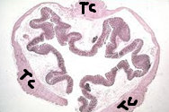
-Stem cells are also present in the basal part of the glands.
- paneth cells ; might be present but usually they are absent .. if they are present we can find few of them in the basal part ..the reason that we have them less in the large intestine or absent; is that the number of them in the small intestine is enough to do their job which is maintaining the amount of the bacterial flora inside the intestines so no need for more of them in the large .
- in the basal part of the glands in the small intestine we have numerouspaneth cells , goblet cells , enterocytes , stem cells ,and DNES cells so a section that has all these cells will be an indicator that it has been taken from the small intestine ..
- muscularisexterna : the outer longitudinal layer is thickened in three parts only and thin all around ,those thickened parts are known as Taeniae coli ( TC),Except for the appendix which has many lymphatic nodules and no thickened parts.
- The circular mucosal folds or elevations toward the lumen include submucosa and they are temporary structures , known asplicaesemilunaris in large intestine , in small intestinethey are present but they are permanent and called plicaecircularis.
Keep in your mind that the parts that are surrounded by Serosa are intraperitoneal and they are:
jejunum ,ileum , the beginning and the end of the duodenum , the anterior part and the lateral parts “ sides “ of the large intestine ..
While the parts that are surrounded by Adventitia are extraperitoneal and they are:
the middle of the duodenum and the posterior part of the large intestine.
* Labnotes:
- as we go to the basal side,the stain becomeslighter, because the glycosylation becomes less and the secretion becomes more watery as it can move to the surface.
- Numerous goblet cells indicate that this section was taken from a large intestine.
- to differentiate between the large intestine and the stomach, mainly the cardiac region, we should look at the number of goblet cells for there is numerous of them in the large intestine.
-in the large intestine we don't have a pit before the gland ,it's always directly the gland (straight), however in the cardiac region of the stomach the pits do coiling instead of branching.
- Vermiform Appendix :
- A diverticulum 5-6 cm from the posteromedialaspect of the cecum , since its from the posterior then its covered with adventitia.
- lumen filled with debris .
- mucosa is similar to the mucosa of the large intestine except for the thickening of the longitudinal layer ( taeniae coli ),(it's normal (not thickened)) and it differs in having numerous lymphatic nodules ,much more than that in the large intestine.
- the cells are the same as the large intestine except for the abundance of M cells because of the numerous numbers of lymphatic nodules .
the doctor showed these tables in the lecture ..inthe first table; please pay attention that crypts of liberkuhn are shorter in the colon “ large intestine “ , the doctor asked to correct it in the slides,I alreadycorrected it here ….
* Table (2) :
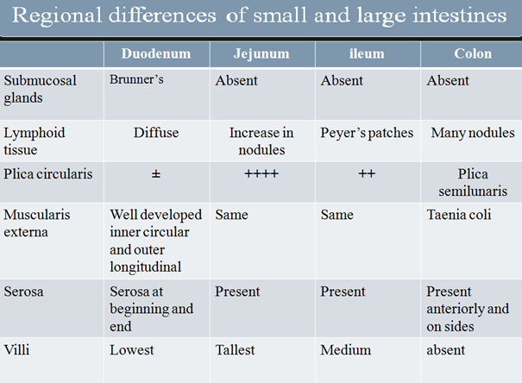
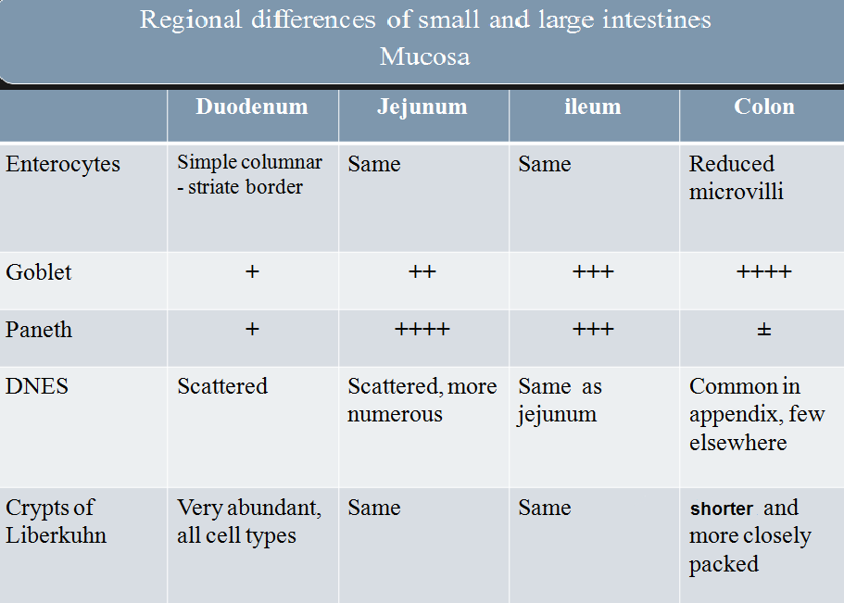
Liver :
Glands associated withthe digestive system include the liver , gallbladder and the pancreas, we will take them all.
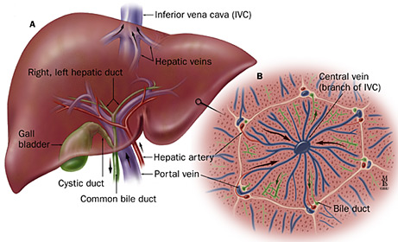

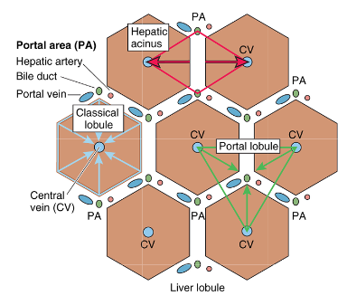
- the blood supply of the liver comes from two sources ; theportal vein and the hepatic artery.Portal vein drains blood from the intestine(generally) which means it's nutrient rich and oxygen poor (deoxygenated) because it is venous drainage, so the vein is needed mainly to supply the liver with the nutrients .. Hepatic artery is important forsupplying the liver with oxygen ..
- the Portal Veinsupplies the liver with 75-80% of its needs , while Hepatic Artery supplies the liver with 20-25% which makes the Artery the second source and makes the vein the number one source.
- Liver Lobules :
if we take a closer look at the picture here
we can see that the histological appearance
of the liver lobules have a special
arrangement & because of that we have
three types of lobules :
1) classical lobules .
2) portal lobule .
3) Hepatic acinus of Rappaport's “pathological“.
- Classical lobule :
hexagonal in shape , in the center we have central vein and we can see portal triad on each side ;
the triadas the name indicates has three branches ; a branch from the portal vein , a branch from the hepatic artery and a branch from the bile duct .
The blood that comes from the portal vein and the hepatic artery pour in the same place , which called hepatic sinus “ sinusoid “ . then the blood goes from the sinusoid to the central vein that will in return go back to the heart , then to the respiratory system , again back to the heart , and finally to the whole body .
so the blood that will enter the central vein must be filtered in the sinusoid , because the portal vein’s blood source is the intestine(generally) , So it does have high ratio of nutrients but it also has toxins , so we should detoxify any unwanted material in the sinusoid . Around the sinusoid we have Hepatocytes and the lining of the sinusoids are endothelial cells and Kupffer cells“ macrophages “ that act together to filter (sterilize) the blood in order to make it clean before it reaches the central vein.
- the boundary of the classical lobule is a real connective tissue in animals , But in the humans it'san imaginary boundary .
* Note that the hepatocytes secrete bile,and they take their needs of oxygen from the hepatic artery .
- Portal lobule :
triangle in shape, every angle of the triangle is a central vein . in the center of the triangle we have a triad .
the most important thing to us from this triad is the branch of the bile duct,
the idea of the portal lobule is to explain how the bile is collected into the branch of the bile duct .
________________________________________________________________________________________
The doctor then mentioned the anatomy of the liver ,and he said that he doesn't
demand us to know about it , So u can refer to to the slides if you want to read about it
P.S :Dr.Firas mentioned that there will be NO midterm LAB exam , only the theory material will be included &the exam will be out of 40 marks ..
- The final exam will cover both the lab and the theory, and it will be divided as 30 marks for the lab , 30 marks for the theory ..

