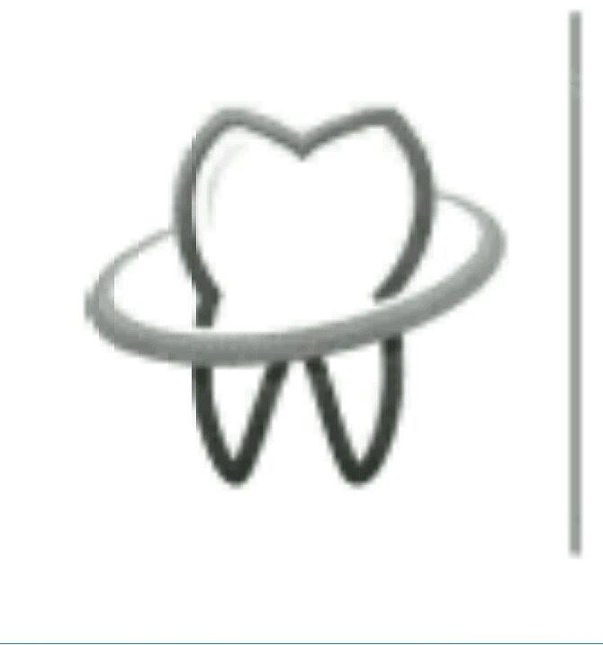
Sheet no. : 10 {Endo}
Refer to slide : obturation
Written by : Alaa Atef {big thnxx}, Hadeel Jaser .
Corrected by :alaa atef ,hadeel jaser .

Last lecture we talk about cleaning and shaping the canals ,adding irregents , adding medicament's {EX: sodium hydroxide },then we add temporary filling.
After we add temporary filling ,patient can leave the clinic ,and in the next visit we will OPTURATE the canal.
Note you should to know ,before we start talk about obturation :-
-step-back technique with increment of {1mm},help to form canal taper of 0.05 {5% taper} .
-This 0.05 taper LARGER than the taper of file that used in clinics {files that used in clinics have 0.02 taper}.

OBTURATION
-IN GENERAL obturation means filling the canal.
-obturation as definition filling of the fully debrided and shaped canal with material ,sometimes it can be temporary ,not necessarily to be permanent {for purpose of the cores we will consider the filling material is permanent}.

Why we don’t leave the canal without filling {empty} after cleaning and shaping ???
1-to remove all space for growing of bacteria {prevent growing of bacteria }.
2-prevent any remaining bacteria inside the canal ,to prevent access to periapical tissue .
3-prevent periapical fluid to get inside the canal { periapical fluid get inside the canal ,will provide nutrition for bacteria }.
That’s done by 3 ways :-
1-entombment the bacteria inside the canal.
2-prevent any substance get enter to the canal as coronal leakage .
***pay attention that prevention of coronal leakage not the function of root canal filling alone ,also crown restoration prevent coronal leakage.
SO Prevention of coronal leakage done by :-
A-Root canal filling.
B-crown restoration filling.
3-provide apical seal to prevent periapical fluid to enter the canal from bone that surrounding the tooth . this doesn’t cause a problem ,but if there is remaining bacteria inside the canal ,this fluid will provide nutrient for bacteria .
In clinic ,when I decide to obturate the canal at this time and when I decide that I don’t want to obturate the canal at this time ???
We take in consideration :-
1-patient symptoms .
2-preoperative diagnosis {status of pulp and periapical tissue }.
3-degree of difficulty.
4-patient management .
5-time the most important consideration,if you don’t have time,don’t tend obturation because hefty job means a lot of mistakes .

Patient's symptoms :-
when patient comes to the clinic and feel pain ,from patient management point of view : try not FILL the canal ,until patient happy and pain free .
***there is exception :- if the origin of pain from inside tooth {not from periapical area , then we can fill the canal in same day WHY ????
Because we remove the pulpal tissue ,so we don’t need to wait after the pain go away .
But if we clean and shape the canal ,and there is inflammation in periodontal ligment ,this cleaning cant ,management this inflammation , so we cant fill at the same time {we let the inflammation heal before obturation }.
SO
If the pain origin from or due to periapical area then wait {don’t fill at same day }get the patient chance to heal the inflammation.
IF THE origin of pain from inside the tooth {which the pulp itself } ,we can fill at SAME day.

  - Preoperative diagnosis :-
We said that we should DRY the canal before we filling \obturating the canal , so we should DRY the canal as much as possible ,before we get the filling in .
In case of drainage inside canal {come out from the canal} , drainage of PUS or BLEEDING or EXUDATE from the canal and we cant dry it meaning that :-we irrigate the canal and there is pus or blood or exudate.
In this case we cant fill the canal we should add medication to the canal and wait resolution happen.
Resolution happen only when we clean and shape the canal properly.

Degree of difficulty
In difficult case ,take your time ,don’t rush.-
-difficult case could be :sever curvature , complicated anatomy , procedure errors
-we should make the preparation convenient then we obturate.

Patients management
Some patient are annoying the dentist , some don’t like to sit on the chair ,also children don’t like to sit on the chair .all these cases you should take in consideration before you start treatment WHY ??
COZ YOU need to tell the patient how many visit you need to complete treatment and that need admitted from the patent .so you should tell patient how many visit you need to complete the treatment ,try to exaggerate meaning , if you need 2 visit ,tell the patient that you need 4 visit .
In general obturation can be done :-
1-as sense the patient asymptomatic .
2- canal is dry.
Don’t and don’t and don’t obturate the canal if there is apical abscess the reason is :-
If any complication happen then you cant deal with the patient with presence of obturation ,if that happen you should to remove the obturation and cleaning the canal again .

Techniques of obturation
Refer to slide 11 all these techniques are existing ,some of them been used ,some abused ,and some of them not used nowadays.
___________________________________________________________
**Lateral compaction technique ,is the one that we gonna talk about. Is the technique where we use multiple cones , what we do actually in this technique is compaction of multiple cones inside the canal.
**paste technique :we don’t use it.
**solvent based technique :is advanced technique.
Why lateral compaction technique is multiple cones technique ,not single cones technique ??
The Q mean :if u prepare the canal to size 35 and the canal taper is 0.04 for EX and I have GP cone have the same size of canal ,then why I don’t use this single GP cone rather than multiple GP cones ???
The answer is : because this single GP is smaller than the canal even if you felt tug-back apically {gd fit apically} ,but GP will not be good fit coronaly because canals are round no matter you do.even if you machine the canal to a perfect round shape the tooth will has a procedure errors which are fracture ,dentine over cutting and straightening .{ don’t worry about them we will get them later on}
** so we cant fill the canal with single cone ,we should use multiple cones .
Q : Why we study the cold lateral compaction technique ,although most of the dentist used warm vertical technique rather than cold lateral compaction technique ??
Answer : Coz it’s the easiest {the leaning carve of lateral compaction technique is the easiest on}.
ADVANTAGE of lateral compaction technique :-
You can control the length of the filling quite easy ,if you have proper cleaning and shaping ,you can control the length easy .
The only disadvantage of lateral compaction technique is time consuming there's 20-25 min per canal ! { lateral compaction technique more time than warm vertical}.
MATERIAL used in cold lateral :-
1-master gutt porcha cones(8) 2-paper point
3-GP accessory cones 4- sealer 5- alcohol .

Instrument used in cold lateral compaction technique :
1-spreders 2-pluggers 3-glick instrument
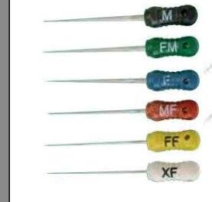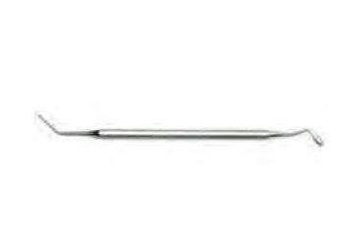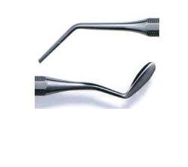

***GP :
IS a natural rubber , processed in way that doesn’t cause allergy ,also processed in a way that heatable ,also its flexible
Accessory cones they are GP but in different sizes
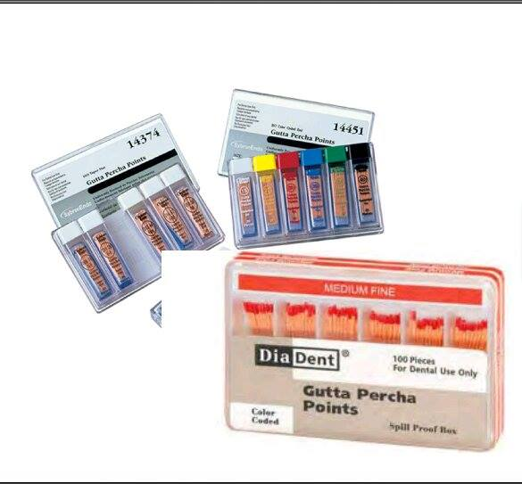

**Sealer : we have different types of sealer need to mixing {the type in the nxt lec}
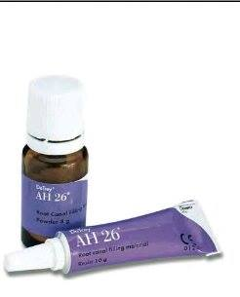

Glick instrument :**
One side similar to carving instrument ,other side is similar to pluggers .

**we need to heat source ,either by cigarette lighter ,or by using device called touching heat {slide 17}
Once we touch this device ,the TIP of this device {only the tip} become heated {its manufactured from special material with one touch }in one second ,the tip become heated {heat could reach to 600C } so we keep it down to 150C or 200C .

The preparing for obturation
**1-we should remove the smear layer .HOW ???
By EDTA with sodium hydroxide .
**2-we should dry the canal {go to slide 19}in the picture paper point {same to the size of GP} when we insert the paper point into canal ,it will absorb the moisture we continue to insert paper point into canal until the paper point get into canal and go outside and still DRY{that mean the canal is dry}.
**3-select master GP: we select the size of master GP SAME TO THE SIZE of master apical file.
EX: if you prepare the canal to size 35 .you should use master GP size 35 .

**we called it master :: because it’s the only that will reach the apex {no anther cone can reach the apex}.
**master GP will reach to the full working length {only cone that reach the apex }.
**master GP should show resistant when we get it out the canal ;in other word when you try to pull master GP out the canal ,you should feel that you want to apply force to get it out the canal.
{ master GP shouldn’t loose inside the canal}.
**this resistance forms due to apical stop or apical seat {friction in the taper of canal }.
EX :if you prepare the canal to size 35 you should use file 35{apically the file should touch the canal wall ,but still loose {just touch} but when you insert the master GP inside the canal it should show resistance or what we called TUG-BACK.
WHEN YOU INSERT the master GP inside the canal you should ensure that the length of master GP is EQUAL TO THE working length of canal ,either :
1-by measuring the working length before insertion the master PG in the canal { left upper pic and left lower pic}

2-by insertion the master PG inside the canal and follow it then measure the length { right pic} 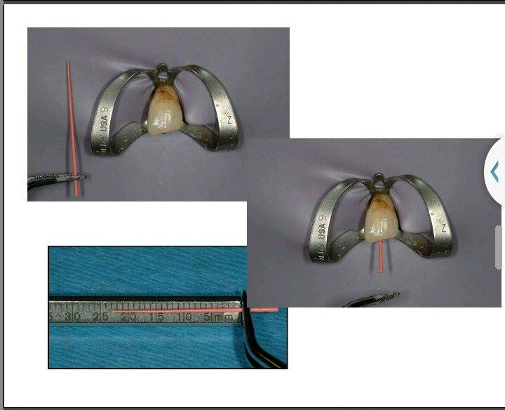
**if the master PG is larger than the working length in this case , either you cut this master PG OR you can use other shorter master PG.
** its preferable to start with larger master PG at first .
**make sure when you measure the length of master GP that you MARKED the desired length on the GP.{by tweezers tip ,press a little bit}
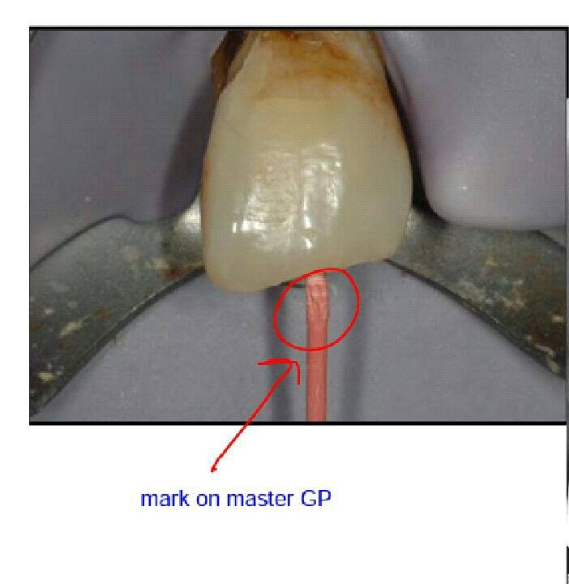
Mark on master GP
**THIS mark should reach to your coronal refrence point of the working length .
Cone fit radiograph {master GP radiograph }
We take this radiograph for :-
1-to check that master GP reach to the working length .
2-to check the apical fit {good adaptation}.
Remember that :
1-the working length is 0.5mm shorter from radiographic apex .
2-the taper of canal is 0.05 ,and the taper of cone is 0.02 .

This cone fit radiograph for molar
-length of the master GP in mesial side is exactly to the length.
-length of distal GPthe cone is taller {its fluch , reach to radiograph apex },you can accepted or cut the cone .5mm.
-in mesial side there is periapical lesion , for this reason you could think that the root is taller from master GP cone ,, but actually its not .so you should follow the periodontal ligament to judge. 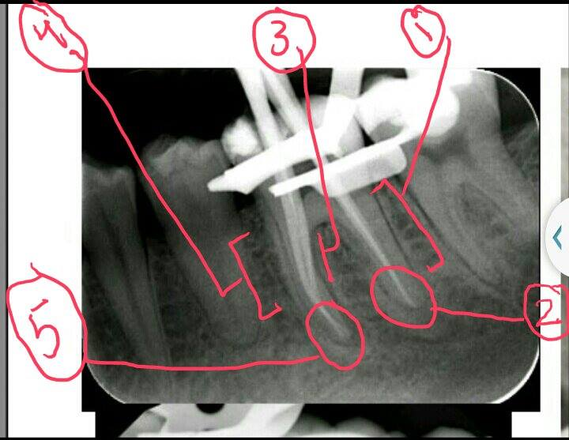
The pic in the nxt page
1-dista side. 2-fluch\zero.
3-periodental ligament. 4-mesial side.
5-0.5mm shorter than radiographic apex, exactly to the working length.
Cone fit radiograph
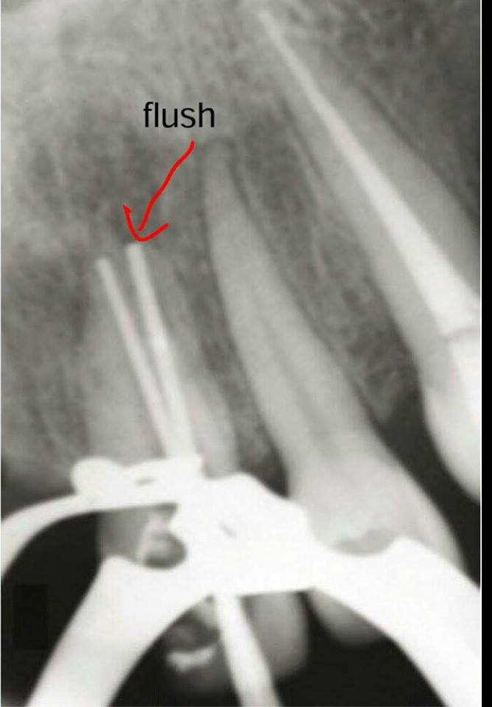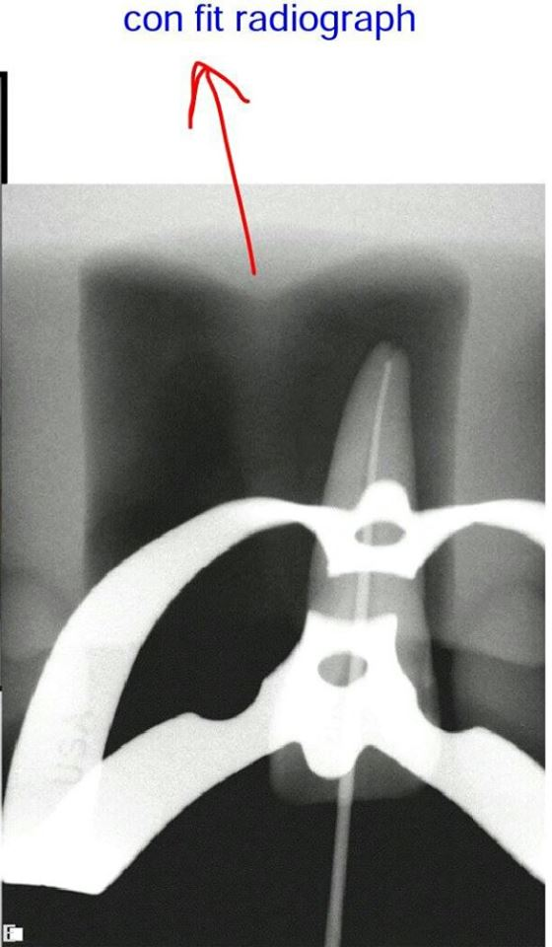
flush
_____________________________________________________
in this case the cone get outside the canal ,WHY?? either :-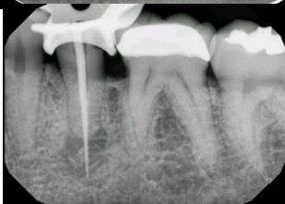
1-there is error during working length determination .
2-you put the master PG without take the length in consideration.
So you should to sure that master PG CONE SAME to the working length before you take the cone fit radiograph .
So ,adjust the master PG cone before you take the radiograph {when you insert the cone into canal ,you shouldn’t take the radiograph unless you sure that the cone reach the working length (not taller not shorter than the working length )}.
***if the cone taller than the working length it will irritate the periapical tissue and cause severe pain ,also it could swelling .
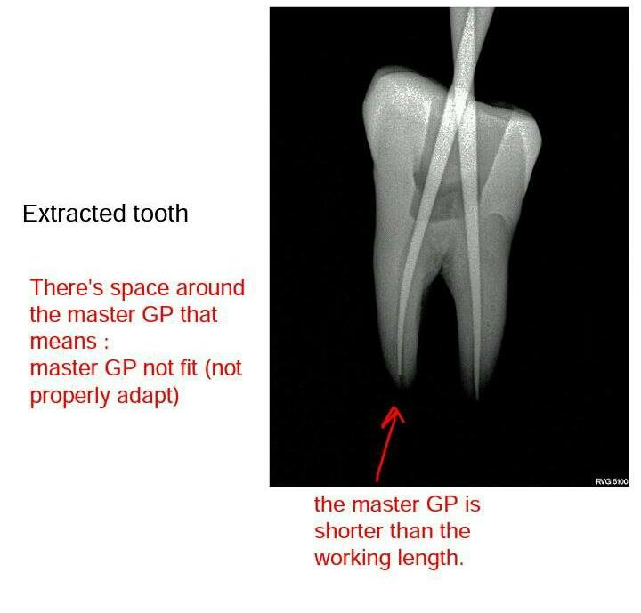
In case short master GP cone you should :-
1-check your patency (no apical debris packed and close the canal ).
2-check ye master apical file {does it reach to the working length or not} if it patent but the file doesn’t get inside ,we should to reclean and reshape .
**also if the file reach to the working length ,but its not loose we should to reclean and reshape again.
Troubleshooting :- again if master apical GP doesn’t go the working length you should to check patency ,cleaning and shaping.
Sometimes you discover that you prepare the canal to SHORT working length ,so you need to readjust the canal
Sometimes you discover that you prepare the canal BEYOND the working length
So either:- you
1-use shorter cone. 2-cut the cone.

**cutting the cone :-
-GP taper is 0.02, so if we cut 1mm of GP cone, the size apically will increase 0.02.
-the size of cone will increase apically 0.02 for each 1mm cut.
EX: if you start with GP cone size 0,35 and it beyond the working length by 1mm ,and you cut the GP cone by 1mm ,its size will become after cutting {0.37}(0.35+0.02=0.37).
-if GP cone taller than the working length by 2mm either you cut 2mm or get other cone larger than the first's GP taper by 0.04.
-after we select the master GP you should select the spreaders.
Remember ,we talk about preparing for obturation which 4 steps :-
1-remove semear layer 2-dry the canal 3- select master GP

4-SELECT spreader: FINGER SPREADER is best than handle spreader WHY?? Because
A-finger spreader is more control inside the canal.
B-less force inside the canal.
C-less risk of fracturing the root (it can happen if you press too much).
selection of spreader :-
Spreader should be 1-2mm shorter than working length .
EX: IF THE apical size is 35 and I used the red spreader {30} if it reach we use it if it doesn’t reach then we go to blue {40}.
***color system of spreader is same as file color system.
WHY we like to use NiTi spreader ??
ANS: Coz NiTi spreader is MORE flexible .its actually defuse the force {distribution the force in way more uniform than stainless steel} ,less internal force generation and less risk of fraction.
-fraction is rare ,but we try to avoid it .
-Don’t take radiograph to check the spreader selection.
***THE figure in slide 27 just to show that spreader shorter 1-2mm from the working length.
-THE NEXT STEP after preparing the obturation is Mixing the sealer .
-some dentist like the mixture to be tacky {means that the mixture get out with spatula around 2 inch }.
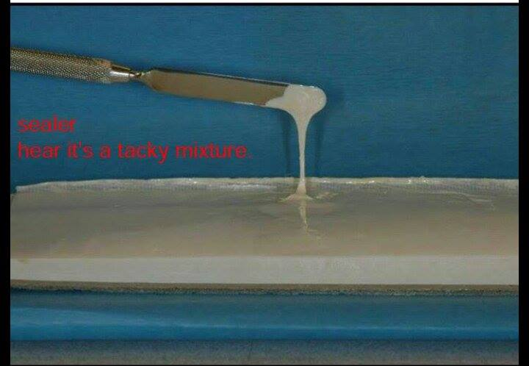
Sealer
Tacky mixture
-next step insert the sealer inside the canal.
-sealer is a paste,we insert it to the canal same way as insertion medicament {sodium hypochlorite l,ledermix……etc} how :-
1-lentulo spiral 2-file 3-injection
4-insertion the sealer by master cone .
**lentulo spiral is best than other method in distribution {what we want is uniform distribution of sealer in the canal}.

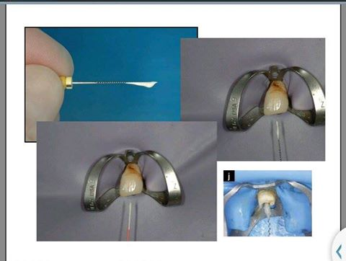
Use GP cone for insertion the sealer inside the canal
Use lentulo spiral for insertion the sealer to the canal
Use lily for insertion sealer to the canal

Remember that
1-sealer function is seal the GP material to the dentin {seal the canal}.
2-its very important to have good and nice, uniform distribution inside the canal .
3-best method for achieve uniform distribution sealer in the canal is lentulo spiral ,if lentulo spiral not available we use the file.
4-file is the 2nd way to get uniform distribution{after lentulo spiral}.
5-when you use file for insertion the sealer to the canal use it in counter clock wise ,not clock wise .also the file that you used should be smaller than the master apical file.
6-why counter clock wise ???
To pull the sealer INSIDE the canal ,not outside the canal.

PAY ATTENSION
When you use the file for shaping the canal (clock wise) to get the dentine debris.
WHEN you use the file for insertion the sealer (counter clock wise) insert the sealer inside the canal rather than outside the canal.

_____________________________________________________
Steps of lateral compaction technique :-*****
1-select master GP .
2-take master cone radiograph {cone fit radiograph).
3-mix the sealer ,then insert the sealer to the canal EX: by file (counter clockwise).
4-select then insert the spreader (you should add sealer to the tip of spreader).
5-insert accessory GP {also you should add sealer in the tip of accessory cones}.
6-continue to insert accessory GP cones and spreader and STOP when spreader cant enter more than 2mm beyond crown ,meaning that spreader cant enter inside the canal .
7-cut the excess part of GP cones by heating source or touch heat device +glick instrument .
8-blugg them by using blogger,{blug mean condensate it in same way of condensation amalgam}.
9-take radiograph {mid abturation radiograph}.
10-use alcohol to remove sealer from access cavity {remove obturation material from the crown};because this material will cause discoloration of tooth.
11-apply temporary filling or permanent filling.
**as we go further the canal start to fill the apical area ,then middle area,then coronal area ,the size of spreader and accessory cones will get smaller.
**postoperative radiograph :-
Take postoperative radiograph after you apply the temporary\permanent filling.
**the obturation on the radiograph ,will determine if the cleaning and shaping is good or not .
**obturation reflect the quality cleaning and shaping.
### You should check the following ,when you look to the postoperative radiograph :-
A-the length of filling {0.05 shorter FROM the radiographic apex}.
B-density[presence of VOIDS or not].
C-taper.
D-level of obturation coronaly:-
-in the anterior teethGP cones should terminate {cut by heat}at cementoenamel junction[CEJ]
-in posterior teeth it should reach to canal orifice.
E-check apical coronal seal :- temporary or permanent filling ,should it apply in proper way or not.
**most of the studies ,focus on quality of the filling [because quality of the filling indirectly reflect the quality of cleaning and shaping].
**in one of classic study done on 350 roots filling using the cold lateral compaction technique :-
1-if canal prepares to the proper length ,after 2 yrs healing percentage is 94%.
2-if canal over fill [either he filling taller than the canal or errors in determine the working length ]after 2 yrs ,the healing success percent will go down to 79%, over filling lead to space around the canal ,so the success percent will go down due to space that allow bacteria to grow not due to over fill by material itself.
3-under fill,after 2 yrs 68% the worest case under fill.
****other studies improve that :- the quality of filling is important ,but not as quality of cleaning and shaping .so obturation itself is not determine of treatment success.
________________________________________________________________
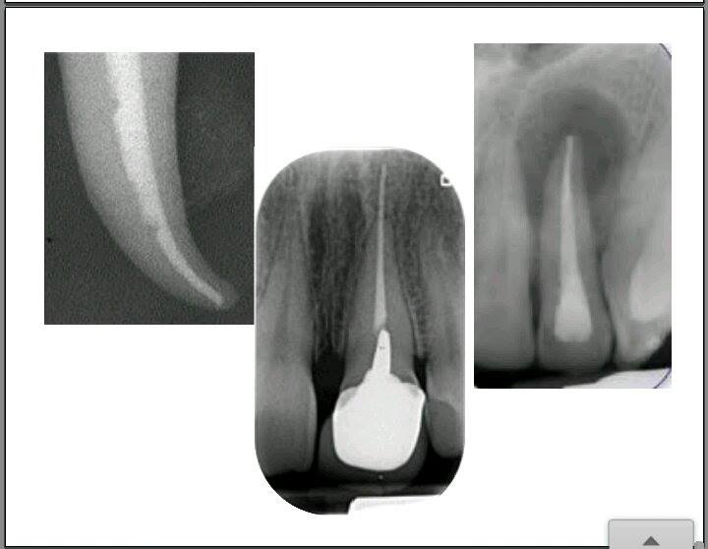
2
3
1
pic #1 there is voids [error in obturation ,compaction doesn’t react to the button of canal]
pic#2over filling but its not proplem ,because its not form periapical lesion.
Pic#3there is spreader tract means that you used small accessory GP cones so the sealer is more that what it should .
**spreader tractappear as lines in the canal .
**effect of spreader tract lead to sealer disintegrate
-in sometimes in the future ,coronal leakage will form,and that will form high way for bacteria grow.
Sealer get outside the canal this called sealer buff.
Sealer buff is not a problem ,and American school like the sealer buff.
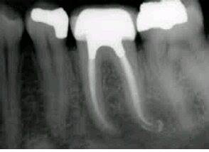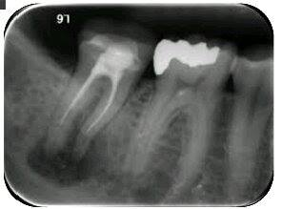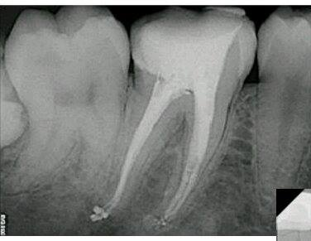
In mesial root of molar ,ther is space between the two canal {it is not a void and you cant remove it} .
-selear buff
-there is avoid.
Space between 2 mesial canal
Mesial side

Under filling

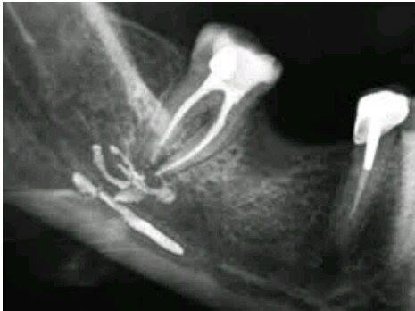-sealer buff doesn’t cause a problem ,but over extension regardless wither it’s the cone GP or sealer ,is not recommended.
-in case over extension of sealer into alveolar canal and the patient get paralysis {permanent due to damage of nerve which is inferior alveolar nerve }.this lesion can caused by:-
1-large amount of sealer.
2-insert spreader more than working length .
3-insert of master cones
4-lower molar are located near the inferior alveolar canal so we should be careful when we work in this area.
*****usually the rods of lower more located buucly or lingually to the alveolar canal,but it could located inside the canal in some case
So it should be extracted
Finally
Best wishes

