What does the word (endodontics) means ?
Endo means inside while dontics refer to the teeth, so endodontics means: what we have inside the tooth.
So endodontic is a specialty of dentistry, that deals with the tooth pulp and tissues surrounding the root of a tooth.
And we have already known from the anatomy and the histology that the tooth is made of layers which are:
- the enamel 2. The dentine 3. The pulp ( innermost layer).
And from the pulp –the apical foramen in specific- the blood and the nerve supply enter the tooth and circulate until reaching the end of the tooth.
And in endodontics, since we are dealing with the pulp of the tooth and the tissues that surround the roots, any infections or problems that occur in the pulp might affect the surrounding area.
So, when an inflammation occurs in the pulp, we will not treat it only but we will also treat and protect the tissues that surround the root of an apex.
Our main target in endodontics is the preservation of the pulp from dying so that the nutrients, the blood and nerve supply can reach the tooth. But if we reach a point in which the pulp can't be preserved due to an inflammation or any other reason, then the pulp must be removed and the canals should be enlarged and cleaned from the infection then we put nerve filling and in this case our target is to conserve the surrounding tissues free from diseases.
So, our main target first of all is to preserve the pulp but when this couldn't be achieved, then our target becomes to preserve the surrounding tissues.
All what we want is to have a functional tooth that is located in its place and do all its functions normally ( in speech, in eating and esthetics).
Our main problem in endodontics ( pulpitis) is the bacterial infections and our ultimate goal is to 1. prevent an infection or 2. to treat an infection. So, the major problem is the presence of the bacteria which will cause a decay that reaches the pulp and leads to an inflammation. But when there is no bacteria, then there is no problem. Therefore, all what we want is to kill the bacteria and prevent the infection from occurring.

Now, why do we do root canal treatment?
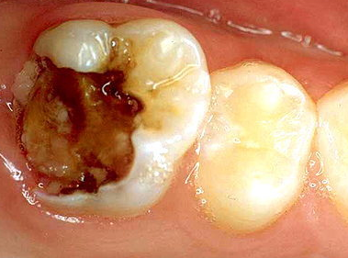
Here we have upper molar tooth which is not normal, it has a decay.
What actually happen is that any decay starts from the outermost layer which is the enamel. Since the enamel has no nerve endings, the patient doesn't feel any pain. Then, the decay spreads to the second layer which is the dentine. Here, since we have nerve endings, the patient starts to feel the pain in the presence of the stimulus and when the stimulus is gone, no pain is felt which means that the patient becomes sensitive to hot and cold water and this gives an indication that the pulp is inflamed to a certain degree.
Now, if the patient doesn't go to the dentist, then the caries increase and reach the pulp causing inflammation to it, and this is what we call PULPITIS. This inflammation starts as a reversible inflammation which means that the pulp could heal itself if we took certain measurements and procedures. But if the inflammation reaches a higher degree, it becomes irreversible which means that the pulp couldn't heal itself and all what we can do is to remove it since the patient will be suffering from a severe pain and he/she can't sleep for several days.
How can we differentiate between the reversible and irreversible inflammation?
From signs and symptoms. So, if the patient comes to your clinic with severe pain that prevents him from sleeping at night or increases when he lays down, then it is an indication that he is suffering from irreversible inflammation and this tooth should undergo root canal treatment or endodontic treatment.
Now, If the patient that suffers from the irreversible inflammation tolerates the pain and took pain killers, what will happen with the pain?
Since the pulp couldn't heal itself and is inflamed, then fluids start to accumulate in this soft tissue which is located inside the dentine ( hard tissue ). This increases the pressure inside the pulp so it tries to expand, however the dentine prevents it to do so and this leads to the death of the pulp that is called pulp necrosis.
Summary:
We starts with a healthy pulp small decay reversible
Increase in the decay irreversible spontaneous pain
Pulp necrosis.
And due to the pulp necrosis, the face becomes swallowed.
In both irreversible pulpitis and pulp necrosis, we have to do root canal treatment.
Another case in which we have to do RCT is trauma: when the tooth gets fractured, the pulp becomes exposed and we have to do RCT even though the pulp is healthy and we have no caries.
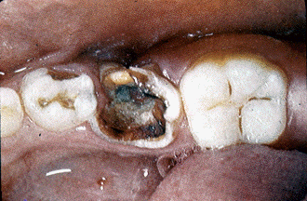

Regarding to the picture above:
Deep decay do RCT
But we have to make sure that the tooth is restorable before doing RCT.
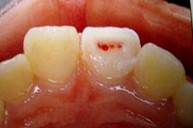
Blood droplets we are in the pulp region.

What are the general steps of root canal treatment?
- Access cavity: which means to gain the access to the pulp that is hidden inside the tooth. So, I have to drill the tooth to reach the pulp in a good quick manner.
- Cleaning and shaping of the canals: after reaching the pulp that is located inside the canals ,I need to determine the length of the canals which are very small. So I start to enlarge and clean them from any pulp tissue.
I clean the canals by washing them using irrigates and I enlarge them using files.
The purpose of enlarging the canals is to clean them from bacterial infections.
- Obturation (filling) of the canals: after cleaning the canals I have to close them using filling materials.
And this semester we will only discuss how to access the cavity .

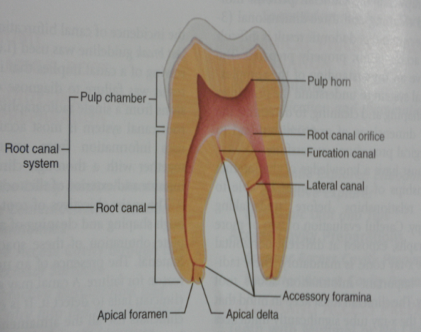
Regarding to the picture:
This is the tooth from inside.
The yellow one is the dentine.
The white one is the cementum.
The root canal system is made from : pulp chamber and pulp canals.
The opening from which the pulp, the nerves and blood supply enter is called apical foramen.
Apex: is the end of the root and apical foramen: is a foramen that is located at the apex.
The openings that are located at the floor of the pulp chamber is called orifices.
So, the canal starts from the orifice until reaching the apical foramen.
The canal is not a single one that goes straight downward, but sometimes it branches from small openings into small canals called accessory canals or lateral canals ; Ex: the canal that is located in the bifurcation area is called bifurcated canal.
Note: we can't reach the accessory canal and clean them using files since they are very small.

Vertucci’s canal configuration:
Vertucci is an Italian scientist that decided to study the shape of the root canals and determine whether all of the roots have a small single canal that starts from the orifice and end in the apical foramen or there are differences.
He brought a huge number of teeth and cleaned them, then he did the sectioning, made them transparent and studied the canal's configurations. He noticed that having a root with a tapering canal and single orifice is an exception which means that a single canal that starts from the orifice and ends in the apical foramen is an exception.
Actually, he found 8 configurations for the root canals:
- Type I: single canal extending from pulp chamber to the apex with no branching (1), which is an exception.
- So we have one orifice and one foramen.
- Type II: Two separate canals leaving the pulp chamber but join short from the apex which means they are joined before reaching the apex (2-1).
So we have 2 orifices and 1 foramen.
- Type III: one canal leaving the pulp chamber that divides into 2 canals then merges again to exit as one canal (1-2-1).
So we have one orifice and one foramen.
- Type IV: two separate canals extending from pulp chamber to apex (2).
So we have 2 orifices and 2 foramens.
- Type V: One canal leaving the pulp chamber and divides and exits the apex as two separate canals (1-2).
So we have 1 orifice and 2 foramens.
- Type VI: two separate canals leaving the pulp chamber then unite to form one canal then divides and exit as two canals (2-1-2).
So we have 2 orifices and 2 foramens.
- Type VII: One canal leaving the pulp chamber then divides into two canals then unite to form one canal then re-divides and exit as two canals (1-2-1-2).
So we have 1 orifice and 2 foramens.
This type is extremely difficult to be treated.
- Type VIII: three separate canals leaving the pulp chamber and exit the apex (3).
So we have 3 orifices and 3 foramens.
These 8 configurations are not the only ones that are found in all populations but they are the most common.
Another researcher called WEIN found four possible configurations:
- Single orifice, single foramen (equals type 1 in vertucci).
- Two orifices, one foramen (equals type 2,1).
- Two orifices, two foramens (equals type 2).
- One orifice, two foramens (equals type 1,2).

It is important to know these configurations because upon studying the characteristics of PM for ex: when I say that the most common configuration is type 4 then in vertucci it is ( 2 ) so when I found one canal, then I have to look for the second one and so on.
Note: the orifice is located at the level of the CEJ.
Apical root anatomy (end of the root):
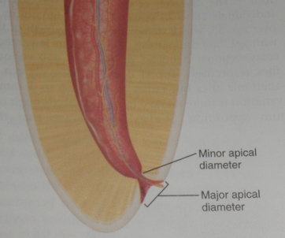
Arrow 1: dentine
Arrow 2: pulp
Arrow 3: apex
If this picture was a radiograph, then the apex is called radiographic apex but when we extract the tooth and look at its apex then we call it anatomical apex.
Upon doing sectioning for the canal and look at it under the microscope, they realized that the widest region is in the orifice while the narrowest region is located at a region just before the foramen and is called the apical constriction region.
Notice that the canal starts from a wide region then it becomes narrow then wide again.
Now, upon doing RCT, the best area to be reached and in which the shaping, cleaning and filling can be controlled is the constriction region. Beyond to it, it becomes difficult to be controlled since it is getting wider.
The apical constriction region is called minor apical diameter.
While the apical foramen is called major apical diameter.
Important notes:
- When making RCT, your main goal during cleaning and shaping is to reach the apical constriction region not the apical foramen.
the apical constriction region is the best area where you can stop and do your filling -no more, no less-.
- It is not necessary for the apical foramen to be located inside the apex, so the canal may not exit from the apex – especially in the lower molars- , it can exit lateral to it .
How can we differentiate between apical constriction region, apical foramen and the apex ?
Using X-rays.
We enter the file through the canal and see the tip of it in relation to the apex whether it is shorter than it in 1mm or 2 mm.
And we are going to learn that upon entering the file in the canal, we don't reach the apex instead we have to reach the apical constriction region. And researches have shown that the distance between the apical constriction region and the foramen is 1 mm while between the foramen and the apex is 2 mm. So upon doing RCT ,we have to stay shorter than the apex.

Done by : Dina Musa
Best wishes.

