Extra notes for Anatomy lecture # 3
Slides: Skull 2

-Superior view of the skull
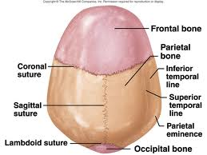
Coronal suture : A joint between the anterior bone (frontal) and the two parietal bones
Lambdoid suture : A joint between the posterior bone (occipital) and the two parietal bones
It looks like the letter Y ..
This sign Y is called lambda that’s why this suture is called “Lambdoid”
Sagittal suture :between the two parietal bones .

-Superior view of skull at birth :
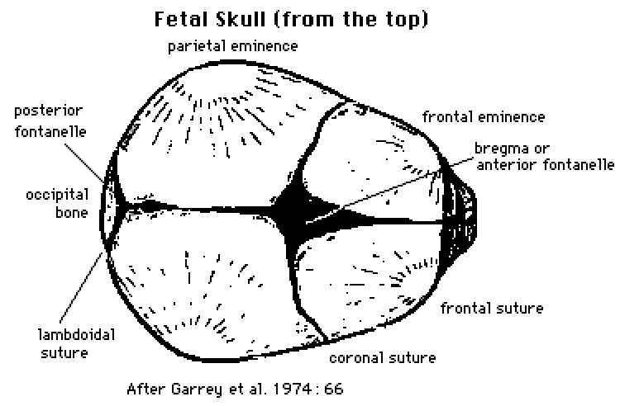

All the bones were 2 parts :
Frontal, parietal and the occipital ,all of them were 2 bones (not fused)
The 4 bones (2 frontal and 2 parietal ) got a soft gap in between called: Anterior fontanelle ”Diamond in shape”
The 4 bones (2 occipital and 2 parietal) got a soft gap in between called: posterior fontanelle “Triangular in shape”

** The importance of the Fontanelles :
-Easy birth : To minimize the circumference of the baby head to pass through the pelvic
-Postnatal growth : because the brain is growing

-Mandible :
It was 2 halves joined by “symphysis menti “
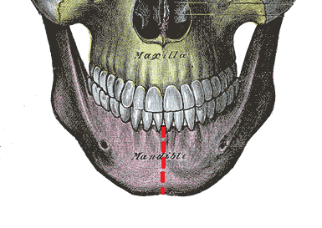
-The oblique line:
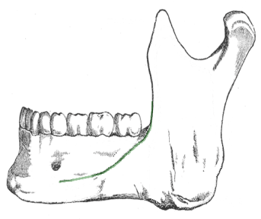 The anterior border of the ramus continuation is the oblique line

-You can see “Symphysis menti” and “mental protuberance” from the anterior view of the mandible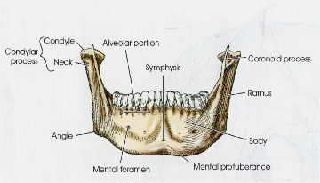

-Body inner surface :
Mylohyoid line devides the inner surface into upper triangle/part and lower part .
Each part with : 1-Glandular fossa for the sublingual gland
2-nerve groove for the lingual nerve “Sometime when you do tooth extraction for the wisdom tooth you cut it by mistake because its close to the root of the wisdom tooth .
Mental spines :
At the inner angle of the mandible .
Origin for Genioglossus and Geniohyoid .
Submandibular fossa : for submandibular gland
Mylohyoid groove : For mylohoid nerve which is a branch from inferior alveolar nerve that is a branch from the mandibular nerve which is a branch from trigeminal nerve .
Ramus of the mandible :For insertion .

Good luck
Your colleague : Qais Mismar

