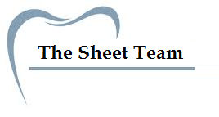
Title of Lecture: drug-receptor interaction

Date of Lecture:30/9/2014

Sheet no: 8

Refer to slide no. : 28-44

Written by: Ghaidaa abuzahra & Nahla Eliwi
In this lec. We will talk about the drugs that mediate their effects through receptors at the site of action ( drug –receptor interaction )
s.28
we start with a given dose until a response is shown, we increase the dose until reaching the point with no further response is achieved , this point is the (Vmax).
There are specific number of receptors at the site of action . At the Vmax → all receptors are occupied with the drug. And sometimes we reach the Vmax without full occupancy of receptors , eg: Insulin hormone . * insulin → decrease blood sugar level
→if you increase the dose, you increase the response , but you don’t need it, because excessive increasing in response could be harmful to the patient .
Imagine that we have 100 receptor at the site of action, and we have a drug (molecule) that attaches to these receptors until reaching the V max (maximal response ).
Eg. What do you think of drug( insulin ) that occupies only 10 out of 100 receptors ( 10%) in order to reach the Vmax? Excellent drug because there will be a 90% of receptors are free not occupied yet ,so the drug can use the 90% , if these 10% of receptors are damaged due to frequent use .
So we reached the Vmax with 10% of dose which is excellent , but if I continue with increasing the dose of insulin the patient will be in a comma and may die ( hypoglycemia- high insulin with low concentration of glucose ) so I need to reach maximal response that produces the desired effect without side effects.
*most drugs need to occupy all these receptors in order to reach Vmax (most important parameter in pharmacodynamics and pharmacokinetics )
Hypoglycemia is more dangerous than hyperglycemia
Normal blood sugar level 80-120
If Glucose concentration <40 ml (hypoglycemia =death ) but hyperglycemia will not lead to death only a comma .
*sugar will enter obligatory – independently to essential organs (liver –CNS) because sugar is important to these cells .
Eg.if we put an organ (heart ) in an organ path +10 ml of specific drug→ increasing contractility .
If we increase the dose to 20ml , the contractility will increase gradually ,then 30 ml the response will increase more and more until we reach a point with no more increasing in response (Vmax) .
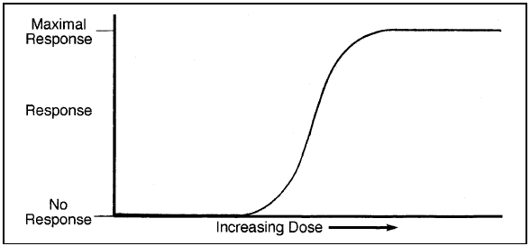
↑ dose→↑ response until reaching Vmax (maximal response )
s.29 in pharmacology we use log dose instead of dose in the curves →we have same concept (increasing the log dose will increase the response until reaching Vmax ) with different shapes ( the curve here is sigmoidal )
s.30
remember in kinetics the relation was between T1/2 and concentration
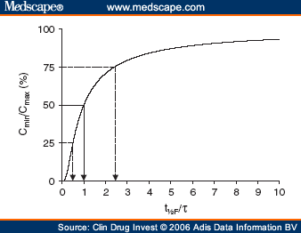

But here the relation is between log dose and response
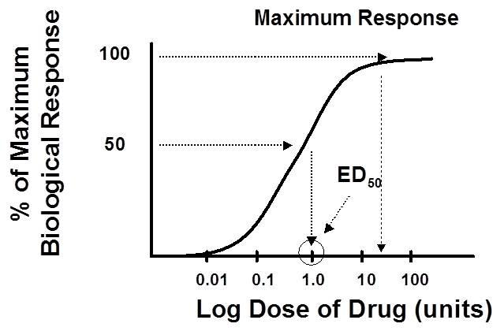
50%of response is defined as effective dose 50 =ED50
Vmax here is 100% response
ED50 is 50%response
Be careful : all previous curves are graded
s.31 we have to identify LD50 before approving any drug
Safety is assisted based on such a parameter LD50 (lethal dose 50 ) and it’s tested on animals not on humans .
Experiment: number of animals +specific dose of drug we increase the dose gradually until all animals die , this is the Vmax THEN we construct the curve to determine LD50 the dose which kill 50% of animals.
** in humans we determine the SIDE EFFECTS not DEATH .
s.32 patient – dose curve
Left arrow : non responders area right arrow : side effect area
In the middle : people who respond to a given dose

s.33 when distance between the left line (desired effect) and the right line(side effect ) ↑↑ the drug is safer .
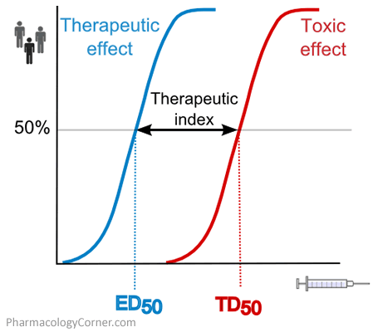
-Eg. Lets consider that we have a drug , its ED50=10 AND LD50=1000 the distance between 2 curves(therapeutic window ) is wide . so it’s a good drug.
if the therapeutic window is narrow drug is not safe BUT sometimes we have many drugs that have a narrow therapeutic window and widely used in medicine eg. Anticancer drugs.
-the patients that take anticancer drugs should develop side effects.
REMEMBER:
1)Any patient who takes a drug with a narrow theraputic window drug must be monitered and the patient must be monitered from toxicity .
2)in kinetics we need to keep concentration of a drug at static state must be within peak-trough value but without reaching a toxic level .
S.34
Maximum response= efficacy (fa3aleeyt el dawa2 )= intrinsic activity (al nasha6 el da5alee ll dawa2 )
Remember in the first lec. We said that any search starts with an idea and the first step is to assess the efficacy.
s.35 theraputic index (is defined as a ratio )
TI : theraputic index LD50:lethal dose ED50 :effective dose
Eg : LD50=1000 ED50=10 TI ?? TI= 1000/10 = 100
Eg : drug #1 WITH TI= 100
Drug #2 with TI= 50 WHICH DRUG is safer ?? drug # 1

Potency is the strength of the drug. It’s a term that is used whenever we compare the dose of two drugs from the same category or the same class.
NOTE: Potency is comparable only for drugs within the same class.
As an example, we can’t compare the potency for Beta blockers with calcium channel blockers drugs, because they refer to different classes, While Efficacy can be compared between drugs from different classes or categories.
so when we compare Beta blockers with Calcium channel blockers , we depend on their efficacy and their effect on Blood pressure , so we can say , Beta blockers lower the blood pressure , to the same extent as calcium channel blockers.
B
A

Which of those two drugs A and B , is more potent ?
(A) , because only a small dose is needed of the drug to achieve the Vmax.
- So the drug with the higher ED is less potent.

ED50 10mg ED50 500mg
Drug A Drug B

But in a general term , Drug’s potency , or how much is the daily dose , and how many times this drug is taken , Doesn’t matter in pharmacology as long as the drug has reached its Vmax.
Affinity
is the bonding strength of the drugs to the receptor , the stronger the bonding the more the affinity , the more the stability of the drug-receptor complex is .
Affinity depends on the binding forces , and drugs can bind with receptors by more than one type of force . it’s not necessary to bind by one force only , but most of the drugs are bound by Van dar Waals force .
So a good drug , is the drug that has a good affinity to the receptor and forms a good complex , with a reversible type of binding.
-Drugs can be evaluated by many indices and all of them are the same as the Therapeutic index (TI) .
Margin of safety (LD0.1/ED99.9) , this means the dose that causes side or toxic effects is 1% , compared to that dose that causes 100% .
The larger the value , the better is the drug .
*( the doctor said he only wants us to know the equation of margin of safety , and that it means , that the dose is effective dose and produces response in more than 99% , and produces side effects in less than 1% .)
The more the index , the better is the drug.
Margin of safety= LD1 - ED99 / (ED99) x 100%
For example, if a 100mg of drug causes toxicity in 1% of the population and 10mg is effective in 99 %, then the standard margin of safety equals to:
100 - 10 /10x 100 = 900
This means that the dose which is effective in 99 % must be increased 900 % to be toxic to 1% of the population
So the higher the margin of safety the better is the drug. But we should know that there are some drugs which have low TI but still are commonly used , as anti-cancero drugs and digoxin, they have narrow therapeutic window , but they are still used , and for that reason we have to balance the dangerous effects of disease VS Safe effects of the drug .
PROTECTIVE INDEX (PI)
Is an excellent index to evaluate the safety of the drug , and it measures the side effects of a drug .

ED50 producing side effects
PI =
ED50 producing desired effect
A ratio of 1 means that this drug produces good effects in 50% of individuals , but at the same time produces side effects in 50% of individuals .
The higher the PI the better the index is .
-Slide no. 41
Drug A , TI = 100 / 50
100 is the dose that causes side effects , 50 is the dose that causes good effects .
Drug B is safer , because the dose that causes side effects is 250 mg , while taking 100 mg of the drug A
causes side effects , So B is safer , the higher The TI the safer is the drug.
-referring to slide no. 42
Considering that these are different drugs , A , B , and C are within the same class -Drug A is more potent than C
-Drug A , C , and D have similar efficacy ( Vmax ).
-Drug B has the lowest efficacy .
- A is more potent than B , Because the effective dose for drug A is less compared to the effective dose for the drug B.
-Drug B is more potent than drug C .
- We cant compare the potency of drugs D and C , because they are within different classes (different curves ) , So D is NOT more potent than C , but they have similar efficacy.
AGONISTS AND ANTAGONIST :
Agonist is a drug that binds the receptor , and produces a response .
Antagonist is a drug that binds a receptor , and produces no response.
A strong agonist occupies number of receptors and produces maximum response , and this is called FULL AGONIST.
which means the spare receptor theory is a good theory , as insulin , it only occupies 10% of the receptors .
PARTIAL AGONIST : this type attaches to the receptor and produces response , but it has lower efficacy , and reaches the maximum potency .
Agonist-antagonist agonists , it’s like an agonist that has some antagonistic effects.
INVERSE agonist : is a drug that produces an effect opposite to the agonist’s effect.
He didn’t explain slides number 45 , 46
slide 47
this slide shows that the agonist produces effects while the antagonist produces no effects , and the inverse produces opposite effects to the agonist.

Written and corrected By :
Nahla eleiwi and Ghaida’a abu Zahra

