General Surgery sheet # 6
Otolaryngology .
Written by : Aseel Al-majali & Saja Al-garalleh .

The ear is divided into 3 parts: the inner part, middle part, external part.
External ear : extend from the external auditory to the tympanic membrane .
Middle ear : consist from ; malleus , incus and stapes .
Inner ear : cochlea , circular canal and the receptor organ which is responsible for hearing and balance

There are some tests that examine the hearing ability :

1-Rinne test :
Placing high frequency vibrating fork against the patient's mastoid bone , patients with normal ears should hear the sound bilaterally!
The sound has 2 ways of conduction :
- Air conduction which uses the apparatus of the ear directly to the inner ear .
- Bone conduction via the bone of the skull to the apposite ear ( louder sound ) .
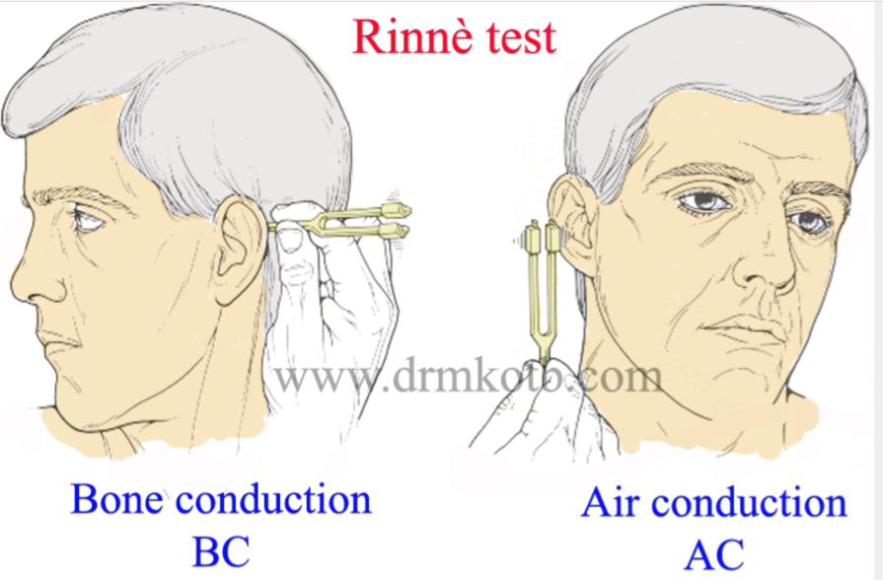
* in normal ear : air conduction is better than bone conduction and the patient hear the voice in both ears with the same intensity .
* in blocked ear : bone conduction is better than air conduction .

2- Weber test : ( more sensitive test ) .
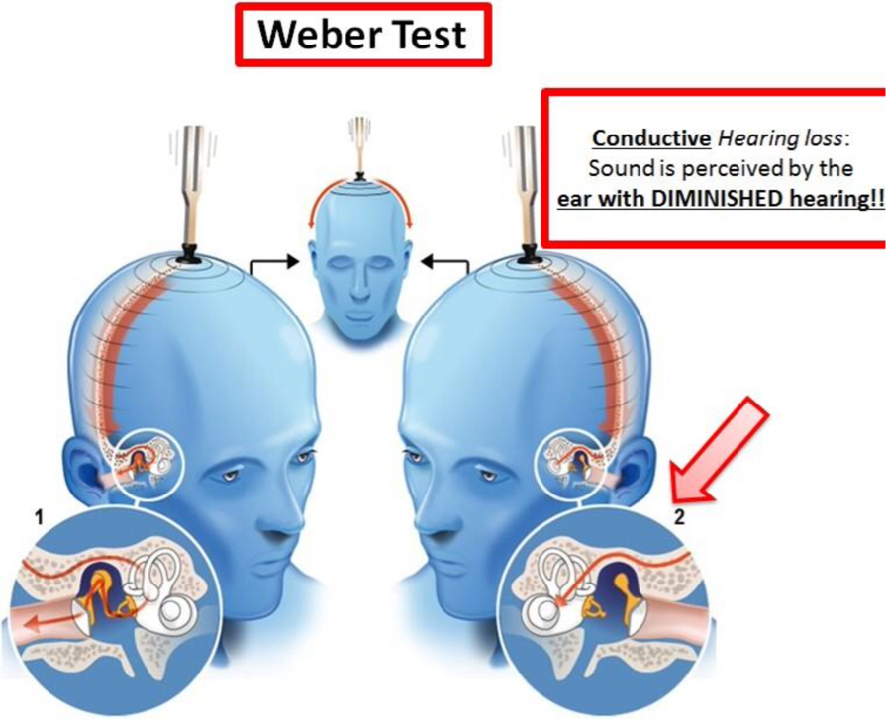
Test in which the stem of vibrating fork is placed on the midline of the head to ascertain in which ear the sound is heard by bone conduction .

Otalgia :
- pain in the ear .
- it's either primary or secondary .
*primary otalgia : pain in the ear itself due to trauma or otitis media (plugging of the tympanic membrane ) . Usually happened in children.
* secondary otalgia : the origin of the pain is outside the ear and radiating to the ear . There are several nerves that transfer the pain to the ear :
1- Trigeminal nerve : related to dental problems ; dental infections , dental caries , malocclusion, TMJ disease and TMJ arthritis.
2- Facial nerve : reactivation of herpes zooster in the ganglion of the nerve causes secondary otalgia .
The vesicles of virus in the ear causes primary otalgia .
3- glosso-pharyngeal nerve : when the patient suffering from Acute tonsillitis or glosso-pharyngeal neuroglia .
4- cervical plexus mainly C2 & C3 .

Nose and paranasal sinuses :
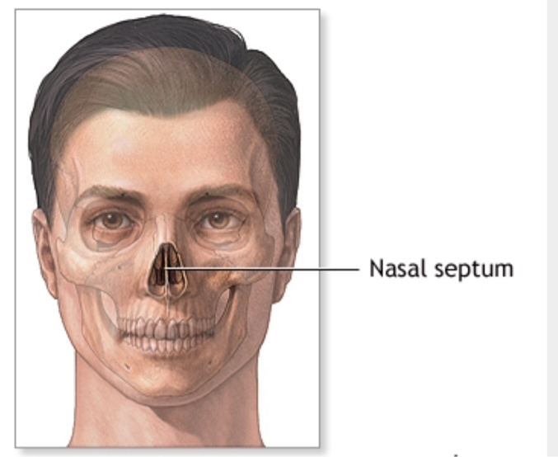
Nose: hollow space in the face composed of left and right chamber separated by a septum .
Septum: composed of posterior bony part and anterior cartilaginous part .
Superiorly ; bordered by cribriform plate which lined by olfactory epithelium.
Inferiorly ; bordered by the hard palate .
Anteriorly ; bordered by anterior Nares .
Posteriorly; bordered by post opening to the nasopharynx ( post choana ) which connect the nose to the nasopharynx.

* Each chamber has medial wall (which is the septum ) and lateral wall ( which composed of three turbinates and opening of the sinus ostium ) .
*** note : each turbinate ( concha ) has a meatus !

{ Cribriform plate lined by olfactory epithelium while the other parts of the nose lined by respiratory epithelium except the anterior part which lined by squamous skin } .

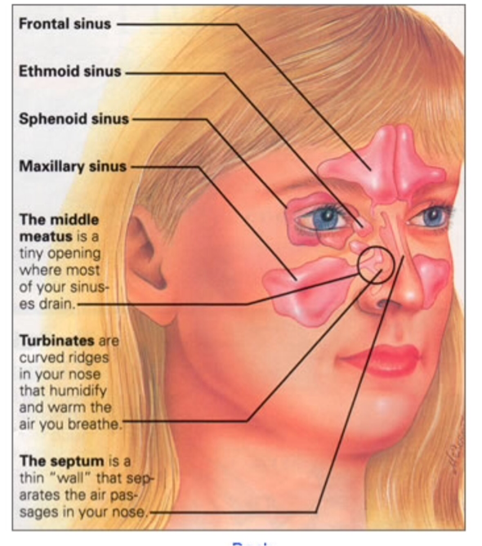
Paranasal sinuses :

Composed of 4 pairs of sinuses :
1- Maxillary sinus : the largest one , close to the roots of upper premolars , first molar and second molar .
2- Frontal sinus .
3- Ethmoidal sinus : located between the eyes and divided into anterior and posterior ethmoidal and separated by ...... ( sry i can't hear it ) .
4- Sphenoid sinus : most posterior one .

* The anterior sinuses: The maxillary, the frontal and anterior ethmoidal .
* The posterior sinuses: The sphenoid and the posterior ethmoidal .

It's very important to know where each sinus drains :
- post ethmoidal drains in the superior meatus under the superior turbinate .
- sphenoid drains in the sphenoethmoidal recess above the superior turbinate .
- maxillary , frontal and anterior ethmoidal drain in the middle meatus under the middle turbinate .
- nasolacrimal duct drains in the inferior meatus under the inferior turbinate .

*** Common symptoms of nasal disease includes ; nasal obstructions, sneezing and snoring, facial pain and anosmia .
- Physical examination performs by Thudichum speculum allow the physician to examine anterior turbinate and middle turbinate , other posterior structures like nasopharynx examined by endoscopy .

~ Now we are going to talk about some clinical situation related to the otolaryngology. 🙂

Epistaxis :

Bleeding from the nose usually from the anterior part of the septum.
* dental causes of epistaxis : traumatic dental extractions , maxilla facial trauma , Antrum fistula or tumors of dental origin .

- Treatment:
- Go for ABC and secure the alveoli .
- Do manual hemostasis : applying pressure by squeeze the nose for 5-10 min , this should stop the bleeding .
- The patient should keep his / her head elevated .
If the bleeding doesn't stop ; put adrenaline of congesting pack inside the nasal cavity .
- Doing cotalization .
- Nasal packing either anterior or posterior . Anterior packing by using wrippon gauze bilaterally and inject with normal saline just to apply pressure at the source of bleeding , posterior packing by fully skapetars ( size 10 or 12 ) .
- If we failed to control epistaxis using this method we could go for imaging, arteroligation or embolization .

Maxillary sinusitis :

Cause :
90% Rhinogenic or nasal causes like deviated nasal septum , anatomical problems in the nose
10% dental origin causes like apical abscess of upper premolars or molars , faulty extractions or traumatic foreign body get inside the sinus .
Sinusitis divided into Acute and Chronic sinusitis , they have the same sign and symptoms : ( purulent discharge , headache , pressure and facial pain ) .

{In dental origin usually unilateral and the discharge is malodorous because of anaerobes from dental infections } .

** the difference between acute and chronic is only clinical in the major and minor criteria of diagnosis :
-Fever considered a major symptom in the acute sinusitis but a minor symptom in the chronic sinusitis .
- The duration of the disease :
Acute sinusitis last for 4 weeks whereas the chronic one last for more than 12 weeks .
In Subacute sinusitis the disease last for 4-12 weeks .

Investigations :
*In case of acute sinusitis we start with plane radiography. ( this method is not sensitive and not specific ) .
* If there is no improvement in the situation of the patient after 2 months in the chronic sinusitis , the best standard technic to use is the CT scan ( coronal and axial ) .
* In the acute there is no need to do a CT scan unless we suspect any complications in the eyes or the in the brain .

- Treatment:
Acute : usually viral infection but if it bacterial give the patient antibiotic . If it viral give the patient supportive treatment ( nasal decongestant and analgesic )

Chronic : medical treatment for 2 months with antibiotics and local corticosteroids ( flexonase or histamine ) . If there is no improvement surgical procedure must be done ( endoscopic sinus surgery) .

Facial pain of ENT origin( ear,nose,throat)

- otitis externa
- sinusitis
- Atypical facial pain

***CaldWell Luc Operation , Also called “Sublabial antrostomy” :
** infra-labial from canine fossa inferior to infra orbital then to maxillary sinus

* Indications:
1. Foreign bodies in maxillary sinus.
2. As a route to the pterygopalatine fossa.
3. Insertion of submucosal implants.
4. Selected cases of maxillary cysts and tumors

* Complications: 1. Sublabial oro-antral fistula.
2. Trauma to the root of the teeth or their nerve and blood supply (devitalization of teeth).
3. Infraorbital neuralgia ( trauma to the infraorbital nerve)

**Pharynx : nasopharynx , oropharynx, laryngopharynx:

Nasopharynx: rostrum of sphenoid bone to hard palate .
Oropharynx :hard palate to hyoiod bone .
Laryngopharynx: hyoiod to cricoid cartilage .

***Trismus:

Trismus by definition is limitation in jaw opening. It has a relation with lateral pterygoid muscle.

Causes :
1) Dental infections:
2) Impacted wisdoms.
3) Separation around the pharynx such as peritosilar and parapharyngeal.
4) External otitis or otitis externa.
5) Tumors.

Whenever we have a pathology involving the head and neck and around pterygoid muscles it will cause trismus and limited mouth opening.

***Adenoids:
Is a common disease that we practice in our clinics. Most pediatrics age group has large adenoids and after the age of 7 we have limited adenoids and it just decrease in size.

characterized by :
1. Open mouth and thick dry lips. 2. Hitched-up upper lips. 3. Protruding incisors , faulty bite, caries. 4. Receding chin. 5. High arched palate. 6. Flat nasolabial folds (expressionless face). 7. Mucoid or mucopurulent nasal discharge. 8. Inactive ala nasi.

Investigation:

X-ray shows the post nasal space. it’s a lateral view of the post nasal space that show a large adenoid.

Treatment:
Actually the treatment of adenoids we go for surgery called adenectomy.

***Tonsillitis:
Acute tonsillitis is an infective process involving the tonsils. It can be divided into : follicular , catarrhal …. Congested tonsils (catarrhal) which may be studded with yellowish spots (follicular).

-Most common cause of follicular tonsillitis is streptococcus groups.
-Catarrhal means viral infection.(not superimposed bacterial infection

Clinical picture:
Fever, sore throat , dysphasia , coated tongue , halitosis , congestive tonsils , large tender jugulodigastric lymph nodes.

Differential diagnosis:
* other causes of sore throat.
* Diphtheria ( true membrane).

Complication of acute tonsillitis:

1) Peritonsillor abscess .
2) Otitis media.
3) Autoimmune disorder: Rheumatic fever, Acute glomerulonephritis

Treatment of acute tonsillitis:
Oral antibiotics and systemic antibiotics.

***Peritonsillar Abscess (Quinzy)

* Pus collection between the capsule of the tonsil and its bed (superior constrictor muscle).
* Types:
- Superior (98%): In the soft palate. Follows AFT.
- Lateral (2%): Dental origin (Lower wisdom).

Clinical picture:

*symptom: 1. Throat pain ( more severe on one side). 2. Dysphagia. 3. Halitosis. 4. Trismus. 5. Otalgia. 6. Fever.
* Signs: 1. Tonsils are congested and pushed medially. 2. Soft swelling above and lateral to the tonsils. 3. Edematous uvula. 4. Torticollis. 5. Enlarged tender JD lymph nodes. 6. Coated tongue.
* Complications: 1. Parapharyngeal abscess. 2. Laryngeal edema and stridor. 3. Septicemia.
* Treatment: – Pre-suppurative stage (cellulitis): antibiotics, gargles.
– Suppurative: Drainage, antibiotics , +/- tonsillectomy after one month.

Parapharyngeal abscess***
* Suppuration in the parapharyngeal space.

* Etiology: 1. Dental infections. 2. Quinzy. 3. Trauma.

*Symptoms: 1.Throat pain. 2. Neck pain. 3. Dysphagia. 4. Fever and malaise.

*Signs: 1.The tonsil and pharyngeal wall are pushed medially. 2.Tender soft neck swelling. 3.Trismus. 4.Torticollis
.
*Complications: 1. Laryngeal edema. 2. Spread of infection to other neck spaces and mediastinum. 3. Jugular vein thrombosis

*Treatment: 1. External drainage. 2. Antibiotics.

Retropharyngeal Abscess***
Pus formation in the retropharyngeal space (retropharyngeal space is only found-common- in pediatric patient and is regumentary? At the age of 6)
We may have retropharyngeal abscess in elderly patient and its due to tuberculosis and malignancy.

** Acute: – Infants and children
- Clinical picture: 1. Difficult feeding and breathing. 2. Chocking. 3. Croupy cough. 4. Cystic hyperemic swelling to one side of the midline.
- X-rays: Widened retropharyngeal space. • Complications: 1. Stridor. 2. Rupture. --
Treatment: 1. Drainage (Trendlenburg position). 2. Antibiotics.

**chronic : – Adults. – Cervical T.B. infection (Pott’s disease).
-clinical picture: 1. Dysphagia. 2. Chocking. 3. Painful cervical spine. 4. Soft cystic swelling in the midline.
X-Rays is diagnostic. • Treatment: External drainage , anti TB drugs.

Ludwig’s Angina***

* Cellulitis of the floor of the mouth and the submandibular space submental spaces and sunlingual from
* Etiology: 1. Dental infections.
2. Trauma
3. Bacteriology: Anaerobic organisms, Staph
* Clinical picture: 1. Fever. 2. Dysphagia. 3. May be stridor. 4. Firm tender swelling in the floor of mouth and submandibular region. 5. Tongue is edematous and is pushed upwards and backwards.
* Complications: suffocation
* Treatment: 1. Drainage. 2. Antibiotics. 3. May be tracheostomy

***Stridor: Difficult noisy breathing due to partial obstruction of the upper airway.

Classification: *
a) Inspiratory: Laryngeal obstruction.
b) Expiratory: Bronchial obstruction (asthma).
c) Mixed: Tracheal obstruction.

• Dental causes of stridor:
1-Trauma: 1. Inhalation of denture or tooth. 2. Maxillofacial injuries
2-Inflammation: 1. Ludwig’s angina. 2. Deep infections of the neck.
3- Tumors : 1. Tongue. 2. Hypopharynx.
4- Laryngeal edema: 1. Vincent’s angina. 2. Allergy and idiosyncrasy.
5- Anaesthetic problems

. * Degrees of stridor:
1- Mild stridor:
1. Noisy breathing. 2. No dyspnea. 3. Suprasternal and supraclavicular retractions.

2- Moderate stridor:
1. Moderate dyspnea. 2. Suprasternal, supraclavicular, and intercostal retractions.

3- Severe stridor:
1. Severe dyspnea. 2. Tachycardia, tachypnea, and sweating. 3. Cyanosis. 4. Epigastric retractions. 5. If untreated the patient develops respiratory failure and calm down. Death eventually occurs.

​​
* Treatment of stridor:
– Mild and moderate: 1. Corticosteroids. 2. Wet Oxygen. 3. I.V. fluids. 4. Antibiotics. 5. Close observation.
– Severe and progressive stridor: 1. Tracheostomy (tracheotomy). 2. Endotracheal intubation.

Best of luck ... 😊

