Sheet no : 1
Refer to slide no : 1
Written by : Mahmoud Qaisi
corrected by Sahem Jamaen
*******************************************
** The slides SHOULD be studied
In order to know if the disease is “genetic” or just a “common” disease, we should know if the disease has spread in the “family tree” (if it has affected relatives).
Genetics: Is the branch of biology that deals with heredity and variation in all living organisms.
The subfields of genetics:
Human genetics
Animal genetics
Plant genetics
Medical genetics
Nucleotides “ATCG” are the determinant of the genes of all species “humans, animals, plants, bacteria, etc”, the difference that determines what species it is, is based on how the nucleotides are arranged.
Medical genetics is different than human genetics, medical genetics deals with diseases that are produced due to genetic problems “it studies the variations that pertain to a disease (for example in thalassemia we should recognize what gene/nucleotide has mutated or changed to produce this disease)”, while human genetics deals with normal and abnormal conditions of a human gene.
There are some people who have certain arrangement of nucleotides, which make them more susceptible to develop certain diseases “diabetes for example”, this does not mean that these people have some sort of illness or their gene is abnormal, they are just more susceptible to diseases that’s all.
Until now there is no drug that can cure genetic diseases.
History of genetics:
the first person who explained how characteristics are transferred from one generation to another is Mendel “he was a mathematician, and he studied peas which were growing in the field of the church”
then after him they started studying other living things like (Maize, drosophila, mouse).
Medical genetics has started very late in the 1960’s.
Back to Mendel, Mendel was able to describe how some genetic characteristics are inherited in
peas. (Refer to slide#7)
Mendel has also found that when the traits are transferred from one generation to another, it’s a mathematical relationship “for example 25% of the next generation will get red colored flowers, while the other 25% will be white, and the remaining 50% will have a mixture of both colors”.
Each character in the pea plant has two traits (for example flowers color can be purple or white), so Mendel suggested that on the genome there must be two “things” that control the trait “one for the white color and one for the purple color”, and these “things” were called “alleles”.
So for every trait there are two alleles which control this trait.
Mendel has also explained:
1-segregation “how the allele’s are segregated in the next generation”
2-dominance “that one allele can dominate the other (which is called recessive)”
3-independent assortment “that the traits segregate independently (flowers color trait and seed shape trait segregate independently in the same pea plant).
1901 Dominant inheritance of brachydactyly “shortness of fingers”
1902 Inborn errors of metabolism “they discovered that some people can’t metabolize certain chemicals, so the chemical will not produce the end product and it will accumulate in the body and cause the disease” this disease is found in children.
1918 Anticipation described “the first generation is normal, the next generation have a mild disease, the next generation will have a full disease, this is what’s called anticipation, which means the severity of the disease will increase with generations ”.
1931 Cytoplasmic inheritance of mitochondrial DNA “Mitochondria have DNA so they can also pass diseases independent from the cellular DNA, and it’s passed from the mother not the father to the fetus”.
1937 Linkage of color blindness and hemophilia “which means that if a person has certain characteristics he will be associated with certain disease, “like HLA B27 associated with ankylosing spondylitis””.
1983 PCR “it’s used to amplify the small number of nucleotides in a certain gene, so we can study this gene”.
1986 Duchenne muscular dystrophy gene “it’s the largest gene in our bodies”.
1991 Draft sequence for the human genome.
2001 Human genome sequence completed.
Generally the revolution in genetics has started in 1953 “when Watson and Crick discovered the DNA”.
Before the human genome was completed the scientists thought that the human being has about 150,000 gene, but after its completion they discovered that we have only 30,000 genes.
Only 1-2% of the human genome codes for proteins, 24% are for translation, and the remaining 75% are junk “they are not really junk, they have association with certain diseases, but we don’t know their exact function yet”.
Repetitive elements:
-Satellites (regular, mini-, micro-)
-Transposons
-Retrotransposons
-Parasites “oncogenes and proto-oncogenes are considered parasites (entered to our bodies through viruses) found in the human genome, they are not self component”.
In human beings 99.9% of the nucleotide sequence is the same, they differ in the remaining 0.1%, which gives the shape of the human beings “his traits”, this 0.1% can also be harmful causing “diabetes, cancer, heart disease, Huntington's disease, and hemophilia”, and it can have latent diseases.
Genetic variation:
Scientists assume that billions years ago there was only a single cell and from this cell new generations were produced and each generation differ from the other generations, these differences may be due to environmental effects, and then many species were produced from this cell. “there is no proof for this theory”
the changes are due to these ingredients:
-variation: means that there are differences between species
-selection: means that the individuals who adapted to the environment are the ones who survived
-time: means that with time the changes will happen (for example the teeth of human in the past were well developed, nowadays 3rd molars aren’t even important and we may lose them in the future)
Each off spring should resemble his parents, but this doesn’t happen, because of mutations recombination “cross over between the chromosomes coming from the father and from the mother”.
Variation is extremely important for survival.
Definitions:
Character/trait: a structure, function, or attribute determined by a gene or group of genes
Phenotype: we can see it.
Genotype: we can’t see it, determined by two alleles, and it determines the phenotype.
Mutation: changes happen in the gene end up with pathologic condition happening.
Polymorphism: difference in the sequence between individuals “one person has guanine while the other has adenine”, in order to call a change in the sequence “polymorphism” it should be present in more than 1% of the population, if it’s present in less than 1% then it’s called “mutation” which is pathologic condition.
Locus: location of the gene on the genome/chromosome.
Alleles: can be maternal or paternal, if the two alleles are the same then it’s called “Homozygous”, if they aren’t the same then it’s called “Heterozygous”
Hemizygote: when there is only one allele “it’s present in the sex chromosome of the male “XY” but not the female “XX””
Genome: the whole DNA in the body, while gene is only one segment.
Linkage disequilibrium: random mating, theoretically the genes in parents should go to the children’s chromosomes in the same percentages, but this doesn’t happen actually because one chromosome might get more percentage from the maternal chromosome than it does from paternal chromosome due to cross over.
Haplotype: combination of alleles.
Causes of genetic variations:
-evolution
-gene flow and drift
-gene frequency
-adaptation
-natural selection
-mutation
1-evolution:
it refers to change over time, it happens mainly due to environmental causes.
Evolution can be divided into:
microevolution: it’s change in gene frequency in a population “from one generation to the other”
macroevolution: it’s production of a whole new generation “for example: when we put antibiotic on a type of bacteria the bacteria will die, but in some cases a few number of bacteria “evolve” and produce resistance to this antibiotic and this is “macroevolution””
2-gene flow
it means if we have a pool of genes and mating happened within this pool, then this pool of genes will move to the next generation, but if mating happened from another pool, then we will introduce new genes to the next generation. “For example mutations for thalassemia are 23 types in Middle East, but they are only 12 or 13 in Europe or in China, this means that the ones in the Middle East are mixture of both” “other example, people who live in Amazon are closed community and that’s why their genetic pool is constant and doesn’t have many variations”
3-Adaptation
it can be physiological “like heat conservation, or sickle cell anemia (heterozygous, the patient can breathe normally, but when he goes to high altitudes he will start having problems)”
other example on adaptation is a type of red mushroom which grows in Britain, after the use of coal in industry in Britain the air became polluted and the mushroom’s color became black instead of red to adapt to its environment.
4-Mutation
any change that happen in DNA sequence that results in pathological condition, mutations are heritable.
Variation types:
-Macro: it happens at the level of chromosome.
-Medium: one segment of the chromosome will vary.
-Micro: single nucleotide will change.
Genetic variations can be associated with diseases, can improve certain survival characteristics to the environment “and this happen by natural selection and other causes of genetic variations”.
Variation can be classified also into:
1-continuous variation: “phenotype” that is controlled by several genes “like skin color , Human height, intelligence, glucose level in diabetic patients” they produce a “bell shaped curve”.
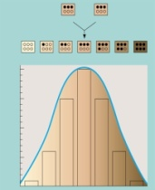
2- Discrete variation “non-continuous”: phenotype that is controlled by a single gene, so the trait is either present or absent “like sickle cell anemia, thalassemia”.
Demographic changes
again if the change is present in more than 1% of a population then it’s considered polymorphism, but if it’s present in less than 1% then it’s considered mutation.

In the previous photo, the first line (a), no mutation was present so with time the population’s genetics will remain the same. While in the second line (b) there is one person with mutation “half black/half white circle” this mutation is called “founder mutation” because it’s the first mutation that is found in the population, with time “in the second generation” the number of people who carries the mutation increases, in the next generation people who carry the mutation start mating which will result in people who have the disease “black circle”, in the next generation the number of people who have the disease will increase. This is called “genetic drift”.
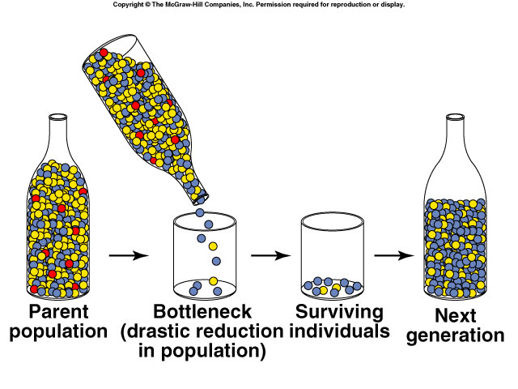
Another type of genetic drift is “bottleneck effect” (the previous photo), it happens at close populations, at first three colors “genetic types” were present, with time one color disappeared while the other colors survived, “in some cases even the other color will disappear and the survival will be only one color”.

