Sheet no: 6
Refer to slide no: 6 “until slide 56”
Written by: Mahmoud Qaisi
Sex- linked disorders
the diseased gene here is either located on the “X chromosome” or on the “Y chromosome”, all the “Y” linked diseases are transmitted from the father.
“Y” chromosome is one of the smallest chromosomes in our genome it contains about 70 Mb, and it contains a small area responsible for giving the male characteristics for the human being “testicular and genital development”.
There are some other areas found on the “Y” chromosome called “pseudo-genes”, will be explained later.
Before the HLA minor histo-compatibility genes where used to determine the gender of the fetus, because they are transferred on the “Y” chromosomes from the father to his son “not to his daughter”.
While in X-linked disorders, there are three possibilities from where the X might come “2 X’s from the mother and 1 “X” from the father”, so the possibility to have “X” abnormality compared to Y abnormality is 3:1.
“X” chromosome is considered a large chromosome, it contains nearly 160 Mb “700 genes”, most of these genes are recessive genes, and few are dominant genes. “X” chromosome accounts for about 5% of the total human genome.
Inheritance of X- chromosomes is coming either from the father or from the mother, so if the mother carries a certain disease on the “X” chromosome, and she transmitted this chromosome to her son the son will have the disease “because he has only one “X” chromosome”, but if she transmitted this chromosome to her daughter, she will be also carrier for the disease “because she has 2 “X” chromosomes”.
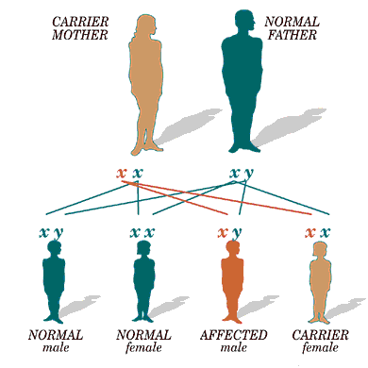
Now, if the father has a certain disorder due to a problem on his “X” chromosome “he is infected”, then he can transmit the abnormal “X” chromosome to his daughters and they will become carriers, but he can’t transmit the disease “the “X” chromosome” to his sons, because he has to give them the “Y” chromosome (not the “X” chromosome) in order for them to become males, so all his sons will be completely normal.
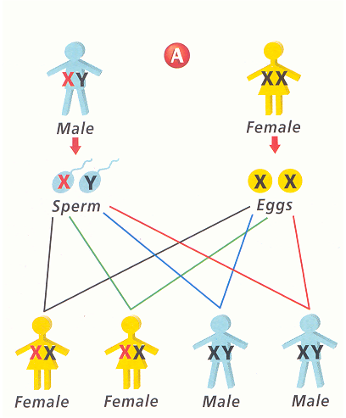
X-linked dominant family pedigree looks like autosomal dominant family pedigree “in each generation the disease is present”, the difference between them is that, in X-linked dominant family pedigree if the male is infected in the first generation then in the second generation only females will carry the infected X-chromosome, while if the disease is autosomal dominant then in the next generation both males and females have equal chance in getting the disease.
There are many examples on X-linked dominant diseases, dwarfism, Incontinentia Pigmenti (it’s lethal in males, while in females it’s very mild), Congenital Generalized Hypertrichosis “CGH” (here the whole body of the patient will be filled with hair), X-linked hypophoshatemic (Vitamin D-resistant rickets), Congenital Bilateral Ptosis (here the eyelids will drop).
X-linked recessive disorders
In the second point the doctor said that this happens when the disease occurs in males because they have only one “X” chromosome.
The inheritance of X-linked recessive disorders is exactly the same as X-linked dominant disorders.
In the family pedigree on the other hand the X-linked recessive disorders may skip a generation “this generation will contain only carrier females with no symptoms at all, in X-linked dominant disorders the female will have some symptoms but they will be mild.
Sometimes we may not be able to know if the disease is recessive disorder or dominant disorder, because:
-Small family: the family infected may be small.
-New mutation.
-Germ-line mosaicism.
In the previous slide the doctor didn’t mention the phenotypes of the disorders.
“Y” chromosome disorders.
One of the diseases seen in “Y” chromosome linked diseases is hairy ears.
The pedigree of Y-linked diseases is easy to be recognized because only males will be affected with these diseases.
Sex differentiation, it happens very early in fetus life “at 7 weeks”, the Wolffian duct will be formed in males, while Mullerian duct will be formed in females.
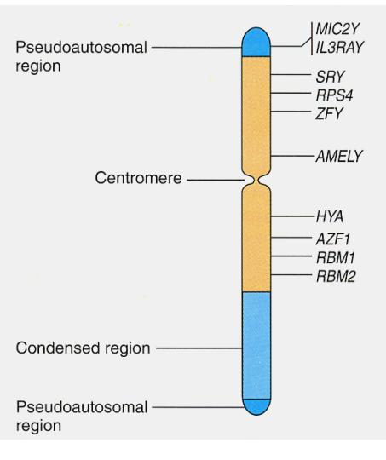
ZFY: stands for zinc finger protein which is responsible for development of sperms.
Sex development
there are some genes “in the picture below” used when there is sex reversal to determine the gender of the patient “phenotypically the patient is male while genetically he is a female, or vice versa)”.
SRY “sex reversal”
SOX9 is on chromosome 17 “sex reversal”
DAX1 is on chromosome 21 “sex reversal”
WNT1 “sex reversal”
(HERE I THINK THE DOCTOR MEANT THE REGION WHICH THE GENE IS PRESENT ON NOT THE NUMBER OF THE CHROMOSOME ITSELF BECAUSE ALL THESE GENES SHOULD BE PRESENT ON THE SEX CHROMSOMES NOT ON AUTOSOMAL CHROMSOMES).
“Sex reversal” means that if the gene is in a female it will change it into a male, and if it’s present in a male it will change him into female.
Gonadal sex in the previous picture, means when the gonads of the fetus start to develop.
-Hemaphrodites
is a type of mosaicism
-Androgen insensitivity
XY males become phenotypic females
-Pseudohermaphroditism
XY males at birth are phenotypically female; at puberty develop a male phenotype
There is a psychological-hormonal disease where the patient is a male, but he feels like a female inside, or the patient is female but she feels like a female inside.
“X” and “Y” chromosomes have different genes,G6PD for example is an X-linked gene that is not found on the “Y” chromosome, but if we measure the concentration of G6PD in both males and females it’ll be the same, the reason for this is that one of the “X” chromosomes in the female is inactivated.
On the other hand, vitamin D resistance protein is found only on the “Y” chromosome, but the concentration of this protein in both males and females is the same, this happens because in the females there’s what’s called “pseudo-autosomal genes” these genes are present on the inactivated X-chromosome “so this “X” chromosome is not completely inactivated” to simulate some of the genes that are present on the “Y” chromosome and compensate for them.
There is a homologous area between “X” and “Y” chromosomes and this area is about 15% of the X chromosome and this area skip inactivation “so it is activated” they are found on the p- and the q- arms of the chromosome”.
some of these genes are:
-steroid sulfatase
-Xg blood groups
-Kallman syndrome
-Housekeeping gene “like SOX9 gene”
As mentioned earlier SRY gene is present on the “Y” chromosome, during development of the sperms and genetic exchange that happens in them this gene may be transmitted from the “Y” chromosome to the “X” chromosome, if this sperm “which contains the “X” chromosome with SRY gene on it” has been incorporated in the zygote formation the resultant will be an “XX” individual who contains SRY gene on one of the “X” chromosome, if we look to this person phenotypically the person is a male but genetically he is a female.
also if the SRY gene has been transferred from “Y” chromosome to “X” chromosome and the “Y” chromosome which has no SRY gene now has been incorporated in the zygote formation then the resultant will be a person who is phenotypically a female but genetically he is a male.
this emphasizes the importance of SRY gene in determining the SEX of an individual.
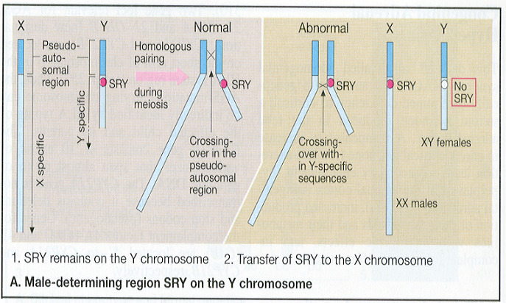
Testicular feminization
-Genotype: XY
-Testosteron in sera is normal
-Testis in the abdominal cavity
-Feminine statue
this may happen due to:
error of differentiation after testosterone action, or testosterone can influence development of wolff-tubule at differentiation
X chromosome inactivation was first proposed by Mary Lyon in 1961, she noticed that in females the X-linked protein’s concentration is equal to that in males although females have two X’s while males have only one “X” chromosome
The “X” inactivation is completely random, this means that in a single female, in one cell the maternal “X” may be inactivated while in another cell the paternal “X” will be inactivated. This means that if we take an iso-enzyme test for G6PD for example “X-linked protein”, in males we will find only one type of this protein “because there is only one “X” chromosome”, while in females we will find to types of this protein but the concentration of the protein in both males and females is the same “because the female has two “X” chromosome and the inactivation of them is random so the paternal X may be translated in certain cells while the maternal X may be translated in others”.
In albinism for example, if the male has the disease he will be completely whit, but if the female has the disease then she will appear pink “and she will have black spots in the sclera”, because of the random inactivation of X-linked genes in females.
The inactivation of the “X” chromosome will happen early in the fetus’s life in the first 7-10 days.
Usually if the female has a certain disease that is present on one of the X chromosomes, the “X” chromosome which carry the disease will be inactivated.
The inactivation is controlled by a gene called “XIST” (X-inactivate specific transcript) gene, this gene produces m-RNA, but this m-RNA will not be translated, it’ll just cause methylation to the “X” chromosome and it’ll be inactivated.
If the inactivated “X” chromosome is involved in the formation of the zygote, then this “X” chromosome will be reactivated during fertilization.
In the previous picture, the inactivated “X” chromosome (barr body) is pointed at by an arrow.
Anhidrotic Ectodermal Dysplasia, this is a disease in a gene that is responsible for the production of sweat, in females some spots in her body can produce sweat and other spots will not produce sweat. But if this happens in males, he will not produce sweat at all and generally they die early.
Also the color of the fur of a cat for example, females usually have more than one color while males have only one color.

