Microbiology
Lec#3
Done by :Ruaa salah al-deen
Growth and culture of bacteria
first thing to ask is why do we need to culture bacteria ??
from the diagnostic point of view,we actually culture bacteria so we can recognize them and make the proper diagnosis.
Basically ,If we want to culture any organism we have to provide it with something to eat ;in order to live and survive , since the food is important as a source of energy and a source of building blocks for renewing the organs, structures and to provide necessary elements required for the division and multiplication.

First step in bacterial growth is increment in cell size , then duplication of the chromosome, after that the septum from the cell wall goes in the middle and separates the two new chromosomes ,ending up with two bacteria which are identical to mother cell…and that’s how bacteria duplicate. This process is called binary fission.
So it’s one bacteria divides to two and two to four and four to eight and so on. The resulting bacteria are identical to mother cell that gave rise to them, check slide#3
<< Doubling time >>
-the time for one bacteria to become two .
-It varies along bacteria, but when we talk about most of the pathogenic bacteria that cause diseases, it’s about 20 minutes. Of course with some exception for example : Mycobacterium tuberculosis ….the bacteria that causes tuberculosis ,its doubling time is around 18h.
- So we can see that some of bacteria are very slow growing , and others can double in less than 10 minutes.
- the rate at which the doubling occurs can give an idea about the disease :
1)Too Short DT >Very acute disease ,when the numbers multiply very quickly ,so here the disease occurs very threatening and processes quickly.
2)too long DT >very chronic disease, here the disease takes time to actually manifest ,also takes time to produce symptoms and takes time to cure as well .

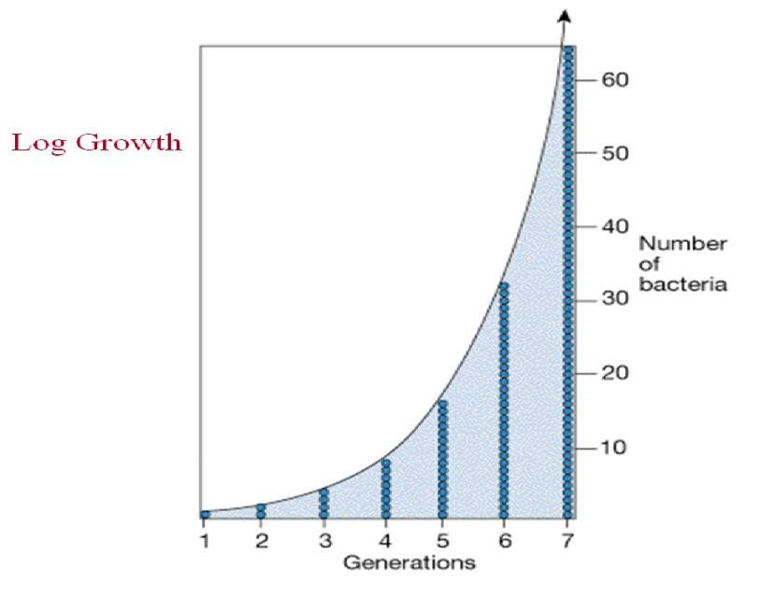

Bacterial division occurs according to a logarithmic progression (two cells, four cells, eight cells, etc.).
First there is a little change in the number of cells then the number of cells increases surprisingly fast
*infact if u give enough space\food for bacteria ,they can actually become as the size of the earth from one single cell at a very very short time!!
*but talking about the growth of bacteria ,they will continue multiplication but of course there are factors that affect and stop their growth. ex : nutrition, space, environment (ph ,temperature ..),building up of toxic material or metabolites. So eventually the growth of bacteria will stop according to these factors.
*doubling time is also called generation time.

<< NUTRITION >>check slides 5&6
Nutrition is important as a source of energy ,building blocks ,elements for multiplication .elements which consist of (C, H, O, N, S. P, K, Mg, Fe, Ca, Mn, and traces of Zn, Co, Cu, and Mo.)>> as u can see u need a variety of elements to be provided to the culture.

*CHEMICAL REQUIREMENTS
1) Water >> most of these reactions need water .
<< 2)Carbon 3) Nitrogen4) Sulfur and phosphorous 5) Oxygen 6) Minerals >>building blocks for multiplication
7) Growth Factors>>8;27
*Physical Requirements > affect the environment in which the bacteria is growing.
- Hydrogen ions (pH):
each type of bacteria needs a certain ph to grow , but most of the pathogenic bacteria grow at optimal human body ph which is about 7.4.
**with some exception, ex: some bacteria like to grow at higher ph like: vibrio cholerae bacteria which grows at ph around 9, another exception : lactobacilli grows at ph around 4 .
[although there are some exception but as a rule ,ph that has to be provided to the culture of bacteria is about 7.4]

- Temperature :
again u need something around the body temp. 37c ,as most of pathogenic bacteria grow best at this temp.
**but there are bacteria that can grow at room temperature 20-25c ,like staphno peroxide.. some bacteria live in hot springs at 70c...and other types of bacteria like: monocytogene can grow at fridge temp. around 4c.
[although there are some exception but as a rule ,temperature that has to be provided to the culture of bacteria is about 37c ]
- Osmotic pressure :
it should be normal ,otherwise if it’s too high osmoses outside, the bacteria becomes shriveled and vies versa. if the outside is very diluted ,the cell will burst.
*Check slides 9&10
>Oxygen for bacteria can be:
necessary or detrimental and sometimes doesn’t make a difference
>Bacteria that require O₂ for growth; they use O₂ as a final electron acceptor in aerobic respiration ,these are known as [strict aerobes\ Obligate aerobes]>>can’t grow unless oxygen is present
>On the other hand; bacteria that do not need or use O₂ as a nutrient. In fact, O₂ is a toxic substance, which either kills or inhibits their growth.these are known as [strict anaerobes\ Obligate anaerobes]>>can’t grow if oxygen is present, oxygen must be absence completely !
>most of the pathogenic bacteria are organisms that can switch between aerobic and anaerobic types of metabolism. known as [Facultative anaerobes or facultative aerobes] >> live with or without oxygen .
> bacteria with an exclusively anaerobic (fermentative) type of metabolism but they are insensitive to the presence of O₂. They live by fermentation alone whether or not O₂ is present in their environment, these are known as [Aerotolerant anaerobes]>>if oxygen is there they still can grow without being harmed.
But..Why is oxygen harmful for any cell ??
because it can produce free oxygen radicals ,which harm bacteria if it couldn’t deal with it.
*free oxygen radicals can harm cells ,that’s why antioxidants (like vitamin c) are good thing, as they reduce the risk of having cancer by eliminating these radicals*
Free oxygen radicals will be converted in the presence of water to hydrogen peroxide but hydrogen peroxide is harmful too, so it will be converted again to water and oxygen , For example:
superoxide which is a free oxygen radical is formed from oxygen then it joins water to give hydrogen peroxide, hydrogen peroxide is oxidizing agent unless it is converted into water and oxygen.
<in conclusion bacteria need enzymes to get rid of free oxygen radicals>
- Catalase :
Enzyme which converts hydrogen peroxide into oxygen and water. resulting in getting rid of the harmful effect of hydrogen peroxide.
H2O2 + H2O2 => 2H2O + O2
- Peroxidase : which produces water and energy.
H2O2 + NADH +H+ => 2H2O + NAD+
3) superoxide dismutase : converts free oxygen radicals into hydrogen peroxide and oxygen.
O2- + O2- +2H+ => H2O2 + O2
NOW . what do u expect the enzymes that aerobic bacteria must have ??
it obviously must have the enzymes that remove the harmful effects of the radicals and hydrogen peroxide which are: 1) catalase 2) superoxide dismutase.
overall equation of these two enzymes : 4 O2- + 4H+ =>2H2O + 3O2

Now, let’s talk more about chemical requirement of the culture...
We need water, carbon , nitrogen,..actually we can bring these together from different sources BuT the easiest way is to use MEAT ! Because if u think about it ,meat has protein ,and it has all necessary elements for the growth of bacteria .
of course meat itself isn’t really useful! but it could be digested by means of enzymes to produce short peptides which are known as “peptoids”, then we put peptoids in water to end up with “ peptone-water\peptone-broth”..now this water will have all the elements necessary for the growth of bacteria. The next thing to do is to take the bacteria, put it in this solution ”peptone-broth” and incubate it at the right temperature . This is known as the [liquid medium], which is very easy to produce,very easy to deal with, and we can grow the bacteria in plenty of space, plenty of nutrients to multiply and grow.
**But the disadvantage in “peptone-broth” is that we can’t get pure culture and it’s hard to separate one bacteria from another.. why??
if you take a sample from an infection (ex: patient mouth, pus from the skin), this sample itself can be contaminated by other types of bacteria from the environment around the infection or from anywhere else, that’s mean that the sample you took is probably mixed ( contains more than one type of bacteria along with the causing bacteria that we want to isolate ) , so u can’t guaranty when u take the sample that the bacteria is going to be pure. After that when u put the sample in the broth, all types of bacteria from the sample will grow haphazardly and they will be all mixed up together, ending up with “mixed growth” as well. Eventually you won’t be able to know which of the organisms was actually causing the infection.
** As a conclusion if u really want to get a pure culture and isolate the one type of bacteria that causes the infection.. “broth” won’t be a good choice !.. But u can use it to increase the number Of certain bacteria that u already have.
**at the end of the day what really matter is to get a pure culture, have a correct diagnosis to identify the bacteria, and do special studies on it to know antibiotic sensitivity ..eventually end up with the right treatment.

Media ….
[undefined\complex culture medium ]
Liquid medium\peptone-broth is [ undefined\complex culture medium ] since we don’t know how much fat, carbohydrate or meat we have , in another words *we don’t know exactly what is present and how much is present , it’s good for general purposes.
[ defined media ]
but sometimes especially in researches and with certain types of bacteria we need to know exactly what and how much is present, in this case the medium has to be prepared especially with specific amounts and defined materials. this medium is called a [ defined medium ] *we know exactly what is present and how much is present.

[Selective medium]

allows growth of one certain bacteria and not other for ex:

there is SS Salmonella Shigella medium this allow the growth of some Enterobacteriaceae like shigella and salmonella and suppress the growth of other.

[indicator medium]

indicates that something has happened ,for ex: machonci medium has lactose in it , what happens that the organism ferments the lactose and that will produce acid, acid changes the color of the medium from white to pink , in this case if we grow an organism in this medium and then we get a pink color , this mean that the organism is fermenter of lactose.

[transport medium]

this is a temporary media in which we have to transport the sample from the clinic to the lab when the is not next door, because some bacteria can’t actually exist outside the body for too long .
for example the bacteria that causes gonorrhea, dries up very quickly outside the body ,so it’s important when taking a sample from urethra or the vagina not to leave it for hours outside the body and then send it to the lab ,because the bacteria will be dead.
[Enriched media]
Addition of something that will enhances the nutritional value of the medium, for example blood can be added as the blood is a good source of neutrino and energy.
>>To have a pure culture and isolate bacteria from each other, we have to use [solid or semi-solid] media, the media structur’s is similar to gel (not very solid nor very liquid).
This semi solid media is derived from AGAR which comes as a powder extracted from seaweeds, and it’s prepared in the same way used for preparing powdered jello at home(bring the powder and then dissolve it in a hot water about 65c until it dissolves completely then pouring it into a mold(petri dish) and leave it to set.
but can we cultivate bacteria on it now ??
NO, we can’t since agar has no nutritional value at all and it’s not metabolized by the bacteria, so before pouring the agar into the petri dish we have to add some nutrients, we can either add peptone-water and this will be known as “nutrient agar” or by adding blood(animals blood) to the mixture of agar and water and this is known as “blood-agar” ,these two types are the most commonly used in the lab.
Now.. if we bring a sample of the infected material that we have obtained from the patient and put it on the agar .. what do you expect to happen ??
actually all bacteria will grow and the growth will be a confluent growth, we will have also some colonies(cluster of bacteria which has been derived from one bacteria) and since the sample contains many bacteria and too many types, it will be a confluent growth of different colonies around and above each other in random ways preventing the detection of any harmful bacteria ,this is also known as a mixed growth. so indeed if we want a pure culture in blood agar or nutrient agar we have to use [streaking method].
Streaking…
Bacterial streaking can be used to identify and isolate pure bacterial colonies from a mixed culture.
How do we do streaking ??
First u have to put (inoculate) the sample on one edge of the rounded petri dish using a wier loop and then spread it out , what we are really doing is spreading the different microorganisms, we do it once and then we do it again spreading the bacteria from the end of the first streak into a second site ,and we do it a third time .after the final time what we hope to achieve that the bacteria now is separated from one another . although the sample contains a mixture of bacteria but the most abundant bacteria will be the one which causes the infection, ,and by the time we get to the last spread , most likely that the bacteria which is going to be there is the pathogenic one .After doing the streaking we put the dish on the incubator (oven) at 37c then growing of different colonies starts to take place ,and when they grow , we will notice that at the first site of inoculation there will be confluent growth\mixed growth, in the second area the types of colonies will be less and so on,until we reach the final site where we hope to find few colonies which are pure and exactly the same , now we’ll take a sample from the pure culture and put it in broth to increase the number of it or we take the sample and do a gram stain to see exactly what it is , or maybe we take it and do some biochemical reactions to define the type of bacteria or we can spread it on another plate to know which antibiotic works with this organism.
AND THIS IS HOW WE GET PURE CULTURE !
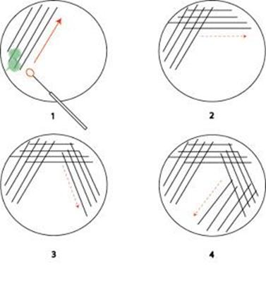
Here where we can find the isolated colonies (final site)

