Sheet no. :2

Refer to slide no. : لا يوجد

Done and corrected by: Haya JadAllah and Batool AlHiari

-Head injuries are one of the most common causes of morbidity and mortality in road traffic accidents (RTA).
-According to the epidemics in the US, 2.000.000 medically attended cases per year as a head injury, that’s a big figure. 75.000 die every year due to head injuries in the US. We have almost the same figures here in Jordan, but the causes of head injuries are different, mainly RTA, while in the US it’s mainly due to sports and falls.
-So head injuries are seen in both developed and developing countries.
-Causes if head injuries:
1- RTA.
2- Falls.
3- Assaults.
4- Domestic accidents.
5- Wars.
6 and 7 I couldn’t understand.
-Head injuries are not only brain injuries, injuries of the scalp (فروة الرأس الخارجية) for example cut wounds, are also considered head injuries. So it’s injuries that affect any part of the head.
-Fracture of the skull will result in a head injury. Also injuries of menengies, dura, arachnoid, and pia.
-The main pathophysiology of head injuries that we are dealing with is increased intracranial pressure. As we know, the cranium is a rigid organ, so any increase of the internal size or volume will affect this normal structure resulting in higher pressure on vital sites in the brain. This can be secondary to brain edema, intracerbrel/intracranial hematoma.
-Sometimes pts that come to ER with head injuries are also having facial injuries. So maxillofacial surgeons or residents in the ER should know what Glasgow scale means for example, that’s why you’re taking this.

-We devide head injuries into 2 types: primary (at time of injury) , and secondary (after the injury), primary Is irreversible, so our main goal is to prevent secondary injury
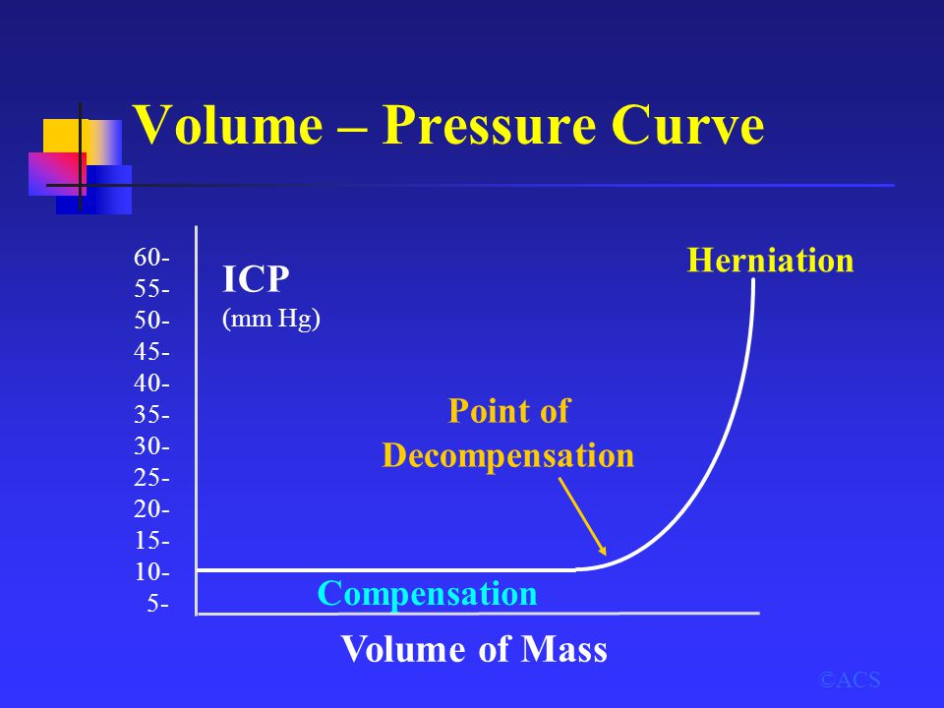

-This curve is an important one, there is a point if we didn’t interfere before there will be decompensation and herniation. As we know, increase in intracranial pressure will result in compression on the vital organ and finally herniation (herniation means death, either suprtentorial or infratentorial herniation, compression on brain stem resulting in damage and deterioration vital signs then death.). So we should prevent reaching this point or the damage will become irreversible.
-Again, time of impact is unavoidable (primary), the time after impact is (secondary) which is avoidable .
-Types of primary head injuries:
1- Concussionارتجاج دماغي: a functional abnormality in the brain without structural abnormality. The patient will appear normal in the CT-brain, but clinically, the pt will say that he can’t remember or he lost consciousness for example. So here the problem is metabolic changes at the cellular level of the brain NOT structural damage.
2- Contusion رضة دماغية: the CT will show a blood or an injury to the brain (blood or sth).
3- Diffused axonal injury (DAI): brain edema, it’s a severe form of head injury. Etiology: acceleration deceleration injury results in shearing in the normal axon (white matter) which eventually leads to loss of consciousness.
-These previously mentioned terms are important to be known.
-secondary brain happens due to hypoxia, hypotension,hematoma… (The rest are written in the slides which we don’t have).
A patient came with a car accident might also have a chest injury or any other organ injury, so he might be having hypovolemic shock> ischemia> less blood supply to the brain, and this will complicate the head injury if present, so I need to prevent all theses secondary causes not to have a more complicated case.
-There supposed to be a classification of any injury or disease to facilitate management and determine prognosis.
-According to mechanism, head injuries are classified into:
1- Blunt injury.
2- Penetrating head injury. E.g. bullet injury or a sharp object injury.
-According to the severity, head injuries are classified into:
When a patient come to the ER, we classify his case into a mild, moderate or a severe head injury, each has its consequences, each needs a special management; e.g. ICU, intervention immediately…
Glasgow scale is the scale we use to determine severity; it is composed from 15 points and classifies head injuries into mild, moderate and severe.
14-15 > mild, 9-13> moderate, less than 8>> severe.
A patient with a scale <8, means that I need to do intubation to secure the airways because the patient will be unable to maintain his airways.
-Items of Glasgow Coma Scale:
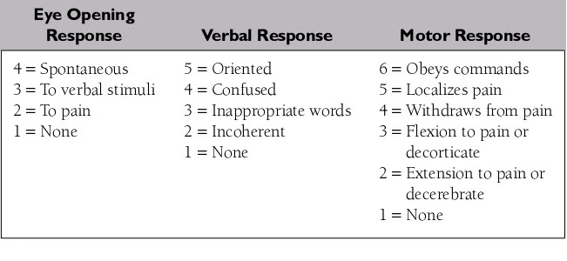
we have 3 componants:

The dr. mentioned only those things:
-Eye:
- opens spontaneously >> 4 points
- Opens in response to speech >> 3 points
- In response to painful stimuli >> 2 points
- No response >> 1 point

-Motor:
- Obeys commands >> 6 points (ex. when you ask him to move his right hand he will move it)
- Localization of painful stimuli >> 5 points
- Flexion/ withdrawal
Verbal:
The most important thing about it is if the patient oriented or not.
So, a dead person will take 3 points according to this scale.
The lowest is 3 and the highest is 15. And according to those points we will decide whether the patient has mild , moderate or severe head injury .

-We also pay attention to morphology:
We have 2 types of fracture that we could see after taking an x-ray and CT-scan: vault or basilar. According to these 2 criteria (Glasgow coma scale and morphology viewed in CT-scan ) we will say for example that this patient has mild head injury (Glasgow coma = 14 or 15 points, with linear skull fracture according to the radiographic findings.

-In general, head injuries considered as emergencies so it will be managed the same way as you start in resuscitation in management of other injuries:
- ABC; Airways, Bleeding, Circulation
- Be sure that the cervical spine is not involved “approximately 17-20% of patients with head injuries are associated with cervical spine injuries”. So spine precautions should be taken whenever we have head injury, any wrong movement may cause complete paraplegia.

The dr. showed some slides for:
- A post-partum specimen in a pt that had brain contusion. [figure no.1]
- He also showed an ex. Of linear skull fracture on CT-scan called bone window (crack in the skull bone only). [figure no.2]
- Depressed skull fracture in a CT-scan, brain parenchyma view. (depressed inward not only a crack) [figure no.3]
- Basal skull fracture : it’s close to the dura which leads to dural tear and we will have CSF leak (means meningitis) >> we will have indirect sign
- Fracture in temporal bone, especially if it was close to the ear, leads to tear of tympanic membrane causing CSF leak from the ear [figure no.4]
- If the fracture of the base of the skull was in the anterior cranial fossa, we will have CSF leak from the nose (rhinorrhea) leading to meningitis because we will have continuation between cranial cavity with a dirty cavity like the upper respiratory tract
- The signs that make you think of basal skull fracture is: periorbital ecchymosis (raccoon eye), or battle’s sign (retromastoid ecchymosis)[figure no.5]
- Another pic “صوره طبقيه” showing a lot of pneumatocele (air inside the cranium or pneumocephalus) >> this is due to basal skull fracture and dural tear, so it will open into the sinuses or mastoid air cells, so air will enter into the brain (indirect sign of basal skull fracture). [figure no.6]
- The most common finding is usually subarachnoid hemorrhage “appears as hyperdensity in the pic” [figure no.7]
- Another pic for subdural hematoma, this leads to shifting of the falx, we will do urgent treatment and evacuation of hematoma. [figure no.8]
- Diffuse brain injury. Notice the white-grey matter differentiation, the pt has scalp hematoma outside the brain, the brain has diffused edema.
- Extradural hematoma [figure no.9]. Arterial bleeding, need immediate surgical evacuation or the pt will die due to herniation.
-The dr. showed an example of how we do evacuation: first we open the skull, we remove hematoma if it was extradural, but if it was subdural we open the dura also and then remove the hematoma.

[The most important investigation for head injury after taking history and physical examination is CT-scan for the brain (it only takes 2 min and not cost effective). It’s the ideal investigation for head injury].
Will we do CT-scan for the brain for every head injury?
The indication for taking it is either:
- We have decreased level of consciousness (Glasgow coma scale below 15).
- Symptomatic with neurological deficit (e.g. Pt with Glasgow 15 but he can’t move his hand, can’t see, seizure, intractable headache).

-complications of head injury (important):
Early complications: hypoxia, hematoma, cerebral edema, epilepsy /convulsions (in this case you should give the patient anticonvulsive to avoid worsening of the condition, this will increase the head injury because the metabolic rate will decrease and the patient will have brain hypoxia, and we will enter the cycle of decrease intracranial pressure and brain damage).
Delayed complications: hydrocephalus (dilated ventricles in the brain because as a result of hematoma the blood will be in the CSF pathway and will accumulate there in ventricles, without absorption, late epilepsy (may occur 4 year following the injury), chronic subdural hematoma and infections.

Sorry for any mistakes.

