We start with tongue and the salivary gland because the oral cavity is considered part of the digestive system.
- Tongue is the muscular organ that is covered by mucus membrane. Muscles inside the tongue form bundles separated by connective tissue continuous in that with lamina propria.
As we said in the tongue the areas which have submucosa are only the posterior one third of the dorsum of the tongue, other areas don’t have submucosa. They have epithelium, lamina propria then muscle directly. So posterior one third of the dorsum of the tongue have epithelium, lamina propria, and submucosa which are minor salivary gland mucus the muscle.
The dorsum surface of the tongue is covered by epithelium :
The anterior two thirds of the dorsum surface of the tongue is covered by stratified squamous keratinized epithelium. BUT the posterior one third of the dorsum is covered with stratified squamous non-keratinized & ALSO the ventral surface of the tongue " under surface "
We have Sulcus terminalis which is a V shaped structure that marks the boundary between anterior two thirds of the dorsum of the tongue and the posterior one third of the dorsum of the tongue IT ALSO mark the junction between the oral and pharyngeal part of the tongue depending on the empryogenic origin.
The epithelium of the Anterior two third of the dorsum of the tongue is derived from oral cavity (oral ectoderm and ectomesenchyme).& The epithelium of the Posterior one third of the dorsum of the tongue is derived from endoderm of the pharynx (pharyngeal endoderm). Circumvallete papillae in spite of its location which is anterior to the sulcus terminalis they are empryogenically derived from pharyngeal endoderm (posterior two thirds of the dorsum of the tongue).
*Sensation of the ــ anterior two thirds of the dorsum of the tongue
-General sensation is carried by the trigeminal nerve (supplied by lingual nerve which is a branch from trigeminal nerve).
-Special "Taste" sensation is supplied by the chordate tempanae which is a branch of the facial nerve (which is a little branch than accompany the lingual nerve)
ــ The Posterior one third of of the tongue
All sensations of the posterior one third of the tongue are carried out by glossopharyngeal nerve which gives general and taste sensation excluding the most posterior part of it (the area near the epiglottis and the epiglottis itself) are supplied by the vagus nerve either general or taste sensation.
*General sensation means touch, heat, chemical sensation (any type of sensation except taste sensation )
* Special sensation which is related to nasal cavity includes function and smell .Special sensation which is related to oral cavity is the taste sensation.
**Circumvallete supplied by glossopharyngeal which gives it taste and general sensation because it is empryogenically derived from posterior one third.
All muscles of the tongue receive motor sensation from hypoglossal nerve excluding one muscle which is called palatoglossus which is supplied by vagus nerve that give motor sensation.
- Types of lingual papillae:
1-Filliform
2-fungiform
3-circumvallete
4-foliate
- Filliform:
1-They are present all over the anterior two third of the dorsum of the tongue.
2- They are conical in shape.
3- They are keratinized
4- They don’t have taste buds (So they don’t have taste function)
5-They have musticatory function
- Fungiform papillae
1-They are scattered among filliform papillae (in the anterior two thirds of the dorsum of the tongue)
2- They are mushroom like in shape
3- They contain taste buds on their top surface.
- Foliliate papillae
1-In the most posteriolateral region of the anterior two thirds of the dorsum of the tongue
2-Their shape like ridges (longitudinal) and grooves
3-Taste buds are located on the sides of the grooves,
4-They are poorly developed in humans( in other animals they are more developed)
- Circumvallete papillae.
1-About 12 in number (Range 8-18)
2-They are present infront of the sulcus terminalis (just anterior to the junction)
3-They have numerous taste buds on their side, each surrounded by a deep groove or sulcus or what we call it a trench.
4-Associated by minor salivary glands (serous type) which are von-epner's glands which open on the bottom of the sulcus. These secrete watery secretions with enzyme called lingual lipase.

- The doctor showed us a coronal section of tongue and he pointed to these structures ( bundle of internal muscles in different directions ,Filliform papillae, Circumvalletes are associate with von epner's gland & their taste bud on the sides of the trench , and Fungiform "do not associate with von epner's gland nor a trench & their taste bud on the top surface)

- Filliform: surrounded by thick keratinized epithelium on the contrary Fungiform: surrounded by thinner epithelium.
- We have skeletal muscles on multiple directions on the tongue which have central nucleus, lamina propria .

- We can determine the posterior one third region if we say lymph nodules (lingual tonsils area) and minor salivary gland (submucosa) and muscle fibers extending to the submucosa
- Filliform papillary can change their shape from conical to another shape so we can't depend on their shape to recognize it, we depend on keratinization ( they have highly keratinized)
- Serous gland (round nucleus) but mucus gland (flat nucleus)
- Minor salivary gland has two types of ducts
1-Intercalated duct: dark and nucleus occupy most of the cell.
2-Minor collecting: light and nucleus occupy one third of the cell.
There is no striated and major collecting.

- Crypt: invagination of epithelium and it is a place that accumulate microorganisms and it is near lymphatic nodules (This is only on posterior one third)
- Salivary glands are divided according to the nature of their secretions into
- Serous: Parotid + von epner's
- Mucus: Minor salivary gland
- Mixed: The majority either serous ( seromucus) or mucus (mucuserous)
: Seromucus: Submandibular
Mucuserous: Sublingual

- Glands are divided according to their duct system into
Simple: From secretory elements to its single duct to secretion and this doesn’t apply to salivary gland
Compound: (Branched): Eg. Salivary gland because its duct system is branched, they start intercalated then become striated then minor collecting then major then the main .
- Glands are dividing to their secretory elements into:
1-Tubular like mucous
2-Acinar (alveolar) Eg: "serous "Parotid gland
3- Tubuloalveolar
- Mixed glands are mucus with serous demlunis)
- Doctor recommended us to read the anatomy of salivary gland.
- Minor salivary gland: distributed all over the oral cavity and account for 10% of the saliva, but the most is the mucus.
- Major salivary gland: each surrounded by capsule of variable thickness, septa is divided the gland incompletely into small lobules (lobes then lobule)
- Duct system is branched compound secretory type contain either serous or mucus :-
 | Serous | Mucous
Shape | Pyramidal | Cubodial to columnar
Nucleus | Round and basely | Flat (basal located)
Cytoplasm | Contain zymogene granule ( Vesicle contain enzyme or protein) | Have mucus vesicles( foamy appearance)  Vesicels have protein called musin

- Serous have short irregular microvilli in the apical part and they are typical protein synthesizing cell , adjacent cells are joint by tight junction , the cells are arrange in acini
- Musin once it is hydrated it is converted to mucus.
Mucus cells arrange themselves to from tubules. The sub mandibular and sub lingual(the end of some tubules are surrounded(capped) by serous demilunes.
- myoepithelial cells :
- Found around secretory elements and intercalated ducts.
- When they contract they push their secretions toward the duct system.
- Epithelial in origin and muscular in function(they have a contractile function )
- They have flat nucleus* with multiple branches so it is named basket cells.
- They have junction between them and with the secretory part .
*we can see this in the serous gland like the parotid gland .
- Duct system: Intercalated to striated to minor to minor collecting to major collecting to main secretory duct. But we have exceptions like:
Sublingual: There is no striated and main collecting
Minor salivary gland: There are only 2 types: Intercalated and minor duct
Execratory system : we mean the minor , the major and the main ducts .
Intra lobular : they are
- Intercalated duct: has high mitotic activity so it can replace the duct cell and secretory cells
- Striated duct: are simple columnar that have center nucleus (It takes third of the size of the duct so it appears light in color. It have basal striations ( It is not a condition of it)
- Interlobular:
1- Minor collecting ( simple columnar like striated)but with no striation .we find around it connective tissue .
2- Major collecting: Two levels of cells first as pseodostratified then stratified columnar that means it has basal layer (cubodial) then columnar layer.

- Main excretory duct: It is stratified columnar except where it opens in the oral cavity, it becomes stratified squamous non-keratinized epithelium

- Notes:
1-When we notice striated surrounded by connective tissue it must be minor.
2-Sub-lingual gland doesn’t have striated.

- This is a table for comparison of glands:
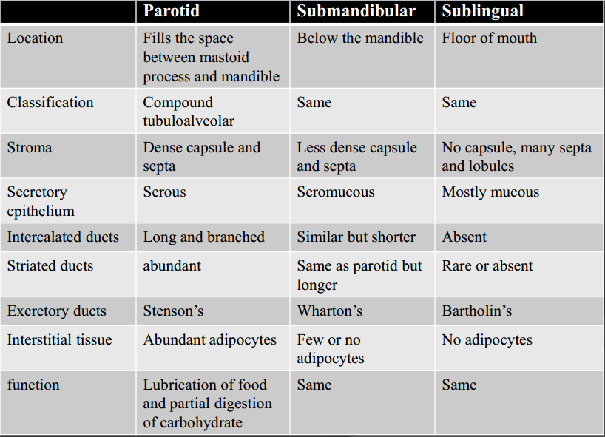

Sub Lingual have multiple major collecting duct , the largest one called bartholin's
Sub Lingual striated ducts take it absent .
I apologize for any mistakes

