Spleen
Spleen and thymus gland both considered as lymphatic organs like lymph nodes because they are completely encapsulated " with capsule".
Spleen is the largest lymphatic organ ,it is located between the stomach and the diaphragm at the left side.
structure is similar to lymph nodes it's surrounded by capsule (dense CT).
SPLEEN-lymphatic vessel has efferent lymphatic vessel but no afferent or sinuses .
Histology of spleen :named so becouse their apperance in fresh sections
1)red pulp.appeare red also histological section in contains all the components of circulating blood.
2)white pulp (lymphocyte) similar to lymphatic nodules-- in histological section appear blue ( because the nucleus of the lymphocyte takes most the size of the cell and its deeply stain )
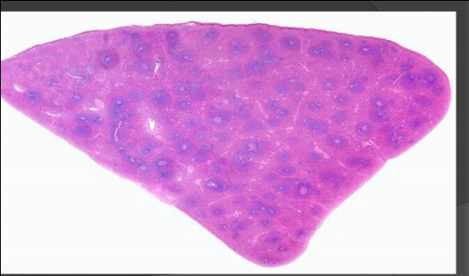
Blue white pulp redred pulp
Spleen function
1)filtration (the main fun.) if there is no spleen the liver will do the filtration
2)stores blood and this fun Very imp. in severe bleeding ,HOW??
In severe bleeding the spleen will contract becouse of the myofibroblast (high ability to contract) and when it contract it will push the blood from it to the general circulation to reduce the affect of bleeding .

Spleen structure
1)capsule around the spleen
2)hilum splenic artery (input),splenic vein and efferent lymphatic vessel (output)
3)trabeculae divide spleen to small parts {every trabeculae must contain vein and artery} , VEIN( thin wall )
White pulp
Collection of lymphocyte "basophilic". found around the central artery .no central Artery no white pulp.
T lymphocytes surround the central Artery ,Central A COME from trabecular Artery
Trabecular A surrounded by connective tissue , central A surrounded by lymphocyte (white pulp).
B lymphocytes found around corona.
White pulp
not exposed to antigenfew white pulp around artery (perearterial lymphatic sheet) mainly T lymphocyte with SOME B lymphocyte
when it is exposed to antigen white pulp SIZE increase – B lymphocyte increase and make the secondary lymphatic nodules which contain the germinal area which is surrounded by corona then the central vein will push it excentric .
white pulp can make secondary lymphatic nodules(germinal area)
Germinal area contain plasma cell that come from B lymphocytes .put plasma cell contain more cytoplasm and it's larger than lymphocyte so the density of nucleolus per area less germinal area stain lighter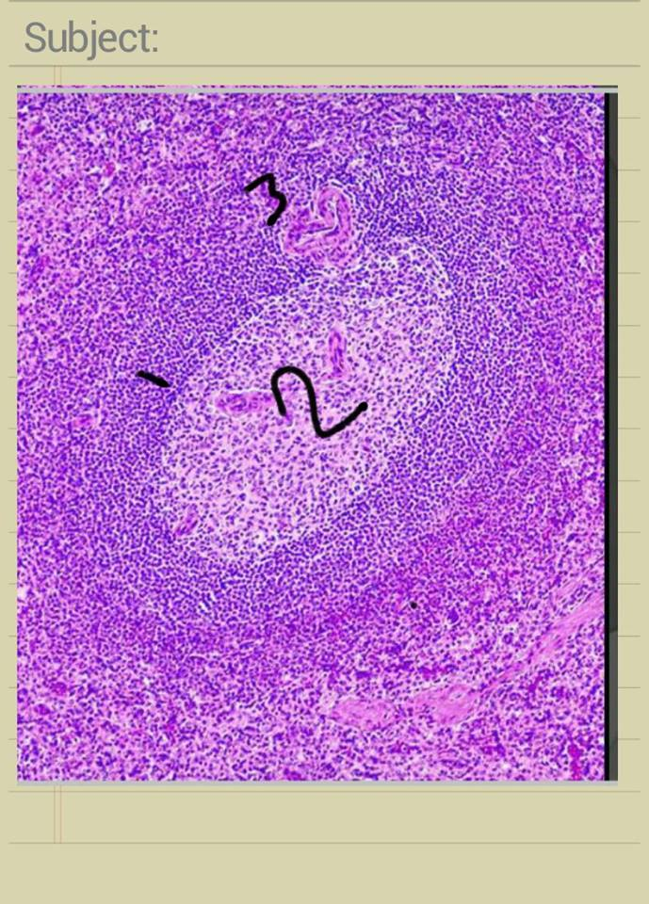
1) corona that surround - 2) germinal center -3)central artery excentric
How does the spleen filtrate the blood ,?
In human there is something called open circulation mean that the blood come to splenic sinuses and around these sinuses there is something called splenic cord ,this splenic cord contain microphages and neutrophils to kill unwanted cells.
Thymus gland
It is a bilobed lymphoepithelial organ.{epithelial cell +lymphatic cell}
Located in the anterior and superior mediastinum . its epithelial component originated from endoderm of the 2nd and 3rd pharyngeal pouches. between 2nd and 3rd , 3rd and 4th arches respectively.
. Its lymphocytes are mesoderm in origin
Reaches its maximum size at ~ 15 years and starts involution , becouse its tissue replaced by adipose tissue in old age.)
Surrounded by connective tissue capsule.
The capsule sends trabecula inside the gland dividing it incompletely into lobules.
Each lobule has its cortex and medulla..
The medulla of adjacent lobules are continuous.
Cortex lymphocyte more than epithelial cells so darker
Medulla(no sinuses)epithelial cells more than lymphocyte so lighter
Medulla IN lymphoid many sinusesso lighter than cortex
Thymic cortex
Rich in small lymphocytes that make it appear darker than the medulla.
Composed of :
1)steam cells of T-lymphocytes (T cell precursors)(thymocytes from bone marrow ).
2)microphages.
3)epithelium reticular cell. Three types in cortex (type 1,2,3) , and three in medulla (4,5,6)
Type 1 squamous cell- we find it under the capsule –the function : isolate the capsule from the cortex.
Type2 multidendritics stallate cell and has many processes – functions to present self antigen and foreign antigen to maturing thymocytes " by +ve selection".
So thymocytes (stem cells of T-lymphocytes) they are presented by self and foreign antigen by type2 epithelial reticular cells
Type 3 from cortex +type 4 from medullasquamous-the function: form a barrier between the cortex and the medulla .
The cells that make reactions will be selected that’s called positive selection (select the positive ,,, select what is reactive )
The cells that doesn’t react when presented to antigen (self or foreign) are called nonreactive cells are going to be killed by macrophages .

Type 5 in medullamultidentritic like type 2 -their function is to present the cells that pass the barrier with self antigen the cell that react with it will be killed because we don’t want them to react against the body we want them to react against foreign bodies >> so the cell that acts positively should be killed by the macrophages
The cells that are selected by the negative selection process will mature to form either CD4 T-helper lymphocytes or CD8 cytotexin T-lymphocytes then they go to blood stream
Thymocytes came from the blood stream from the post capillary venules in medulla as stem cells then it enters the medulla then crossed the barrier ( because stem cell are allowed to pass through and go to the cortex ) then it goes through the positive selection process then pass the barrier then negative selection process then go to the blood
Type 6 they are sqamous cells form onion shaped corpuscle (called hassell's corpuscle it secrets mainly hormones that helps in the positive and negative selection process ,It is a distinctive characteristic for the medulla. “What we have the reactive is for the self and foreign. Excluding the reactive for self and so we are left with the reactive for foreign.”
If there’s any disfunction, there will be an autoimmune reaction
Epithelial reticular cells:type2.
. Stellate cells 1.
. Have light staining oval nuclei 2.
. Joined together by desmosomes 3.
. Cytoplasm contains cytokeratin 4.
5. Some of them surrounded by a small population of maturing lymphocytes forming thymic nurse cells.
.
Thymic medulla
Medulla has Hassal’s corpuscles which contain type 6 epithelial reticular cells, flat in shape arranged in onion shape pattern.
Medulla has 3 types of reticular epithelial cells, very differentiated T-lymphocytes since they passed the test.
Thyrocorpuceles , contain flattened epithelial cells which are type 6 filled with keratin, found within the medulla. Has partially known function; they secrete hormones which help in positive and negative selection.
Vascularization of the thymus
Medulla: Normal vascularisation [blood comes from the artery, distributes into capillaries, then drain into venules then veins. Nothing special, like any other tissue in the body].
Cortex: Special modification since it has immature T-lymphocytes/ Thymocytes. It should be protected from any contact with the blood components, therefore; we have thymus blood barrier.
thymus blood barrier un fenestrated:
The endothelial cell layer: wall of the capillary + pasal lamina + pericyte layer + macrophage layer+ basal lamina of type 1 reticular cells.
are needed for survival. This is to ensure no activation.
No afferent lymphatic vessels (nothing goes into it).
Doesn’t form filter for lymph.
All lymphatic vessels seen are efferent (going out of the thymus).
It is the site of selection and differentiation of T-lymphocytes.
Continues to produce T-lymphocytes until old age.
T-cells precursor do not have receptors on their surface. They originate from the liver; migrate to bone marrow and thymus. Dived in the thymic cortex
Thymic secretions are mainly from Hassall's corpuscle cells.

Has several growth factors
Thymosin –α
Thymopoietin
Thymulin
Thymus humoral factor
Maturation, selection then released into blood stream.
All t-lymphocytes in body must have passed through the thymus.
Cortex is more darkly stained, while medulla is more lightly stained. We have trabeculea around it which divides it into lobules.
Corpuscles are an indication for the medulla.
Whitetrabecula
Dark area cortex
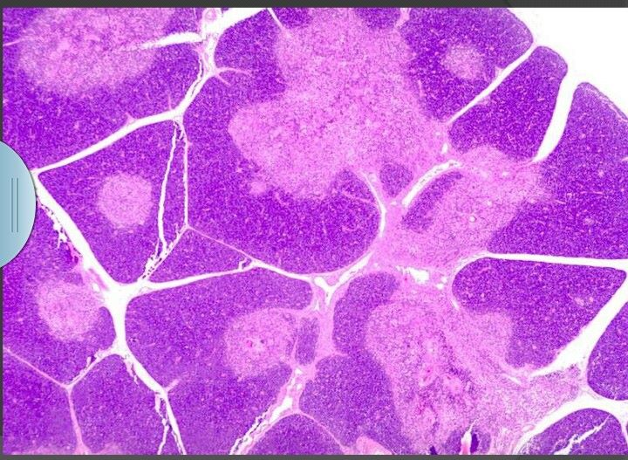Light areamedulla
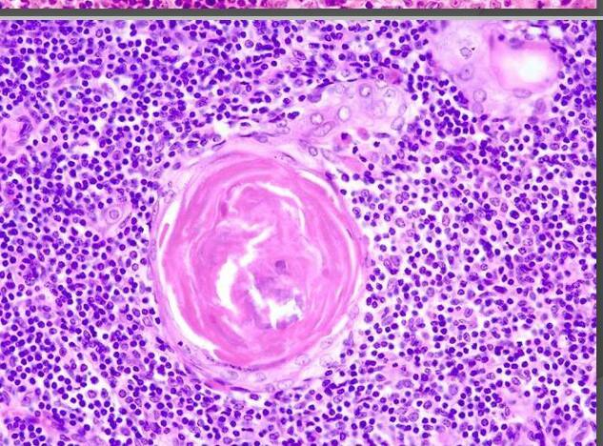
Hassall’s corpuscles

