How to manage failed restoration ?
- If the problem is in a single piece of the whole restoration , just repair that piece , but if the restoration has multiple or sever problems you need to redo it, and sometimes the restoration won’t be repairable then you have to extract the tooth.

- Signs of restoration failures :
overhangs
2ry caries
open contact
gingivitis
- symptoms:
pain like pain upon chewing
food impaction
discoloration
sharp edges
sensitivity
broken tooth or filling
loose tooth or filling
falling filling or tooth
muscle spasm
tmj problems due to high restoration or fractured restoration or
pulpitis
do a risks and benefits assessment to decide whether to replace a failed restoration or not

- treatment pathway :
we start with CC and symptoms , make sure to recapitulate these symptoms into clinical signs ; if we have pain as a symptom we have to do a sensitivity ( vitality)test , or if there is overhang restoration or food impaction ; check the filling with a floss , so the idea is to reproduce the symptoms that the ptn has into a clinical signs that we can confirm from our own perspective as a dentists.
history > clinical examination > special investigation >sound clinical judgment > correct dx
if there is an odontogenic emergency it is always related to one tooth in particular
Case :
*severe pain in lower right area
*8 was carious, tender to percussion , BD , sensitive tooth
*7 ; large lesion , not tendered to percussion , not sensitive
*6 ,5 and 4 ; almost sound
treatment : extraction of eight , but the next day the ptn came with even more pain so they did a rct for the 7 and after two days the pain was relieved then again back to severe , the end treatment was 3 rct , extraction but pain is still there >> here the ptn has an atypical facial pain , which is very difficult to diagnose , usually diagnosed by exclusion , the idea here is that you have to be always careful and only treat the definitive diagnosis.

Remember that clenching and bruxism and other ptn habits may be the cause of restoration failure.
- Case :
a ptn came with 8 crowns restorations done by dr.mohd 5 years ago
two of them are post retained crowns and one of these two posts became loose .
note : if the crown’s post stayed loose even after re-cementation , the likelihood of vertical root fracture becomes high so the tooth needs to be extracted before intra-oral infection starts as a root fracture complication.
so now the ptn needs implants to replace extracted teeth ; (since teeth stayed loose even after re-cementation thus needed extraction) , but if the dr was competent 5 years ago by taking an appropriate history&examination and gave her a night guard this wouldn’t happen as the post loosening was due to bruxism and clenching .
Note :
bruxism ptn with conventional crown >crown fracture
bruxism ptn with post retained crown > root fracture

- Defenitions :
success : 99 % correct
survival : below average ( bnja7 dafish :p )
failure : needs redo
success class 1 amalgam restoration : intact margins , no 2ry caries or high restoration , no fracture , smooth , no pitting ,good anatomy ,stable color..
Survival class 1 amalgam restoration: for ex after 10 years of restoration u don’t expect to see a success class 1 amalgam,u might see some marginal integration but without bacterial accumulation, flat cusps due to occlusion , stained restoration
Note : in good isolation and criteria like restorations done for researches, class 1 amalgam will age up to 12-15 years , 8-12 years for proximal amalgam restoration.
UK study :
done on ptns treated by dentists who do 20-30 cases daily , they found that average lifespan for class 1 amalgam was 5-7 years .
but at the end it all depends on probabilities , and what we try to do is to make our restorations as rigid as possible.
- failures related to tooth structure :
most commonly 2ry caries esp with amalgam more than composite, fracture could happen in amalgam or composite with high loading on restoration esp with undermined enamel ,dentine margins failure ,loss of pulp vitality, split root .
note : post is the last chance to save the tooth as any failure to the post indicates extraction ; if we can do a foundation restoration without a post a longer restorative cycle will be achieved
failure of amalgam restoration :
ditching
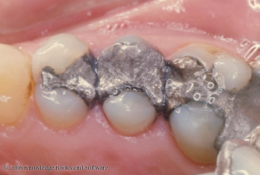
Ditching: Deficiency of amalgam along the margin, preventing the margin of the cavity preparation from being flush. It’s a gradual deterioration of amalgam at tooth-restoration interference.
This happens due to amalgam creep ( viscoelastic proparities ) so it tends to expand slowly and go above the margin
*those are failure restorations ,amount of failure : on 5 if we remove the amalgam restoration we need a crown , on 4 a new simple restoration might be enough, but keep in mind that if these restorations were done 15-30 years ago this result will be above the average ,(not a failure )might even considered as a success .and if the ptn is happy with them leave them !
considered survival :if there isn’t any major problem ( ex dentalveolar abscess )

the doctor talked about similar example in endo ; if you see a tooth with an amalgam restoration and a mummified pulp ,and the tooth don’t have any symptoms , you don’t have to do anything and you consider this as survival because we believe that there is a chance at anytime for this tooth to have an abscess, acute periapical periodontitis or any painful episode.
*mummification is an old technique to treat inflamed pulps , not used anymore ; was performed by first placing arsenic and then using paraformaldehyde over the dead pulp tissue. Root canals were filled with cotton moistened with creosote, tricresol-formalin, or an essential oil
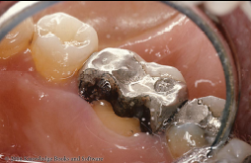
Tooth Fracture mostly occurs in case of undermined tooth structure under occlusal load .
it’s a failure with possible debonding of the restoration
The tooth needs a crown and as you can see the restoration extends to the pulp chamber so if there is a previous RCT we might need to redo it .

- when to repair & when to replace ?
this is determined under certain criteria :
- Ryge criteria 1973
Alpha:
Ex: sharp restoration that needs polishing , darkened composite that needs to be re-burnished by composite finishing disks.
• Excellent, fulfilling all quality criteria; tooth
and/or surrounding tssues are adequately
protected
• 2 Highly acceptable, though one or more
criteria is not ideal; minor modifica6ons can
be made to the restoration but is not
necessary
Bravo:
Ex: when we use burs to remove part of the cavity; caries in cervical margin of a composite restoration > remove caries and part of the composite > add composite and finish (repair)
• Sufficiently acceptable but with minor
shortcomings in areas where any
instrumentation may result in damage to the
tooth; no adverse effects are anticipated
Charlie:
Ex: fractured amalgam
Unacceptable but repairable

Delta:
Ex: root fracture
Unacceptable and must be replaced

- united state public health survey indices
rating system to rate the restoration if it’s repairable or should be replaced
ex: gd OH ptn with marginal detching restoration there might be a chance to keep the restoration comparable to a poor OH ptn where the restoration must be replaced.
RECALL
fissure staining in low caries risk ptn > review every 6 months or one year
fissure staining in high risk ptn > fissure sealant and review every 3 months

- Recall appointments
in ideal setting :
• Baseline: 1Week-1 month
• Then 1,2,3 years

What We do is a definitive fillings not a permanent.
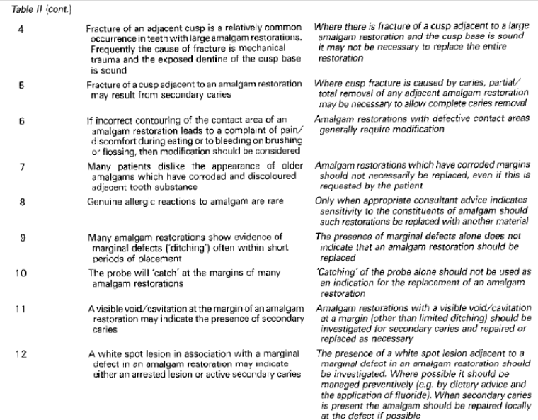
Written by : Ruaa khazaleh
corrected by : razan al laham

