Sheet no: 1

Refer to slide no. : Hypertension

Written by: Samar Al-Jaiose & Sana Esleim

Hypertension
* HTN is the most important disease that affects humans.
* It starts spreading.
* The likelihood of the disease is 30%-40% of the population.
* It accounts for 13% of the total mortality around the world annually.
* Some people say there is benign and malignant HTN, but HTN is always malignant because it’s dangerous.
*Bad:
1- Most of the time people are not aware that they have HTN (don’t know).
2- It is a silent killer.
3- It is a masked killer: causes kidney failure, HF “heart failure”, CVA “Cerebrovascular accident”, MI “myocardial infarction”.
4- Financially: it is the most expensive disease.
*BUT good:
1- It is preventive: changing the life style.
2- Has a very effective available cheap safe drugs (in comparison with the cancer drugs that are not effective and not safe).
* 65 million in America have HTN and they are increasing.
* If we don’t treat it, complications will happen. These complications cause important diseases.
* Prevalence of the disease in the world:
- In America it’s less than other countries because they worked hard for 30 years.
- But notice that even the first world countries like and Germany the prevalence can reach 50%.
- In Jordan we can say it’s 30% or 35% for adults above 18 years old, but above 50 years old it becomes 50%, above 60 years old it becomes 60%. So with age the prevalence increases.
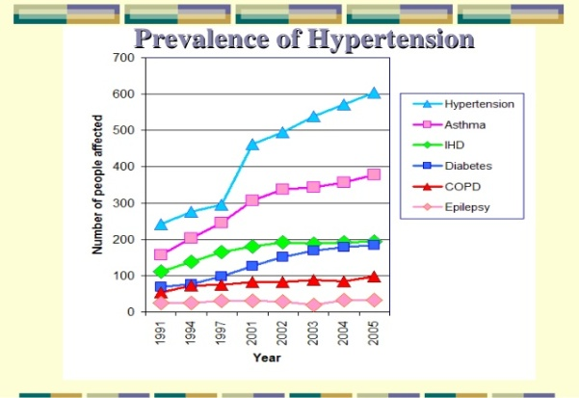
* In comparison with other diseases HTN increases continuously, probably after 20 years old the prevalence becomes more than 50%.

* There are important terms related to HTN: 1-Awareness. 2-Treatment. 3-Control.
* Before this we have prevalence: It is 40% (نسبته بالمجتمع).
* How many from this 40% are aware that they have HTN, in Japan it’s 16% only, in America (they work hard to educate people about HTN)it’s 70% (the best countryin the world). In Sweden, Germany, and Spainthe awareness is low.
* Most of the people don’t know that they have HTN.
* How many of the people who are aware are treated: in America it’s nearly the half, in England it’s 25% only (although they have an advanced health system).
* The worst thing is control: to reach the target that we want (to prevent the complications of HTN).
* In America the control is 30%, England is 10%.
* So we have to improve the situation of this disease globally.
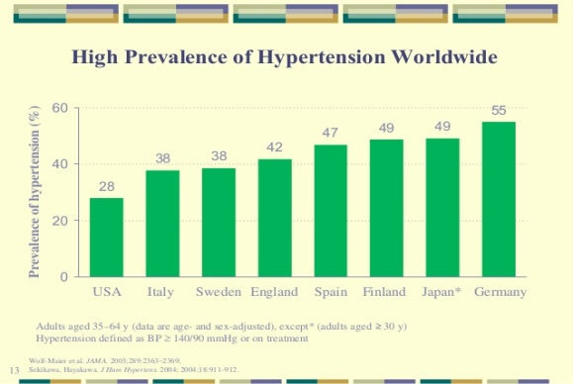
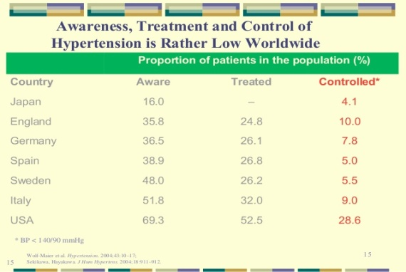

* Now, the awareness, treatment, and control are low.
* In America they did campaigns that improves the situation.
-Awareness: in 70(s) it was 50%, now it becomes 70%.
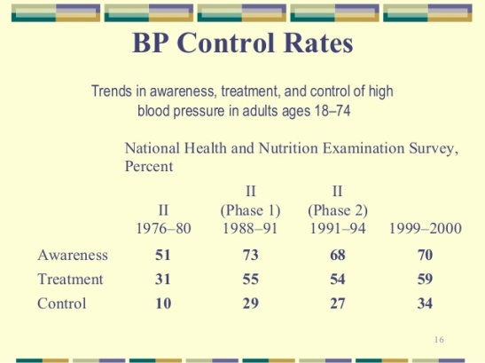
- Control: in 70(s) it was 10%, now it becomes 35%.

* Hyper pressure is the first killer in the world. The second one is smoking.
“Usually HTN and smoking are together”.
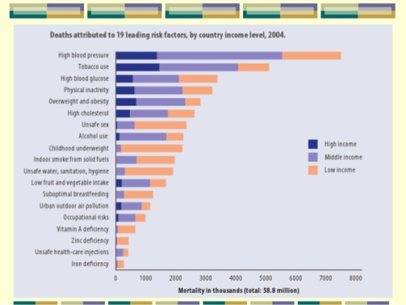
* HTN is responsible for 12.8% (13%) (7.5 million) mortality in 2010.

* What is HTN? HTN is hyper pressure, but not every hyper pressure is HTN.
* Normal blood pressure is a parameter.
* Blood pressure= cardiac output (CO)* systemic vascular resistance (SVR).
* So the interaction between heart and artries controls the blood pressure.(2 components):
1- The cardiac output controls the systolic blood pressure (high).
2- The reaction of the vessels (artries) on the blood controls the diastolic blood pressure (low).
* HTN by the definition is hyper pressure.
* HTN: is the level of blood pressure linked with a doubled increased long-term risk for adverse events. OR: the level of blood pressure at which the benefits of action (i.e therapeutic intervention) exceed those of inaction.
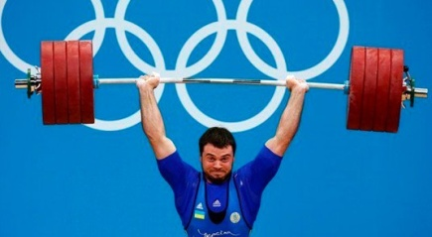
* This person blood pressure is 400/200 which means that the device we use to measure the blood pressure can’t measure this number, but he didn’t have MI or brain damage because it is a physiological process, once he stop the weight lifting his blood pressure will come back to normal. So he has hyper pressure but not HTN.
* So HTN is not only hyper pressure, it is an unjustified hyper pressure, not physiologic (like someone has a high blood pressure at the night and he is not angry, this is HTN).
* Sometimes HTN has causes and sometimes not (primary and secondary).
* HTN is a continuous high blood pressure.
* Normal blood pressure is:
- systolic < 120mm Hg.
- Diastolic < 80 mm Hg.
* HTN is :
- systolic > 140 mm Hg.
- Diastolic > 90 mm Hg.
* Between them there is prehypertension:
- systolic 120-139 mm Hg.
- Diastolic 80-89 mm Hg.
* HTN has divided into :
- Stage 1: 140-159 / 90-99 mm Hg.
- Stage 2: >160 / >100 mm Hg.
* These numbers are according to JNC8 ( in the slide it is JNC7).
*** JNC: Joint National Committee.
* What determines the degree is the higher whatever it is systolic or diastolic.
- If systolic > diastolic, systolic will determine the degree and vice versa.
*Example:
- 145/110: stage 2.
- 160/80: stage 2.
* The BHS classification is hard.
* JNC has made improvements, JNC7 continued for 10 years and finished in 2014. JNC8 is until now.
* In 90(s) JNC determined that the normal blood pressure is 140 not 160.
* Previously the classification depended on the diastolic, now it depends on the higher value whether it is systolic or diastolic.
* Systolic is more dangerous than diastolic.
* JNC6:
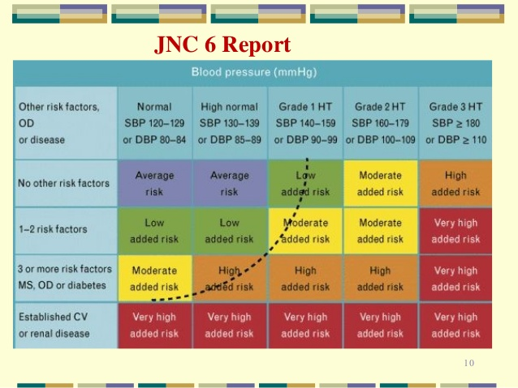
* HTN depends on the interactions between the risk factors.
- For example 130/89 is normal but if the person has an established risk factors (like coronary vascular disease): It will be very dangerous.
- On the other hand someone with a very high blood pressure without risk factors (smoking, obesity, diabetis): it will be less dangerous.
- So two people with the same blood pressure can be no like each other.
* If the person is prehypertensive or hypertensive, his treatment must start as life style modidications (stop smoking, weight reduction, decrease sugar eating, sport), BUT JNC7 said that:
- Stage 1: lifestyle modificstions with one drug everyday.
- Stage 2: lifestyle mosificatiions with two drugs everyday.
* JNC8 that we depends on these days made a little changes like increasing the target of the normal blood pressure in people above 60 years old to reach 150/90, so we will treat the patient if his blood pressre is more than 150/90.
***Good medical practice depends on:
1- Knowledge (evidence based, universal):
- A: systematic review, the highest.
-B: single study.
-C: case study (note sure).
-D: experts opinion.
2- Ethics (Local).
3- Experience (the interactions of ethics with knowledge, depends in the person).
* We have to treat HTN (reach the target) to prevent fatal complications.
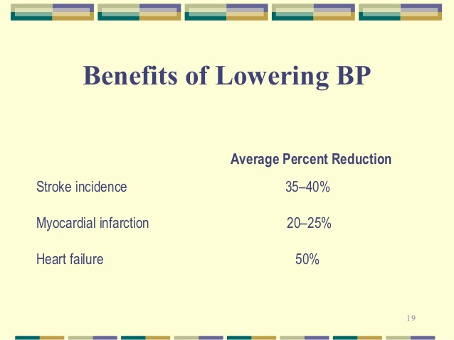
* Cardiovascular risks: hyperlipidemia, smoking.
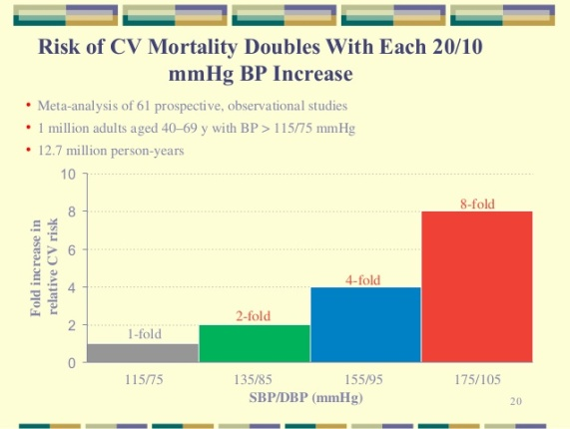
* Each 20 systolic, 10 diastolic increase in normal blood pressure, the cardiovascular risks will be doubled. "يخالف التعريف بالبداية"
* From 115/75 to 135/85 the risk will be doubled although both of them are normal.
* From 135/85 to 155/94 the risk will be 4 folds.
* From 155/95 to 175/105 the risk will be 8 folds.
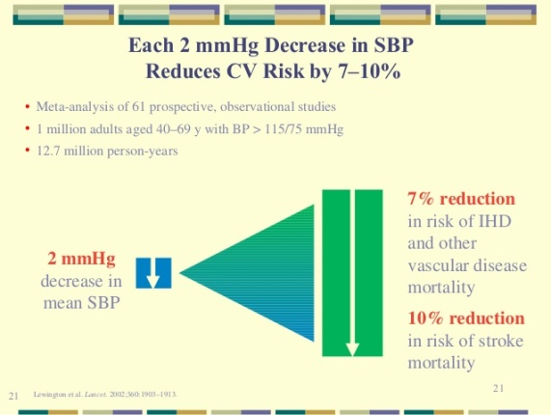
* If we reduce the blood pressure 2mm ONLY, we will decrease the stroke 10% and the cardiovascular risk 7%.

* How does HTN comes? Usually it is asymptomatic.
* The underlying cause of epistaxis may be the HTN, the same thing applies for headache. BUT the patient may have headache with a normal blood pressure and vice versa, so there is no strong correlation between this disease and the symptoms written in the slides.
* HTN is a very common disease and it is the first killer then tobacco comes secondly.
* So how can we measure blood pressure?
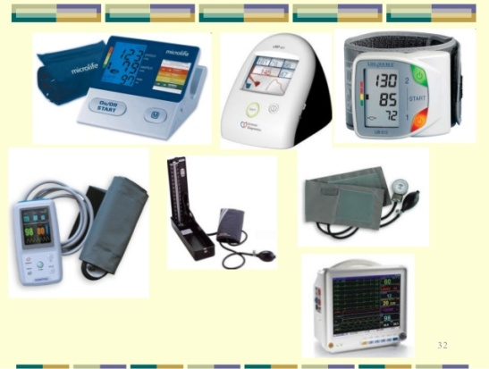
- Mercury type is not the accurate and can give us variable readings during the day.
- The one that is used in ICU “MBSV monitory” is the most accurate and can give us definite readings.
- There is a type of machines that you can put it around your waist for the whole day 24 hours, but it is nit that accurate “ABPM”.
- The digital type is good for clinical usage.
*Phantoscopy “note sure” is a useful method to diagnose HTN.
* Blood pressure is normally variable, with each cardiac output or stroke volume it changes. So some machines have a button when you press it the machine by itself takes three readings then it deletes the first one and takes the average of the rest.
* There is a very advanced machines that measure central pressure but we don’t have it!!!
* Which is more accurate clinic or home readings (measuring)?
- If they were both the same (both high or both low) there is no problem, but if there is a difference we go for what we call “white coat or office hypertension”.
* Normal blood pressure at home but high at clinic:
- 25% of females who attend the clinic for the first time have the white coat for mainlt the first five appointments.
* High blood pressure at homebut normal at clinic:
- Reverse white coat (masked): dangerous type, 10% can’t be diagnosed in clinic.
* So having a measuring device is mandatory at homes.
*** 140/85 at home : is high.
* We have something called dipping that happens normally at night (totally normal).
* Dipping: reduction in blood pressure (like 130 during day becomes 120 at night).
* Some people don’t have dipping or in some situations blood pressure increases instead of decreasing, here the patient has HTN.
* 90% of HTN cases are primary (environmental, lifestyle, hereditary).
* 10% ofHTN cases are secondary causes: so you have to treat the cause first. Example: a woman that takes CCP.
* Remember:
- Stage 1 and 2: lifestyle modifications and medications.
- Stage 3 and 4: management: hospitalization.
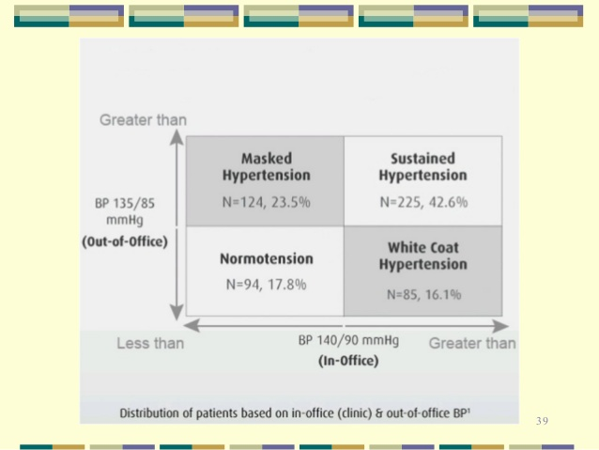
***Clinic VS Home measurements:

- Both are high: hypertensive patient or uncontrolled HTN.
- Both are normal: normal or controlled HTN.
- Home normal, clinic high: (discrepancy)
Mis-diagnosed as hypertensive patient: something that doesn’t exist, cost and side effects (treatment).
- Home high, clinic normal: (discrepancy)
Mis-diagnosed as a healthy patient.
* So there is a tendency not to take any measurements of blood pressure at clinic and give the patient a table to fill according to home measurements.

