Immune sheet #13
Refer to: last year slides 12+13
Written by: Zainab Mohammad
Corrected By: Aliya alMulla , Aisha alyasi

We talked about the hypersensitivity and just to remind you that we classified them according to the time of reaction from challenging with the antigen until we see the reaction, the other characteristic is that this reaction means that the subject is already immunized and already has immune response ( B or T lymphocyte) specific to that Ag.
and we classified as : type 1 hypersensitivity (:immediate /anaphylactic )
type 2 (cytotoxic)
type 3 ( immuno complex )
in type 2 +3 always the complement is active and the main destruction is due to Ag/Ab complex and to the complement activation.
now we are going to talk about type 4 hypersensitivity :
it cell mediated means that we don't have Ab activated or involved in this rxn mainly we are talking about cells
time of reaction : delayed because it starts after 12-24 hrs ( minimum 12 hrs to see the rxn but mostly more than 24 hrs)
here we are talking about T helper1 cell ( TH1) which is causing cell mediated immunity , so the first exposure it should induced the production of specific TH1 lymphocyte , In the second exposure the entering Ag will activate the TH1 through APC and produce certain factors , these factors will accumulate and enhance the rxn as we will see in a minute
so theoretically when the Ag enter for the first time that one will activate the cell mediated immunity ( CD4 OR CD8 ) , In the second exposure these already cells which will found in circulation they will react to the Ag and release many factors and these factors will cause a little start rxn in the body like cellular infiltration: macrophages, monocyte , proliferation to T lymphocyte (and then we will find direct killing of the macrophage and monocyte ).... then the end result will be tissue injury.
so the cell mediated immunity will produce many molecules like
- IL3 >>>> Hematopoiesis
- Interferon gamma , TNF, IL 1 >>> Extravasation to the activation area
- MCAF (macrophage activating factor) >>> Attracts macrophages do its function efficiently
- MIF (macrophage inhibitory factor) >>> Retains macrophages ( this is important in keep macrophage in the infectious site because its mobile cell)

this what happen in the first exposure : refer to slide 63
Ag will enter the body >> APC will present it to T lymphocyte through 2 signals (Ag signal + B7 CD28 signal) >> cell will recognize Ag and will produce TH1 lymphocyte ( most important cell in delayed type hypersensitivity)
sometimes some epitops can activate CD8 but the fast major repeat is TH1.
NOTE: The Type of Ag is what direct TH0 cell (naive cell ) to differentiate to TH1 or TH2 or both because some Ag require both cell mediated immunity and Ab.
in the second exposure: refer to slide 64
same thing will happen and already we have synthesized T lymphocyte and the macrophage already has phagocytic material (Ag or another) , this will activate macrophage even more when there is INF-gamma and other factors cause more expression of class 2 MHC (molecule) on the cell membrane and make rxn stronger.
this macrophage is the activated macrophage that will do function against invader or infector (infected cell) or bacterial cell or whatever the target cell.
so TH1 will produce cytokines and the macrophage will express more class 2 MHC in the surface + TNFalpha + O2 radicals + NO all will increase . these molecules important for killing microorganism inside phagosome.
Because the function of macrophage has 2 :-
1- oxygen dependant : where these H2O2 and all the other will come oxygen radicals
2- non oxygen dependant : depend on the enzyme which could found in the phagosome like ..oxidase enzyme and many other enzyme
So these target cell macrophage will be activated will be very strong active to destroy the target cell , so these what happened in the primary and secondary cell
molecules that produced by TH1 will do chemokines and macrophage recruitment to the site of Ag ( having chemotactic factors to attract macrophages)
ex: if you have infection in your leg the inguinal lymph nodes will be swallow because of the inflammation and accumulation of macrophages
INF-gamma will activate macrophages and increase release of inflammatory mediators.
TNF-alpha and Leukotrienes are important in local , increase permeability of vessel and more migration of cells in the infection site
IL-3 and GM-CSF activate bone marrow to produce more cells because cells when do phagocytosis they die at end so I need more cells at infection site
SUMMARY: in the secondary exposure you have activated macrophage , TH 1 OR 2 , and when we talk about inflammation there is other cells like mast cells and eosinophils and their products like anaphylatoxins will increase permeability of vessel , so there will be a lot of accumulation in that area.
What are the Ag that cause cell mediated immunity? refer to slide 66
in delayed hypersensitivity generally they are intracellular infection , ex : mycobacterium , AG proteins , insect venom ..
locally you can see skin swelling , erethyma , cellular infiltration , induration and dermatitis , also cell mediated immunity can cause contact hypersensitivity or contact dermatitis and all the Ag are different ( the Dr mentioned examples : the thing that placed in the finger used in sewing and the metal clamps that woman used in the past to wear long socks .. )these can cause allergy but not type1 hypersensitivity because they contain nickel and other things like chrome , some metal ions ... which can change structure of the cell or proteins and cause type4 hypersensitivity and generally there is local erythema in that area
or we can have butant sensitivity (a material in the wheat crust called butant ( I'm not sure)) that can cause hypersensitivity in the GI and its also type4 and we can see atrophy and malabsorption in the small bowel in the same time it can induce Abs ( and for diagnose we look for Anti-gliadin)
all these things and different types of Ag can cause different type of cell mediated immunity
How we can test this cell mediated immunity?
we cannot look for Ab because we don't have Abs , so mainly we can do vivo and vitro tests
in vivo : generally its skin tests
-jones-mote test : a test for 24 hrs
-contact test : like nickel put it in the skin and see the allergic rxn
-tuberculin: this for Tb , used to check if you have immunity against Tb or not , inject it intra-dermal and after 48 - 72 hrs examine the injection site
*skin test we can use it for both :1.cell mediated immunity 2.for Ab , but the end result is different , we will talk about in just a minute
-granulomatous test : this when we look for the function of the macrophages because we might have immunity the macrophage can do phagocytosis but it cannot kill the organism inside the cell and here the macrophage will accumulate in that area and cause granulomas
sarcoidosis for example we can diagnose it with granulomatous test

**Tb is intracellular infection , when the microorganism enters they will grow inside the cells
if its host with dendretic cell it will seen by T lymphocyte through class 2 and we will get cell mediated immunity through TH1 , it will produce INF and destroy macrophage
also mycobacterium can enter the macrophage because it can do phagocytosis and the recognition here through class 1 then CD8 (cytotoxic T ) will be activated and it will destroy infected macrophage
so we have both immunity to destroy Tb. 1. TH1 2. CD8
tuberculin : is a purified protein from tuberculosis bacilli , that tuberculin we inject it intra-dermally and after 48-72 hrs examine the injection site , if look something like this redness more than 0.6 - 0.7 mm then we can say its positive , why? because its Ag doing second challenge means the macrophage will come to that area and there will be local rxn where we can see it like this
IF we are looking for Abs , we have skin tests for Abs like shick test for diphtheria , when we inject toxoid and after 24 hrs we examine injection site , if there is rxn and redness this mean that I don't have Abs , if no rxn this mean that I have Abs and they neutralize toxin
so if we inject Ag like tuberculin and there is a rxn >>> person is immunized
if we inject toxin and there is NO rxn >>> person is vaccenated
There is a fifth type (Type V Stimulatory Hypersensitivity )
this type the rxn between the Ab and the Ag is a stimulatory type of rxn , the others is activation of the complement and destruction of the target , in this type you stimulate the target , ex : thyroid gland it is stimulated by TSH from pituitary and produce thyroid hermons T3 or T4 until they reach certain level and cause feedback inhibition and the TSH will be stopped , BUT if we have autoantibody to the same TSH receptor then these Ab will react on that receptor and thyroid will produce thyroglobulin but this is not controlled no feedback inhibition
this we can see it in :
1- Grave's disease
2-Myasthenia Gravis : Ab work as ach on muscles causing contractions but without control
3-Hashimoto's thyroiditis
Systemic lupus erythematosus 4-
so type5 is Ab mediated immunity

Transplantation
Transplantation means Transfer of living cells, tissues and organs from one part of the body to another or from one individual to another.
We have different types of Transplantation:*
Autograft is self-tissue transferred from one body site to another in the same individual.
Isograft is tissue transferred between genetically identical individuals ( identical twins )
Allograft is tissue transferred between genetically different members of the same species ( human to human )
Xenograft is tissue transferred between different species (animal to human )
<<Now we're going to talk about each of them:
*Autografting :
1-skin grafts
2-bone marrow transplantation: in those who has leukemia OR lymphoma after treatment they will take their BM and store it, and make sure that it does not have tumor cells , if the tumor come back again , they transplant their own healthy BM.
3- Hair
*Allografting :
widely used , from mother to daughter , brother to brother ..... relatives generally there is at least 50% matching.

*Xenografting:
maybe in the future if we know how to do certain tolerance to the transplanted organs , or if we clone heart or liver or kidney in animals and transplanted in humans will be great.
…...
So, what is the principle to do transplantation?
The main important thing is to find a matching donor (the target organ or WBCs should be matched between the donor and the recipient) to do this we mainly look for HLA type because HLA Ags is the transplanted Ags , the recipient body will recognize those, and this done by doing HLA typing or mixed lymphocyte culture reaction.
-First it was done by simple methods (microcytotoxicity test)
-Now it's done by DNA sequences
......
*So the laboratory test: done by selecting a donor and make these tests for him/her:
•ABO Blood typing
•Tissue typing (HLA Matching(
•Lymphocytotoxicity test
•Mixed leukocyte reaction
•Screening for Presence of Preformed Antibodies to allogeneic HLA
•Crossmatching
……
Why we do cross match even if HLA types are completely 100% match?
Because due to infection we have some Ab that can cross react with WBCS or tissues.

Where we use HLA type ?
In transplant solid organs ( kidney , heart ) , BM , stem cells ....
How we do HLA types ?
Generally we should have monoclonal antibody for each type of HLA ( we have around 1600-1700 type of HLA).
so we will take donor/ recipient WBCs and we add to them Ab specific to one Ag ( we mean one HLA type ) then we add complement, so the end result will be perforation of the cell membrane cause the membrane is so rigid ( if RBC the end result will be lysis ) and then add vital stain that will stain dead cells only (will stained blule), and the cells which not stained they called micorcytotoxicity cell.
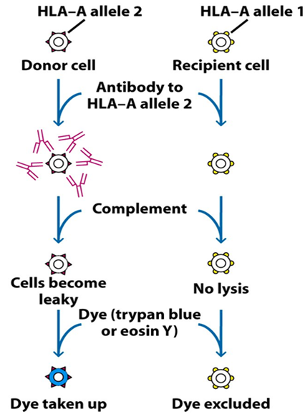
And by this we can determine HLA types in the donor and recipient cells and do matching ( microcytotoxicity test ).

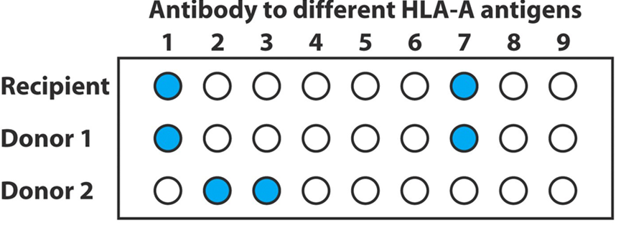
But the micricytotoxicity test does not give 100% matching because we can't do the test for 1600 type of HLA; it was done in the past and still in certain places.
Then we do cross match, take recipient serum and mix it with the donor WBCs, if there is rxn this mean that there is Ab that I don't know.
Mixed Lymphocyte Reaction:
we take recipient lymphocyte and the killed donor lymphocyte by irradiation or by add cytotoxic drugs, and because donor cell is dead this mean that it work like an Ag, if its recognized by the recipient cell this recipient cell will responds and proliferate producing clone of cells that respond to the Ag , and from how much proliferation happen I can measure it:
- Strong Proliferation (HLA not matching)--->High incompatibility
- Weak proliferation--->Low incompatibility
- No proliferation (HLA matching)---> 100% compatibility

*Now by molecular biology we can do many tests for example: restrictive fragment lymph polymorphism , sequencing and priming ?? , ................ (Sorry but I couldn't hear what the dr. said at that moment (38:16)).
*In any one of the above tests we can do PCR and we can find exactly your Ags and which allele you have (in microcytotoxicity I can't know allele type).
*So molecular biology : more specific and more sensitive.

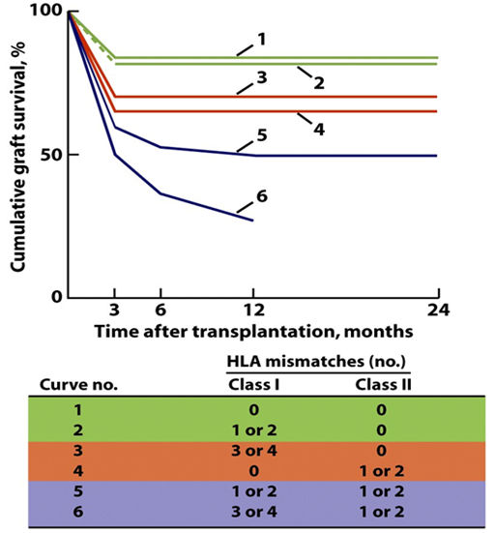

This is an example : shows HLA type matching or not between donor and recipient in a kidney transplant :
1 = if there is no matching the patient will not survive
2 = if 1 or 2 class2 mathcing and no matching class1 the patient will have butter survival
6= the survival much much butter
Thats why HLA is extremely important *
Now , if there is no matching we don't do transplantation ?
generally in transplanting solid organs 50% is enough and the other 50% will suppressed by immunosupressor drugs
but when I talk about hematopoitic system it should be at least 85% matching because I am transplanting immune cells that can react.

How rejection happened?
exactly as immune response by cell mediated immunity and Ab both will work ( no difference as we learn before)

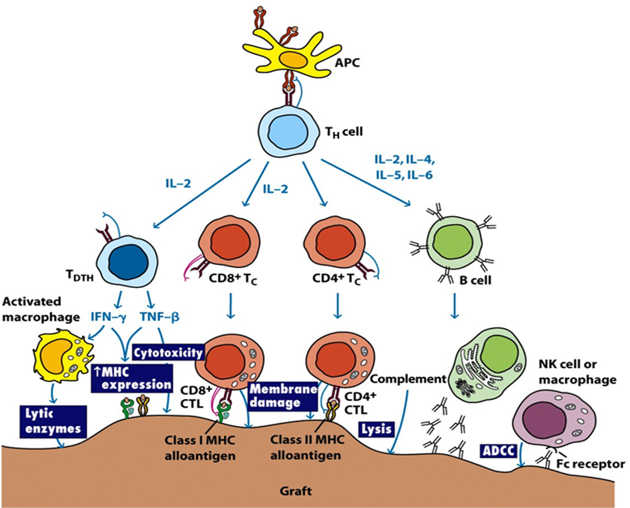

This is our graft cell recognized by immune cells which will recognize the lytic enzymes from activated macrophage or the destruction will happen by cytotoxic T LYMPHOCYTE or destruction by class2 alloantigen or class1 or by ADCC .
......
So all the immune response will be activated against graft cell . Treatment : immunosuppressive therapies. (for any of the above at any stage)

Rejection clinically we can see it in 3 different types:
-Hyperacute rejection : already I have Ab in the body due to immunization, or postreactive antibodies, or pregnant women have accumulate antibodies or by cross rxn , and with few hrs of transplantation rejection will happen.
-Acute rejection : the immune system will recognize Ag and rejection will be after 7-10 days from transplantation.
-Chronic rejection : the macrophage cell mediated immunity or some hypersensitivity or delayed hypersensitivity , rejection around 6 months.
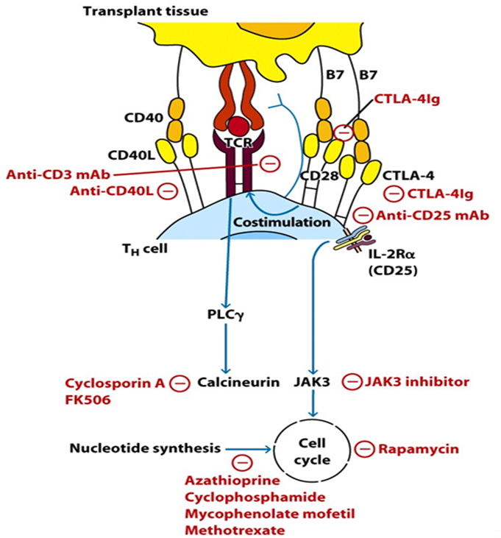

*TREATMENT:
-Anti-CD3 monoclonal antibody: loss recognition completely -
-Anti-CD40L: NO Ab production
-CTLA-4Ig: no second signal
-Cytotoxic 4Ig: no second signal

* The treatment is depends where we do it and for life and the patient should be monitored for the cytotoxic effects.

