* Immunology * Generation of immune response * Lec #10
Brief revision:
- Last thing we talked about last time is : How the cooperation between (B & T lymphocyte)
or between (antigen presenting cell & T lymphocyte) can lead to generation of immune
response?:
B lymphocyte or APC can present the antigen on the cell membrane through the MHC
molecule after degradation or metabolization of the antigen
then 2 reactions can occur:
1. First reaction: - between the epitope and the T cell receptor
- act as first signal signal 1 leads to recognition by T cell
2. Second reaction: - between B7 and CD28
- act as second signal signal 2 leads to activation of T cell
These 2 signals coming to the T lymphocyte transform it to activated form, producing
certain chemicals/molecules that will START to be presented on the cell membrane of T
cells; for example here the t lymphocyte has no CD40 BEFORE ACTIVATION, but after
activation they start to present.
these molecules “CD40” interact with the ligand fond on the B lymphocyte, giving it
“ B cell” the second signal
** Note: first signal through the epitope
after these 2 signals, B lymphocyte will be activated, and start to produce antibodies
this is how these two work together
Note:
* B lymphocyte carries out 2 responses depending on the antigen;
1. T-independent antigen; if the antigen is T independent, then there is no need for T
lymphocyte “B lymphocyte can response in the absence of
T lymphocyte”
2. T-dependent antigen; if the antigen depend on the T lymphocyte then B lymphocyte
can’t respond in the absence on the T lymphocyte o it’s
products
these B cells “as precursors”, when they become mature; having on their cell
membrane: IgM and IgG as receptors, and at the end, they will become plasma cells
that are able to produce antibodies.
The beginning of the lecture :
- may be we will have another B lymphocyte “other than the mature” that is:
* different from the first one “mature/ B2 B cell/ normal”
* called : B1 cells
It’s the precursor of the cells, which can be activated to produce IgM only,or
may be, it’s the one limiting from that cell
this lymphocyte has a special mark on the cell membrane which is CD5
** this CD5 isn’t found on the B lymphocyte which can respond to T-dependent
antigen, it’s only found on the T- independent B lymphocyte which can
produce IgM
so that CD5 positive B lymphocyte can produce the IgM;
- those IgM are called : - Natural antibodies
- Produced by Bymphcyte B CD5
- what are the natural antibodies in the human body?
** Blood groups are natural in human body without stimulation of antigen,
meaning that we don’t inject specific antigens aming for producing
antibodies against those AGs
* Characteristics of B1 B cells:
has no memory cell; - it sees the antigen as if it’s faced for the first time
- the cell that produce the IgM will die without memory cell
for that antigen, so if that antigen entered for the second
time it will be combated as I it’s faced for the first time
no secondary immune response which can be produced
they are present from birth
- So the antigens which can produce primary IgM T independent have specific
characteristics, “not ANY antigens”
- this process isn’t innate because:
at the end we have immunpglobulin production IgM
not immediate response “s/min/1-2 days”, it needs 5-7 days

Differences between B1 & B2 which can be found normal in the body:
- Renewal of B2 occurs through bone marrow as stem cells
- spontaneous Ig production by B2 cells is low because it needs a signal for stimulation
---------------------------------------------------------------------------------------------------------------------------
B2 Lymphcytes: it’s course:
- can produce all types of immunoglobulins
- when we inject the antigen, there is a “lag phase”; meaning that from the entrance till
we see the antibody, there is a lag phase
- this lag phase include: - metabolization of the antigen
- interstitial equilibrium
- antibody production that takes 10-15 days to be produced
- then we have a lobe, where after removal of antigen-antibody complex from the
circulation, then there is increase # of antibodies exponential
- it will reach a certain concentration till the plataue phase, then the antibodies will
decline
this is the normal typee of antibody production by B2-B lymphocyte
---------------------------------------------------------------------------------------------------------------------------
*If we look what will happen here;
- there will be the recognition by T lymphcyte
- then there will be a clonal selection; which means that the T
lymphocyte that recognize that epitope will be stimulated
- then there will be the clonal expantion, meaning that they will
start to divide and increase their #
- then there will be exponential # till the reach the peak; here we
have the differentiation of the T lymphocytes, whether we need
to produce T-helper 1 or T-helper 2 as well as B cells
- they will never go to zero, because the memory cells will stay in
certain # somewhere in the circulation
-those which will respond, they will undergo apoptosis and
distorted from the body
so we have; recognition, activation, effector, decline, and
memory.
this is for all the types of immune responses we have

---------------------------------------------------------------------------------------------------------------------------- Primary vs. Secondary response:
- The Lag period here is different.
- The type of antibody produced is different.
- What will happen here:
- one of those cells will recognize antegin, starting proliferating and producing a clone of cells,
- the clone will produce antibodies, and one of those cells will be memory
- these memory cells will only recognized the epitope that was recognized before; so those cells are committed to produce antibodies against this recognized epitope for life long; the won’t switch to produce other type of Abs with other specificity
----------------------------------------------------------------------------------------------------------------------------
primary response: when we inject the antigen for the first time, then there will be
recognition, activation, then differentiation “specific amount of Abs
will be produced”
secondary response: when we inject the antigen for the second time, or 2 antigens
together;
- the antigen which has memory cell will have a very large amount of response
- the antigen which has no memory cell will have a response as PRIMARY

- So, the difference between primary and secondary:
1. Lag phase is short in secondary
2. The type of Ab in the secondary is IgG
3. The amount of Abs in the secondary is very high
4. The avidity and affinity is much higher in the secondary immune response;
resulting in AFFINTY MATURATION
---------------------------------------------------------------------------------------------------------------------------
- when we inject the T-cell memory cells “the virgin lyomphocytes”, the will produce a clonal cells, those cells will respond
- when we inject for the second time, Memory cells will respond and due to expantion, they will be much much higher : so those will have the function and memory cells for the third rxn, resulting in a high # of cells in the secondary immune response.
Note:
- the T-independent antigen, if you inject it for irst/second/…./ tenth time; the same altitude an the same type of antibody will be produced
Memory cell:

we said that the immunoglobulins in the primary immune response is IgM, BUT how
the immune cells “B lymphocyte” will be able to switch from IgM to produce IgG, or IgG,
or IgE, or IgA : Who is giving the trigger?
- we have a certain interlukines “cytokines”
- so at first we have recognition, activation, and then the proliferation
- In proliferation; there is sth. Called AUTOOCINE:
- in which the T lymphocyte starts to express on it’s surface
interlukines-2 receptors,
- at the same time , the cell will produce interlukine as a
soluble material, then this IL will interact with the IL-2
receptors ON THE SAME CELL, resulting in it’s activation,
this is what we mean by autocrine.
Autocrine: same cell has the receptor and the
corresponding protein
- then after activation, we have also another clonal expantion in which we have IL-4 and
IL-14 are very important in this stage
- then maturation for these immunoglobulins; If they will produce:
IgG: then we will see IL-4,IL-5, IL-6, and Gamma interferone “IFN”
IgM: then we will see IL-4 and IL-5
IgA: the we will see IL-5 and T-cell growth factor beta “TGF B”
IgE: then we will see IL-4 alone
- so these cytokines produced by T-helper lymphocytes are responsible for directing
the B-lymphocyte to do switch between one immunoglobulin and another

Here:
down arrow : suppression
up arrow: stimulation
suppression or stimulation to produce
B- cell of specific IL
--------------------------------------------------------------------------------------------------------------------------- Superantigens:
- Exactly same as the normal
- We can see more cell that are activated to produce different type of Abs
---------------------------------------------------------------------------------------------------------------------------
Clonal selection:
- From a poole of T-lymphcyte or B-lymphcyte, one cell will recognize the epitope, results in it’s activation, therefore producing clonal cells to keep the immunoglobulin and this is the # of cells that we can see in cell activation.

---------------------------------------------------------------------------------------------------------------------------

-as we know, we have 2 types of T-lymphocytes “at least”:
1. T-helper
2. T-suppressor
3. In addition to the T-rgulator : which can regulate the immune response
---------------------------------------------------------------------------------------------------------------------------- T-helper 1: it will tell T0 which doesn’t recognize any thing to go to T-helper 1 or
T-helper 2
The IL generated:
- If IL 11 or 18 : will activate T0 to go to T-helper 1
- If IL4: will go to produce T-helper 2
The function of each one is different:
- those which have IL4 , T-helper 2 will go to tell the B lymphocyte to produce
immunoglobulins
- while the other one will go to produce cell mediated immunity for the intracellular
infection, for the tumor infection, and for the other
- so that one will be directed by interlukines to tell here or there
---------------------------------------------------------------------------------------------------------------------------- Interactive characteristics:
- If you increase the IL4, this will suppress the T-helper 1
- If you increase the IFN gamma, this will suppress the T-helper 2
- so these is an interaction through which they can control their function between the T
subsets of cells
---------------------------------------------------------------------------------------------------------------------------- Factors generated by T-helper 1 and T-helper 2:
* The cells between barackets:
- MQ macrophages
- DCdedritic cells
- Nk natural killer cells
* SO here the antigen preseting cells
produce almost the same IL
What is the function of each one:
---------------------------------------------------------------------------------------------------------------------------- What will happen to T-helper 1 in presence of gamma INF:
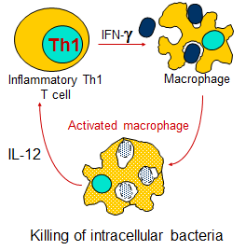
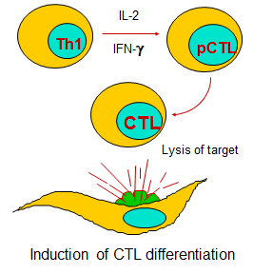
- when we talk about IL2 and gamma INF
will activate the cytotoxic T-lymphocyte
- This activation leads to interaction of the
cytotoxic cell with the infected cell
- resulting in destruction of the infected one
- both are generated from T-helper but the
way of action is different depending on the
antigen
- the infected macrophages will be destroyed
- at the same time , the activated
macrophages will produce the IL 12 to
increase the function of the T-helper 1,
so it’s a circle where each one activate the
other aiming at the end to kill the bacteria
inside the macrophages

GM-CSF: Granulocyte-macrophage colony-stimulating facto

so when we talk about T-helper 1 and T-helper 2 , gamma INF will inhibit T-helper 2
while IL4 will inhibit T-helper 1, so the type of immunoglobulin would be activate
depends on the types of ILs generated from these cells
In more details:
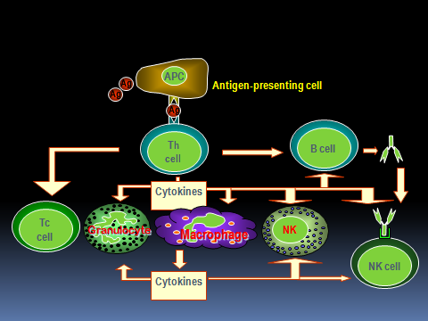
-APC metabolize the antigen presenting it to T-helper lymphocyte
- Th cell will help the B cells to produce Igs
- Nk cells which have receptors on the Fc portion of Igs, will be armed with the Ab
killing the target cell because it has specific receptor “mesh elha bs jay mn
barra!”, or this Nk cells and cytotoxins act on the infected to the granulocyte
“infected cells”
- also the cytokines coming from the Th-lymphcyte act on the macrophage
activating the cytotoxic T-cells
- so there are agroup of cells that would be activated through this course
Note:
** the cytokines from the Th activate all the cells
** cytokines from Th cells activates the macrophage to increase the production
of cytokine

----------------------------------------------------------------------------------------------------------------------------
*Here as we said about Th 1 & 2:
when they become activated, at the end they will activate the:
1. B lymphocyte
2. Eosinophils
3. Macrophage
remember that IL5 activates the B cell to
produce the IgE activating the : 1. Mast cell
2. Eosinophil
because they have receptors for them, then
this activation leads to allergy
this activation depends on the type of IL that Th
cell will generate

----------------------------------------------------------------------------------------------------------------------------Mechanism of cytotoxic cell killing:
- After activation of cytotoxic T lymphocyte, there will be direct contact between it and the
target cell “wehter infected by virus/ wehter it’s a macrophage…”
- when the contact happen, there is a certain molecule will be activated, that some of them
are caspases and the other are fast ligands, through which the apoptosis will be activated,
so the cell at the end will be apoptotic and die.
- so if these molecules reacts with the target cells, then the cytotoxic T cells will producr the
Perforine: - a protein molecule
- which will perforate a cell membrane
- then that cell will produce another molecule Granenzymes: that will destroy/degrade
the enzymes found inside the cells
- the action of these released molecules together on the target cells, lead to cell death
Notes:
- granenzymes come from the granules within the CT ells,
- peforine perforate the cell membrane of the target helping the granenzyme to do it’s
job “causing Ca +2 reflux and degrade the enzymes”
----------------------------------------------------------------------------------------------------------------------------
T-helper 2:
Note:
- here we need the macrophages to:
1. go to the infectious side
2. to be kept in the infectious side
- so there is a molecule called Migration Inhibition Factor:
1. macrophage are motile cells having pseudopes helping them in moving
2. Migration factor helps them to be KEPT at the infectious area
----------------------------------------------------------------------------------------------------------------------------
What will happen to T-helper 2:
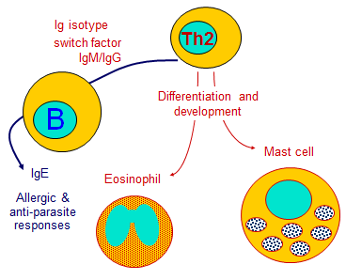
- when it’s activated, it will help
the B lymphocyte to produce the
Igs
- these released Igs will bind the
eosinophils to produce the allergic
anti-parasitic reactions

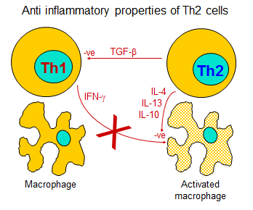
----------------------------------------------------------------------------------------------------------------------------Immune Regulation:
- How the immune system will be regulated?
- meaning that any activated cells or Igs can’t be acteivated or released without any
control, and if that happen we will get a very serious immune diseases, so there must be
a very restrictive control for this system
Concept of immune response:
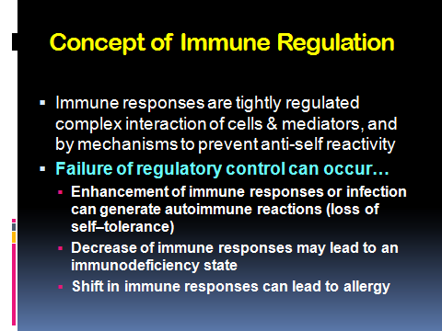
Balance between lymphocyte activation and control:
-Example:
1. if we have a tolerance for O-antigen, then there is no response,
2. but if by way or another, the response is activated, then we will get Autoimmune
disease, indicating the disruption of balance.
3. If there is OVERactivation of immune response, especially if there is a CROSS RXN, then
the result is also autoimmune disese.
-so If there is a balance between activation and regulation “response and tolerance”,
then we will have an excellent immune responses without any problems
- If one of them lose it’s control, then we will have very very serious types of diseases
----------------------------------------------------------------------------------------------------------------------------- when we talk about regulation, we must take in our consideration 3 conditions we talked
about: 1. Recognition
2. Activation
3. Proliferation
- each of these conditions has a specific way of regulation
1. Recognition:
the recognition of the receptor to the epitope
what helps in recognition: - T-cell receptor
- B-cell receptor
- MHC
2. Activation:
between B7 and CD28 “second signal”
3. Proliferation:
- when we talk about the EFFECTOR then we mean the end product of the immune
response:
antibody production
Th1
Th2
Cytotoxic T cells
---------------------------------------------------------------------------------------------------------------------------- Regulation:
1. Antigen:
- is the fisrt regulatory of immune response
- so the antigen can regulate the immune response
- here the regulation depends on many things:
1. The chemical nature of the antigen; whether it’s a protein, soluble, or particle
if it’s protein, then all immune responses will be generated
if it’s polysaccharides, then this will generat IgM
2. The dose of the antigen; are we injecting LARGE/SMALL/OPTIMUM dose:
Low dose: leads to tolerance
Largge dose: leads to paralysis
Optimum dose: no problem
3. The Competition between more than one epitopes; if we give two similar epitopes,
may be one will be responded and the other one no
4. The site where the antigen is injected; if they injected IV then they will be
metabolized quickly, thus the immune system won’t see it
5. Are we injecting the antigen alone or with adjuvant
----------------------------------------------------------------------------------------------------------------------------2. Genetic factors:
- the gene that is coding for B cell receptors and t receptors also regulate the immune
response; if we have mutations with B cells or T cells, then ther will be abnormal
generation of action and Ab
3. MHC type:
- If there is an abnormality with MHC, we will have different type
- remember, we have MHC restricted inection, then:
if we have that type, we will be responder
if we have the other type, we will be resistant
- so this also has a very important role in control
All the others which are for example, let’s tailk about the cytokines:
- we said that if one has specific cytokines, he will be resistant ti HIV
- if he has the other cytokine, he will be susceptible to the disease, so these again
genetically they control the immune response
4. Antibodies:
- the antibodies can regulate the immune response
- when we talk about the antibody regulation, we have the antigen-antibody complex
which acts through what’s called : feedback regulation
feedback regulation;
we said that in primary immune response IgM will be produced,
while in the secondary, IgG will be produced, so if we give the IgM to the patient to
be complexed with epitope A, then the immune response will be activated to
produce IgG increasing it Bbecause it’s already exist + feed back
while if we give IgG then we will have – feedback because it, for example if a woman
has a negative rh factor and she is pregnant with positive rh, then she will produce
antibody to the RBCs, resulting in having an antibodies of IgG types
in the second pregnancy if she also was pregnant with + rh, then those existing IgG
can pass the placenta to the fetus, but if I give her IgG to RBCs at birth or befor one
day of birth, then she won’t producr that one.
---------------------------------------------------------------------------------------------------------------------------- Idiotypes: recognize the changes in the antigen-binding sites
crosslink: when the antigen link to site othe than the Bcell receptor for example, then
there will be no reaction
activation of the antibody immune complex, for example CD3 which is component of C3
it’s important to eliminate the immune complex from the body, so if we activate that
then all will be eliminated without being seen by the immune response (specific receptor
responsible to recognize that epitope)!!!!
Idiotype-Antiidiotype:
- the changes of the molecule in idio type is in the “hyperactive region” where it can
recognize the epitope
- example:
- we have antigen and it’s receptor
- in the receptor we have the hypervariable region that will be recognized by the idiotype
as if we have a cell in the body having a receptor that will recognize the epitope
- but the 3 of these cells is very very low, and because they are low enough, they will
prevent the production of the immune response
- however, if we activate the cells to produce large amount of that cell, they will be
recognized by idiotype, that cell function will stop, therefore, these cells won’t
recognizes the antigen, and the function will be stopped
- But in normal case, if our B ot T cells aren’t activated “no much clonal cells”, then there
is no recognition
---------------------------------------------------------------------------------------------------------------------------- for who couldn’t understand:
- we have a cell injected by antigen
- the cell respond to this injection by producing a group of cells specific to that epitope
- at the same, we have in our body another cell which can recognize the changes in the
cell membrane “B/T cell receptors”, that recognition will happen by self
- keep in your mind that there are another cell in the body that can recognize the epitope
other than the corresponding one, this leads to suppression of the function of the
corresponding one because the recognition doesn’t occur at the area of rxn
“sawaleeeeeeeef”!!!
-------------------------------------------------------------------------------------------------------------------------
other way of regulation is through the complement:
- complement is very imortent to promote the APC because they have a receptor for the
complement
- CR1 will be activated to remove the complex from there
- C1, C2 stop the unction of B lymphocyte if they recognized it
------------------------------------------------------------------------------------------------------------------------
Regulation through the B7-CD28 “B-stimulators”or TCL-antigen4 or ligand and antiligand
on the surface of B cells.
also the regulation can be through cytokines, we have IL that can do inhibitions and
other do the activation “green for stimulation and orange for inhibition
also we have regulation through cell interaction.
--------------------------------------------------------------------------------------------------------------------------
* Done by : Dana Ayman
- This is generally the anti inflammatory properties of Th2

- There should be a balance between
the normal cel function and the
tolerarne
Tolerance: is one way of
regulation, in which we have a
recognition but without response
“unresponsiveness”

