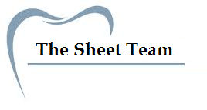
Title of Lecture: immunoglobulins

Date of Lecture:23-10-2014

Sheet no: 5

Refer to slide no. :5

Written by: Haneen Al-Khateeb

As a reminder:
- immunoglobulin (structurally) is composed of :2 heavy chains & 2 light chains,
& (Functionally) its divided into:
1-Fab portion … for the antigen binding site
2-Fc portion …for biological function
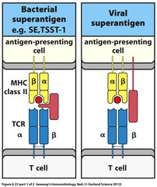
- the difference between viral & bacterial superantigen:

-Superantigen of the bacterial is bind to MHC receptor on the macrophage & to T cell receptor directly from the out side, & there is no direct connection with antigen presenting cells
-viral superantigen will bind both receptors, but it has some connections with antigen presenting cell directly, because the virus is an intracellular infection means that part of the virus still found in the membrane of the antigen presenting cell
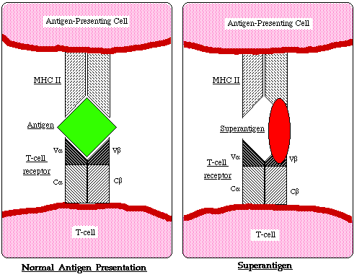
NOTE: there no direct contact between antigen presenting cell & T cells, but the connection is made by the superantigen & there is no processing & no specificity . But in normal conditions (normal antigen), the epitop is what makes the direct connection between T cell & MHC receptor of antigen presenting cell .

-we have 2 types of antibody:
1- first type is which secreted by plasma cells & do its function in the circulation
2-second type is bound to the cell membrane on receptors
Both have the same specificity which means antigen binding site is the same

Super family:
- super family means: a group of the same type of receptors that present on all cell membranes, not only T cells . all have domains like immunoglobulin but they are not Ig.
Super family contains:
-Immunoglobulin's are part of the super family that bound to cell membrane
-at the same time we have T cell receptor that has almost the same structure functionally 2 variable region & 2 constant region , it consist of 2 polypeptide chains .
-we have in major histocompatibility complex molecules which are present on white blood cells that make blood grouping H & A ,it won't change cause its inherited ,we born & die with them.
-Ig α & Ig β : are heterodimers which are important in the recognition of the T & B cells
-poly Ig R – fcR receptor – fcƳ receptor & other many receptors.
All what we mentioned are part of the super family

-other characteristics:
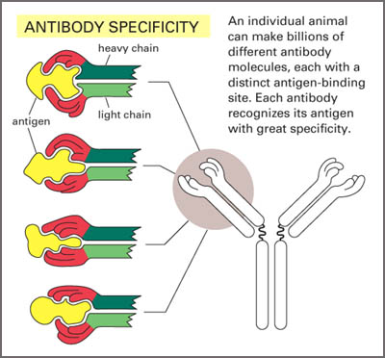
1-We have the variable region & the constant region , in variable region we have 3 spots areas where they are hyper variable (CDR1-CDR2-CDR3) . There are 110 a.a in the variable region , if this region changes 10% , the high variable region will change 100 times comparing the others ,that’s why we call them hyper variable regions. We call the high variable regions : Complementary determining regions (CDR). The importance of this region is that the configuration of the high variable region gives a set for the epitope, meaning that there will be a loop in this region which recognize the antigen, binding to epitope don’t happens in a sequential manner, the amino acids which bind the epitope are not sequenced . the specificity of the reaction comes from folding of the heavy & light chain to produce the groove where the epitope will react. It's like holding an apple . NOTE that : the sequence of the amino acid between different Igs could be the same , but the difference is in the configuration ( the same sequence, but the folding is different) .

2- J chain : we find it in the polymoltemeric immunoglobulin like IgA & IgM . IgA consist of monomer ,dimer or trimer . IgM is a pentamer . J chain functions as a linker .
3- secretary piece: immunoglobulins that are produced in the secretion have secretory piece like IgA. Secretory peace is produced by epithelial cells in the mucous membrane un like Igs that are produced by B cells. it protects IgA & resist proteolysis in extra secretary liquid.

Immunoglobulins:

We have 5 types of Igs : IgA – IgM – IgD – IgG – IgE

IgG:
-IgG has the most high concentration in the circulation. its almost 80% of total serum.
- it has subtypes : IgG 1 – IgG 2- IgG 3 –IgG 4
-IgG (1-3-4) : can cross placenta, so it could transferred from mother to fetus during pregnancy.
-IgG 3 : complement activator
-IgG 1 & 3 : have receptors on the white blood cells or macrophages, & this is important for phagocytosis where they do opsinization . (opsinization : means covering of microorganism with Igs).
-NOTE: IgG 1 has the highest concentration in the serum , unlike IgG 4 that has the lowest conc.
- half life for IgGs around 21-24 days , that’s why it's in a high conc. In the body & it's important in the secondary immune response.
-IgG 2 & IgG 4: won't make complement activation

IgM
-IgM is extremely important for 2 reasons :
1- Its important as a primary response. This means that when we get infection the first Ig that is produced is IgM because we want to get rid of this microorganism as soon as possible . so , IgM is more potent to act on microorganisms because it has theoretically 10 binding sites.
2- it will activate the complement that is function to lysis the target cell.
NOTES:
1-its 10% of the serum conc.
2- before the recognition of antigen, B lymphocyte (version B lymphocyte) receptors are composed of 2 molecules : IgM monomer & IgG , that are important in the recognition . when the recognition happens ,IgG get lost & B cell only produces IgM . IgM is specific, but not as IgG .
3- it’s a pentameric & has at least 5 binding sites

IgA
-We have three different types: monomer – dimmer – trimmer ( & some times tetramer)
-monomer – trimmer - tetramer : we can find them in the serum & circulation
- the dimmer : we find it in the secretions ( tears –milk- saliva)
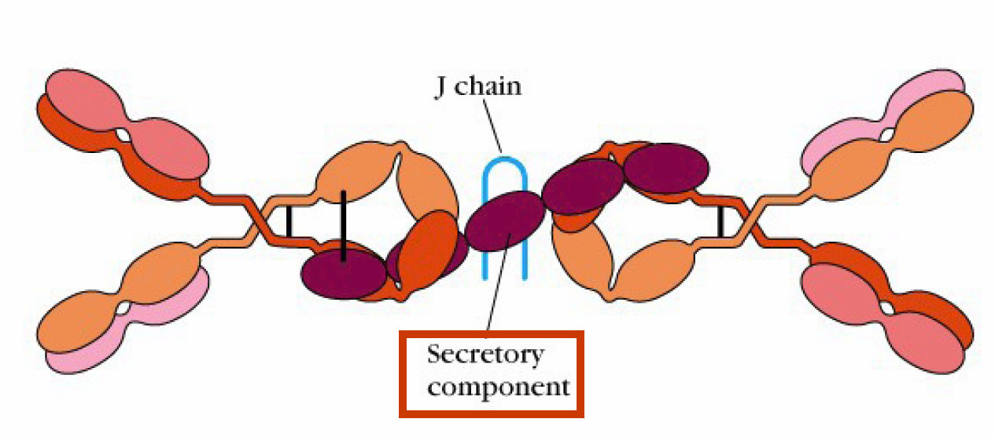
-its 10 – 18% of total serum Ig.
- the picture shows a dimmer IgA & a secretary peace that comes from epithelial cells in the secretions.
- IgA will be synthesized locally in the lymph node which we can find it in the mucous membranes.
-when the B lymphocyte is activated to produce plasma cell in the secretion ,the dimmer immunoglobulin -which contains the J chain - would secreted & pass from the epithelial cell to go to the lumen & secretion , during this passage, the secretary peace will react as a receptor for the dimmer immunoglobulin (IgA) → IgA will be taken inside a vesicle → inside the vesicle, that peace will bound with the dimmer IgA & then it will be secreted to the secretion ,so it will acquire that peace while passing from lamina propria to go to the secretion .
This video may help : http://youtu.be/Q24x1r2rfzQ

IgD
-The conc. Of Ig is measured in micro gram , unlike other Igs that are measured in mille gram. This indicates that its conc. Is very low , around 2 microgram /dL. 0.2% of Igs in the serum.
-its main function : we don’t know anything except version B lymphocyte recognition of the antigen for the first time.

IgE
-the conc. Is much less than IgD & is extremely low
- there is an extra domain in the Fc portion
- its 0.3 microgram/ml
-its very important in the parasitic infection as well as allergy
-it’s a specific receptor on the mast cells & basophiles , both cells contain granules that contain histamine. When the reaction happens : degranulation of these cells will happen & the allergy will be seen .
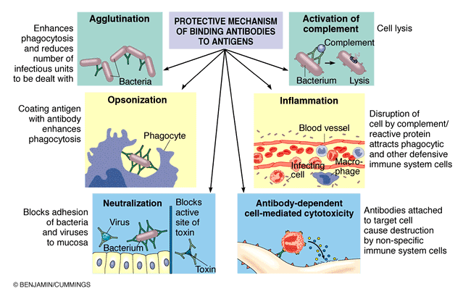
When antigen enters the body for the first time →Ig will be produced → it will go & bind mast cell at Fc receptor → but at the second time when the antigen enters , the antigen will react with the mast cell activating it to be degranulated , & the granules content will go to the allergic points circulating in the blood.

The functions of the immunoglobulins:
1-opsonization …coated antigen will have more phagocytosis than the non coated
2-Activation of complement (IgG & IgM)
3-Antibody-Dependent Cell-Mediated Cytotoxicity (ADCC ): natural killer cells are large lymphocyte containing granules, direct contact btw NK cells & coated cell will kill the coated cell directly.
4-Ab transport through epithelium or placenta
5-Activation of mast cells, eosinophils and basophiles by IgE
6-neutralization: when we have a virus, the antibodies will coat the virus ,so as a result, this virus wont be able to attack its target cell
Antibodies are proteins found in each person , & there is a variety of these AB.
There is a difference in the sequence of a.a between Igs in the same person. For ex. : if we take IgA & IgM that are specific to the same antigen ,there will be a difference in a.a sequence in the heavy chain in the same person. So , it’s the difference in the same person. (The differences is due to differences of the subtypes)

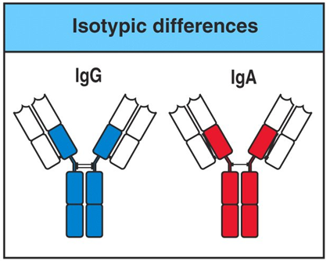

isotype
Differences between 2 persons in the a.a of the variable light & heavy chain. This comparison is used during organ transplantation .it's used also in forensic medicine & paternity testing.
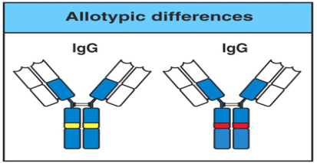

The difference btw the same immunoglobulins within the same sequence ,but the CDRs in the high variable region are different . (within the same person)
Allotypes

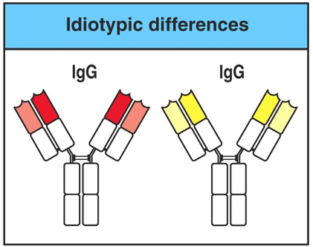

Idiotype

-we have millions of antigens , but only 5 immunoglobulins, so, the strong question: how these 5 types of Igs coup with millions of antigens & can differentiate between different antigens?
In this case we should look for 2 things : the receptor of( B lymphocyte & immunoglobulin) & ( receptor of T lymphocyte) , both have variable regions ,the difference is that B cell has 2 acting binding site & T cell has only one, but the principle is the same , both have variable & constant regions . B lymphocyte before maturation started as stem cell, & to be mature B cell will pass throw different developmental stages ,from a stem cell ( there is no any marker that we can see) → cytoplasmic markers → then mature B lymphocyte that has IgM & IgD on the cell membrane & this is the cell which can recognize the foreign antigen at the first time → there will be a response , we will have memory cells that will have on its surface IgG ,and also antibodies . 1 B cell makes one antibody with one specificity .Ig first appear on the surface of B lymphocyte & this will give the specificity of that antigen .how that happened? ..during the development of the immune system there will be rearrangement of the genes which responsible for the production of Igs , & u will find each B lymphocyte has different specificity . mature human ,in the spleen or lymph node have a variety of B lymphocyte with variety of receptors on the cells .when antigen enters ,it will choose the cell which can recognize it, that cell will respond , after response we will have ig & receptor , this receptor has the same specificity , when the antigen attacks again , this cell will recognize it ,so we will have ig committed to this cell alone .
Better explanation :
An antigen enters the body for the first time → it will choose a B lymphocyte specific to that antigen → B lymphocyte will respond by dividing , maturing & making different cells : 1-making antibodies. 2- making memory cell kept in the body → when the same antigen enters for the second time , these cells will recognize them.
Genes responsible of the production of the immunoglobulin
Sense we are talking about immunoglobulin , theoretically we have 5 different genes
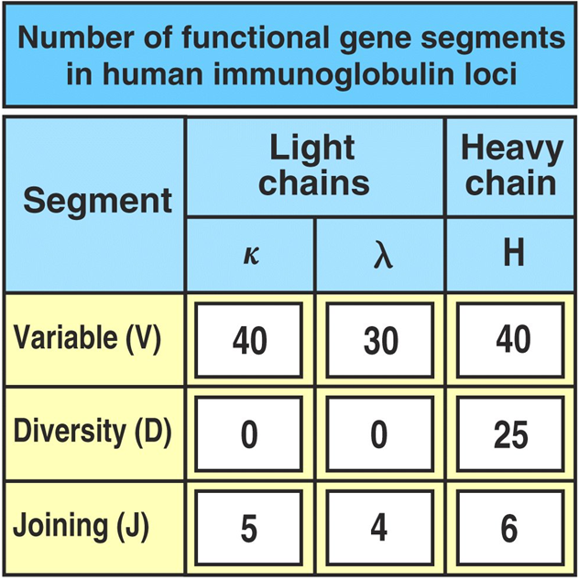
We have around 45 variable region , & we have J chains that link variable region with constant chain , we have around 6 different joining chains , & between variable & other variable regions we have 23 chains , so there is many different possibilities. That’s why the rearrangement of these genes during the development of the human body or the animal will give wide possibilities with different specificities
Important thing: if there is a default or rotation or mutations in the linking(V J variable joining chain) , a tumor will arise.
-Rag 1 & Rag 2 (12 & 23) :controls the specificity

The specificity of the antibody is controlled by 7 mechanisms:
- gene segmentation
- combination between variable region, diversity & joining
- junctional flexibility
- p region ( Rag 1 & Rag2)
- Somatic hypermutation
- Combination of light & heavy chain.
- N region
(its better to refer to slides for more explanations of these mechanisms because the dr. didn’t explain well these points as how it is written in the slides)

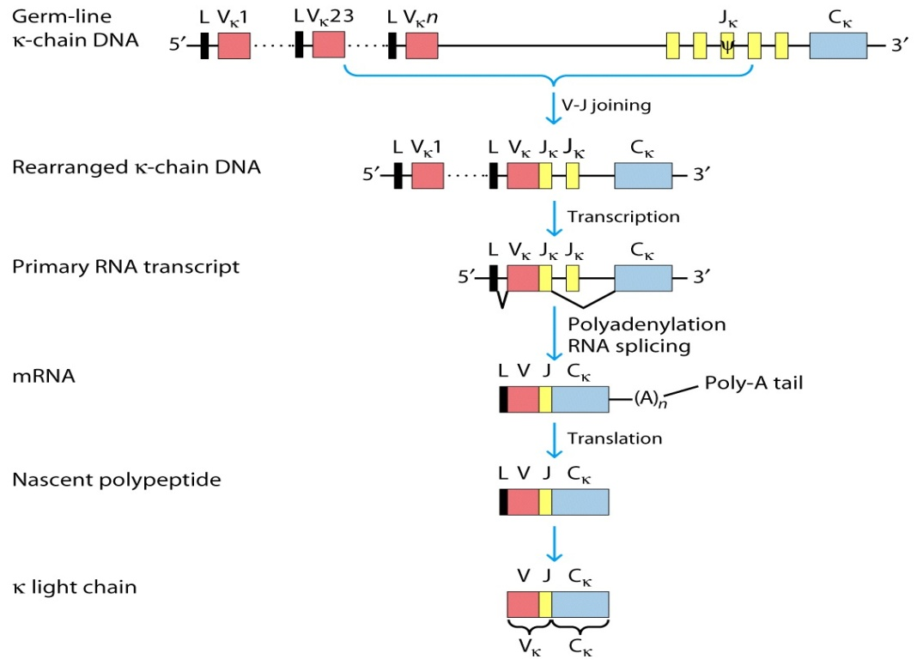
Kappa light chain rearrangement

In the secondary response:
For example , the IgM must changes to IgG , so we have to make loops.
Variable region will be the same, because its what determines specificity , & the joining region just get rearranged .

