Sheet no.:9 (Immunology)
Written by:Mays Abu-Afifeh
Corrected by:Zaid jebreen

- An important note : HLA=MHC

- As a reminder:
There are two types of HLA found on the cell membrane:
- Class 1: composed of two polypeptide chains. Alpha-1, alpha-2, and alpha-3 “are regarded as 1 chain”. And beta-2 is the second chain. The beta-2 chain is not attached to the cell membrane.

- Class 2: Also composed of two polypeptide chains. Alpha-1 and alpha-2 make up the first chain, and beta-1 and beta-2 make up the second chain. However, the difference is that both chains are attached to the cell membrane and penetrate the cell membrane to the cytoplasm. The part of HLA that is in the cytoplasm is important in the signaling

- The function of these molecules :
To present the Ag to the immune cells whether we’re talking about T or B lymphocytes.
MHC is found in the Ag presenting cells, if we don’t have it the Ag won’t be presented to T lymphocytes but B lymphocytes can recognize the Ag directly unprocessed in the absence of MHC.

- Characteristics of these Ag presenting cells :

Langerhans cells:
-Dendritic cells.
-Generally found in skin.
-They ingest the Ag by phagocytosis.
-When they pick up the Ag they’ll be transferred to the regional lymph nodes.
“If the infection is related to blood the spleen is the station, if it’s related to skin then to the regional lymph nodes”
-Ag presenting cells in that lymph node will process the Ag.
-Then the Ag will be presented either to class 1 or class 2.

Macropages:
-They ingest the Ag by phagocytosis.
-Not as efficient as the dendritic cells.
-Effective in activating the memory T suppressant cells.
B lymphocytes:
-Bind the Ag directly because the receptor is on the surface.
-No processing.
-They ingest the Ag by phagocytosis.
-less efficient but low concentrated Ags will be presented more efficiently by B - lymphocytes.

- Cytosolic pathogens like viruses or Intracellular infection like bacterium tuberculosis or extracellular pathogens like toxins,the presentation of these cells is different.
So we might have the Ag inside the cytosol or inside a vesicle inside the cell or on the cell membrane.

-Cytosolic pathogens: Class 1 presentation
-Intracellular infection or membranous : Class 2 presentation .

- In general,
- The pathogens which are killed in the cytosol are mainly recognized by cytotoxic T-lymphocytes (CD8 T cells) and that reaction will end in killing of that cell. The peptides of those pathogens bind to MHC class I.

2) The pathogens which enter the vesicles by phagocytosis are mainly recognized by CD4 T helper cells which would result in the death of the pathogen as the phagosome contains a lot of acidic material which can kill pathogens but not the cell. The peptides of those pathogens bind to MHC class II.

-When Phagocytosis occurs the Ag will be metabolized inside the cell.
“Metabolisation means that the Ag will be degraded to small chemicals”

-To transfer those small chemicals from the phagosome,2 peptides are needed
“they are called :
Transporter associated with antigen processing –TAP 1 AND TAP2”

These 2 molecules are presented on the membrane of ER to transfer the metabolites to ER the golgi apparatus.

-At the same time of degradation of the Ag,the HLA molecules ,“We’re talking now about class 1”, Alpha 1,2,3 and beta 2, will be synthesized inside the cell
Remember that cell membrane molecules are dynamic molecules they’ll be re-uptaken when there’s no need to them and synthesized again if they’re needed.

-In simple words,
IN MHC 1 AND NOT II: When the antigen enters, the antigen will get metabolized inside the cell into peptides (small chains of amino acids). These amino acids will get metabolized and then transported into the inside of the endoplasmic reticulum through specific molecules called Transporters Associated with antigen Processing (TAP) molecules. These are important in the transport of the peptides from one compartment of the cell to another. This transport process is well-regulated when enough antigens gets transported it won't allow any more to enter and this regulatory process depends on the amount of energy inside the cell.

- In MHC class I antigen processing:
A cytosol antigen will get degraded by proteosomes into peptides. On the other side the HLA (MHC) 1 should get synthesized inside the endoplasmic reticulum with the alpha 1, alpha 2, alpha 3, and Beta 2 macroglobulins will get synthesized as well to form a large complex. If there are no molecules to stabilize the newly formed complex, it will get degraded in the body. There is a stabilizing molecule that will get associated with the Beta 2 macroglobulin and HLA 1 which is a self-component (not the antigen) and will stabilize the complex by reacting on the groove on the MHC-1. Once the antigenic peptides enter the endoplasmic reticulum through TAP it will get assembled with the newly synthesized MHC-1 molecule, and the self-component molecules which stabilized it previously will get degraded. Therefore an exchange occurs between the stabilizing molecules and the antigenic peptides. Then it will pass through the Golgi apparatus towards the surface of the cell where the CD8 cytotoxic T-cells will get interact with them. This is what happens with endogenous antigens.
“In ER there’ll be joining between epitop and MHC”

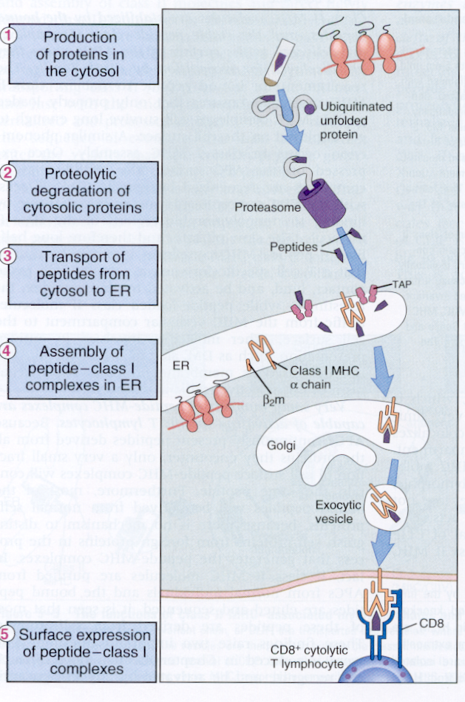

- In MHC class II antigen processing:
The antigen will enter into a phagosome which will split the antigen into small peptides; there are no TAP-1 and TAP-2 transporters here. On the other side inside the endoplasmic reticulum class II MHC will start to get produced but here we have the invariant chain that interacts with the groove and blocks it. “The whole complex will be transformed to golgi apparatus”.
Inside the Golgi apparatus, the antigenic peptides will get associated with the class II MHC molecules( by exchanging the invariant molecule with what we call “Clip” then the peptide”Ag” will bound to it “to the clip”) and they will get expressed on the cell surface where the CD4 T-helper cells will interact with them. This is what happens with exogenous antigens.

-invariant chain (Ii):
1-serves as a chaperone to direct the alpha and beta heterodimer to an endosomal, acidic protein–processing location
2-it serves to protect the antigen-binding site of the MHC-II molecule so that it preferentially will be loaded with antigenic peptides in this endosomal–lysosomal location.
“Called invariant because it can react with any type of HLA”
“NOT each HLA has its own invariant molecule”

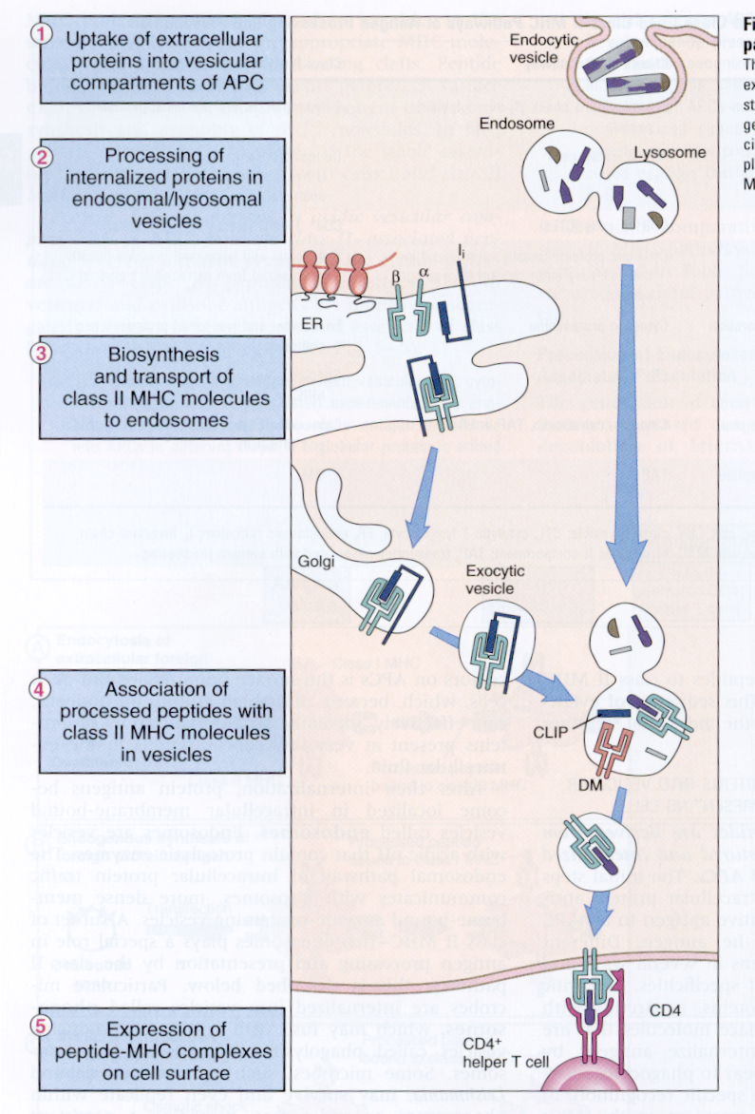 The invariant molecule

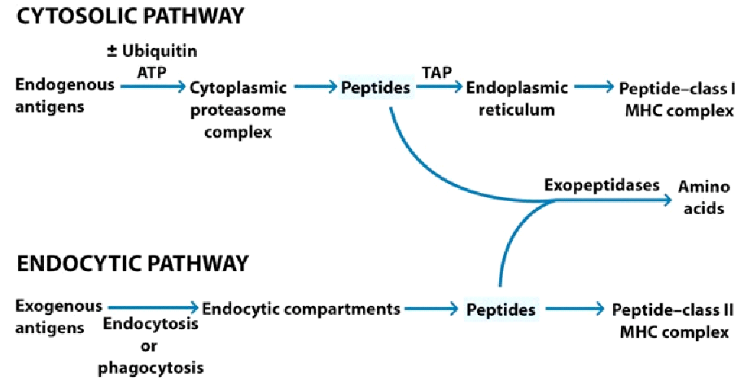

-Peptides from self “ like autoimmune disease “and non self proteins can get associated with MHC molecules.
-Chemical nature of MHC group “Around 9 to 11 class 1 and 30 groups class 2” determines which peptide ”Ag” will bind.
- The same HLA type is found in different persons with different genetic structures, that's what we call : polymorphism.
-T suppressant are restricted to recognize the content of self antigens only.
-Antigen MHC dependent infections: That infection(Ag) which produces that special epitop can react only with a specific type if HLA (without that type of HLA you’ll get the infection without being immunized)
-Notice that: Defected MHC=Defected immune system (No presenting for lymphocytes and no Ab production)
-Stem cells go to thymus then get educated to recognize self and non self components, this education happens by MHC so MHC are extremely important in development of stem cells.
-Also,some MHCs are associated with certain diseases:
By having MHC (type DQ101 or DQ102) you are more susceptible to type 1 diabetes but having DQ303 then you’re more resistance to diabetes type 2 so there’s an association between certain diseases and MHC type .
Ankylosing spondylitis (اعوجاج العمود الفقري) Associated with HLA B27 (90% out of 100 Ankylosing spondylitis patients got the HLA B27.
BUT this does not mean that everyone with HLA B27 has Ankylosing spondylitis.
The Dr answered a question for a student and said that T suppressant cells are not activated only by self antigens, also by viral cells. “Even though he mentioned earlier that they’re restricted to recognize the content of self antigens only!”

- What’s the importance of HLA?

1-Transplantation:You cannot do tissue transplantation without detecting the HLA type to find the matching donor and recipient

2-Have some association with diseases: If we know the HLA type we can suspect the disease and then we’ll have a good follow up

3- HLA and medical jurisprudence “اثبات الامومة و الابوة” : To know jurisprudence, the first method was “Blood grouping”, by this early method we can EXCLUDE ONLY ,not a definite result but with HLA, since we’re talking about alleles, you can be more specific, up to 95% accuracy.
If we have a child and we're not sure who the child's real parents are we examine the HLA type: the child's HLA type should be 50% from the mother and 50% from the father (should be a haplotype “should be a combination of the HLA type of the mother and the father” ). But now we don't use this method; we use DNA related methods.

4-In crimes : to detect the criminal.

- To detect these HLAs :
We use Antibodies specific to HLA.
Before” Monoclonal antibody “ technology ,since they’re weak antigens,antibodies were taken from mothers who gave birth more than 3 babies,HLA type to her son/daughter and her HLA type are different,so she would be immunized against her child’s HLA.
“But this won’t cause a disease since we have small concentrations .”
So as mentioned, antibodies were taken from mothers.
Then with Monoclonal antibody technology , we can produce antibody to each epitop.

- How can we do HLA typing?
Microcytotoxicity test.

- How do we carry out this serological reaction (microcytotoxicity test)?
Suppose this test is carried out for Class 1 HLA. We have a plate with for example 96 or 100 wells. In each well we put a specific antibody. Then we isolate the WBCs from the patient and to each well we will add these WBCs (remember that HLA complex is on the cell membrane of these WBCs). So the antibody that is in the well will react with the lymphocytes in the wells where there is antibody specific to the HLA of the lymphocyte.
However, we will not be able to see this reaction between the antibody and the WBCs since we don’t have RBCs to be hemolysed . In order to see it, we add complement. This is because since we have an antigen-antibody reaction between the HLA and the monoclonal antibody, the complement will be activated and this complement activation will kill the cell Up to this step, we still can't see where the HLA and antibody reacted in the wells. Then, we add a stain called a vital stain. This stain enters the dead cells and stays outside the living (vital) cells.

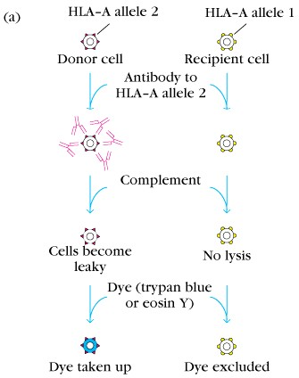

- HLA-B 27 & HLA-B 57 : with these you might get no disease from HIV or a mild disease in worst cases
- HLA-B 35 :The elimination of HIV from the body is faster
Because what’s mentioned before is MHC restricted infections
- HLA-Drb1 associated with better control of “ hemorrhagic diseases ?? “

- How will the immune system get generated?
The Ag should enter the body by different ways ,and to get an immune response we should have an appropriate dose since exposure to higher doses produces immune paralysis & lower doses lead to tolerance.

- How are we injecting the Ag?
With adjuvant which is a substance that enhances immunogenicity and keeps the Ag at the injection site as long as possible.

- According to the injected Ag,are we using it soluble or as particles?
When we inject the soluble material for the first time,the concentration is 100% initially then this material will be distributed in the body to keep a state of equilibrium,then that antigen will be metabolized by catabolic pathway ,degradation occurs to those metabolites also then there’ll be the immune elimination and our Ag-Ab rxn will start after about one week and the Ab will do its action so we’ll have immune complex elimination and finally a complete clearance for the Ag.

When we inject the Ag as a particle “we can’t talk about the dose, because for example if we’re dealing with bacteria it’ll start growing until it reaches the optimal concentration” it would be eliminated by phagocytosis not by pinocytosis.

This is what we’ll see:

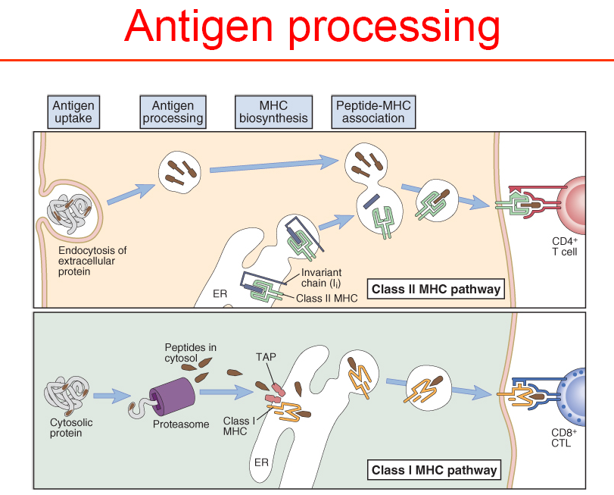

-Our Ag enters whether it’s a virus, bacteria or protein…etc. It’ll be taken by the Ag presenting cell then degraded by phagocytosis and then represented with MHC class 2 on the cell membrane.
This will be recognized by T cell.
This rxn alone will not be able to activate the T lymphocyte so at the same time of Ag presenting that cell(Ag presenting cell) will produce interleukins (IL6,12 OR 1),”these are the products of the Ag presenting cells”,at the same time after rxn with the Ag this Ag presenting cell will start getting suppressed by B7 molecule.
After the rxn between T lymphocyte and Ag presenting cells,T lymphocyte will produce CD28,so this rxn between CD28 and B7 will give the cell the second signal,so one signal is not able to activate the immune response.
The third signal which comes from interleukins for differentiation.
The first signal which comes from the rxn between epitop and MHC is important for specificity .

  - Previous reactions are weak reactions so these molecules are important for strengthening the reaction :
CD2/LFA-2
LFA-1/ICAM-2

“ That’s what the doctor said and also what Google says,but in last year’s slides what’s mentioned is : CD2/LFA-3 LFA-1/ICAM-1 !! “

-Ag presenting cell here produces interleukins and T lymphocyte produces other interleukins.

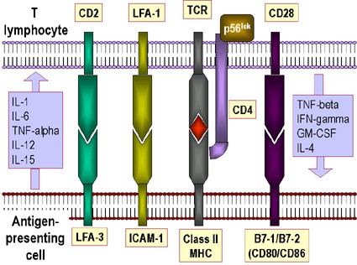

T lymphocyte produces:IL-4
TNF-alpha (Tumor necrosis factor alpha) *The Dr said TNF-alpha but in the slides its written TNF-beta so it’s confusing!!*
IFN-gamma (Interferon gamma)
GM-CSF(Granulocyte macrophage colony-stimulating factor
Ag presenting cell produces:
TNF-alpha
IL-1 ,6,12,15

  - T cells-B cells interaction :

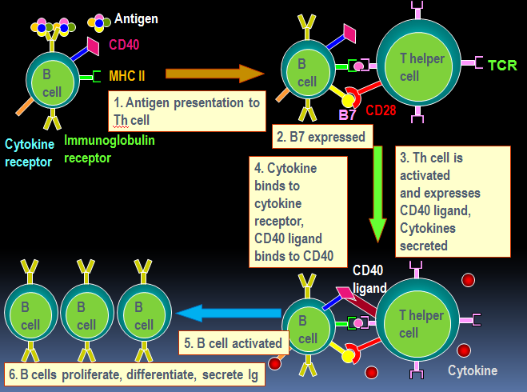

B lymphocytes recognize the Ag without any processing but B lymphocyte
is an APC, so the first signal that will come to the B lymphocyte, is the direct interaction between the antigen and the immunoglobulin found on the B lymphocyte. But to activate the B lymphocyte we need a second signal. From where does this second signal come?

If we look at the B lymphocyte in the previous graph, we will find that it doesn’t have a B7 on its cell membrane, instead it has a CD40. However, after its interaction with the antigen it will start to produce the B7. The B lymphocyte will process the antigen and present it with the MHC 2, which will be then seen by the T lymphocyte. When the B7 is presented on the B lymphocyte’s surface, this will give the second signal to the T lymphocyte after interacting with the CD28 on its surface, which will transform the T lymphocyte from a resting state to its activated state (which will activate proliferate and all what we mentioned before). Then the T lymphocyte will start to produce the CD40 ligand, which wasn’t present before, after receiving the two signals. This CD40 ligand will interact with the CD40 already presented on the B lymphocyte. This will give the B lymphocyte the second signal. Then this B lymphocyte will proliferate and start producing immunoglobulins. This is the interaction between the T cells and the B cells which will happen in the T dependent antigens. (There are T dependent and T independent antigens).

B cells also produce interleukins which are important in switching of immunoglobulins.

