Title of Lecture: Antigen-Antibody Reactions

Date of Lecture: 13/11/2014

Sheet no: 7

Refer to slide no. : 6

Written by: Tala Ghishan
Since my target is RBC what will be the end result? Hemolysis, because the complement system function is destroying the targeted cells.
The main important thing about this reaction is that it has a different buffering system, magnesium and calcium must be added, the complement is only activated in the presence of these cations so they must be added to the buffering system to aid the reaction.
We said that the end result is hemolysis so it’s a visible reaction you can see the tube red in colour. This was the third type of antigen-antibody reaction which we can see.
As a revision, the 3 reactions which are visible 1) Agglutination 2) Precipitation 3) complement fixation.
Now we will talk about primary manifestation of Ag/Ab reactions which are not visible meaning we cannot see them by our eyes, we need machines to measure them.
In these tests we are not measuring the Ag/Ab reaction directly because in here we are measuring certain labels that we add on the Ag or on the Ab, these labels are either immunofluorescence we add a dye and when these dyes are exposed to UVlight they will emit a specific wavelength of light (excitation).or we can use radioactive material or even enzymes (if we add a substrate its colour changes) so again as we said in here we are measuring these labels that are indirectly corresponding to Ag or Ab component.
- Immunofluorescent:
We can utilize it in 3 different ways:
- Direct test
- Indirect test
- Sandwich test
-Direct means what is known to me is labelled, for example if I have a stool specimen or a sputum or any specimen you want and we are looking for a certain microorganism in it ( TB in the sputum or salmonella or toxiplasma in stool) .Firstly I'll put the specimen on a slide and then I will add an antibody specific to the suspected microorganism and this antibody would be labelled with a fluorescent.
-However in the Indirect generally we are looking for the antibody in the specimen. For example we are looking for anti-toxiplasma antibody in the serum in this case my antigen would be the toxiplasma so on the slide I will add toxiplasma antigen and above it I add the serum of the patient, if the antibodies were present in the serum a reaction would occur, after that I wash the slide so that any unbound antibody would be washed away to this I add secondary labelled antibody (antihuman) this antibody is specific to human antibody so we will have an antihuman bound to the human antibody which is bound to the antigen.
Imp. Note: Both direct and indirect have the same end result under the microscope, both have an antigen bound to the antibody but in the first we did not know if there is an antigen and we added a known/specific/labelled antibody and the second the antigen is known and I added on it the patients serum not knowing is there is an antibody (Different steps).
-Sandwich test: as you remember one B lymphocyte produces one antibody to a specific epitope, what I will do is that I bring the cell of a tissue like spleen (an organ producing b lymphocyte) put the cell on a slide add an epitope if this cell has a receptor on its surface for this epitope a reaction would occur after that you wash the slide then add a labelled antibody this antibody will also react with epitope of the same antigen making the cell fluorescent(labelled) this technique proved that we did a correct vaccination and the patient contains B lymphocyte that produces antibodies.
Examples on direct immunofluorescent (in kidneys and stomach)
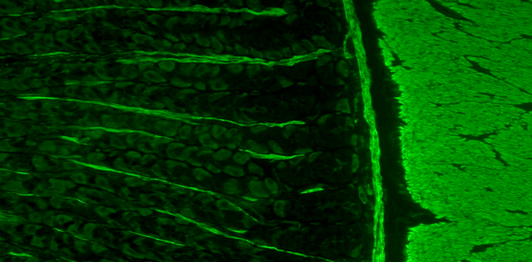
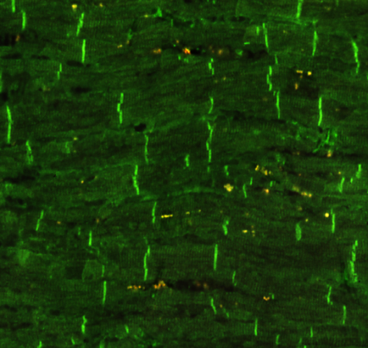
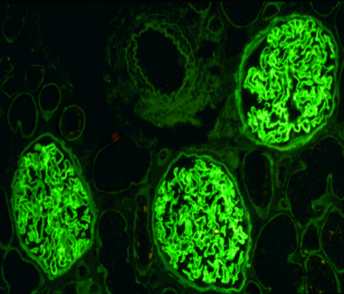

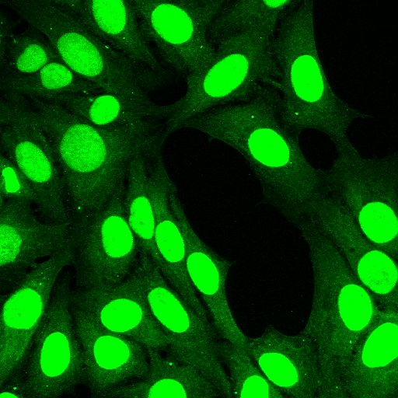
Examples on indirect tests ( Treponema pallidum causing syphilis)

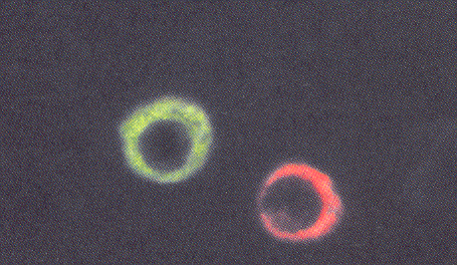
In the previous example as you can see the appearance is exactly the same the only difference is in the steps
Examples on Sandwich technique
As we said that each b lymphocyte produces one antibody and in here we have a proof if one antibody was labeled red and the other green then two cells will appear having two different colours because each one of them produces a different antibody.
-All of the examples above are manual, we see under the microscope (UV light) and in order to be accurate in these tests I must test at least 100 cells. However we have automated machines which can do all of this for us and we can use different labels such as fluorescent or Rhodamine (red in colour) and these will give us different colours to differentiate between cells.
Lymphocyte has a cluster of differentiation CD4 or CD8 or both or it can have CD19, CD3 and so on, these cells we can look for them and isolate them using the machine (automated way). The way the machine functions is that it allows the passage of one cell at a time and a laser will hit each cell alone doing excitation to cells and now the machine will analyse the cells according to two characteristics 1) Forward scatter which is dependent on the size of the cell and the other part 2) Side scatter which is dependent on Granulation of the cell.
Note: we know that lymphocytes has low granules and also the monocytes have no granules but is large in size while neutrophil, basophils and eosinophils have high number of granules. Remember that RBCs has NO granules and are small in size.
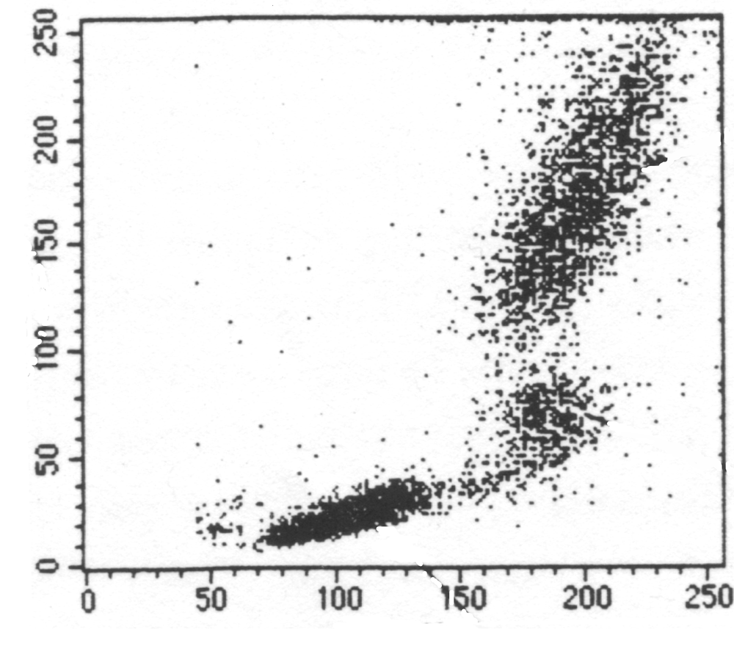
Check the graph below!

Now, when I add a fluorescent anti-CD4 or anti-CD19 or antiCD3 the lymphocyte will be labeled with the colour on antiCD's and if I analyze the cells again but now according to the colour what will the mechanism be? Cells will go through a filter cell by cell and generally there is a light source (laser) when the cell passes through the light it will give excitation. We have a detector that will measure the reflection of colour if the colour was green it'll pass through the green filter and if it was red it'll pass through red filter and so on each filter is connected to a multiplier to increase signal ( it's a very complexed machine, the doctor said we don’t need to know it in details but we have to know that according to colour we got an analysis to cells as the following

RBC&platlets

This is a picture of the machine:

This technique is known as flowcytometry and it is extremely important when we are looking for leukemia or lymphoma or immune-sensitive diseases. Note: lymphocytes when they mature from a stem cell to a mature BorT lymphocyte, the receptors and surface molecules will be different in a stem cell than in a mature one so with this techniques we can know at which stage the leukemia or lymphoma occurred.
2-Enzyme-Linked Immunosorbent Assays (ELISA):
The principle is the same but I can use an enzyme instead of a fluorescent. Again we can use either indirect ELISA or sandwich ELISA …
-what is known to me is bound to the tube (antigen or antibody). Then I add the patient's serum and after that I add another antibody labeled with the enzyme then I add a substrate to enzyme, the colour is going to change once the substrate binds to enzyme. To be sure that the colour changed I add some molecules to stabilize the colour and finally we measure the colour intensity which corresponds to the amount of Ag or Ab that we are looking for.
Enzymes used:
1-Alkaline
2-horseradish peroxidase
3-B-galactosidase
We can do these reactions to tissues for example in pancrease to detect islets of langerhan and in lymph nodes.We can also use it in vivo, a patient having cancer to know if we have metastasis (cancer is spread) we generally use MRI, X-ray, CT scan but in MRI and CTscan in order to detect metastasized cells there is a minimum size which is around 1cm3 and if these cells were less than that the machine has to be very sensitive to be able to detect them. However using immunological reactions we can see almost any size of cell. How to use it? If I have lymphoma and I know which type of lymphoma for example CD19+ I produce an anti CD19 and label it with a radioactive material then inject it into the patient intravenously, it'll go all over the body and it is going to react to any cell having a receptor for the antibody after that we use gamma counter to detect radioactivity.
Last method,
- Radioimmuoassays (RIA):
Again same principle but the label is different.
Methods of RIA
Competitive RIA,what we mean is that the same material have a label and another doesn’t contain a label. Example if I want to measure TSH in a patient I'll take the patients serum add it to the antibody theoretically the TSH will bind to antibody but we will not see the reaction after that I add a labeled TSH (already made) if there was available binding sites on antibody then there will be a reaction with labeled TSH but if I don’t have any available binding sites no reaction occur. So low TSH in patient serum will increase the available binding site and we'll have more radiation and vice versa. We have a competition between labeled and non-labeled TSH.
** Remember when we talk about quantitations we have controlled tests so as to draw a curve and compare and get results of unkown.
-Solid phase: what is known to me is bound to the tube.
-Equipment is ofcourse different between the techniques in here we need radioactive material that will give radiation, in enzymes we need a spectrophotometer that will measure colour intensity while in immune-fluorescent we need a flowcytometry or fluorescent microscope.
-As we said the principle is the same in all techniques, only change labels.
- Remember that the purpose is for diagnosis:
Gold standard method for diagnosis is isolation of microorganism and culture but many microorganisms cannot be cultured like mycoplasma, viruses and some parasites so I depend on serological reactions, I look for Ab of microorganisms but we have many types of antibodies either from vaccination or I got the disease but didn’t die, or subclinical infections and so on, to be able to use serological reactions for diagnosis I have to look at two things, type of Ab (IgM indicates primary response while IgG secondary immune response) and if it was IgG I have to take two specimens one at first period of disease and other in last 2 weeks and see difference how much IgG increased in the 2 weeks. These are done for common infection but for HIV, hepatitis, HCV for example we only need to know the Ab, the amount is not a problem because they are not common so there presence is an indication of infection.
We can use serological reactions for:
1) Organisms difficult to culture
2) Organisms cannot be cultured
3) Fast diagnosis
4) Epidemiology tests: the science that studies the pattern, cause, effects of health and disease conditions in a defined population.
5) Autoimmune diseases
- High sensitivity and specificity of antibodies in this methodology, for example if we took precipitation rxn in fluid we can measure 20-200mg of antibodies but in RIA we can see 0.00001 microgram of Ab (labeling is a very sensitive process it can measure very low conc. of antibodies).

Now we are going to talk about complement system:
-How did they discover it?
They found that when you add to the microorganism that caused an infection a fresh serum from patient it is going to get lysed however when you isolate the antibody and then add it to the microorganism that caused infection no lysis occurred.
So they suggested that we have other material in serum that caused the lysis, completed the reaction and that’s why it's called complement reaction.
- First time reported by bordet in 1890's he called it complement.
- Complement: is a group of proteins, around 30 different proteins that work in a cascade and each reaction generally is cleaved to give 2 components.
- They are glycoprotiens, their concentration is 3g/L
- The C is taken from first letter of complement and we have from C1 to C9 and other factor D & B.
- They are degraded/cleaved e.g.: C4 when an enzyme is added to it, it is cleaved to CD4a and CD4b usually a is the small molecule and b is large molecule except in complement number 2, a is large and b is smaller.
- Produced in liver.
- We have three different reactions:
- Classical complement pathway
-In order to intiate this reaction there should be an Ag/Ab complex.
-Complement activation start at C1 till C9.
2) Alternative pathway
-in here we don’t need Ag/Ab complex, certain molecules like LPS activate this pathway, another difference no need for activation of C1,C2&C4 the activation start at C3 then C5,6,7,8,9
3) Lectin Pathway
- MBL (Mannose-Binding Lectin) it's found on bacterial cell wall.
*Generally the reactions start in recognition (Ag/Ab complex,LPS,MBL) then enzyme production and then biological activation.
Activation in classical complement pathway:
1) C1q binds to Ag-bound Ab
2) Binding of C1q to Fc induces a conformational change in C1r, C1r converts to an active serine protease enzyme, C1r which cleaves C1s to a similar active enzyme, C1s
3) C1s has two substrates, C4 and C2, C1s hydrolyzes C4 into C4a and C4b, and hydrolyze C2 into C2b and C2a, C4b and C2a form a C4b2a complex, also called C3 convertase, referring to its role in converting the C3 into an active form.
4) C4b2a (C3 convertase) hydrolyzes C3 into C3b and C3a, C3b binds to C4b2a and form C4b2a3b (C5 convertase), C4b2a3b cleaves C5 into C5b and C5a.
- C3a has biological function; it binds to basophils and can do anaphylatoxin and opsonizatio
- Amplification: 1 C1s molecule activates 100 molecule of C4b2a and this activates 10000 C3b and 10000C3b activates almost 1 million of others.
-C6,7,8,9 will not be cleaved, when C5 is cleaved it attaches to C6, then to C7, and the C5b67 complex inserts into the membrane,binding of C8 to membrane-bound C5b67 induces a 10 Å pore. Binding and polymerization of C9, a perforin-like molecule, to C5b678. (completed membrane-attack complex (MAC)) the cell here is destroyed having holes.

