Title of Lecture: Antigen-Antibody Reactions

Date of Lecture: 30/10/2014

Sheet no: 6

Refer to slide no. : 1

Written by: Qais S. Mismar

- We can classify antigen-antibody reactions into:
- In vitro tests: we will take the serum from the patient and test it inside a tube (outside the body)
- In vivo tests: we observe the reaction within the body

- General characteristic of Ab/Ag Reactions
- Non-covalent interaction (similar to “lock and key” fit of enzyme-substrate)
- Does not lead to irreversible alteration of Ag or Ab
- This exact and specific interaction has led to many immunological assays used to:
- Detect Ag or Ab: which means that if I know the antibody I can know the antigen and vice versa
- Diagnose disease: especially viral diseases
- Measure magnitude of humoral IR: for example if we did a vaccination campaign and we want to know how many people became immune
- Identify molecules of biological and medical interest: Ag/Ab reactions are used to measure the amount of a hormone, a protein, and many other molecules in the body
- Ag/Ab reactions are simple reactions
- They depend on simple bonds, there bonds are:
- Hydrogen
- Ionic
- Hydrophobic interactions
- Van der waals forces
- Each bond is weak on its own, but when they are gathered the sum of them is strong
- To “hold” they must be close, thus requiring high amts of complementarity!

- There are three Distinct Phases of Ag-Ab Reactions:
- Primary phenomenon (reation): sensitization, we add a pure antibody to a pure antigen, a reaction will occur, but that reaction is not visible, we cannot see it with our eyes
- In order to see the reaction we must have certain conditions, we must have a proper temperature, a proper concentration (the number of epitopes must be almost equal to the number of antigen binding sites of the immunoglobulins)…
- Secondary phenomenon (reaction): the reaction is visible in these kinds of reactions
- Examples of secondary reactions:
- Lattice Formation
- The Fab portion of the Ig molecule attaches to antigens on 2 adjacent cells-visible results in agglutination
- If both antigen and antibody are SOLUBLE reaction will become visible over time, ie, precipitation
- Tertiary phenomenon (reaction): occurs in the body, we cannot measure it, but we can see the end result of it, so the reaction is not visible, but it is detected by its effect on tissues or cells

- Factors affecting the measurement of Ag/Ab reactions:
- Affinity: strength of the reaction between a single antigenic determinant and a single Ab combining site, or the attractive forces between a single epitope and a single antigen binding site
- If that attraction is strong enough then I have a high affinity, if it is weak then I have low affinity
- Avidity: incorporates the affinity of multiple binding sites, i.e the reaction between the common epitopes and the whole antigen binding sites (we are talking about the whole reaction)
- it is the true strength of the Ab-Ag interaction within biological systems
- The interaction at one site will increase the possibility of reaction at a second site
- High avidity can compensate for low affinity (secreted pentameric IgM has a higher avidity than IgG)
- Ag:Ab ratio: the concentration is an important factor.
- if the antibodies are more than the antigens, the reaction is not visible
- if the antigens are more than the antibodies, the reactions is also not visible
- in order to have a visible reaction we must have an almost equal number of antibodies and antigens (optimal concentration)
- The physical form of the antigen: solid, soluble…

- Specificity: the ability of an individual antibody combining site to react with only one antigenic determinant, or the ability of a population of antibody molecules to react with only one antigen.
- Cross reactions: the ability of an individual Ab combining site to react with more than one antigenic determinant, or the ability of a population of Ab molecules to react with more than one Ag

- Secondary Manifestations of Ag-Ab Reactions (we can see secondary reactions in the following processes/reactions)
- Precipitation
- Agglutination
- Complement dependent reactions (cytolysis, chemotaxis, opsonization)
- Neutralization
- In the end they will form a Latuce formation
- Remember that secondary reactions are visible

- Primary Manifestation of Ag-Ab reactions (those reactions are not visible so we will use methods that will give us indirect results):
- Immunofluorescence (IF)
- Radioimmunoassay (RIA)
- Enzyme-linked immunosorbent assay (ELISA)

- Factors affecting solubility:
- Size: the more antigen determinants the bigger the size,
- Charge: the epitope has the opposite charge of the antibody
- Temperature
- Solvent ionic strength
- The flexibility of the hinge region improves the efficiency of antigen binding and cross-linking

- Monoclonal antibodies: one type of antibodies specific to a single epitope (antibodies that recognize one epitope only)
- Much more complicated to produce than polyclonal antibodies
- Polyclonal antibodies: one antigen induces the production of many antibodies
- Much less expensive than monoclonal antibodies
- When I take serum from a patient he will have polyclonal antibodies

- PRECIPITATION TESTS
- Reaction of soluble antigens with IgG and IgM antibodies (soluble antibodies)
- Form visible molecular aggregates called LATTICES
- Precipitation only occurs where the ratio of antigen to antibody is optimal

- TYPES OF PRECIPITATION REACTIONS

- Double Diffusion (Ouchterlony): it is the simplest one, it is quantitative, needs about 72 hours to be completed, done by putting antibodies on one side of a pure agar, antigens on the other side, and letting them diffuse, highest amount of precipitant formed is in the zone of optimal concentration (zone of equivalence)
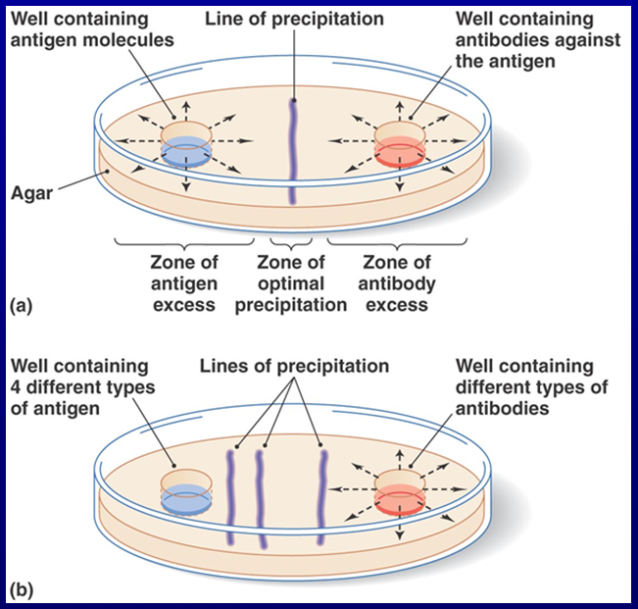
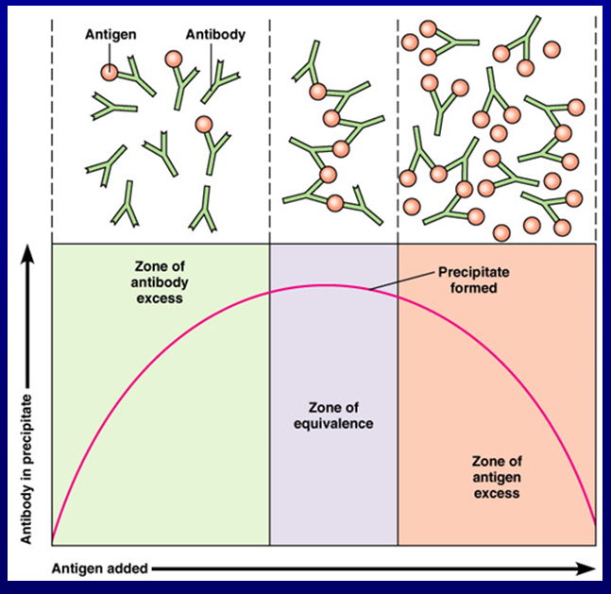
- We can use a fluid to do the precipitation test also:
- Precipitation – formation of an insoluble complex when a specific antibody is reacted with a soluble antigen (usually in a gelatin-like substance)

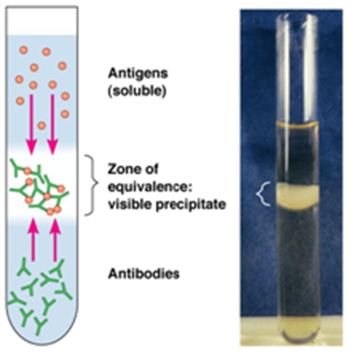
- Those tests can be used to identify unknown antigens:
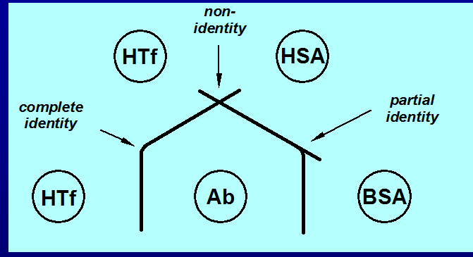
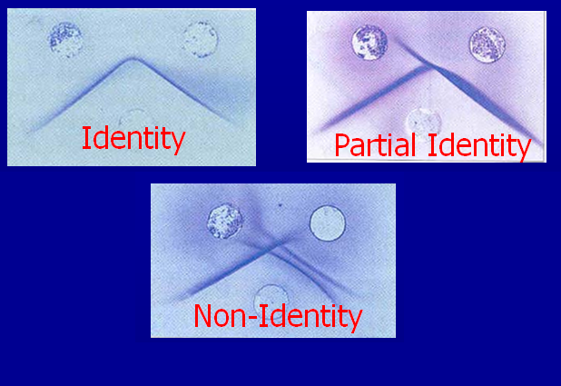
- Identity (two antigens are the same): the precipitation appears as a continuous line in the form of an angle between those two wells and the C well. There are no spurs at the angle and this type of reaction is termed a band of identity
- Partial identity (there are similarities between them, there is a common antigen but there are extra antigens): if Ag A (patient) and Ag A1 (control) share a common element but are not exactly the same (Abs to A), a single spur is formed. This is the line of partial identity
- Non-identity (the two antigens are different): if the material in wells 1 and 2 do not possess common antigens and the antiserum in well 3 possesses specificities for both materials, the reaction will appear as two crossed lines

- Countercurrent electrophoresis: the second type of precipitation reactions, if we want a faster reaction we use this one, same principle as double diffusion but with electricity involved, used only when Ag and Ab have opposite charges, qualitative, rapid
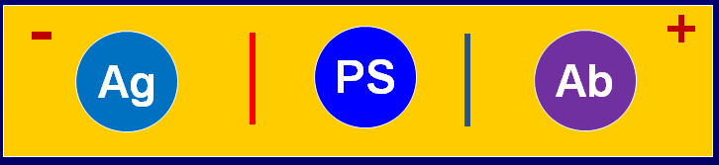
In this example, we take the patient's serum, we put it in the center, we put the antigen on one side, the antibody on the other, if the precipitation occurred between the PS and the Ag then I need the Ab, if it occurred between PS and Ab then I need the Ag, in this way we can tell if the patient is infected or not

- Elek's test, also known as the immuno diffusion technique, is an in vitro virulence test performed upon Corynebacterium diphtheria. It is used to test for toxigenicity of C. diphtheriae.
- From Wikipedia (because I didn’t understand what the doctor said but this is similar to what he said): A filter paper strip impregnated with diphtheria antitoxin is buried just beneath the surface of a special agar plate before the agar hardens. Strains to be tested, known positive and negative toxigenic strains are streaked on the agar's surface in a line across the plate, and at a right angle to the antitoxin paper strip. After 24 hours of incubation at 37 degrees celsius, plates are examined with transmitted light for the presence of fine precipitin lines at a 45-degree angle to the streaks. The presence of precipitin lines indicated that the strain produced toxin that react with the antitoxin.

- Single radial immunodiffusion: Single radial immunodiffusion is used extensively for the quantitative estimation of antigens. In this method, the antigen-antibody precipitation is made more sensitive than in double immunodiffusion, by the incorporation of the antiserum in the agar solution before the gel is made. Thus, the antiserum is uniformly distributed throughout the agar gel. Antigen is then allowed to diffuse from wells cut into the agar gel. This is an example of single (simple) immunodiffusion. Initially, as the antigen diffuses out of the well, its concentration is relatively high and it forms relatively soluble antigen—antibody adducts. However, as it diffuses further and further from the well, its concentration decreases. When its concentration becomes equivalent to that of the antibody in the gel, a disk of antigen—antibody precipitate (precipitin) is formed. The greater the initial concentration of antigen in the well, the greater the diameter of the precipitin disk. Thus, by running a range of known antigen concentrations on the gel and by measuring the diameters of their precipitin disks, a calibration graph can be constructed. The antigen concentrations of unknown samples run on the same gel can then be found by simple interpolation having measured the diameters of the respective precipitin disks. Diameter of the ring is proportional to the concentration of Ag.

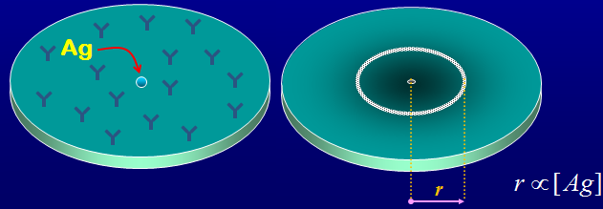
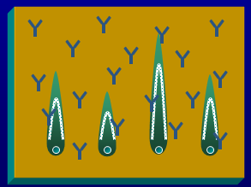
In Electroimmunodiffusion I measure the height of the rocket

- Serum Protein Electrophoresis (SPE): uses an electrical field to separate the proteins in the blood serum into groups of similar size, shape, and charge.
- Blood serum contains two major protein groups: albumin and globulin. Both albumin and globulin carry substances through the bloodstream.
- Using protein electrophoresis, these two groups can be separated into five smaller groups (fractions): Albumin, Alpha-1 globulin, Alpha-2 globulin, Beta globulin, Gamma globulin
- Each of these five protein groups moves at a different rate in an electrical field and together form a specific pattern. This pattern helps identify some diseases.

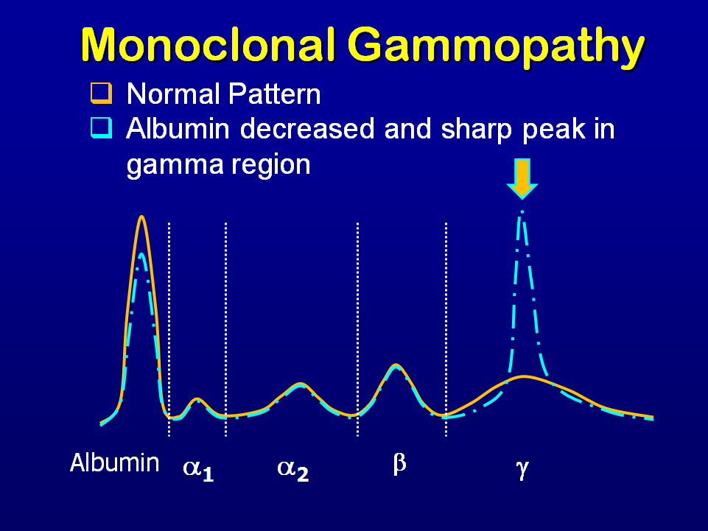
This slide shows a comparison between a normal and an abnormal graph of protein electrophoresis

- Immunoelectrophoresis:
- Combines serum protein electrophoresis with immunometric detection
- Electrophoresis provides separation, Immunoprecipitation provides detection
- It is a method of determining the blood levels of three major immunoglobulins: immunoglobulin M (IgM), immunoglobulin G (IgG), and immunoglobulin A (IgA)
- Combines separation of antigens by electrophoresis with immunodiffusion against an antiserum
- Used frequently to diagnose multiple myeloma, a disease affecting the bone marrow
- Serum proteins separate in agar gels under the influence of an electric field into albumin, alpha 1, alpha 2, and beta and gamma globulins. Immunoelectrophoresis is performed by placing serum on a slide containing a gel designed specifically for the test. An electric current is then passed through the gel, and immunoglobulins, which contain an electric charge, migrate through the gel according to the difference in their individual electric charges. Antiserum is placed alongside the slide to identify the specific type of immunoglobulin present. The results are used to identify different disease entities, and to aid in monitoring the course of the disease and the therapeutic response of the patient to such conditions as immune deficiencies, autoimmune disease, chronic infections, chronic viral infections, and intrauterine fetal infections.

- Immunofixation Electrophoresis: combines zone electrophoresis with immunoprecipitation, may be used to identify and characterize serum proteins, in IFE, proteins of sample are first separated by electrophoresis on a support (agarose) according to their charge and after that the medium is overlaid with monospesific antiserá reactive with specific protein – antigen, if the antigen is present a characteristic immunoprecipitin band will be formed

- Western blotting is used to diagnose certain viruses like HIV and hepatitis

- All of the previously mentioned tests are manual, nowadays we have automated machines that will do the task

- Agglutination Tests
- Visible clumping together of particulate matter by antigen combining with its specific antibody
- The clumps will be called agglutinates
- Performed on:
- Slide
- Tube
- Tile
- Micrtitration plates
- TYPES OF AGGLUTINATION REACTIONS:
- Direct agglutination: uses whole organisms as a means of looking for serum antibodies.
- Hemagglutination
- Indirect (Passive) Agglutination
- Agglutination inhibition

