Introduction of Removable partial denture
Lec # 14
Written by : Farah al khouly

We talked about RPD in the 2nd semester last year and you are going to apply it next year enshalla .
*So what’s dental prosthodontics ?
It’s the part of dentistry which deals with replacement of any soft or hard tissue structures
*What is the removable partial prosthesis ?
It’s a prosthesis that replaces part of the teeth not all of them and can be removed “not fixed”.
*The dr. showed a pic and asked about the treatment options that can be done for this patient >> implants , fixed bridge , RPD , we can put 2 implants and apply a bridge on them but its not a good option , you can accept this situation and do nothing for him .
The dr showed another pic “part of the anterior teeth were missing” >> the treatment options could be ; implants , resin bonded bridge , complete denture but this isn’t a good option , also another option is implant with a partial denture on top of it , Co/Cr partial denture , or we can do nothing for him .
Note : if we chose to do a conventional bridge there will be some complications like pulpitis and loss of vitality .
Note : in this case we prefer to do the resin bonded bridge a cantilever bridge because it will be able to move with the teeth so there wont be decementation , whereas the fixed-fixed bridge is more rigid and will decement from the teeth .
*Indications of the RPD :
1- long edentulous span
2- when the pt cant afford for an implants
3- free end saddle
4- when we have so much bone loss and at the same time we cant do bone augmentation so we do RPD
5- can be used as a provisional
6- In any case that has loss of hard and soft tissue
7- when there is multiple missing teeth
8- excellent oral hygiene ( actually its not an indication , it’s a must when we want to put an RPD)
*Types of RPD : 1- acrylic 2- Co/Cr
Generally the acrylic RPD is used for : esthetic , space maintainer , to establish an occlusal relationship
* how can we reach the retention in complete denture? By creating a negative pressure that is achieved by a proper peripheral seal .
* how can we achieve the support in complete denture ? by the primary and secondary support areas.
*The components of RPD :
1- direct retainer “clasps” : it provides retention , it engages in the under cut
2- rest : the rest seat provides support for the RPD ( also the type of the RPD aids in the support)
3- major connector : the part that connects the components on one side of the arch to the other side
4- minor connector : the part that connects everything with the major connector
5- saddle : the area where the teeth are missing , its replaced by a mish
6- guiding plates : part of the RPD , whereas the guiding planes are part of the teeth

*Classification of the RPD :
1- support classification : tooth borne , mucosa borne , tooth and mucosa borne
2 - kennidy classification : according to the number and the place of the edentulous spaces
Class1 > bilateral edentulous free end saddle
Class2 > unilateral edentulous free end saddle
Class3 > unilateral bounded saddle
Class4 > anterior bounded saddle crossing the midline ( there is no modification for this class )
*Firstly , to do an RPD we must take an impression . Usually we take it with alginate or silicon or agar >> they are all an elastic material
- why would we use an alginate as an impression material ? because its cheap and elastic material (doesn’t tear in under cuts ) and has a quick setting time
- what’s the limitations of alginate ? we have to pour it immediately . ( in case the lab was 1hr far away from the clinic put the impression in a plastic bag with humid cotton . if the lab was very far away use another material )
*we take the impression with perforated boxed plastic tray ( don’t forget to apply the adhesive )
*Secondly , After taking the impression we do the diagnostic cast , its made of type 3 or 4 stone ( usually type 3 ) . we need this study cast for these reasons :
- to put the treatment plan
- to do initial surveying on it
- record for the patient
- to present it to the patient
- for designing the RPD
- for communication with the technician
*Thirdly , we do surveying >> its marking the most bulbous part of the tooth and the soft tissue before designing an RPD
- dental surveyor : device used to determine the parallesim of the teeth surfaces and the undercut in relation to a common path of insertion and displacement of the denture
- the components of the surveyor : base , vertical arm , horizontal arm , mandrel , accessories ( analyzing rod , carbon marker , wax trimmer, undercut guage )
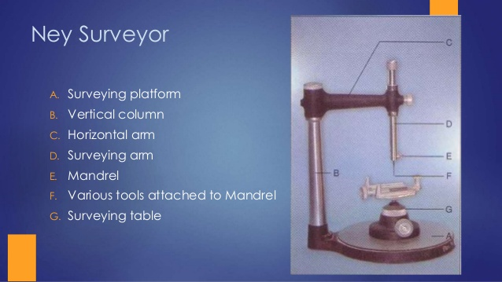
- Surveying line : it’s the hieght of contour of the tooth which there will be an undercut beneath it ( be careful when you do surveying you must touch the soft tissue , otherwise the surveying will be wrong )
- The undercut : it’s the part that locates between the survey line and the gingiva. Could be a true or false undercut (( the false undercut will happen when we tilt the cast so the occlusal plane wont be parallel with the table ))
- So if we tilt the cast the common path of displacement wouldnt be perpendicular with the occlusal plane and thus we will get a false undercut, UNLESS we tilt the cast and had a new survey line bellow the previous one
- Also there is tooth undercut and soft tissue undercut .
- The common path on insertion : shouldn’t be the same of the path of displacement . There is only one case that the path of insertion is the same of displacement >> when the cast at the zero tilt
- The path of displacement should be always perpendicular to the occlusal plane
- The main objective of surveying : defining the undercuts in order to block them , because if they aren’t blocked the RPD wont set properly .

GOOD LUCK :D

