Local Anasthesia
sheet #1
Done and corrected by : Nisreen and Elaf.

The structural unit of CNS is neuron, this neuron either sensory or
motor.
*components of them:
-sensory: 3 main components;
1- zone of free nerve ending (most distal part /away from the center),
present in peripheral tissues , eg. Oral cavity.
2-axon; cable like structure, consist mainly of nerve membrane (the
most important part of the neuron as most of the changes are
attributable to this structure). This membrane separate the axoplasm
(cytoplasm of the neuron) from extra cellular fluid. All the process
when you feel a pain happen in the axon membrane and the most distal part of the axon synapse with multiple nuclei in the CNS to distribute
the impulse.
3-cell body; in sensory neuron its located at distance from the axon,
how?
the cell body in the sensory neuron as we can see is located at a distance
from the neuron not in the pathway of the neuron so for that reason its not
involved in the transmission of impulses , the only function is to provide
metabolic support for the neuron . (** where as in the motor neuron the cell body is located at the same pathway of an axon, function in metabolic
support and involvement in cell excitation**)

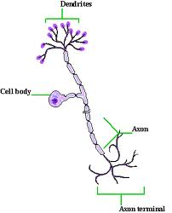
when excitation happen in the nerve, changes happen in the membrane of the axon not the cell body.
Let’s talk about the most important structure which is the nerve
membrane.
-changes that happen in the nerve membrane are responsible for
impulse transfer.
-this micro structure consist mainly of bilipid layer, so only lipid
molecules can pass through it, except for molecules that pass through
channels (called protein channels/ transport proteins).
-stimulus occur when there is excitation to
the peripheral nerve endings,(this process
which takes around one second induce
changes to the nerve membrane).
-after excitation (must be above threshold)
Na+ channels open and membrane potential changes from resting potential and
depolarization occurs.
-all these happen when the stimulus is above the threshold; for ex.
When you touch your finger, you just stimulate C fibers and there is no
pain.
But if you pick it by a brooch: stimulus above the threshold excitation    opening of Na channels Na+ influx.
-Na influx will provide the energy needed for impulse transfer; if
there is no Na influx no conduction.
-this process continues until the stimulus is end, so Na channels close
and no transfer.
-so if there is asymmetry around the membrane and without LA; Na
influx will continue and the impulse will be transferred through the
membrane to the CNS.
-speed of impulse transmission:
*It depends on 2 main factors:
1- type of the nerve..if its myelinated or not.

2- diameter of the nerve.

-As the diameter increase the
thickness of myelin sheath will
increase, and the internal sheath
nodes of ranveir will increase as
well   more rapid transmission.
- the method of transfer of
myelinated nerve fibers is a
jumping process and this will make
the transfer faster than in non myelinated which where the process is a creeping process(زحف).

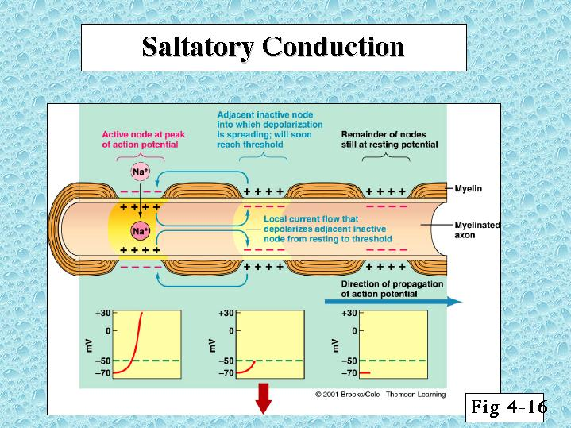
-as a result, doing LA to block the myelinated nerve for sure the impulse transmission will be very fast. and if you do gentle touch to the nerve by a needle this will lead to electric shock pain.
-the same applied when you block a nerve with large diameter, if you
touch the trunk of the nerve, immediately electric shock pain occurs
followed by rapid anesthesia.
-structure of non myelinated:
Not covered by myelin, just covered by Schwann cells.
Impulse transmission is slower than myelinated nerves with the same
thickness. ( remember that you have 2 factors to consider).
Process of transmission is creeping. 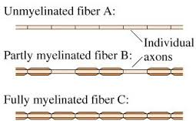

*according to our understanding to the normal function of the nerve
( physiology) , this will lead us to understand the mechanism of action
of LA.
-it depends on impulse transmission; With LA no impulse
transmission    no pain.
*theories explain the mechanism of action of LA:
1-MEMBRANE EXPANSION THEORY
LA consist mainly of lipophilic molecules
So LA dissolve in the membrane and lead to the expansion of the
membrane    closure of channels   no Na influx    no impulse.
From the last year sheet:
when we deposit the local anesthetic solution close to the nerve membrane
that will induce changes in the nerve membrane itself .. the main component of some local anesthetics are lipophilic molecules , so when you inject the LA which is mainly composed of lipophilic molecules it will bind with nerve
membrane .
so the nerve membrane will expand , and some morphological changes will
happen to the sodium channels , causing obstruction , so no sodium influx ,
but this theory is only applicable on LA that’s mainly composed of lipophilic molecules like benzocaine for example .

2- receptor specific theory: ( most favored theory ).
There is receptors on the nerve membrane bends with the L.A drugs and make block to the Na+ channels.
- in both theories the blocking of Na+ channels happen.
Accordingly, L.A are classified into 3 main types:
- Receptors dependent L.A's : depend on theory 2 not 1
- L.A's working depending on theory 1 ( bezocaine ).
- L.A's depend on both theories :
- more effective.
- most of our L.A's that we use.
L.A's carpool consest of :
- L.A drug.
- vasoconstrictor.
- preservative ( sodium bisulfate ) . ( should be present with vasoconstrictor because it is shortly lived).
- all these components are L.A molecules composed of :
1- lipophilic part ( basic)
2- hydrophilic part ( acidic )
3-intermediat chain .

- most of L.A's are vasodilators and this will increase the absorption of L.A's and thus increase the toxicity and decrease the duration of
L.A's .
- the L.A's which are composed of lipophilic material just used
topically , it is not dissolve in water and tissue fluids, so that it will
not enter inside the tissue .
- for that reason they called the hydrophilic part ( acidic) because
acid is the best to interact with the base ( lipophilic ) and the result
will be salt ( hydrochloride ).
- these hydrophilic and lipophilic materials connected with each
other by intermediate chain which determine the type of L.A .
- intermediate chain is either ester or amide groups. So L.A types are divided as ester or amide, accordingly.
- so if the L.A broke in the sun after the evaporations of the water, the remaining material will be a salt
( hydrophilic ( acid)+lipophilic (base)).
PH of L.A's
The PH of this hydrochloride salt is relatively close to the PH of the
tissue = 7.4, range = 5.5-7.
Thus, where the PH of L.A is close to the tissue PH, this means the injection is possible ( no pain while injection) , but if the L.A PH lower than 7.4 ( acidic ) it will be painful .
* What about the vasodilation in the L.A?
Ofcourse , I don’t want that because I don’t need L.A to diffuse and I need a longer duration of action for that reason they add the vasoconstrictor to balance the effects of L.A .
Henderson-hasselbelsh equation
this equation used to determine how much the lipophilic and the
hydrophilic molecules in the L.A drugs .
$$\log{\frac{base}{acid}={PH}_{tissue}-PKa}$$
This equation depend on :
- PH of the tissue = 7.4 ( it will become less than that in inflamed tissue)
- PKa = dissociation constant of the L.A ( each L.A has it is own PKa)
By knowing the PH and PKa and according to the equation I can know how much I have base ( lipophilic ) and acid ( hydrophilic ).
Example:
If we inject 1000 molecules of a local anesthetic agent (etidocaine) which has a PKa of 7.9, injected in the tissue outside the nerve sheath and the tissue PH is normal (PH=7.4) :
- How much RN molecules (lipophilic molecules) and RNH+ (hydrophilic molecules) we have?
According to the equation:
RN is 25% so 250 molecules from the 1000 molecules are lipophilic molecules
RNH+ is 75% so750 molecules from the 1000 molecules are hydrophilic molecules
- Which molecules are able to diffuse through the nerve membrane?
The lipophilic molecules (250 molecules)
250 molecules have enter through the membrane and reach the axoplasm (anterior to membrane), inside the axoplasm further dissociation happen to have 25% of 250 molecules as RN (lipophilic) and 75% of 250 molecules as RNH+ (hydrophilic) >> according to the equation
But here the charged molecules (hydrophilic molecules) are the molecules which are able to bind to the receptors, so 180 molecules out of 250 molecules (75%) have bind to the receptors to induce the conduction.
PKa increase >> the lipophilic molecules decrease >> slow onset of action.
PKa decrease >> the lipophilic molecules increase >> rapid onset of action.
the (RN) molecules are 70 molecule of 250 molecule (25%) witch
able to diffuse .
the (RNH+) are 180 molecule of 250 molecule (75%) witch are able
to attach to the receptors in Na+ channels.
- now , lets see in the case of infection :
in inflamed tissue PH will be lower =6
according to equation , just 1% of L.A present as a lipophilic part so that just 10 molecules (1%) of the L.A are diffused while it was 250
(25%) in the normal tissue. And just 7.5 (75% because of normal
PH=7.4 inside the nerve) from these 10 molecules will bind.
note that in inflamed tissues the low PH is just in the ECF but the PH
inside the nerve is normal .
so that, response will be delayed and there is no successful
anesthesia .
Barriers of L.A
just small amount from L.A we inject go to the nerve and the rest absorbed else where in the blood vessels and lymphatics and other
tissues.
but, the most important barrier of L.A is the perinureum .
influence of factors on the characteristics of L.A ?
there is no evidence in the literatur says that the properties of L.A
like onset and duration of action influenced by smoking ,age, BMI or gender.
although its still under research, first results refer to that the age
and smoking have a significant influence on L.A .

sorry for being late

