Pharmacology of vasoconstrictors
Sheet Number: Three
Done by: Leen Al-Qudah.

Remember local anesthesia has a vasoactivity (Vasodilation), except cocaine.
LA injection leads to:
Increase in absorption in the CVS (because LA leads to vasodilation)
Increase plasma levels (toxicity)
Increase bleeding (due to increase of perfusion to tissues)
Decrease in depth and duration of local anesthesia.
Remember: Local anesthesia once it's injected it will lead to a quick effect of vasodilation.
Vasoconstrictors are agents added to the LA to balance the LA activity and counteract the effects.
It'll decrease bleeding, absorption, plasma levels and increases the depth, duration and the potency of the LA.
This gives an indication how the absorption differs when we have vasoconstrictor and when we don’t.
**You should memorize the maximum dosage for LA (LA dose, VC dose, Caritdges number) especially (Lidocaine,Prilocaine, Artricaine, Bupivicaine and Mepivicaine)**
Most of the Vasoconstrictors are sympathomemics similar to the Epinephrine and Norepinephrine.
Examples on Sympathomemic VC:
-Epinephrine
-Norepinephrine
-Levonordefrin
-Isoprofevenol
The first two are naturally occurring
The last two are synthetic.
**Naturally occurring catecholeamines; Epinephrine, Norepinephrine and dopamine.
Noncatecholeamine vasoconstrictors:
(Because they don’t have the hydroxide group on the aromatic ring)
Example: Amphetamine; a drug that is mainly given to children with ADHD syndrome.
Once this drug is stopped it will lead to a crash (relapse) because of its indirect effect on stimulation the E &NE secretion and this will lead to decrease in the E and NE in the body so there will be no more to be secreted.
This drug is also abusive in Yemen as Al-Qatt.
Felypressin:
Non sympathomemic Vasoconstrictors.
Analog of vasopressin (ADH)
Doesn’t affect the sympathic receptors (Alpha1, Alpha2, Beta1 and Beta2) so it doesn’t cause direct action on smooth muscles through these receptors.
It has a direct effect on the Smooth muscles through other receptors.
So, it stimulates the secretion of E and Ne through direct and indirect action.
Felypressin is best for arrthymias patients.
Mixed Acting sympathomemic VC:
Metaraminol.
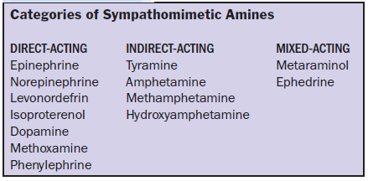
Refer to table 3-3 in the book.
Remember:
Cardiac muscles mostly have Beta1 receptors
Skeletal Muscles mostly have Beta2 receptors
**Activated mainly when adrenaline is released under fight and flight situation (it increases heart rate (tachycardia), Cardiac output, sweating, pupil dilation, skeletal muscles need for energy so it increases the glucose blood level)
Now let's talk about VC dilutions:
1:1000 means:
* Each 1g = 1000 milligram
*And each 1milligram= 1000 microgram
1g/10001mg/ml 1000Microgram/ml
The maximum dose of a LA that contains vasoconstrictor for a CVS patient is 40micrograms/ml .
Norepinephrine has more significant effects on the cardiovascular system because it effects the Alpha1 receptors more than the Beta2 receptors thus it has higher effects on increasing the blood pressure than the Epinephrine.
Epinephrine reactions: Apprehension, tachycardia (Cronotopic), sweating and palpation.
1:100000 means 100000 micrograms/ml (Epinephrine)
This dose is given only in emergency situations such as; anaphylactic shock and cardiac arrest.
Epinephrine uses:
1- Management of acute allergic reactions
2- Management of refractory bronchospasm (status asthamaticus)
3- Management of cardiac arrest
4- As a vasoconstrictor for hemostasis.
5- As a vasoconstrictor for local anesthesia.
6- To produce mydriasis.
Important table: 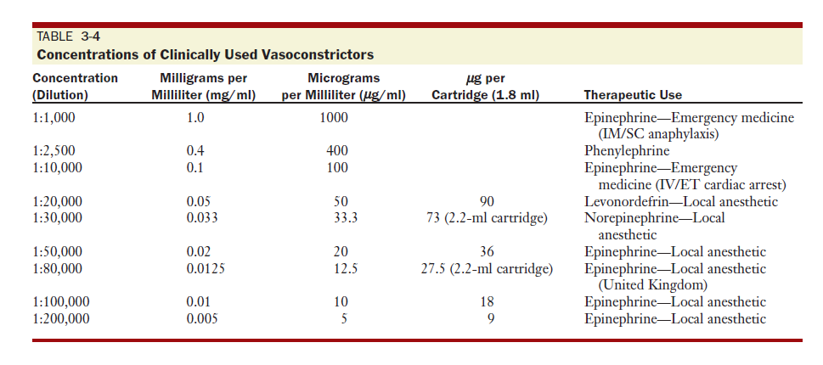

Referring to the previous table note that: 1:50,000 and 1:80,000 aren't used nowadays.
Resting epinephrine plasma level: 39picogram/mL
This level is doubled after one cartridge injection with local anesthesia.
Its extremely difficult to give a painless parental injection with plain LA that’s why we use VC.
Because of the presence of the vasoconstrictor in the LA you should follow the safety way when injecting LA:
- Slow injection
- Aspiration
(Using the aspirating syringe that has a ring that allows you to do multiple aspiration before injecting in the right area)
- Minimal amount.
Each IV injection of LA that contains 0.015 milligram of VC leads to:
- 25-70 beats/min increased
-20-70 mmHg increased on the systolic phase of blood pressure
-Arrhythmias and PVC's
Na+ Bisulfide is used as preservative to the vasoncostrictor and this component mainly causes allergies.
Shelf life of the LA alone is 3 years and with a vasoconstrictor is 18 months.
Epinephrine deteriorates in air, heat and metals.
Mode of Action:
Coronary Arteries: Vasodilation affecting the Beta2 receptors to increase the blood flow
Blood pressure: initially it increases the systolic and reduces the diastolic phase but as the concentration increases it will lead to increase in the diastolic phase.
Vasculature, mucus membranes, skin and kidney : vasoconstriction (Alpha1).
Skeletal muscles: vasodilation (Beta2) later vasoconstriction due to activation of Alpha1.
Hemostatic: Vasoconstriction followed by delayed vasodilation, bleeding 6 hours post operatively.
Respiratory system: Bronchodilation.
Given for anaphylaxis (allergy) and for bronchospasms.
Termination of action:
MOA/COMT
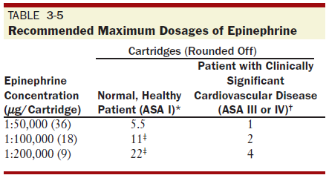
As you can see in the previous table the healthy patients could take up to 11 cartidges but we avoid that because we fear the LA agent to accumulate in their bodies.
What limits the number of cartidges given for CVS patients is the VC.
Only minimal effective doses are given.
ASA 1: Healthy patients.
ASA 2: Chronic situations e.g. Hypertensive patients and controlled diabetes patients
ASA 3: Patients with Angina, MI, uncontrolled diabetes
ASA 4: patients with unstable angina, severe heart failure, severe situations.
**patients with bisulfide allergy and thyroid problems are considered ASA 3/4 patients.
Surgical anesthesia is easier than pulpal anesthesia, pulpal anesthesia needs 2 sectioning and once you reach the pulp the patient starts to feel pain.
The pulpal anesthesia is the last step you make.

Study this lecture from chapter 3 and refer to the indicated tables.
Good luck!
Leen Al-Qudah

