Sheet no: 6.  
refer to slide no: no slide available.

Refer to chapter: 5,6 and 7 ( dr advise us to read chapter 9 )

Date: 15/11/2015

Dr: omar karadsha

Written and corrected by: lubna Marmori

This lecture was in exams weeks. dr refuse to give us the slide ,so to some extent this sheet is prolonged and extended. I used to check all information from the book, internet. I inserted all pictures that dr talked about, to make it more easy once there is no slide. Added stars in this sheet indicate wt dr mentioned in the lec. If you have any question, please do not hesitate to ask google.

Be happy when you read this lecture, كان الله في عونكم

We will discuss the equipment necessary for the administration of local anesthetics; this includes the syringe, the needle, the local anesthetic cartridge.

All of us deal with anesthesia, needle, cartridge and the syringe and so on, what is the difficulty that faces you? If you have any choice to change your current equipments, then what will, you decide.

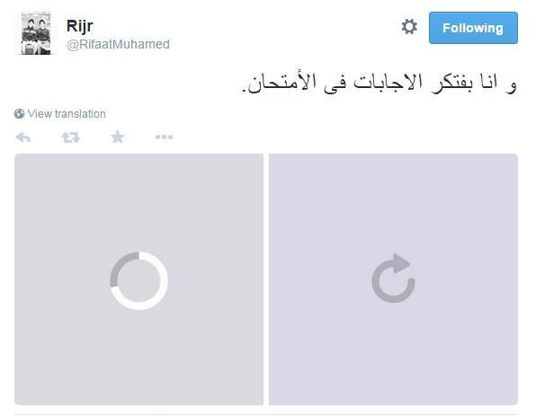

***Local anesthesia equipments***

1. ***Syringe:***

* **Should be ;**

1. Lightweight
2. durable (متين)
3. Not expensive
4. Autoclavable ( if not , then disposable)
5. Effective aspiration  
   ** they was said that there is 2 type of syringe; aspirating and non aspirating, now Syringes that do not permit easy aspiration (e.g., nonaspirating syringes) are not discussed because their use unacceptably increases the risk of inadvertent intravascular drug administration. Use of aspirating dental syringes (capable of the aspiration of blood) represents the standard of care.
6. capable of accepting a wide variety of cartridges and needles of different manufacture, and permit repeated use.

* **Syringe type available in dentistry (بشكل عام):**

1. non disposable **( same as we use in our clinic )
2. disposable
3. “Safety” syringes
4. Computer-controlled local anesthetic delivery systems

** *Breech-loading =* implies that the cartridge is inserted into the syringe from the side.  
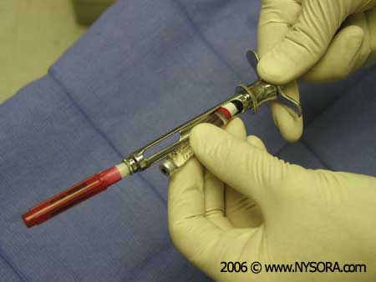  
 ** there is another type that cartridge inserted from back (as we use in clinic ) but we will not talk about it for unknown reason ;) . Breech loading is safer to use.

The first type of syringes is breech – loading metallic cartridge.

* Doctor discusses one pic and he told us the syringe part.

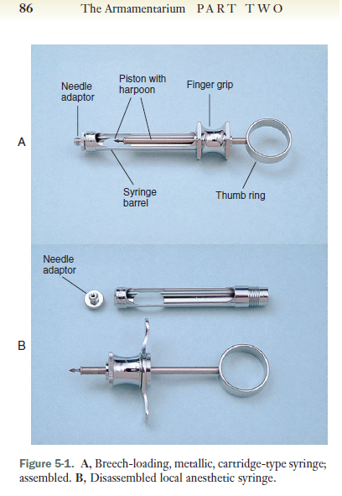

**Don’t forget :**

**local anesthetic armamentarium : syringe , the needle and the cartridge).**

**Remember :**

**The difference between aspirating and non aspirating is : presence of harpoon ; when you aspire there will be negative pressure and then the fluid will enter within cartridge.**

Where the needle engage the cartilage .

اصحوا تفكوها وتكبوها بالغلط لانه بعدين ببطل في داعي لكل السرينج.

**The *aspirating* syringe has a device, such as a sharp tip{sphere shape, triangle}(called the *harpoon*) that is attached to the piston and is used to penetrate the thick silicone rubber stopper (bung)).متل الرمح**

**>> piston : الحديدة الي بتفوت وتطلع**

Some dentist have problem in aspiration , why ?? Because their hand is small , and when you insert the needle and try to make aspiration there will be some difficulty.

There is another type of such syringe that is designed with smaller thumb finger .  
  
  
Advantages :

Mainly it is metal so it can use again and it is durable, then dr read this information

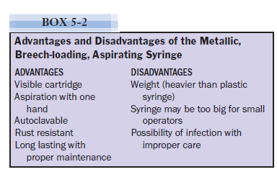

Note :

**Why ” visible cartridge” is an important advantage ?**

To know how much we give the patient local anesthesia .

The second type is: **breech loading, plastic, reusable, aspirating syringe.**\*\* dr told us that there is **no that difference between plastic reusable and metallic syringe** but with repeated autoclave it will be not effective. {{Note there is another type of plastic syringe which is not reusable; single use }}

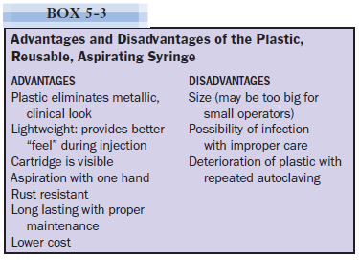

The third type which is ***Breech-loading, Metallic, Cartridge-type, Self-aspirating.***

* The applied force is less.
* Before we talk about their principle , you should know that ; intravascular administration of local anesthesia can be dangerous , from here aspiration seem to be very helpful
* The incidence of positive aspiration may be as high as 10% to 15% in some injection techniques (you inject inside blood vessel O.O )
* There is a study said that 63% of dentist do aspiration before Inferior Alveolar Nerve **Block** injection ( exactly as wt we do in clinic -.- which may be reach to **0%** ) .
* The same study said : 40% of dentist do aspiration before maxillary **infiltration**
* **Why** do they make a such type of syringe (self-aspirating) ??   
  1- to facilitate the aspiration process

**2- you** can do aspiration as much as possible before do procedure .

* **It depends on the elasticity of the rubber diaphragm in the anesthetic cartridge to obtain the necessary negative pressure for aspiration. The diaphragm rests on a metal projection inside the syringe that directs the needle into the cartridge.   
  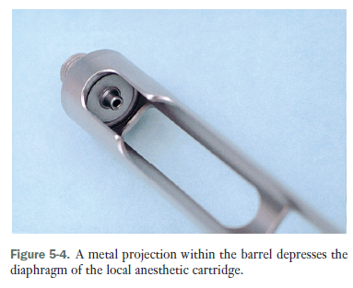  
  Pressure acting directly on the cartridge leads this projection to stretch the rubber diaphragm, producing a positive pressure within the anesthetic cartridge. When that pressure is released, sufficient negative pressure develops within the cartridge to permit aspiration.**

بتحطوا الكاربوله وبعدين بتضغطوا شوي وعليه هاد الاشي الطالع رح يضغط الكاربولة مو كل الكاربولة الاشي الي براس الكاربوله (زي المطاط ) كلنا بنعرفه .

هاظ السترتش هو الي راح يعمل الضغط النقتف الي بدنا اياه وبالتالي بزبط معنا ال  
aspiration   
من دون اي غلبة

* **So** you only apply small pressure to let the cartridge to get inside the projection (only ☺ )
* Dr shows a pic and he said : شايفين هاي الدويرة الي عليها سهم >> it is called **thumb disk ;**They think that it will be more effective if you press here.
* **So The thumb ring (disk )produces twice as much negative pressure as the plunger shaft.**

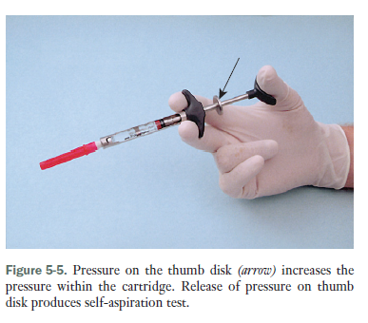

* This syringe was introduce in 80’s last century. (ولحد هلا ما وصلتلنا ☺)
* After an initial period of enthusiasm, **the popularity of this syringe decreased. Because it is not reliable ( غلبة وما غلبة ومن هالقصص , لازم تحط اصبعك على هديك الدويرة والدنتست ما عجبهم ).**
* They make a study and found that this syringe is reliable so to fix this problem, they develop a second generation of it; they remove thumb disk , so only you press then aspiration will happen .
* a self-aspirating dental syringe permits multiple aspirations.
* it have a advantage and disadvantage : ( it is metallic so it have a mutual advantage with metallic syringe .

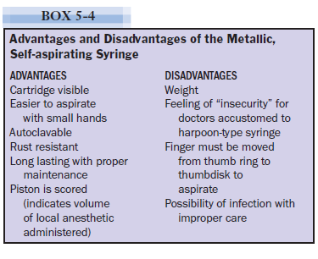

The fourth type is **pressure syringe :**

* Made for specific technique (one of local anesthesia technique which used to inject within **periodontal ligament (PDL) injection (also known as the *intraligamentary injection* [ILI])**, because it need a lot of pressure, this technique is painful and sometime it used only in extraction {may be used in endo when you face problem with the canal (تصعب عليك=تعصلج معك). ((so **it have mechanical advantage** )) .
* They develop this syringe to facilitate ILI.
* It is supplementary (you can’t dispense (تستغني عن) metal syringe.
* It helps you to give you **major doses.**
* Easy to administer.
* but ( too easy ) lead to ( too rapid ) administration >> so you will give ( too much ) , then will lead to patient discomfort.
* Too expensive, so it used only in specific cases. (when conventional anesthesia ما زبطت معك
* 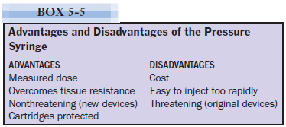

The original pressure syringes looked somewhat threatening, having the appearance of a gun. So patient will be worried and scared , Newer devices are smaller and considerably less intimidating.  
كان شكلها متل الفرد كانت بتخوف

* ** **jet injector or needle-less injection** :
* Principle : Rapid or forcing fluid out of through very small openings( holes ), called jets, at very high pressure can **penetrate intact skin or mucous membrane** (visualize water flowing through a garden hose that is being crimped). ( in fact ; you are not injecting , it just using spray have high pressure , high speed fluid .
* It gives anesthesia for 1-2 ml.
* The primary use of the jet injector is to **obtain topical anesthesia** before the insertion of a needle. ((Some dentist said that it might work in palatal injection)).
* The book said: it might used to obtain mucosal anesthesia of the palate.
* Not an adequate substitute for the more traditional needle and syringe in obtaining pulpal or regional block anesthesia . (It is **not replacement** for normal syringe ! ☹ )
* Many patients dislike the feeling accompanying use of the jet injector, as well as the possible post injection soreness of soft tissue that may develop even with proper use of the device.
* Expensive ( 600 -1500 jd) vs .5 jd for normal topical anesthesia !!

**Disposable Syringes**

* As wt we use in irrigation, insulin syringe.
* Plastic disposable syringes are available in a variety of sizes with an assortment of needle gauges.
* **Used for intramuscular or intravenous drug administration**.
* **Dose not accept cartridge. (يعني بتحط انت المحلول جواتها ).**
* Sometime, it is sterile.
* Inserted into a vial or cartridge of local anesthetic or drug and an appropriate volume of solution withdrawn.( e.g. vitamin b 12 injection ) .
* Not accept to use more than once.
* Aspiration can be accomplished by pulling back on the plunger of the syringe before or during injection.
* Its use should be considered only when a traditional syringe is not available or cannot be used.
* Label it for more cautions.(حط عليها ملصق , الاحتياط واجب)

**Safety syringe:**

* https://www.youtube.com/watch?v=IeTo8FLqcMk
* They are similar to normal syringe, but they have a small trick that they introduce to prevent needle stick injury.
* These syringes possess a sheath that “locks” over the needle when it is removed from the patient’s tissues, preventing accidental needle stick.
* It has different shape than normal syringe by having 2 parts, one part with cartridge and needle , other with sheath ((It consists of an autoclavable syringe handle and a disposable self-contained injection unit.)) (هاد الغطا هو الفرق الرئيسي والاهم )
* 
* All dental safety syringes are designed to be single-use items (changed after each injection , because it is locked ! ) .
* it is **Disposable.**
* Here doctor make an interruption. And ask us to read chapter 9 .he said: it is easy!! اقروه لحالكو .

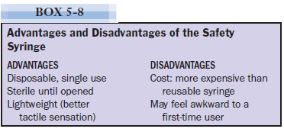

**They need a course to learn how to use it !!**

**Computer-Controlled Local Anesthetic Delivery Systems ((CCLAD) system)) :**

* It is called *The Wand/CompuDent (العصا السحرية )*
* *Principle :* it look like a pen , so you have more control . { The system enables a dentist to accurately manipulate needle placement with fingertip accuracy and deliver the local anesthetic with a foot-activated control .The lightweight handpiece is held in a penlike grasp that **provides increased tactile sensation and control compared with the traditional syringe.**
* 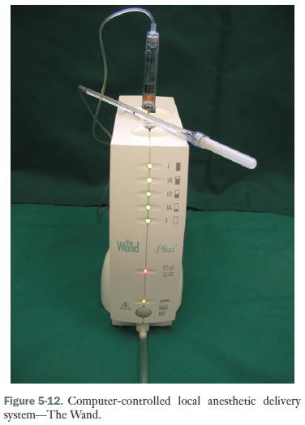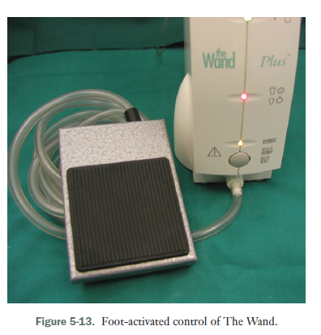

هون بتحط رجلك وتدعس

* Needle on the wand enter within tissue , and when you compress the foot control of wand , the liquid start to get out .
* Advantage: control and reduce pain reception and more comfortable .
* Was developed in 1997.
* New product develops from wand called STA (single tooth anesthesia).it depend on something used in medicine in subcutaneous injection, which called **dynamic pressure sensitive technology (DPS).**
* There is a sensor on needle when You enter the needle, the sensor will measure the amount of pressure that present in the current location (create by fluid around the needle ) ,then it will give you **feedback where the needle locate** e.g. inside submucosa, loose tissue, bone, etc.
* It is important in many cases e.g. pdl injection.
* It has a single-use disposable “safety” handpiece and conventional medical **Luer-Lok needle** (not a traditional dental needle) is attached to the handle. ( the same as we put the needle on the cartilage of traditional syringe , the lur-lok needle inserted into the handpiece.
* The new generation of this technique allowed to recapping (one hand recapping no need to use the other hand). 

“cool blue” “safety” wand handpiece with a self-retracting needle

* Easy to manipulate for both patient and dentist

فيها زي الزنبرك برجع الابرة لحالها لجوا الغطاي .

* It is disposable.
* It have a lot of gauge e.g. 25 , 27 and 30.
* Revolution was in pdl injection , it was painful , difficult and you can’t inject within pdl unless you are experience (the operator encounters significant resistance ) .
* **has a visual gauge and emits little beeps to let the dentist know when they’ve placed the needle correctly. It can even speak!**The most advantage is giving the feedback . e.g once you enter within the tissue the red light start to run indicate that pressure is not that much . when you get deeper the light will be more dark(من احمر فاتح ل احمر غامق), this mean pressure increase . So the light will guide you plus it will tell you by words for example when you teach pdl it will tell you: pdl pdl pdl.
* **This lead you to give accurate dose (no great volume ) , avoid blood vessels =maximum absorption for anesthesia you give, very deep, very fast and comfortable anesthesia.**
* It is important to use with a new technique develop to anterior superior nerve block or nasopalatine block or maxillary block or mandibular block.
* Its major disadvantage is the cost ; it’s so expensive.
* Disadvantages : 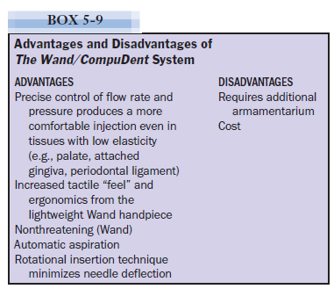

**Comfort Control Syringe :**

* 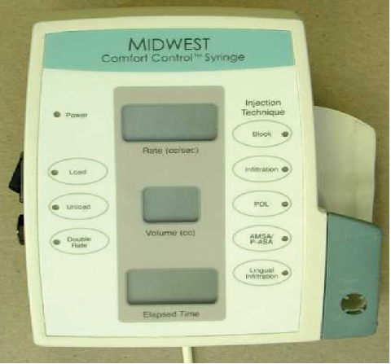
* In 2011 developed.
* every button have specific function. You can press on what technique you need , then it will complete the process ☺
* 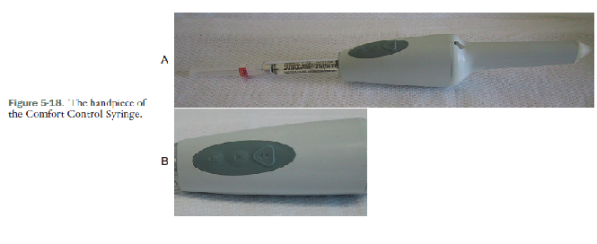

Hand piece of the CCS.

* It looks like syringe.
* The CCS **has a two-stage delivery system**; 1- the injection begins at an extremely slow rate to prevent the pain associated with quick delivery which last 10 second . 2- After 10 seconds, the CCS automatically increases speed to the preprogrammed injection rate for the technique selected. (اولا بيدخل عالمكان الي بدنا اياه ب 10 ثواني بعد هيك في عالجهاز كبسات بس تضغط الكبسة الي بدك اياها متلا كبسة الانفلتريشن والجهاز لحاله بيحط السرعه اللازمة عشان الانفلتريشن.) )
* This device has buttons everyone has a function e.g. button: for infiltration, for intraosseous injection , for block injection and so on.
* There is button for aspiration.
* Cost one of its disadvantages.

**CARE AND HANDLING OF SYRINGES**

* How do we clean the syringes?

1. Wash it then Autoclave it
2. Every five times it is preferable to تفكوا all syringes and cleans all of its part. the syringe should be dismantled and all threaded joints and the area where the piston contacts the thumb ring and guide bearing should be lightly lubricated. The harpoon should be cleaned with a brush after each use.

**Problems associated with syringes:**

1. Leakage during Injection

* Why does this happen? **Point of perforation of cartilage becomes small. Ideally you put the cartilage first then insert the needle so the perforation will locate in the center of the rubber diaphragm. If you do the opposite, which needle first then the cartilage, here the needle may تطعج and the perforation will go to incline mesially or distally (to right and left) from the center. Here there will be leakage of solution. **An off-center perforation produces an ovoid puncture of the diaphragm that allows leakage of the anesthetic solution around the outside of the metal needle and into the patient’s mouth**

B- Breakage cartridge (bent needle can cause this, you exert pressure and no anesthesia exit this will lead to more pressure on cartridge so finally will break). c- Bent harpoon   
**recommendation: aspiration syringes. Self syringes for small hands.**

***2- Needle***

**Don’t forget : **

**local anesthetic armamentarium : syringe , the needle and the cartridge).**

**TYPES**

* **Most needles used in dentistry are stainless steel (metal) and are disposable. Other needles are constructed of platinum or an iridium-platinum or ruthenium-platinum alloy.**
* **The stainless steel needle is highly recommended.**

**PARTS**

* **All needles have the following components in common: the bevel, the shaft, the hub, and the cartridge penetrating end .**

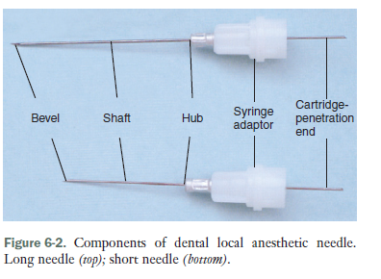

Long needle

Short needle

* You should know that hub is a plastic or metal piece through which the needle attaches to the syringe.
* When you give the injection , the bevel should facing **downward**. If it facing upward, it will expand the tissue, so it facing downward to reach the area you want without expanding tissue.
* **Deflection**: if the bevel lies on center of long axis of the tooth , you don’t give deflection . long axis of the tip lies in the center of shaft. So it is non deflecting needle.(طعجة الابرة)
* 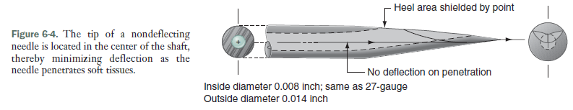

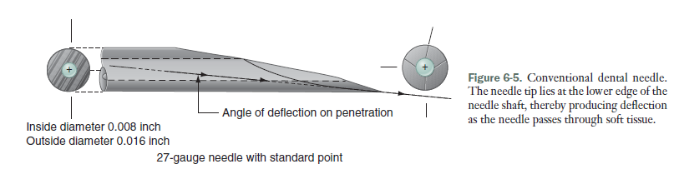

- The **greater the angle of the bevel, the greater is the degree of needle deflection.**

**- our clinic ?? we have a deflecting needle ( the dentist improve their self to exceed this problem !)**The *bevel* defines the point or tip of the needle**. the greater will be the degree of deflection as the needle passes through hydrocolloid (or the soft tissues of themouth) .**

**-** mainly when you choose needle , you should consider this issue.

**- Gauge**: diameter of the lumen of the needle**; the smaller the number, the greater the diameter of the lumen**. A **30-gauge needle has a smaller internal diameter than a 25-gauge needle.**

-They discover that the pain not affected by the gauge. All of it has the same effect.

** **but pay attention that the small and longer needle have more deflection.(it also depend on the thickness of tissue )**  { smaller less resistant >more deflection}

** the problem with small needle is the **difficulty in aspiration**, when lumen decrease in size , the aspiration become difficult. (it is difficult to withdraw any tissue or fluid).

**Two factors to be considered about this component of the needle are the diameter of it lumen (e.g., the needle gauge) and the length of the shaft from point to hub.**

* Why should we use larger gauge?

1- Less deflection so give you more accurate injection.  
 2- Less chance for needle breakage.   
3- easier aspiration.  
 4- In pain effect >> no difference

So which one should be used?

* We use in our clinic gauge 27 .  
  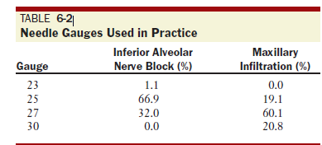
* Less than 20% of people use 25 needle with long and short length.
* The discover that **the most commonly used** (most purchased) is the small gauges (large diameter).{ the **27-gauge long, and the 30-gauge short**.} ** (most common doesn’t mean the right use )
* The most preferable is 30and 27 purchase more than 25.
* 25 needle preferable for most of injection(especially vascular injection). **Larger-gauge needles (e.g., 25-gauge) should be used when there is a greater risk of positive aspiration, as during an inferior alveolar, posterior superior alveolar, or mental or incisive nerve block. { easier penetration . less deflection , etc. }**
* 27 can be used, it is not bad and used in blocks injection.
* The 30-gauge needle is not specifically recommended for any injection, although it may be used in instances of local infiltration, as when obtaining hemostasis during periodontal therapy.

Doctor discuss this table

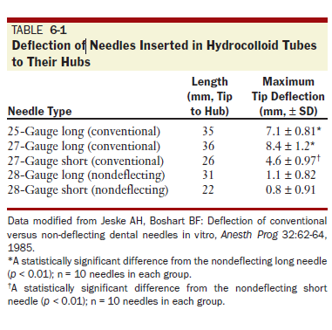

25 gauge have 7 mm deflection which is a lot . 27 gauge have more deflection around 8

28 gauge long , deflection reach 1.1

**Minimizing Needle Deflection:**

* Rotational Insertion Technique

The technique of rotational insertion (described **as bi-rotational insertion technique [BRIT**]), a technique in which the operator rotates the handpiece or needle in a back-and-forth rotational movement while advancing the needle through tissues, is similar to techniques used for acupuncture or endodontic instrumentation. Needle deflection could be virtually eliminated by using a rotational insertion technique during needle movement.

Is it reliable or accepted to rotate syringe within tissue?? No.

The length : We have short and long

Short 20 mm

Long 32 mm

***Needles should not be inserted into tissues to their hubs unless it is absolutely necessary for the success of the injection.* One of reasons for this precaution is needle breakage,**

**CARE AND HANDLING of needles:**

1- Needles must *never* be used on more than one patient.

2- Needles should be changed after several (three or four) tissue penetrations in the same patient.

a. After three or four insertions, stainless steel disposable needles become dulled. Tissue penetration becomes more traumatic with each insertion, producing pain on insertion and soreness when sensation returns after the procedure.

3. Needles should be covered with a protective sheath when not being used to prevent accidental needle stick with a contaminated needle.

4. Attention should always be paid to the position of the uncovered needle tip.

5. Needles must be properly disposed of after use in sharp container .

**Problem associated with needles:  
Breakage :**

Caused by :

1. *Bending :* weakens needles, making them more likely to break on subsequent contact with hard tissues, such as bone.

When did dentist go to bend needle ??   
A- An inferior alveolar nerve block (IANB), a posterior superior alveolar (PSA) nerve block.  
B-irrigation.   
C- an intrapulpal injection, an injection into the PDL, and the intraosseous injection.   
there is a new technique in which you can give the aneshthesia without bending needle . so **blocks can given in straight needle , even pdl and intrapulpal injection. So all cases need straight needle except in 3 situations :**A-the distal root of a mandibular second molar (PDL).  
B- root canals in posterior teeth (intrapulpal).  
C-injection into bone distal to a second molar (intraosseous). in which the injection site is not accessible with a straight needle.

This point from book . Dr did not mention it.

* **It is not dangerous; Because the needle does not enter into soft tissue more than 2 to 4 mm (PDL), or at all (intrapulpal).**

1. *CHNGE DIRECTION OF THE NEEDLE .No attempt should be made to change the direction of a needle when it is embedded in tissue.* If the direction of a needle must be changed, the needle should first be withdrawn almost completely from the tissue and then its direction altered. No **attempts to force a needle against resistance should be made** (needles are not designed to penetrate bone).  
   - Smaller (30- and 27-gauge) needles are more likely to break than larger (25-gauge) needles.
2. *Pain on Withdrawal* : A- can be produced by “fishhook” barbs on the tip. Fishhook barbs may be produced during the manufacturing process, B- but it is much more likely that they develop when the needle tip forcefully contacts a hard surface, such as bone.
3. *Injury to the Patient or Administrator:* Penetration of, with injury resulting to, areas of the body with the needle can occur unintentionally. A major cause is carelessness and inattention by the administrator, although sudden unexpected movement by the patient is also a frequent cause. The needle should remain capped until it is to be used and should be made safe (sheathed or recapped) immediately after withdrawal from the mouth.

***3- The Cartridge***

**Don’t forget : **

**local anesthetic armamentarium : syringe , the needle and the cartridge).**

* Have 1.8 ml OTHER contain 2.2 cartridge (in U.K).
* You should know calculation, if its concentration 10%, what does this means?
* Plastic labial on cartridge is very useful. Why? 1- Have information about the present drug 2- if the cartridge breaks, it prevent he cartridge t o go to small pieces (ما تتفتت).
* COMPONENTS

1. Local anesthetic agent
2. Vasoconstrictor
3. Conservative (sodium bisulfate )
4. Water : ***Distilled water*** is used as the diluents to **provide the volume of solution i**n the cartridge. ( sometimes is saline to make it as tonic solution. )

** In past , they used to put a bacteriostatic agent (e.g. methylparaben), they discover that it cause **allergy**  and dental local anesthetic cartridges are single-use items meant to be discarded and not reused. Therefore inclusion of **a bacteriostatic agent is unwarranted**.

* From insideit is sterilized , but the glass itself is not.
* No need to sterilize it. sterilization lead to oxidation of molecule.
* Warming the cartridge lead to increase ph.
* Warning : only if it was in fridge.
* Kept in room temperature.
* No need to disinfect . just Wipe it with cohol .
* Cartridge are contained in a sealed “blister pack.” (as wt we see in the clinic), don’t remove the cartridge from it.

**Problem associated with cartridge** .   
1- Bubble in the Cartridge

A small bubble of approximately 1 to 2 mm diameter frequently is found in the dental cartridge. It is composed of **nitrogen gas**, which was bubbled into the local anesthetic solution during its manufacture **to prevent oxygen from being trapped in the cartridge** and potentially destroying the vasopressor. The nitrogen bubble **may not always be visible in a normal cartridge .**

**A larger bubble, which may be present with a plunger that is extruded beyond the rim of the cartridge, is the result of the freezing of the anesthetic solution. Such cartridges should not be used because sterility of the solution cannot be assured. Instead, the cartridges should be returned to their manufacturer for replacement.**

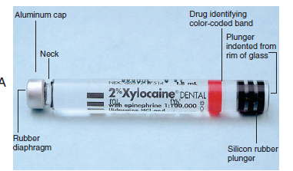

If bubble exit here >> this is because it was frozen.

2- Extruded Stopper:

An extruded stopper with no bubble is indicative of prolonged storage in a chemical disinfecting solution and diffusion of the solution into the cartridge.

1. Burning on Injection:

A burning sensation on injection of anesthetic solution may be the result of one of the following:

1. Normal response to the pH of the drug.

2. Cartridge containing sterilizing solution.

3. Overheated cartridge.

4. Cartridge containing a vasopressor.

5- Old cartridge. (increase ph of it )

During the few seconds immediately after deposition of a local anesthetic solution the patient may complain of a slight sensation of burning. This normal reaction is caused by the pH of the local anesthetic solution; it lasts a second or two, until the anesthetic takes effect, and is noted mainly by sensitive patients. A more intense burning on injection is usually the result of the diffusion of disinfecting solution into the dental cartridge and its subsequent injection into the oral Leakage during Injection Leakage of local anesthetic s

4- Leakage during Injection: we talked about it

5- broken cartridge :

1. From manufacture (returned to the supplier immediately for exchange.)
2. Excessive force
3. The most common cause of cartridge breakage is the use of a cartridge that has been cracked or chipped during shipping.
4. Rust
5. Breakage also can occur as a result of attempting to use a cartridge with an extruded plunger. Extruded plungers can be forced back into the cartridge only with difficulty, if at all. Cartridges with extruded plungers should not be used. Syringes with bent harpoons may cause cartridges to break . Bent needles that are no longer patent create a pressure buildup within the cartridge during attempted injection . *No* attempt should be made to force local anesthetic solution from a dental cartridge against significant resistance.

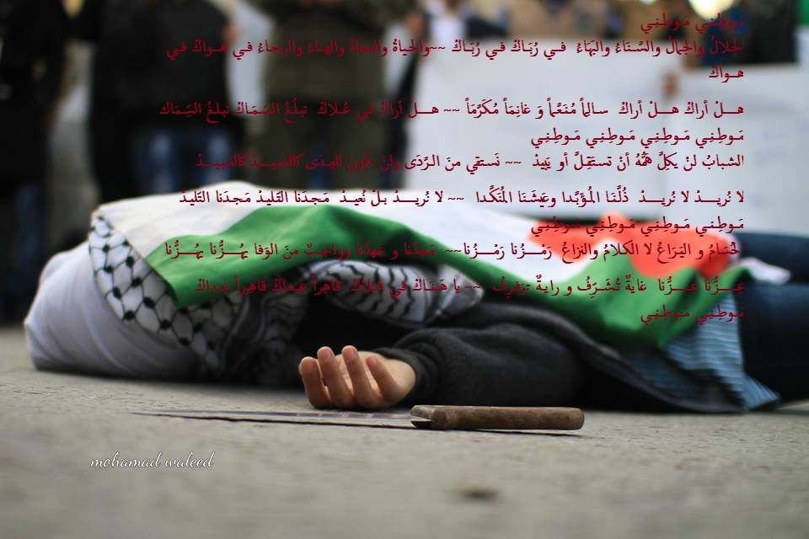

Thank you .